Abari Country Profile
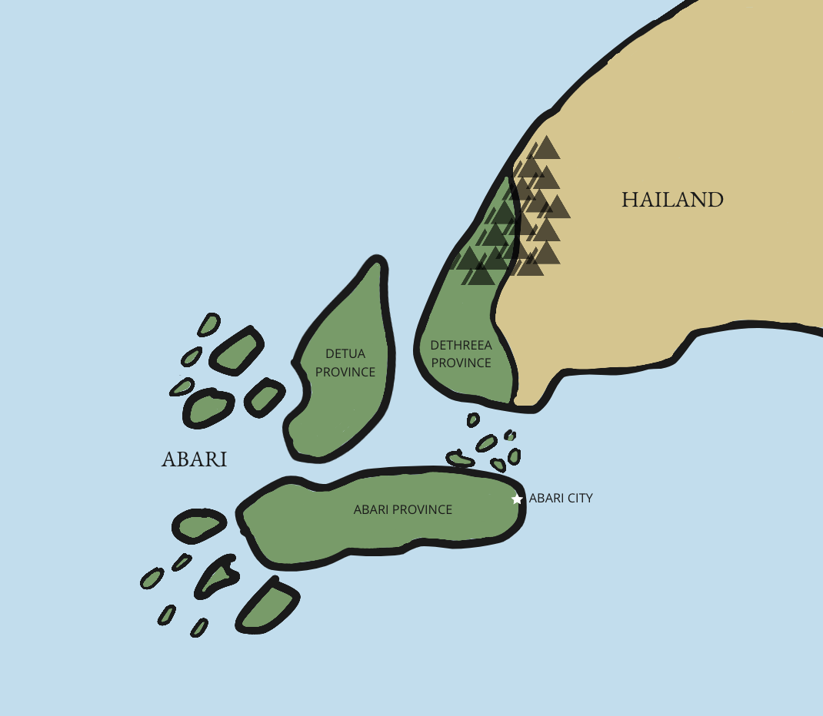
Geography and Climate
The Republic of Abari is made up of two main geographical regions: the peninsular of Abari and the archipelago of Abari, composed of two main islands and 200 minor islands. Abari shares its only continental border with Hailand to the North and East. The capital is Abari City, located on the largest island of the archipelago to the East. The hot, humid climate supports lush vegetation in the majority of the country. The wettest season is from June to November and typhoons are common during this time. Several cause serious damage every year. The southern part of the country is also prone to earthquakes.

Society and people
Abari has a population of about 12 million people, growing rapidly. 1 million people live in the capital Abari City. The official and most commonly spoken language is Abari, followed by Haila. English is spoken as an administrative language. The Haila population, which lives mostly in the province of Dethreea (D3), was divided between Abari and the country of Hailand through the drawing of post-colonial borders between islands during the last century, creating two countries. The Haila people in Abari Dethreea Province have many grievances against the government around land tenure, socioeconomic status and education issues. They claim they were driven from their original tribal lands and forced to live in the more arid high elevations of the North of Dethreea Province. An insurgent group comprising Haila recruits has been waging a low-level armed conflict for the last 20 years. There has been recruitment of child soldiers and sporadic attacks on police stations and military outposts. Thousands of Abarians have been displaced into neighbouring Hailand and still live in very precarious conditions due to the ongoing conflict.
Political System and governance
Abari gained its independence in 1976. The current political system is that of a presidential, representative and democratic republic with a multi-party system. Head of government, head of state and commander in chief of the armed forces is the president. The President of Abari is elected by direct vote by the people for a term of six years. He may only serve for one term and is not eligible for re-election. The second highest official is the Vice-President. Abari’s legislature is a bicameral Congress consisting of a Senate and a House of Representatives. For the past five years a state decentralisation law has greatly expanded the administrative autonomy of the provinces, in part to address growing calls for autonomy from the Haila people in Dethreea province.

Legal Framework

Child Protection Indicators
Legal Provisions | M | F | Source | Child Protection Indicator | M | F
Definition of child (age) | Under 18 |  | Constitution | Birth registration rates | 17%
Minimum age for light work | 12 |  | Labour Code (1983) | Child labour rates | 31% | 21%
Minimum age for work | 14 |  | Labour Code (1983 – under review) | Child marriage (under 18) | Unknown | 31%
Age of criminal responsibility | 12 |  | Juvenile Code (1987 – under review) | Children in detention | 6,000
Minimum age of marriage | 18 | 16 | Civil Code | Children in institutional care | 1000
Age of sexual consent | As per marriage |  | Criminal Code | Children living or working on the streets | 5000
Children with disabilities | Unknown |  |  | Children (0-17) orphaned | Unknown

International Conventions
International Convention | Year of adherence | International Convention | Year of adherence
Geneva Conventions, I, II, III & IV | 1978 | CEDAW | 2004
ICERD 1965 | 1983 | Refugee Convention | 1987
ICCPR 1966 | 1983 | Refugee Protocol | 2005
ICESCR 1966 | 1983 | UNSC Resolution 1612 Children in Armed Conflict | 2007
UN CAT 1984 | 1987 | ILO Convention 132 Minimum Age | 2012
UN Convention on the Right of the Child | 1991 | ILO Worst Forms Of Labour Convention no 138, no 182 | 2012
Hague Adoption Convention | 2004
CRC Optional Protocol (Sale of Children) | 2006 | Convention on the Rights of Persons with Disability | 2012

National Laws and Policies
Law/Policy | Year | Law/Policy | Year
The Constitution of Rhyeti | 1978 (under review) | Law on Counter Abduction and Human Trafficking | 2010
National Strategy for Children at Risk | 2008 | National Strategy for Children with Disabilities | 2011
The Juvenile Code | 1986 (under review) | National Justice Sector Strategy | 2008
The Rhyeti HIV/AIDS Strategic Framework | 2010 | Personal Family Law | 2012
Labour Code | 1983 (under review) | Action Plan for the Elimination of Violence Against Women (EVAW) | 2011
Action Plan for the prevention of underage recruitment | 2007

The legal system is patchy and outdated, at times inconsistent with commitments made to international law. Service delivery systems across all sectors are struggling to function with limited infrastructure and resources.

Over the past 10 years, as outlined by the National Action Plan (NAP), Abari’s government has sought the support of NGOs and CSOs for the establishment of Child Protection Networks (CPN) at the provincial and district levels. These aim to supplement and develop the capacities of Provincial and District Women and Children’s Departments by developing service and referral mapping and providing community outreach and child protection case management. They link with representatives within community-based child protection networks at the village level. Funding for this initiative has been limited and the degree of implementation is variable across the country.

Economy:
Abari is a free market economy with low labour costs. Two-fifths of all Abarians depend on the agricultural sector, mainly small-scale subsistence farming, which remains vulnerable to damage from frequent natural disasters. Poverty, conflict, corruption, vulnerability to natural disasters and low levels of education for much of the population represent some of the most serious impediments to Abari’s economic growth. Remittances are the primary source of foreign exchange, equivalent to more than a quarter of GDP and nearly double the combined value of Abari exports and foreign direct investment.
Close to 50% of the population lives under the national poverty line. Nevertheless, Abari’s GDP has been rising steadily since 2015. This growth was halted by the pandemic in 2020 that lead to additional political instability, decreasing foreign aid and the depreciation of the national currency. Research undertaken in 2007 indicates high levels of child labour, with 21% of boys and 31% of girls under the age of 14 engaged with work both within and outside the household. Boys work on family farms or as hired help on other people’s farms / with livestock, whilst girls perform domestic duties within the household. In coastal areas, boys work on fishing boats. In urban areas boys work in shops, markets and restaurants, whilst girls work as domestic help in other people’s households.

Education data:
School is compulsory from ages 5 to 18, of which the first 6 grades are delivered in primary school. Secondary schooling completes the final 7 years of the Abarian pre-tertiary education programme. The state curriculum is basic. For this reason the children of wealthier families often attend private schools. Abari has moderate primary school enrolment rates, like other countries in the region, with an enrolment ratio (NER) of 90%. Yet 150,000 primary school-aged children remain out of school, 86% of whom are girls and only about 2/3 of the students complete the primary school cycle. Its secondary school NER is much lower, at 58%, which is the second lowest in the region. Vocational and adult education is largely in the hands of private firms where a variety of programmes are available in urban areas. There is a limited variety of post-secondary colleges and universities in Abari. Some of these are state-controlled while others are privately owned.

SUMMARY OF BASIC INDICATORS
Islands of Abari
No. |  | Item | Detail
1 |  | Official name | Republic of Abari
2 |  | Official currency | Abari paiso (average purchasing exchange rate = 5 Abari paisos: 1 USD)
3 |  | Territorial extension | 350,000 km²
4 |  | Language | Official: Abari. A variety of local languages are also spoken, the most important being Haila.
5 |  | Political-administrative divisions | 3 districts
6 |  | Position in the Human Development Index (HDI) 2009 | Republic of Abari: 130  (Friendship Kingdom: 98; U.S. of Freedom: 25; Prosperity: 135)
7 |  | Human Development Index (2009) | 0.650 (world average = 0.722)
8 |  | Population with malnutrition | 40.2%
9 |  | Population according to Official 2000 Census | 15,600,000 inhabitants (M: 48 %; F: 52 %)
10 |  | Territorial distribution of the population (2007). | 60% in urban areas, 40 % in rural areas.
11 |  | Average age of the population (2007) | 30
12 |  | Life expectancy at birth (2007) | Women: 67; Men: 63 (PAHO data)
13 |  | Infant mortality rate (2007) | 45 under 5s per 1,000 live births
14 |  | Population density (2007) | 70 inhabitants per km²
16 |  | Gross domestic product (2009) | USD 7.5 billion (source: Central Bank of the Republic of Abari)
17 |  | GDP per capita (2009) | USD 750 per person per year (source: Central Bank)
18 |  | Family remittances (money sent from abroad) (2009) | USD 500 million per year (equivalent of 20% of exports)
19 |  | Public social spending (2005) | 4% of the GDP
20 |  | Total foreign debt (2009) | USD 15 billion (Central Bank)
22 |  | Economically active population (AEP) (2009) | 6,000,0000 people over the age of 10 who want to work (definition of the Institute of Statistics and Census)
23 |  | Unemployment (2009) | 45% of the AEP (source: National Employment Institute – INE)
24 |  | Employment of the urban AEP by sector (2009) | 65% informal sector, 35% formal sector. (source: INE)
25 |  | Population in situation of poverty (2009) | 75% (50% extreme poverty, 25% relative poverty) (source: INE)
26 |  | Housing deficit (2008) | 1,500,000 units (800,000 overcrowded and 700,000 in poor condition)
27 |  | Housing and basic services | At least 65% of the housing units lack at least three types of basic service
28 |  | Household garbage collection (national level) | 40%
29 |  | Treatment of waste water (national level) | 15%
30 |  | School-aged population without coverage (2008/09.) | Pre-school 75%, primary 80%, secondary 70%
31 |  | National illiteracy rate (2009) | 30% of the population over 7 years old  (M: 25%, F: 35%) (INE data.)
32 |  | HIV Prevalence | 3.5% of 15-49 year olds
33 |  | Under-age marriage | UNICEF data shows that 43% of women aged 20-24 were first married / in union before the age of 18

