CPHA-CPMS learning package

Cross-cutting issues: Environmental considerations

- Objectives
By the end of the session, participants will be able to:
- Discuss the relevance of environmental considerations to child protection in humanitarian action
- Reflect on potential opportunities and challenges when incorporating direct and indirect environmental considerations into CPHA programming

- Key Learning Points
To further explore content on the key learning points listed below, please refer to the “Additional Resources” section at the end of the session.
- Disasters, climate change, noise and air pollution can make children and families more vulnerable as they can lead to or worsen forced displacement and migration, gender inequities, livelihood insecurity and health hazards.
- A range of strategies can be identified to prioritise the protection of children and prevention of violence, even as climate impacts grow, including strengthening protective services, taking a localised approach, using anticipatory actions, working towards multi-sectoral integration and coordination, preparing for the long term while gathering evidence and advocating for anticipatory and preventative funding approaches to humanitarian disasters.
- Humanitarian operations affect the natural environment, both directly and indirectly. Programming must include an assessment of possible risks to the environment and must then identify the means to mitigate these risks. Child protection programming should minimise its environmental impact throughout all areas of programme design, including transport, procurement processes, site selection and choice of resources.
- Child protection programming can also:
- Increase children’s, families’ and communities’ awareness of environmental concerns
- Support child-led or child-focused advocacy on the climate crisis and environmental protection
- Provide supportive programming and psychosocial interventions that can increase children’s resilience to potential and actual environmental crises.

- Session outline
Topic | Methodology | Time
Session Introduction | Trainer input | 5 min
How environment impacts children | Gallery walk and plenary discussion | 25 min
How we can protect children from the climate crisis | Matching exercise in pairs | 30 min
How humanitarian action impacts the environment | Group exercise | 35 min
Session recap | Trainer input | 5 min
Total |  | 100 min

- Instructions for facilitator
Methodologies Face to Face | Methodologies Remote | Time
Session introduction  Welcome the participants and introduce the session objectives.  Note that we are using the term environment to refer to the natural environment and that this should be considered with the climate crisis in mind. |  | 2 min
How the environment impacts children  Instructions: Explain that children’s health, wellbeing and protection can be greatly influenced by the environment and actual or threatened changes related to the climate crisis. Show slide 79 and explain that to help us think more about what this means, we are going to do a gallery walk. Explain that around the room you have placed photos of children in a range of humanitarian settings. Invite the participants to get up and walk around, looking at the pictures as if they were in an art gallery. While they do this, they should think about what they see in the images. What impact do the different environments have on children?  Allow 10 minutes for people to walk around and look at the images, then bring the group back together and ask for any impressions. Use the following questions to guide the conversation:  - What different sorts of environment did you observe?  - Were there any visual differences in the situations of the children, because of their environments?  - Were there any implied differences?  - In your own work, what has been the environmental impact on children in humanitarian settings?  See the supporting information section below for more information on what each image shows. Feed this into the discussion, if appropriate and useful to do so. | In the chat, share a link to the image gallery or PowerPoint. Explain that participants have 10 minutes to look at the images at their own pace. | 20 Min
How can we protect children in the climate crisis?  Instructions: Prepare flip charts with the following headings:  - Strengthening protective services  - Localised approach  - Anticipatory approach  - Preparing for the long term  - Working towards multi-sectoral integration and coordination  - Improved Data and Evidence  - Funding  Organise the participants into pairs and give each pair one card from the “How we can protect children in the climate crisis” table (see supporting information).  Explain that the pairs should discuss their card and decide which of the headings on the flip charts it should be placed under. Allow 5 minutes for discussion, then in plenary ask each pair to read out their statement and explain which heading they selected and why. Correct as needed, explaining why, and then have the pairs place their card on the correct flip chart. | Prepare a virtual whiteboard with the headings listed under facilitator instructions, and moveable sticky notes for each of the statements in the table (see supporting information).  Screen share the whiteboard and explain that we will work together to decide which statements fit under which headings. Allow a few minutes for the participants to read through the headings and statements.  Then ask for a volunteer to suggest where a statement should go and why. Facilitate the choice of the correct answer as needed, then move the note. Repeat with the additional statements.  Check for questions. | 30 min
How humanitarian action impacts the environment  In plenary, ask: True or False - Humanitarian operations affect the environment, both directly and indirectly. Take a show of hands and then note that this is true. This means that not only can the environment impact children in humanitarian settings, but our interventions can have additional or further impacts on the environment. Therefore CPHA programming must include an assessment of possible risks to the environment and must then identify means to mitigate these risks.  Instructions: Explain that we will explore this more through a group activity and show slide 80. Organise the participants into groups of around 4 people. Allocate one image from the gallery walk to each group and then assign each group one scenario card.  Each group should imagine they will be implementing the programming activities described on the scenario card in the environment shown in their image. They have 15 minutes to discuss:  - What are the potential risks to the environment?  - What mitigating measures could we put in place?  They should be prepared to report back briefly to the plenary. Provide each group with a flip chart and markers and allow 15 minutes for the discussion.  Circulate between the groups to support as required.  After 15 minutes, bring the groups back together and invite each group to summarise their discussion in turn.  Wrap up the exercise by explaining that Child Protection Programming should minimise its environmental impact throughout all areas of programme design, including transport, procurement processes, site selection and choice of resources.  Child protection programming can also:  - Increase children’s, families’ and communities’ awareness of environmental concerns  - Support child-led or child-focused advocacy on the climate crisis and environmental protection  - Provide supportive programming and psychosocial interventions that can increase children’s resilience to potential and actual environmental crises  - Encourage adaptations to rapid climate change, such as helping children be stewards of the land / agriculture, community / CFS garden or collection of plants or through working with other sectors, for example joining WASH to deal with waste materials or thinking about how to keep the CFS/school/homes cool or warmer. | Prepare breakout rooms of 4 people.  Copy and paste the scenarios into the chat and assign one to each group, as well as an image.  Copy and paste the questions into the chat and provide a link to a virtual whiteboard space for each group.  Close the breakout rooms and support screen sharing of the virtual whiteboards during the group feedback, as required. | 35 min
Session wrap-up  Remind participants that they can use their learning log at any time to make a note of key learnings and wrap up the session by showing slide 81.  Reflective practice - suggested questions:  - How are environmental crises impacting children?  - What can you do with what you have learnt today? |  | 3 min
- Supporting Information
Images for Gallery Walk

Scenario cards

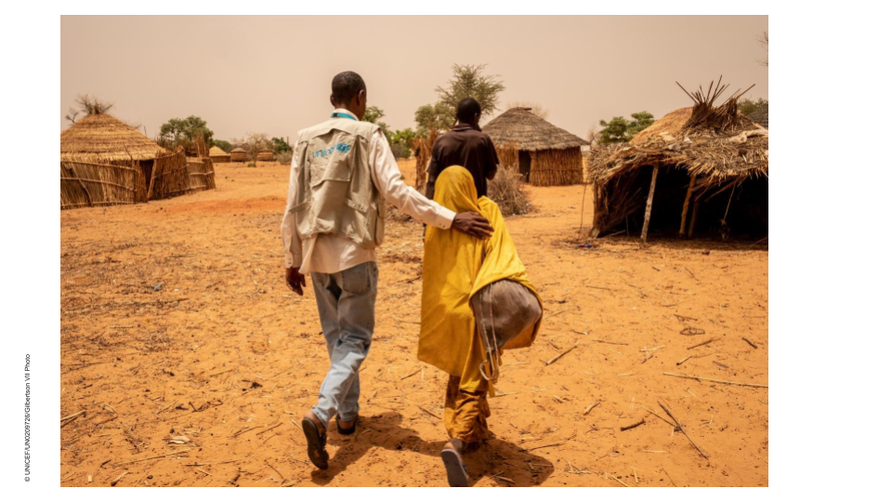
Child Future has set up child-friendly spaces in the internally displaced camp and utilises case management to support the most vulnerable children amongst the IDPs and the host community. The organisation now has 600 child protection cases and is in the process of increasing the number of case workers on its team. However, resources are limited and the number of cases very high. The most common types of child protection cases Child Future sees are children who have dropped out of school or who are at risk of early marriage or armed recruitment. When providing case management to families and children, the organisation works collaboratively with families and children.

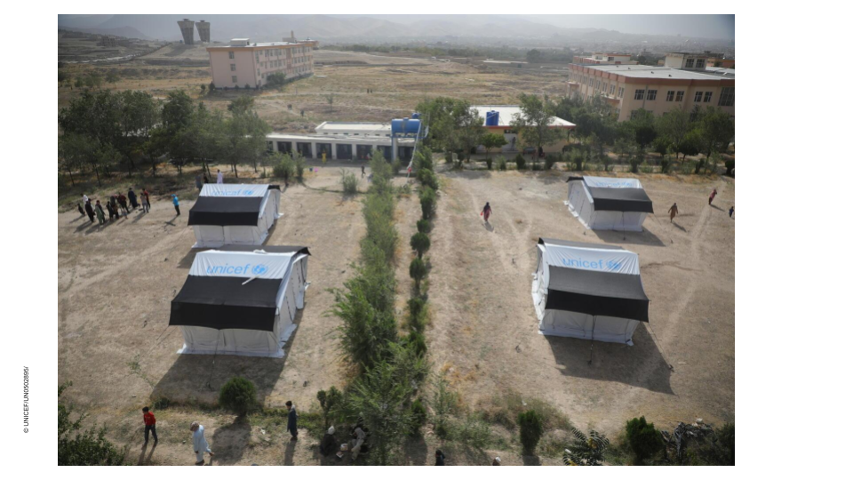
All children who participate in Child Future programming receive psychosocial support. This includes “Life Skills” programming for children ages 6 to 12 in addition to adolescent psychosocial support groups that cover topics such as psychological health, early marriage, puberty (often with the help of a doctor) and exploitative labor. Additionally, one “Life Skills” module is centered around “Peace and Conflict” and includes exercises that help children identify different types of conflicts they may encounter, “not only about the war” but with their friends and with their family. The learning module also includes a section about how to find healthy ways to cope with conflict.

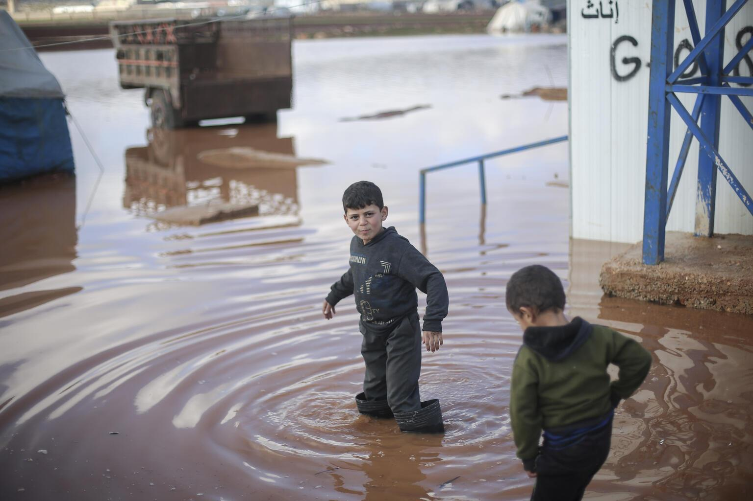
Child Future does community outreach using child protection mobile teams that target communities which significantly lack opportunities for children. These campaigns target children, parents and teachers. Child Future child protection mobile teams go out into communities and provide condensed 8-hour parenting sessions on topics that range from early marriage, hygiene, child armed recruitment and positive parenting skills to evacuation in emergencies. The mobile child protection teams also provide trainings in child protection for those working in close contact with youth. Another form of outreach is the bi-weekly children’s magazine which is distributed in various ways.

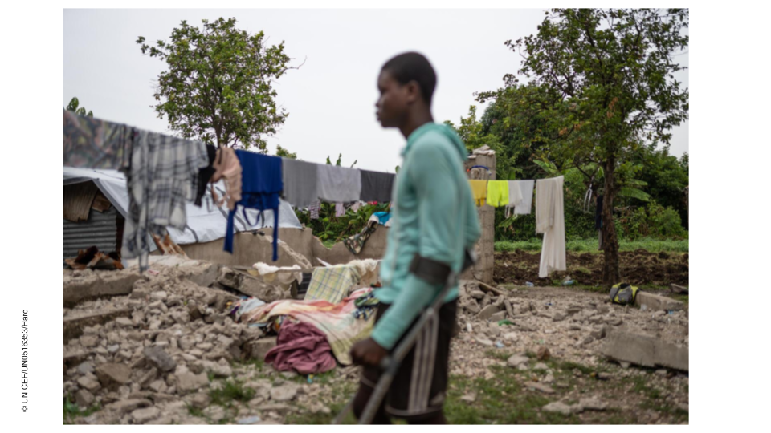
After the earthquake, Child Future runs child-friendly spaces in the most affected neighbourhoods, as schools are not functioning at the moment. Simple shelters have been set up to run the activities and are equipped with hygiene and sanitation facilities. Over 1000 children were registered at the 8 child-friendly spaces in the first 3 weeks of running activities. Child Future relies on the help of youth volunteers who have been trained to conduct the activities. Resources for activities are however limited.

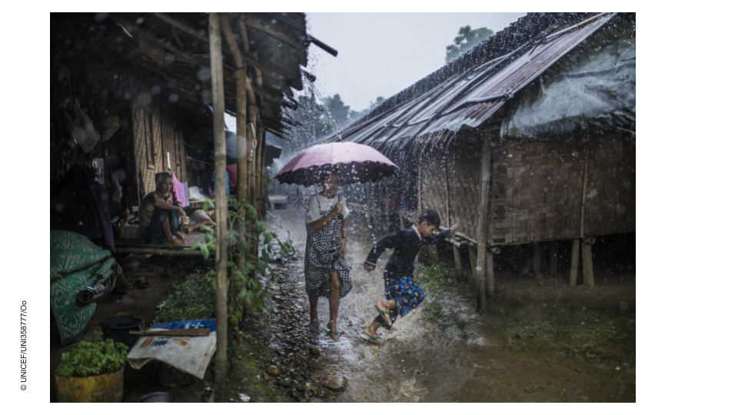
Child Future runs child-friendly spaces for children in the refugee camp accompanied by parenting sessions for caregivers. Child-friendly spaces are not big enough to cater for all children as there is limited space to set up adequate structures in the camp. Parenting sessions are delivered by community outreach workers door-to-door on a weekly basis and are also used to identify children at risk of being referred for case management services run by other organisations.

Interview questions
- In what ways may your CPHA programmes be negatively (or positively) impacting the environment?
- What is currently in place to mitigate or reduce this impact?
- What other ideas do you have?
- Who might be able to help your work on this issue?

How can we protect children in the climate crisis?

Strengthening protective services | Protective systems, services and communities play a vital role in preventing violence against children and enhancing resilience and adaptability to climate impacts. Services must be inclusive and prioritise the needs of the most vulnerable, should be shock-responsive, mobile and adaptable to disaster. Barriers such as fees or exclusion by migrant status should be removed.
Strengthening protective services | In anticipation of growing demand, efforts should focus on strengthening community child protection systems. These low-cost systems have specialised knowledge of the community and risks, and can provide immediate support
Strengthening protective services | Cash-plus transfer systems that provide money alongside a range of other interventions can enhance family resilience and should be prepared to respond during times of crisis.
Strengthening protective services | Education is a critical protective service for children, providing them with knowledge and support, increasing protection from violence especially child marriage and child labour and delivering the skills to diversify and adapt livelihoods later in life.
Strengthening protective services | Psychosocial services should be widely available, adaptable and responsive to provide immediate and long-term support for the emotional impacts of the climate crisis.
Taking a localised approach | A localised approach based on contextualised knowledge and responses increases relevance and stakeholder ownership, especially where social and cultural issues are concerned.
Taking a localised approach | Connections between local and national levels should be improved to ensure that national priorities and responses address local experiences.
Taking a localised approach | Increased long-term investment in community programmes incorporating a child protection focus result in sustainable long-term solutions and enhanced community resilience
Anticipatory approach | This involves anticipating the fast or slow-onset climate impacts expected in a particular area and planning to ensure that protective measures are in place before disaster strikes. While anticipatory approaches to food security or shelter are increasingly common, the inclusion of child protection measures is rare.
Work towards multi-sectoral integration and coordination | The disconnection between the climate and child protection sectors is a fundamental obstacle in protecting children. Climate partners, child protection, finance, education, health and others must be brought together to achieve a comprehensive approach.
Prepare for the long term | Strategies must consider timeframes longer than the next few years and predicted climate impacts must now be considered from a child protection perspective in order to give children the best chance.
Improve data and evidence | There is a lack of systematic research in this area and a pressing need for disaggregated data to improve understanding of children’s particular experiences in any context as well as to target interventions and help increase visibility of climate-exacerbated violence against children.
Funding | There is a particular need and opportunity for a substantial increase in funding for anticipatory and preventative approaches to humanitarian disasters. These approaches are more cost effective and sustainable, enhance community resilience and – importantly - provide much better protection for children than response-based methods. However, so far they have received little investment.

** Drawn from “How can we protect children in the climate crisis?”, End Violence Against Children Initiative, 2022

- Additional Resources
Climate change Protecting the Rights of Children, OHCHR, 2021
The Climate Crisis is a Child Rights Crisis, UNICEF, 2021

