CPHA-CPMS learning package

Cross-cutting issues: Disability

- Objectives
By the end of the session, participants will be able to:
- Discuss the relevance of disability inclusion to child protection in humanitarian action
- Reflect on potential opportunities and challenges when incorporating disability inclusion into CP programming
- Key Learning Points
To further explore content on the key learning points listed below, please refer to the “Additional Resources” section at the end of the session.
- Often impairments can lead to physical, communication or sociocultural barriers that limit a person’s equal participation in society. This can place someone at greater risk in humanitarian settings. Children with disabilities have the same human rights as all children. All humanitarian actors are responsible for respecting, supporting and promoting those rights. Humanitarian actors need to identify and address risks and barriers that prevent children with disabilities from equally accessing goods, services, spaces and information. Facilities and services should be designed for all children’s access and use to the greatest extent possible and should include reasonable accommodations or adjustments for children with disabilities. Throughout the programme cycle, humanitarian actors should analyse the relationships between disability and other risk factors (such as girls with disabilities, children with disabilities who live in institutions etc.). It is always relevant and necessary to disaggregate individual and qualitative data by disability, as children with disabilities are present in every context.

- Session outline
Topic | Methodology | Time
Session Introduction | Trainer input | 2 min
Relevance of disability to CPHA | Power walk | 25 min
Prevention and response scenarios | Group exercise | 40 min
SWOT analysis / applying to your own work | Individual exercise and plenary debrief | 30 min
Session recap | Trainer input | 3 min
Total |  | 100 min

- Instructions for facilitator
Methodologies Face to Face | Methodologies Remote | Time
Session introduction  Welcome the participants and introduce the session objectives. |  | 2 min
Relevance of disability to CPHA  Instructions: Explain that to begin with, we are going to do an activity to explore the relevance of considering disability in CPHA programming. Invite everyone to stand up and move to an open space, either in the training room or outside.  Ask the participants to line up, side by side, at one end of the space and give each person a character card. Allow a moment to read these individually (not out loud).  Explain that you will read a series of statements. They should consider the impact of this statement on the character they have been assigned. If they feel the statement is entirely true for their character, they should step forward two steps. If it is partly true, they should step forward one step and if it is not true, they should stand still.  Check for understanding of the exercise.  Read the statements one at a time. Between each statement, wait for the participants to move, then ask one or two volunteers to explain why they did or did not move and how this relates to their character.  - You have the power to influence people in your community  - You eat at least two meals a day  - You receive (received) primary school education  - You receive (received) secondary school education  - You are listened to in extended family meetings  - You can afford to see a doctor and buy medicine when you are sick  - You have access to specialised services when and where needed  - You can read and write  - You have people who care about you and protect you  - You can plan your future life thanks to your family’s support  - You are not afraid that people might hurt you  - You don’t have to do dangerous things in order to survive  After you have read all the statements, ask the participants to look around at where everyone is standing. Then have each participant read out their character card.  Summarise that disabilities and impairments can lead to physical, communication or sociocultural barriers that limit children’s equal participation in society. This places them at greater risk in humanitarian settings, as we have seen in this activity. | Email or use the chat function to send each participant the text of a character card. Ensure that they see only the information about their own character and not about any of the others.  Have each participant write their own name on a post-it on the previously prepared virtual whiteboard. This is their marker and they should move it forward (by clicking and dragging it to the next “step”) or keep it in place on the grid in response to each statement.  (See suggested layout in supporting information). | 25 Min
Prevention and response scenarios  Invite the participants to return to their seats.  Explain: Children with disabilities have the same human rights as all children. All humanitarian actors are responsible for respecting, supporting and promoting those rights. Humanitarian actors need to identify and address risks and barriers that prevent children with disabilities from equally accessing goods, services, spaces and information.  Show slide 76 and explain that we will now think about what we could have done as CP actors in humanitarian contexts to support some of the characters from the previous exercise. Ask the participants to get into groups of four and reassign one character from the previous exercise to each group.  - In Muzaffargarh, Pakistan, an 8 year-old boy who has been blind since birth sits outside his family tent in one of the worst flood-affected districts in the province.  - Nimrod is 8 years old and has Down’s syndrome. He lives with his family in a village on the outskirts of Jakarta often ravaged by floods. His parents do not send him to school and think that he is just a curse on the family.  - In South Sudan, Bhang Wan, 15, supports his younger siblings Kerwan and Nyalat. The children were separated from their mother after fleeing an attack on their home. A neighbour helped them to get to a safe location, carrying Kerwan, who now uses a wheelchair.  - Shiela is 14 years old. She became blind after conflict erupted in her village and she was caught in the crossfire. Shiela was doing very well in school but there are no facilities for blind children in her village or close by and she spends a lot of time at home alone.  - Mohammed is 15 years old and he lives with his family in a Dadaab refugee camp. He lost a leg in a landmine accident. He has completed primary school but his father died and his family is really struggling to find new livelihood opportunities.  Explain that each group should come up with a list of specific actions that CPHA actors could take to prevent and respond to CP risks to the child on their card.  Check for understanding of the task, provide a flip chart and marker for each group and allow 15 minutes for discussion.  Circulate amongst the groups to observe and support as required.  After 15 minutes, bring the group back together and ask each group to read out their character card, then list one of the key actions from their group discussion. Allow all the groups to do so, asking them to avoid repeating the actions that have already been suggested. Feed in any key points which are missing, which may include:  - Humanitarian actors need to identify and address risks and barriers that prevent children with disabilities from equally accessing goods, services, spaces and information.  - Facilities and services should be designed to provide access and use for all children to the greatest extent possible and should include reasonable accommodations or adjustments for children with disabilities.  - Throughout the programme cycle, humanitarian actors should analyse the relationships between disability and other risk factors (such as girls with disabilities, children with disabilities who live in institutions etc.).  - It is always relevant and necessary to disaggregate individual and qualitative data by disability, as children with disabilities are present in every context. | Prepare breakout rooms of 4 people. Copy and paste the relevant character card text into the chat and assign one to each group.  Share links to virtual whiteboard(s) for groups to make their notes.  Launch the breakout rooms - time 15 minutes.  Close the breakout rooms and support screen sharing of the virtual whiteboards during the feedback, as required. | 40 min
Essential Actions on Disability: Inclusive Child Protection  Instructions: Show slide 77 and divide participants into 5 groups and hand out a set of flash cards to each group, showing the programme management cycle steps and key actions for disability-inclusive child protection.  Explain that the groups should read the key actions and then sort them into the relevant steps of the programme management cycle. Allow 15 minutes for group work.  Once 15 minutes have elapsed, ask each group to present the key actions alongside the different steps of the programme management cycle and invite the other groups to correct as needed. Feedback as appropriate. | Prepare breakout rooms and whiteboards with programme management cycle steps and key actions for each group.  Launch breakout rooms.  Close breakout rooms. | 30 min
Session wrap-up  Remind participants that they can use their learning log at any time to make a note of key learnings and wrap up the session by showing slide 78.  Reflective practice - suggested questions:  - What can you do for disabled children in your own contexts and programmes? Are there any gaps that you have become aware of?  - Is there something you would like to learn more about? | Send case study via chat function or any means most appropriate to the online platform chosen. | 3 min
- Supporting Information
Power walk virtual whiteboard suggested layout

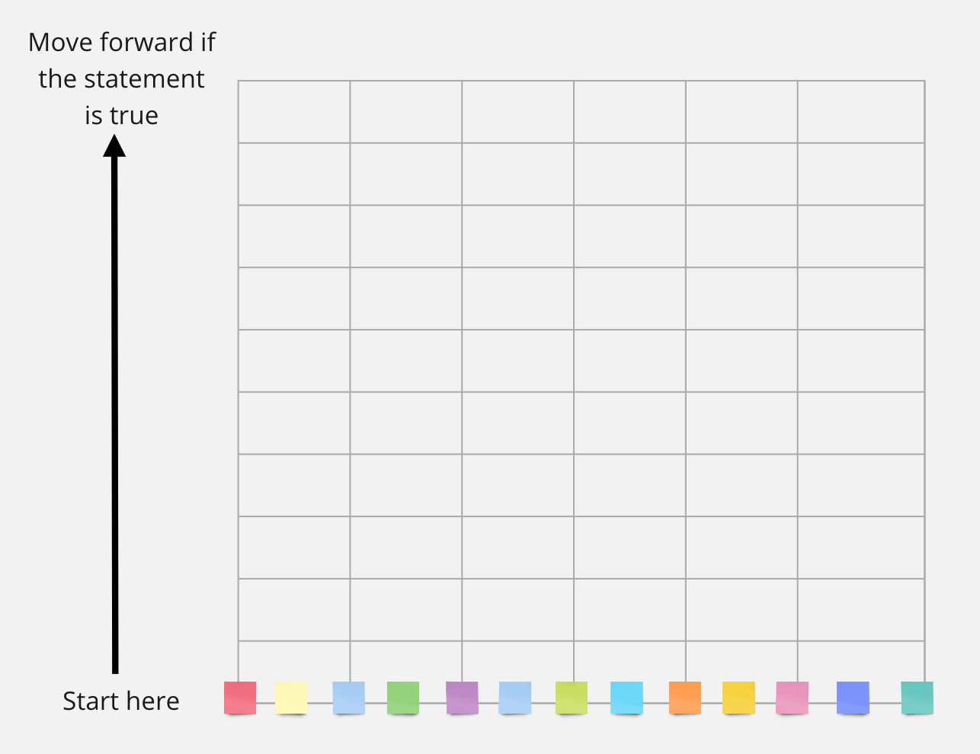

Power walk character cards
In Muzaffargarh, Pakistan, an 8 year-old boy who has been blind since birth sits outside his family tent and sings in one of the worst flood-affected districts in the province. | Alexi, a 5 year-old girl, plays with toys from a UNICEF early childhood development kit in Port-au-Prince, Haiti. Alexi, who has a physical disability, lost her home when it collapsed during the earthquake. | Nour is an 11 year-old girl and participates in a child-friendly space in the Islahiye camp for Syrian refugees in Turkey. Nour, who has Down’s syndrome, fled the Syrian Arab Republic with her family. | In South Sudan, Bhang Wan, 15, supports his younger siblings Kerwan and Nyalat. The children were separated from their mother after fleeing an attack on their home. A neighbour helped them to get to a safe location, carrying Kerwan, who now uses a wheelchair.
Lujain is a 17 year-old girl with Down’s syndrome in a Makani Center child-friendly space, where she volunteers in Amman, Jordan. | Binod is 10 years old and uses a wheelchair. He holds his drawing in one of the 1,400 Temporary Learning Spaces set up after the earthquakes in Nepal in 2015. | Sarah is 17 years old and is blind from birth. She lives in Nairobi with her family and regularly attends high school. | Mohammed is 15 years old and lives with his family in a Daadab refugee camp. He lost a leg in a landmine accident. He has completed primary school but his father died and his family is really struggling to find new livelihood opportunities.
Kevon is 7 years old and has Down’s syndrome. He lives with his family and attends primary school regularly in his home town. He also attends sports classes and other activities outside school. | Mara is 12 years old and lives with her family in her home town. She attends secondary school and has access to many complementary activities with the school and outside. | Sanjana is 7 years old and has cerebral palsy. She lives in a residential institution in Kathmandu, as her parents lost their home after the earthquake in Nepal and could no longer take care of her. | Baha is 5 years old and has a developmental delay. He was separated from his family fleeing war-torn Syria and is now in a temporary foster care arrangement with a family in Lebanon.
Simon is 3 years old. He is cared for by his mother and regularly attends group activities with other children so he can socialise. Simon and his family live in a neighbourhood that was affected by severe floods during the rainy season. | Martin is 10 years old and lives with his family in Port au Prince (Haiti). While his family was affected by the earthquake, they were able to rebuild their house and livelihood fairly quickly and Martin is regularly attending school with his siblings. He also likes to draw and is getting some classes for this. | Shiela is 14 years old. She became blind after conflict erupted in her village and she was caught in the crossfire. Shiela was doing very well in school but there are no facilities for blind children in her village or close by and she spends a lot of time at home alone. | Nimrod is 8 years old and has Down’s syndrome. He lives with his family in a village on the outskirts of Jakarta often ravaged by floods. His parents do not send him to school and think that he is just a curse on the family.
Ania is 11 years old and has a developmental delay. Her education was deprioritised in favour of that of her siblings. She is now working as a domestic helper for a richer family and sees her family very rarely. | Stella is 14 and had her legs amputated at 10 because of an infection she contracted. Recently she has started high school. Stella also volunteers at a sports centre where she teaches other children basketball in a wheelchair. | Amer is 16 and has had a leg amputated as he was caught under the rubble when the building he was living in collapsed. He continues to attend high school and teaches karate to children - his true passion. | Malak is 7 years old and has a developmental delay. His family is very poor; his family does not prioritise his schooling and sends him to beg for money in the street.
Essential actions on disability-inclusive child protection**
NEEDS ASSESSMENT AND ANALYSIS
By collecting data on children with disabilities, it is possible to identify them, assess their needs and monitor their access to humanitarian assistance.
Organise focus group discussions (FGDs) and key informant interviews (KIIs) with persons with disabilities to gather information on how the crisis is impacting children with disabilities, their access to services and local perceptions of girls and boys with disabilities.
Find and analyse the best available data on adults and children with disabilities within populations, from national emergency agencies, departments of health, social welfare, education or other departments.
Include accessibility in assessment criteria or standards used to select child-friendly spaces and other emergency-related buildings and facilities.
Share and use the needs assessment tools and disability data gathered under the above actions to influence UNICEF as well as inter-agency needs assessment and planning processes, such as preparedness actions*, scenario-based contingency plans and Humanitarian Needs Overviews.
HUMANITARIAN RESPONSE PLANNING/STRATEGIC PLANNING
Response plans are evidence-based, consistent with inter-agency planning and aligned with the CO work plan. Plans need to address coverage, quality and equity, which requires including all the affected population - particularly persons with disabilities, including children.
Foster collaboration and partnerships with agencies and organisations with expertise on disability and accessibility, including Organisations of Persons with Disabilities (OPDs).
Support the establishment or reinforcement of a disability coordination mechanism, e.g. Disability Working Group, to promote inter-sectoral and inter-agency coordination of disability inclusion.
Ensure that child protection issues related to children with disabilities have been included in the planning of response and strategic processes, i.e. identify how the crisis impacts children with disabilities differently and describe the specific barriers and risks they face.
Allocate budget for actions to ensure children with disabilities are included in the child protection response, including costs for reasonable accommodation, provision of assistive technology, accessible communication and other support services and supplies.
IMPLEMENTATION AND MONITORING
Implementing humanitarian response plans that are inclusive of persons with disabilities requires on-going monitoring of access to assistance.
Implementation
Assess the systems used to identify children at risk, such as the Child Protection Information Management System (CPIMS), refugee registration, national systems (e.g. through schools and health centres) and community outreach mechanisms and determine whether they are inclusive of children with disabilities (e.g. that they disaggregate data by disability).
Ensure that persons with disabilities, including children, can access all protection programmes and services addressing barriers to access.
Invite OPDs to trainings organised on child protection in emergencies to familiarise them with the humanitarian system, child protection programming and tools and support their participation in the humanitarian response.
Capture information on access to protection services and the barriers faced by children with disabilities in Situation Reports (Sitreps) and dashboards.
Ensure that all AAP mechanisms are accessible for children with physical, sensory, intellectual and psychosocial disabilities as well as their caregivers.
Ensure children with disabilities feature in Advocacy and Communications Strategies and Plans.
Implement strategies that reduce disability-related stigma.
Ensure adequate expertise on the inclusion of children and adults with disabilities.
Create referral pathways through inter-sectoral connections to effectively identify and respond to the needs of households with children with disabilities.
Monitoring
Ensure that monitoring systems, such as Humanitarian Performance Monitoring (HPM), field monitoring plans or Cluster Coordination Performance Monitoring (CCPM) include both disability-specific indicators and indicators disaggregated by disability, to monitor progress in addressing the needs of children with disabilities.
Review and adapt existing mechanisms such as 5W mapping systems to collect relevant information on protection services related to disability.
Support the capacity of own teams and partners to protect the rights of persons with disabilities in relation to data ethics and protection.
EVALUATION AND LEARNING
Inter-agency reporting and evaluations are a key opportunity to evaluate the extent to which persons with disabilities contribute to and benefit from the response and identify lessons to improve future responses.
Capture good inclusive humanitarian practices (what worked and why) and lessons learned and use the findings to provide recommendations for ongoing and future programmes.
Engage OPDs in evaluations including in the identification of evaluation criteria, data collection, analysis and validation of findings, and formulation of recommendations and good practice.
Ensure that periodical Sitreps and final humanitarian response evaluations reflect how children with disabilities have been reached and impacted.

**The “Essential actions on disability-inclusive child protection” checklist has been adapted from the “Essential actions on disability-inclusive child protection” from UNICEF available at this link
- Additional Resources
IASC, Guidelines Inclusion of Persons with disabilities in Humanitarian Action, 2019
UNICEF, Guidance Including Children with disabilities in Humanitarian Action - Child Protection, 2017
UNICEF, Essential actions on disability-inclusive child protection, 2017

