CPHA-CPMS learning package

Cash and Voucher Assistance

- Objectives
By the end of the session, participants will be able to:
- Recall the different modalities and delivery mechanisms of cash programming
- Differentiate between cash programming with indirect and direct protection outcomes for children
- Describe key considerations regarding conditional and unconditional cash transfers in child protection for humanitarian action
- Key Learning Points
To further explore content on the key learning points listed below, please refer to the “Additional Resources” section at the end of the session.
Cash and Voucher Assistance (CVA): CVA refers to all programmes where cash transfers or vouchers for goods or services are directly provided to recipients. In the context of humanitarian assistance, the term is used to refer to the provision of cash transfers or vouchers given to individuals, households or community recipients - not to governments or other state actors. This excludes remittances and microfinance in humanitarian interventions (although microfinance and money transfer institutions may be used for the actual delivery of cash).
Modality refers to the form of assistance. This can include:
- Cash transfer - the provision of assistance in the form of money. By definition, cash transfers are unrestricted.
- Vouchers - a paper, token or electronic card that can be exchanged for a set quantity or value of goods, (e.g. a household kit, 5 kilos of maize). Vouchers are restricted and can only be redeemed at pre-selected vendors.
- In-kind - humanitarian assistance provided in the form of physical goods or commodities.
- Service delivery - the provision of services to affected populations, e.g. healthcare, education, protection etc.
- A combination of modalities. Modalities can be used at household level and at a more general or community level e.g. health services, WASH infrastructure.
Delivery mechanism refers to the means of delivering a cash or voucher transfer (e.g. smart card, mobile money transfer, cash in hand, cheque, ATM card etc.).
Direct outcomes: cash transfer programming with intentional child protection outcomes - programmes where cash injections into households are explicitly intended to achieve child protection outcomes. Indirect outcomes: cash transfers to improve education, nutrition or food security and livelihoods that lead to unintended outcomes for child protection.

Unconditional transfers are provided to beneficiaries without the recipient having to do anything in order to receive the assistance. A conditional transfer requires beneficiaries to undertake a specific action/activity (e.g. attending school, building a shelter, attending nutrition screenings, work, trainings etc.) in order to receive assistance; a condition must be fulfilled before the transfer is received. Cash for Work/Assets/Training are all forms of conditional transfer.
- Session outline
Topic | Methodology | Time
Session Introduction | Plenary | 5 min
Cash Transfer Programming Definitions | Plenary discussion | 10 min
Direct and Indirect Protection Outcomes for Children | Case Studies discussion in small group | 30 min
Conditional and Unconditional Cash Transfers | Small Group Discussion | 35 min
CP and Safeguarding Risk Assessment | Case Study and Plenary Discussion | 15 min
Session recap | Plenary | 5 min
Total |  | 100 min

- Instructions for facilitator
Methodologies Face to Face | Methodologies Remote | Time
Session introduction  Welcome the participants and introduce the session objectives. |  | 2 min
Cash Transfer Programming Definitions  Show slide 69 and explain: CVA refers to all programs where cash transfers or vouchers for goods or services are directly provided to recipients. In the context of humanitarian assistance, the term is used to refer to the provision of cash transfers or vouchers given to individuals, households or community recipients - not to governments or other state actors. This excludes remittances and microfinance in humanitarian interventions (although microfinance and money transfer institutions may be used for the actual delivery of cash).  Instructions: Have 4 flip charts with Cash Transfer, Vouchers, In-kind and Service Delivery written on them. Say that you are going to read some definitions of different modalities of cash transfer programming and that in plenary you are going to be deciding which modality of cash transfer programming is a match to the definition. Once participants have decided the right definition/type of programming, stick the definition on the right flip chart. Read the definitions and ensure they are associated with the right type of programming. Note that modality means the form or type of assistance. Also explain that a combination of modalities can be used. Correct as necessary.  - The provision of assistance in the form of money.  - A paper, token or electronic card that can be exchanged for a set quantity or value of goods, (e.g. a household kit, 5 kilos of maize).  - Humanitarian assistance provided in the form of physical goods or commodities.  - The provision of services to affected populations, e.g. healthcare, education, protection etc.  Show the last two rows of the modalities and delivery mechanisms diagram on slide 70. Explain that modality is the form of assistance and delivery mechanism is the means of delivering the transfer, for example smart card, mobile money transfer, cash in hand, cheque, ATM card etc.  Check for questions.  Optional: show CALP Video on Cash Transfer Programming | Show a virtual whiteboard with 4 sticky notes:  - Cash Transfers  - Vouchers  - In-kind  - Service delivery  Read the definitions of the 4 assistance modalities and post them in the chat. Ask participants to match the definition with the type of cash transfer programming.  Optional: prepare to show video; | 10 Min
Direct and Indirect Outcomes for Children Protection  Instructions: Show slide 71 and in 4 groups ask participants to read through the provided case studies and decide which of the case studies is designed to have direct impact on child protection outcomes and which is designed to have indirect protection outcomes. Allow 15 minutes for reading the case studies and for discussion. Ask each of the groups to present key considerations of their discussion on one of the case studies. Ask the other groups to contribute.  Explain: In emergency settings, the programmes that have most frequently benefited from the use of cash transfers are programmes focusing on response to child labour. By far the majority of cash transfer programmes in emergency settings aim to improve the food security and livelihoods of target beneficiaries. The majority of the existing evidence is focused on responding to child protection risks and needs. Less is available on prevention. Nascent findings suggest that cash transfer programming could be leveraged early in humanitarian responses to support family resilience and prevent child protection risks from materialising. | Set up breakout rooms, distribute case studies via chat.  Open breakout rooms.  Close breakout rooms. | 30 min
Conditional and Unconditional cash transfers  Explain: Show slide 72 and explain that unconditional transfers are provided to beneficiaries without the recipient having to do anything in order to receive the assistance. A conditional transfer requires beneficiaries to undertake a specific action/activity (e.g. attending school, building a shelter, attending nutrition screenings, work, trainings etc.) in order to receive assistance; a condition must be fulfilled before the transfer is received. Cash for Work/Assets/Training are all forms of conditional transfer. The majority of studies reporting on child protection outcomes involve unconditional cash transfers and, to a lesser extent, conditional cash transfers, predominantly ones that incorporate cash-for-work schemes or linkages to education outcomes.  Instructions: Show slide 73 in small groups. Allow 10 minutes for participants to discuss what in their opinions are on the pros and cons of using a conditional or unconditional cash transfer approach for child protection in humanitarian action.  After time has elapsed ask each group to briefly state what the outcome of their discussion was and explain that cash practitioners increasingly consider unconditional transfers to be good practice; child protection practitioners report receiving push-back from cash colleagues when proposing a conditional approach over an unconditional one. Firstly, conditional cash transfers require additional time and resources for design, implementation and monitoring, particularly when involving children and (at times) sensitive child protection outcomes. Secondly, while some circumstances seem to indicate that conditional cash transfers may be more effective than unconditional cash transfers, it is not clear whether it is the condition or the transfer itself that leads to the positive change.  Back in their groups, ask participants to brainstorm regarding how cash transfer programming is or may be used to improve protection outcomes for children in their circumstances. Allow 10 minutes for discussion. After time has elapsed bring everyone back and ask each group to present one of the main points of their discussion. | Set up breakout rooms, distribute case studies via chat.  Open breakout rooms.  Close breakout rooms.  Open breakout rooms.  Close breakout rooms. | 35 min
Child Safeguarding Risk Assessment  Instructions: Ask participants to read the Indonesia Case Study individually. Allow 5 minutes for reading. Then ask participants:  Why was it important to conduct focus group discussions?  Would it have been useful to conduct the study earlier? Why?  Facilitate a brief discussion and explain by showing slide 74: A child protection and safeguarding risk assessment should be conducted before considering a CVA programme. It allows the following aspects to be identified:  - (Child) protection risks associated with the introduction of CVA: CVA is not inherently risky. Yet programming that uses CVA should take into account the challenges and risks that families and children face and whether gender, age, status or other personal characteristics may increase any CVA-associated risks.  - Child safeguarding issues: As with all humanitarian interventions, it is vital that all actors identify the possibility of humanitarian staff, operations or programmes causing safeguarding risks for children and families.  - Possible risk mitigation strategies to ensure the safe receipt and use of CVA: The information gathered can help programme teams to design programmes that proactively mitigate child protection risks and maximise protection benefits. | Send case study via chat function or any means most appropriate to the online platform chosen. | 15 min
Session wrap-up  Remind participants that they can use their learning log at any time to make a note of key learnings and wrap up the session by showing slide 75.  Reflective practice - suggested questions:  - How is Cash and Voucher Assistance relevant to child protection outcomes?  - What is the most important thing you have learnt in this session? |  | 3 min

- Supporting Information
Modalities and delivery mechanisms diagram (Source: https://www.calpnetwork.org/wp-content/uploads/2020/03/calp-glossary-english.pdf)
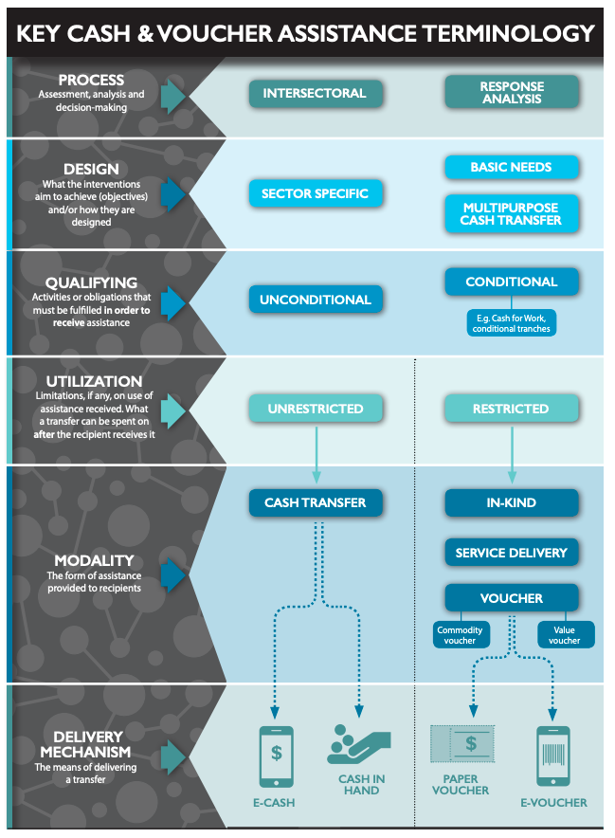

Case Studies
Direct Protection Outcomes for Children: In Indonesia, after the Indian Ocean tsunami and earthquake of 2004, great attention was given to the issue of institutional care, as the number of panti asuhan (children’s homes) grew exponentially. While international agencies addressing child protection needs in Aceh responded by giving cash grants to households to try to ensure families stayed together, some 11 overseas donors, individual givers and the government were supporting institutional care. By the end of 2005, 2,494 cases of unaccompanied, separated and single-parent households had been registered with an inter-agency group. One major concern was the secondary separation of children due to the financial strains placed on foster families and the poor economic conditions that prevailed in the aftermath of the tsunami. As a result the Ministry of Social Affairs, with support from Save the Children, embarked on a major research and policy review. The research found that the overwhelming majority of children in institutions had parents, guardians or family members who could provide care; only 6% of them were genuinely alone. Direct outcomes: cash transfer programming with intentional child protection outcomes assisted 5 orphans. It seems that 97.5% of the children placed in residential care in the aftermath of the tsunami in Aceh had been placed there by their families so that they could receive an education. The research found that government, donors and individual givers exacerbated this by supporting children who were in institutions.
Direct Protection Outcomes for Children: Aminullah is 13 years old and from Swat district in the northern KPK province of Pakistan. Save the Children’s programme in this area originated during the IDP crisis caused by Talibanisation in 2009. In 2010, monsoon floods caused another disaster in the same area. Aminullah was in a religious seminary in the port city of Karachi, over 1,200km away. He and his cousin were among hundreds of boys from all parts of the country. The boys were chained during the day and were regularly beaten with rods and sticks. Aminullah escaped and then, as a stowaway, he managed to find his way back to Swat district where he began working on a small tea stall. He now attends Save the Children’s Learning and Development Centre for children who have never attended school for financial reasons. Save the Children gives vouchers to Aminullah’s mother to cover food and other basics that he would otherwise have to have earned himself. The Learning and Development Centre helps out-of-school children become enrolled in the state education system by providing individual coaching and fast-track learning.
Indirect Protection Outcomes for Children: In Kenya, Oxfam implemented a cash transfer programme reaching 3,000 beneficiaries, where the recipients were primarily women. The objective was to improve food security with a monthly cash transfer of $20. Early evidence showed that people were able to eat better and suffered less stress. Some women had been able to start, rebuild or expand small businesses and others got their children back into school. Children were able to return home from living on the streets or were able to stop the practice of scavenging for food.
Indirect Protection Outcomes for Children: Save the Children targeted pregnant women and lactating mothers in Meket woreda, Amhara, Ethiopia with cash transfers and cash-for-work programmes. The aims were: to assist chronically food insecure people to meet their immediate needs, to stimulate local markets and to learn lessons about linking relief with development and child nutrition support. A 2005 evaluation found that the cash-for-work component led to reduced migration of beneficiaries seeking work, reduced women’s time collecting firewood and doing chores and increased breastfeeding of children. It concluded that, as a result of the interventions, families were more likely to stay together and more time was spent caring for children, indirectly improving children’s development and wellbeing and enhancing their protection.
Indonesia Case Study
In the post-earthquake and liquefaction context of Central Sulawesi, 2018, Plan International Indonesia provided a multi-sector response including multipurpose unrestricted cash, alongside vouchers restricted to dignity and education kits. The focus groups were held in March 2019 in an area near Palu with adults aged 18-60 (6 women and 10 men). As cash distributions had already taken place, this activity was an opportunity to contribute to planning for future cash or voucher interventions. The Cash Programme Officer (male) & interim Compliance & Quality Assurance Manager (female) led the discussions.
The focus group discussions with women and men in Palu identified a lack of understanding about what constitutes GBV, with intra-community violence and intimate partner violence (IPV) accepted within the behavioural norms of the community. GBV was not explicitly mentioned as a consequential risk after the receipt of CVA in this community. However, the discussions revealed intra-household dynamics related to household expenditure that would have positive protection benefits on cash recipients. Both groups of men and women mentioned that discussions would take place between the husband and wife on the use of the assistance and that this would reduce household tensions. Both women and men said that they should be the primary recipients to receive the cash assistance. The women firmly recommended that they should be the primary recipients in case the husband failed to spend all the cash on household needs. Discussion with the husband was considered important to agree priorities and prevent disputes over purchases such as cosmetics. Regarding distribution, women who do not own a motorbike usually depend on motor-taxis for transport to and from the market/ distribution, which incurs a charge and could pose potential risks. Travelling at night especially is considered unsafe. Childcare commitments may prevent women from attending the distribution. Women were concerned that disputes may occur in the household if the money was spent without consultation. Outside of the household, conflict or tension might occur with lenders if debts are not paid and the receipt of money was known; men would ensure middlemen are repaid. Other than with lenders, women considered that community tension would be unlikely as long as targeting criteria were well understood by their neighbours. Men considered the main risks of criminal activity to be perpetrated by outsiders not from the community/ village. Community tensions between selected and non-selected households were not reported as a concern; generally, men and women perceived that the support would improve community relations, as credit could be repaid on loans due to community members and suppliers (for livelihood inputs) and the assistance shared with non-selected households whom the community deemed eligible.
To determine whether incidences of GBV/ IPV related to CVA would be reported, the women discussed whether incidents of intimate partner violence (IPV) are formally reported to authorities or an organisation. They unanimously agreed that the close intracommunity dynamics would prevent reporting of IPV/GBV incidents, unless considered to be a transgression of accepted GBV within the community. However, the women did not offer examples of what could constitute a transgression in terms of severity or perpetrator. The women added they would not expect reports to be properly followed up on by authorities. The women said they would feel safer if the amount distributed were not made widely known to the community, as this may encourage debtors to extract repayment. Under 18s are not legally permitted to have a financial account with mobile money or a bank, in which case the account would be held in the case manager’s name and withdrawn with both people present immediately or even before distribution. Access to withdrawal points closer to the village would make the women feel safer, as well as being well informed of the date and time of the distribution to allow them to plan accordingly. To avoid theft, women are aware of the benefits of saving in a bank account, while others keep money locked in a drawer at home or with the husband. The women suggested that targeted awareness training on GBV provided by an external organisation would be beneficial for everyone in the village.
Read full case study here.

- Additional Resources
Cash Transfer Programming and Child Protection in Humanitarian Action: Review and opportunities to strengthen the evidence, Alliance for Child Protection in Humanitarian Action, 2019.
Monitoring and Evaluating Child Protection when using Cash and Voucher Assistance, Alliance for Child Protection in Humanitarian Action, 2021
Designing Cash and Voucher Assistance to achieve child protection outcomes in humanitarian settings, Alliance for Child Protection in Humanitarian Action, 2023
Cash and Child Protection, Save the Children, 2012

