CPHA-CPMS learning package

Introduction to CP Prevention and Response Strategies

- Objectives
By the end of the session, participants will be able to:
- Explain what is meant by CP strategies and locate each on the levels of the socio-ecological model.
- Distinguish between preparedness, prevention and response actions and interventions in Child Protection in Humanitarian Action.
- Key Learning Points
To further explore content on the key learning points listed below, please refer to the “Additional Resources” section at the end of the session.
- Child protection strategies are approaches and interventions for preventing and responding to child protection risks.
- The socio-ecological approach is the first CP strategy listed in the CPMS. There are six further strategies which apply at different levels of the socio-ecological model. Three are specific to a level of the model: Group activities for child wellbeing, Strengthening family and caregiving environments and Community-level approaches. The three remaining strategies are less specific to one level. These are: Case management (which applies primarily at child and family level, but also society), Alternative care (which applies primarily at child and family levels, but also community and society) and Justice for children (which applies primarily at society level).
- Preventative actions are primarily designed to prevent harm to children. Primary Prevention addresses the root causes of child protection risks among the population (or a subset thereof) to reduce the likelihood of abuse, neglect, exploitation or violence against children. Secondary Prevention addresses a specific source of threat and/or vulnerabilities of a child who has been identified as being at particularly high risk of abuse, neglect, exploitation or violence, due to characteristics of the child, family and/or environment. Tertiary Prevention reduces the longer-term impact of harm and lowers the chance of recurring harm being done to a child who has already suffered abuse, neglect, exploitation or violence.
- Preparedness activities are measures taken in advance of a crisis to ensure an effective response to the impact of hazards, including issuing timely and effective early warnings and the temporary evacuation of people and property from threatened locations.
- Anticipatory action consists of actions taken ahead of a crisis to reduce or mitigate the impact of the shock faster, and more effectively, by acting on the basis of risks rather than needs. It complements preparedness actions taken against unknown threats likely to manifest in the future, by targeting populations most at risk of being impacted by the anticipated shock.
- Response represents one dimension of humanitarian action. It focuses on the provision of services and public assistance during or immediately after a specific emergency in order to save lives, reduce health impacts, ensure public safety, maintain human dignity and meet the basic subsistence needs of the people affected. It should be governed by the key humanitarian principles of humanity, impartiality, neutrality and independence. It can be used interchangeably with humanitarian assistance and Intervention.

- Session outline
*Make sure to facilitate breaks and include energizers as needed
Topic | Methodology | Time
Child Protection interventions within the socio-ecological model | Video  Small group work | 35 min
What is Prevention in Child Protection in Humanitarian Action? | Plenary discussion  And quiz | 20 min
Why is Primary Prevention important? | Plenary discussion  Optional video | 10 min
Prevention, Response, Preparedness, Early action. What’s the difference? | Matching game  Plenary Discussion | 15 min
Recap | Plenary | 5 min
Total |  | 85 min

- Instructions for facilitator

Methodologies Face to Face | Methodologies Remote | Time
Child Protection interventions within the Socio-Ecological Model  Say: Child protection strategies are approaches and interventions for preventing and responding to child protection risks.  Instructions: Play video CPMS Pillar 3: Child Protection Strategies and the Socio-Ecological Approach. Ask participants what CPHA approaches they have heard about in the video. Note them on the flip chart.  (Slide 26) Organise the participants into groups of 3-4 pax. Ask each group to draw the ecological model on a flip chart with the child at the centre and concentric rings of family, community and society. Ask for the flip chart to be hung on the wall or to be put on a flip chart stand. Hand out flashcards with Child Protection in Humanitarian Action interventions. Explain that the groups should discuss and decide where on the model to place each strategy.  **Below is a list of examples that you may think of including, but feel free to contextualise to specific context:  - Child-Friendly Spaces  - Life skills sessions for adolescents  - Positive Parenting programmes  - Group activities for children  - Awareness-raising in the community  - Case Management services  - Advocacy with government actors to improve child protection policies  - Community Risk Mapping  - Training of police officers in child-friendly approaches  - Advocacy to release children from detention centres  - Supporting youth groups  - Supporting community groups  - Identifying and referring vulnerable children  - Training of other humanitarian actors in how to identify and refer vulnerable children  - Supporting reintegration of CAAFAG in own family/community  Allow 15 minutes for discussion.  Bring everyone back together and compare the results, addressing incorrect answers, and summarise by saying: The Socio-Ecological Model provides a concrete framework that supports ‘systems thinking’ for child protection programming. Rather than looking at a single protection issue or a specific service on its own, systems thinking (covered in the guiding principles section of the CPMS ) considers the full range of problems facing the child, their root causes and the solutions available at all levels. It promotes flexible programming that integrates new learning and adapts accordingly throughout implementation. | Share audio and video and play video CPMS Pillar 3: Child Protection Strategies and the Socio-Ecological Approach  Prepare breakout rooms of 3-4 pax. Share a link to a virtual whiteboard.  Copy and paste the list of CPHA interventions into the chat. Participants should copy each one onto a sticky note and place them in the relevant place on their socio-ecological model.  Launch the breakout rooms and monitor the whiteboards/visit the groups to check on progress.  Close the breakout rooms. | 30 min
What is Prevention in CPHA?  Say: Preventative actions are primarily designed to prevent harm to children.  Instructions: (Slide 27) draw or show a pyramid as below  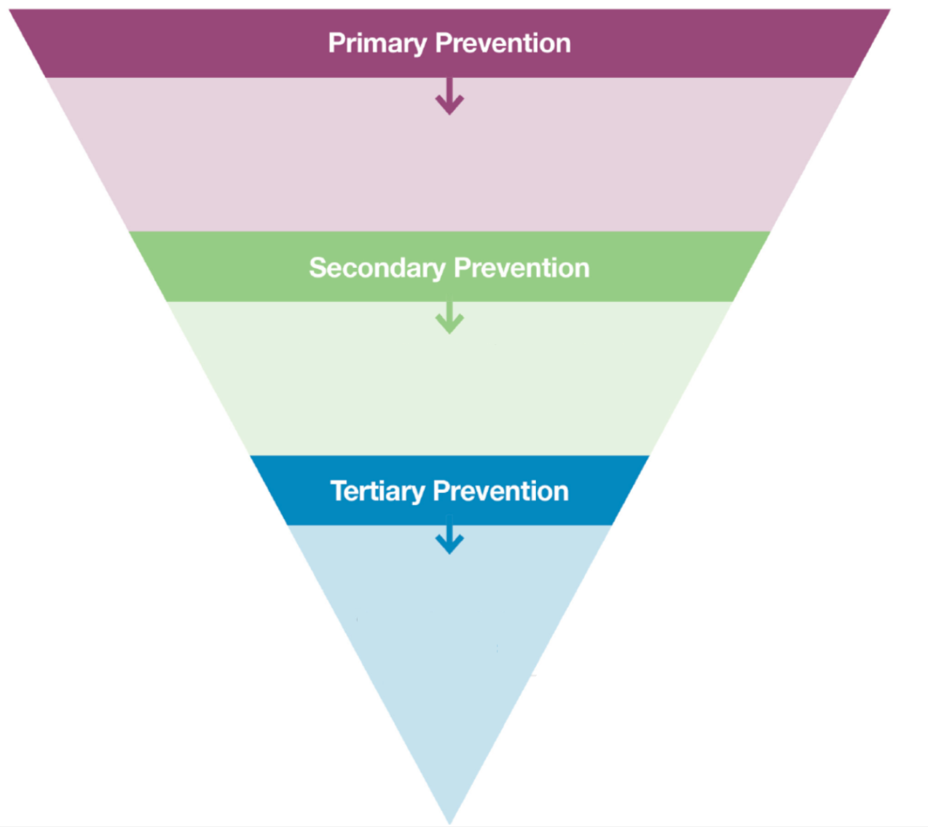  Ask for volunteers to come up and explain what they understand by primary, secondary and tertiary prevention in child protection programming. Hand out flashcards to match with the different levels of the pyramid and ask the rest of the group if they agree or to correct their colleague. Then explain by using slide 28:  - Primary Prevention: addresses the root causes amongst the population to reduce the likelihood of harmful outcomes  - Secondary Prevention: addresses a specific threat and/or vulnerabilities of children identified as being at high risk of harm  - Tertiary Prevention: reduces the longer term impact of harm, reduces the chance of recurring harm  or show video What is Prevention?  Instructions: Read the statements provided below and ask participants to call out or raise the number of fingers for what level of prevention they would relate to:  - Implementation of social protection or other economic policies and programmes that strengthen household financial security (Primary Prevention)  - Reintegration support for children associated with armed forces and armed groups (Tertiary Prevention)  - Life-skills sessions for adolescents at risk of recruitment into armed groups or child labour (Secondary Prevention)  - Community-wide access to parenting support services and information (Primary Prevention)  - Financial support for families where child marriage is identified as a risk (Secondary Prevention)  - Building the capacity within the justice system for interviewing techniques when working with child survivors (Tertiary Prevention) | Set up a virtual whiteboard with a pyramid and post-it notes.  Share the virtual whiteboard link  Participants write their own post-it notes with the meaning of the different layers of prevention: primary, secondary and tertiary prevention, and place these on the pyramid.  Show pyramid with the correct answers in supporting information section.  Or share sound and screen to play video  Participants may come off mute or post their answers on the chat. | 20 min
Why is Primary Prevention important?  Say: Child protection actors are already implementing secondary and tertiary prevention interventions as part of humanitarian programming. There remains insufficient investment in programming that aims to reduce harm for children across a population in humanitarian settings and in the measurement of prevention outcomes. Ask participants why they think primary prevention is important. Take as many examples as possible and then explain using slide 29.  Primary prevention is critical in humanitarian settings for three main reasons:  - An ethical responsibility to prevent harm to children before it occurs whenever possible by all humanitarians  - Improving the sustainability and long-term impact of humanitarian responses  - Increased cost-effectiveness of child protection interventions.  Optional: show video Why Invest in Child Protection Primary Prevention? | Optional: share sound and screen to play video | 10 Min
Prevention, Response, Preparedness, Early action. What’s the difference?  Instructions: (slide 30) Divide participants into small groups, hand out flashcards with:  - Prevention  - Response  - Preparedness  - Early action  And flashcards with the definition below:  - Actions primarily designed to prevent harm to children (Prevention)  - Measures taken in advance of a crisis to ensure an effective response to the impact of hazards, including issuing timely and effective early warnings and the temporary evacuation of people and property from threatened locations. (Preparedness)  - Provision of services and public assistance during or immediately after a specific emergency in order to save lives, reduce health impacts, ensure public safety, maintain human dignity and meet the basic subsistence needs of the people affected. (Response)  - Actions taken ahead of a crisis to reduce or mitigate the impact of the shock faster, and more effectively, by acting on the basis of risks rather than needs. (Early Action)  Ask participants to match the words and definitions. Read the definitions once these have been matched with the correct terminology.  Say: Early action complements preparedness actions taken against unknown threats likely to manifest in the future, by targeting populations most at risk of being impacted by the anticipated shock. | Set up a multiple choice mentimeter, with prevention, response, preparedness, early action as the possible answers  Read out the definition statements and have participants vote on the right answer. | 15 min
Session wrap-up
Remind participants that they can use their learning log at any time to make a note of key learnings, and wrap up the session by showing slide 31.
Reflective practice - suggested questions:
- What programmes are you implementing at the various levels of the socio-ecological model in your context?
- How is CPHA prevention programming relevant to your context? And Primary Prevention more specifically?

- Supporting Information
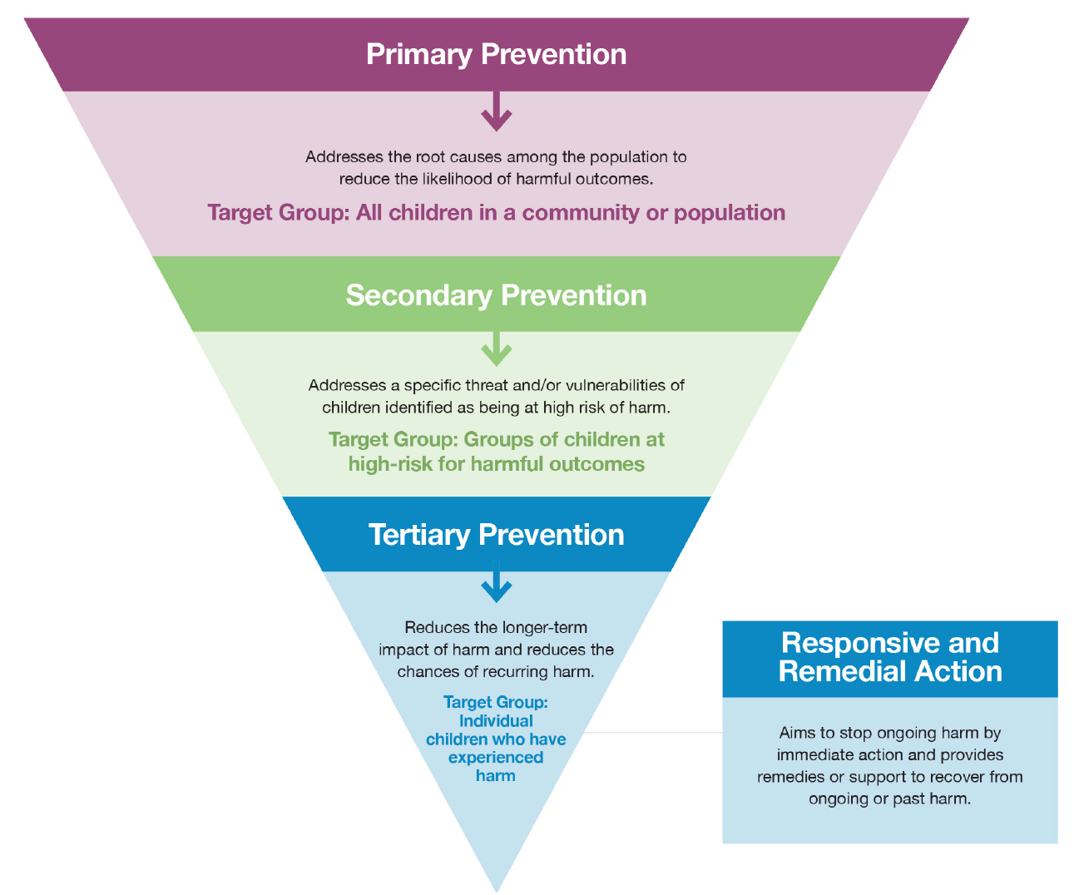
- Additional Resources

Primary Prevention Framework for Child Protection in Humanitarian Action, Alliance for Child Protection in Humanitarian Action, 2021
Anticipatory Action and Child Protection: Acting Early to Better Protect Children in Emergencies, IFRC, 2021

