CPHA-CPMS learning package

Connecting Child Development, Risk and Protective Factors through the Socio-Ecological Model

- Objectives
By the end of the session, participants will be able to:
- Describe children's developmental stages
- Describe risk and protective factors through the socio-ecological model
- Key Learning Points
To further explore content on the key learning points listed below, please refer to the “Additional Resources” section at the end of the session.
- Child Development is the process of individual growth and maturation from birth to adulthood.
- It is important to understand the physical, cognitive, emotional and social changes that occur in all children and young people as they grow older.
- Physical changes are about body growth and maturation: growing taller, gaining weight, hand-eye coordination, fine motor skills (grabbing, holding a pen), muscle development, gross motor skills such as crawling and walking, physical changes linked to puberty.
- Cognitive changes are about learning language, remembering facts, solving problems, curiosity, imagination, processing information and abstract thinking.
- Emotional changes are about learning to identify emotions in self and others, learning to express and regulate emotions, expressing self-confidence and developing a sense of self.
- Social Changes are about learning verbal and nonverbal skills and the ability to express needs, opinion and motives, learning to cooperate and take turns, developing empathy and consideration for others.
- While age groups can vary according to context and culture, developmental stages are often organised into: Early Childhood: 0 to 6 years of age and within this, infancy from 0 to 12 months, toddlerhood from 1 to 3 years of age, pre-school age 4 to 6 years; Middle Childhood: 7 to 12 years of age; Adolescence: 13 to 18 years of age.
- It is important to learn about children’s development in order to: understand children’s basic needs, reactions and coping strategies and how to support caregivers in responding appropriately to children’s reactions according to their developmental needs.
- The socio-ecological model helps us see the interaction between the internal (psychological) and the external (social) world of the child. The closest ‘circle’ to the child represents the family and has the biggest influence on children’s physical, cognitive, emotional and social development. After this circle there is the community i.e. school, community, playgrounds, child social and health services and other community services. The fourth circle represents society, involving the broader economic, political, cultural and social context including the financial situation, conflict and poverty as well as the legal framework and policies.
- The socio-ecological model can also be used to analyse the risk and protective factors that affect the child’s safety and wellbeing. Protective factors are those factors in children’s lives that enhance their healthy and positive development. Risk factors are those factors in children’s lives that interfere with their development and make them more vulnerable. During times of crisis many of the components of a child’s environment tend to be negatively impacted, but can also be a source of strength (e.g. support from friends and community).
- Sess ion outline
*Make sure to facilitate breaks and include energizers as needed
Topic | Methodology | Time
Child Development | Small group work  Plenary discussion  Sorting exercises | 35 min
The Socio-Ecological Model. Risk and Protective Factors | Small group work | 60 min
Accumulation of risks | Plenary activity | 20 min
Recap | Trainer input and video | 5 min
Total |  | 120 min

- Instructions for facilitator

 | Methodologies Face to Face | Methodologies Remote | Time
 | Children’s development  Ask: What is child development?  Instructions: Take a few examples and then:  Show slide 12 and say: Child Development is the process of individual growth and maturation from birth to adulthood. It concerns the physical, cognitive, emotional and social changes that occur in all children and young people as they grow older.  - Physical changes are about body growth and maturation.  - Cognitive changes are about learning language, remembering facts, solving problems etc.  - Emotional changes are about learning to identify emotions in self and others.  - Social changes are about learning to interact with others and to regulate our own behaviour.  Instructions: (Slide 13) In small groups use a flip chart to come up with examples of changes that happen in relation to each type of development (physical, cognitive, emotional and social changes). Explain that you will review answers together and come up with as many examples as possible. Allow 10 minutes for discussion. Get some examples from every group in plenary.  Instructions: In small groups, give flashcards (previously prepared) to participants with the 5 stages of child development (infancy, toddlerhood, pre-school, middle childhood, adolescence). Ask participants to sort them into the right order and stick them horizontally on the wall. Ask whichever group is done first to present. Ask other groups to correct if necessary.  Now distribute flashcards with the age range for every stage of development (0- 12 months, 1 to 3 years, 4 to 6 years, 7 to 12 years, 13 to 18 years). Ask participants in the same groups to associate the right age range to the corresponding developmental stage. The result should be as follows:  Ask other groups to correct if necessary and stick the right age range under each stage of development.  Show Slide 14 and ask if this is different in your context.  Ask: When does a child become an adult, traditionally?  Explain: For some cultures, transitioning into adulthood is determined when a child reaches a certain birthday and is no longer considered a minor: 16, 18 and 21. Other cultures determine a child's transition into adulthood when they hit puberty. Many religions and cultural traditions have an official ‘transition to adulthood’ ceremony to observe the occasion.  Instructions: Say that you are now going to further explore ages and stages of development. Show a flip chart or a whiteboard with the table below.  Read the child developmental milestones below and ask participants to come up to the board and place the statement on a flashcard under the right age range and type of development.  - The child is able to walk  - The child begins to babble  - The child is able to play sport  - The child experiences changes in vocal cords  - The child may experience strong conflict with caregivers  - The child begins to smile  - Peer group identity becomes gradually more important to the child.  Say: There is a wide range of 'normal' when it comes to child development and this may vary even more for children with disabilities. This was just a quick exercise to get you thinking about the relevance of child development in child protection programming. Ask in plenary why they think it is important to learn about child development for child protection in humanitarian action programming.  Instructions: take a few examples and complement with information below:  - understanding children’s needs, reactions and coping strategies  - understanding how children face crises  - supporting caregivers in responding appropriately to children’s reactions according to their developmental needs and understanding the basic needs of boys and girls  - designing/implementing appropriate CP programmes/ activities for children of different ages and abilities | Set up breakout rooms and a whiteboard for each of the set groups.  Open breakout rooms for 10 minutes.  Close breakout rooms.  Prepare breakout rooms of 3-4 participants.  Prepare virtual whiteboard for each group with the 5 stages of development and the age range for every stage of development.  Ask each group to order the 5 stages of development and to associate them with the age range for every stage. After 5 minutes bring everyone back and review in plenary.  Screen share one of the virtual whiteboards from the previous exercise (ensuring it is correct first).  As each statement is read out, ask participants to indicate where they would place it using the Annotate feature, or by accessing the whiteboard and adding a note. | 35 min
  Infancy | Toddlerhood | Pre-school Children | Middle Childhood | Adolescence
  0 – 12 months of age | 12 months to 3 years of age | 4 to 6 years of age | 7 to 12 years of age | 13 to 18 years of age
   | Infancy (0 to 12 months of age) | Toddlerhood (12 months to 3 years of age) | Pre-School Children (4 to 6 years of age) | Middle Childhood (7 to 12 years of age) | Adolescence  (13 to 18 years of age)
  Physical
  Cognitive
  Emotional
  Social
 | The Socio-Ecological Model, risk and protective factors.  Say: As you have learnt through the CPMS E-course module on the socio-ecological model, a child's world is like a spider’s web. Like the spider, the child is at the centre of its web and they are connected to and affected by different things that happen in the different sections of the spider’s web.  Instructions: Draw the socio-ecological model and ask if the participants can recall the various layers of the socio-ecological model from their pre-training work. Once you have taken the suggestions, show slide 15 and explain. The Socio-Ecological Model helps us see the interaction between the internal (psychological) and the external (social) world of the child:  - The closest circle to the child represents the family or primary caregivers and has the biggest influence on children’s physical, cognitive, emotional and social development.  - After this circle there is the community i.e. school, community, playgrounds, child social and health services and other community institutions, services and organisations (i.e. religious institutions etc.)  - The fourth circle represents society and involves the broader economic, political, cultural and social context including the financial situation, conflict, poverty as well as the legal framework and policies.  Instructions: Remind participants of the definition of risks and protective factors by showing slide 16:  - Protective factors are those factors in children’s lives that enhance their healthy and positive development.  - Risk factors are those factors in children’s lives that interfere with their development and make them more vulnerable  Ask the participants to get back in their groups and select a specific age group. Ensure that every group has a different age group and ask them to work together for 20 minutes on risk and protective factors for the selected age group in their own context. Explain that each group will be asked to present risk and protective factors for the age group that they have selected.  Facilitate feedback from each group.  Distribute Annex 1 of the CPHA Primary Prevention Framework with the list of universal risk and protective factors, also available in the supporting information section, for participants to read; ask for any questions. | Show socio-ecological model on slide  Prepare breakout rooms of around 4 pax. Provide a link to a virtual whiteboard.  Circulate between the groups to support as needed and provide instructions for the second part of the group work.  Close the breakout rooms. Share screen as required during plenary feedback.  Share a link to Annex 1 of the CPHA Primary Prevention Framework with the list of universal risk and protective factors also available in the supporting information section for participants to read; ask for any questions. | 60 min
 | Accumulation of Risks  Instructions: Explain that you will share a short story presented in a series of images. Invite the participants to look at this with the person next to them, discuss what is happening in the story and note down any risks that the children in the story face. Hand out the storyboards.  After 5 minutes, show or hand out the version of the story with the text and read it aloud: Rayan is 16 years old and his brother Ali is 10 years old. War has been ongoing in their country for a long time but they had managed to continue schooling. However, during the last bout of violence in their country they fled with their mother. In fleeing they got separated from their mother but reached the refugee camp across the border. Rayan and Ali are living together as a child-headed household while local humanitarian agencies are striving to trace their family. They are being supported but this is the first time they have lived without their caregivers.  Ask: What risk or risks did you identify? Take a few examples and explain that yes there are multiple risk factors including refugee status, separation, being a child-headed household, lack of any expertise to be able to earn an income etc.  Ask: What might we say was happening? Try to elicit that there was an accumulation of risks.  Say: The accumulation of risk factors – or cumulative risk – suggests that children who have been exposed to a number of adverse experiences are more at risk of harmful outcomes than children exposed to one single risk factor.  Ask: What points would you make regarding the age of the children?  Take a few examples, and if participants are not forthcoming, suggest: Rayan is old enough to be able to learn to take care of Ali, who is not a little baby. Rayan and Ali are both impacted by the loss of educational opportunities.  Say: The effects of adversity and protective influences vary in relation to developmental timing. For example: while cognitive ability is associated with greater skills in problem-solving, seeking help and spiritual comfort, it is accompanied by greater awareness of the scope of devastation resulting from a crisis, stigma associated with specific experiences, such as rape or recruitment into armed forces and armed groups, and an understanding of lost future opportunities. | Share the storyboard file with no text through the chat and then ask participants to think individually about what is happening in the story and note down any risks that children face.  Share the storyboard file with text through the chat. | 40 Min
 | Session wrap-up  Remind participants that they can use their learning log at any time to make a note of key learnings and wrap up the session.  Reflective practice - suggested questions (slide 17).  - What more would you like to learn about children's developmental stages?  - What can you do with what you have learnt about children's developmental stages?  - What can you do with risk and protective factors and the socio-ecological model in your own work? |  | 5 min

- Supporting Information
Stages and Domains of Development

 | Infancy  (0 to 12 months of age) | Toddlerhood  (12 months to 3 years of age) | Pre-School Children  (4 to 6 years of age) | Middle Childhood  (7 to 12 years of age) | Adolescence  (13 to 18 years of age)
Physical | - Vision, hearing, taste and touch develops  - Begins to lift own head  - Stretches out the legs and kicks when lying on stomach or back  - Opens and closes the hands, is able to grab other people’s fingers  - Gradual hand-eye coordination | - 12 months: most children sit up without support and possibly crawl  - 18 months: moves up stairs and can manipulate smaller objects such as crayons  - 24 months: able to walk and climb/descend stairs correctly  - 24 months: develops bladder control although this depends on the specific child | - Able to manipulate devices such as scissors  - Bends over without falling  - Able to dress oneself  - Able to run | - Able to play basic sports; control and coordination is improved  - Is more aware of own body as puberty approaches towards the age of 11 or 12 | - Puberty and changes in hormones  - Changes in vocal cords  - Changes related to own sex  - Sexual development
Cognitive | - Watches other faces  - Follows moving objects  - Recognises familiar objects  - Begins to babble | - Learns to point to objects or pictures when named for him or her  - 15-18 months: says several single words  - 18-24 months: uses simple phrases and repeats words overheard in conversation  - 24 months: recognises names of familiar people, objects, and body parts  - Begins make-believe play (role-plays where children pretend to do things or be someone else, e.g. a mother or a father) | - Completes puzzles with 3 or 4 pieces  - Sorts objects with shapes and colours  - Understand concepts of “two” “same” and “different”  - Masters some basic rules of grammar  - Basic understanding of the concept of time  - Speaks in sentences of 5 to 6 words  - Tells stories | - Interested in facts  - Begins to understand different perspectives and to use logic in order to solve problems  - Inductive reasoning is developed: i.e. the ability to use specific information or observations and then draw conclusions (For example: all the cats that I have observed purr — therefore, all cats purr) | - Able to think abstractly and logically  - Deductive reasoning developed, i.e. the ability to use general information or observations and then reduce the general to a particular example
Emotional | - Attachment: a strong and enduring emotional connection to his/her/their caregiver  - Separation anxiety is normal | - Throughout the second year, the child will swing back and forth between independence and clinging  - From 18 months: the child likes to assert him/herself and the favourite word is often “no” | - Shows affection for familiar playmates  - Interested in experiences  - Starts to develop the view of self as a whole person involving body, mind and feelings  - Shows more independence and may even visit a next-door neighbour alone | - Gradually gains emotional control  - Social development  - Peer group identity is gradually more important  - Fear of social exclusion  - Understands some cultural and social norms | - Begins to see their future and can feel both excited and apprehensive about it  - Strong conflicts with caregivers usually decline around adulthood but mood swings and behaviour changes are often part of the process
Social | - Begins to smile  - Enjoys playing with other people after a few months  - Becomes more communicative and expressive with face and body  - Imitates movements and facial expression of others | - Imitates behaviour of others  - 3 years: increasingly aware of self as separate from others  - 3 years: increasingly enthusiastic about the company of other children | - Imitates adults and playmates  - Can take turns in games  - Understands “mine” and “his” or “hers”  - Many children enjoy songs and rhymes  - 5-6 years: wants to please friends  - 5-6 years: cooperates with others and negotiates solutions to conflict | - Social development  - Peer group identity is gradually more important  - Fear of social exclusion  - Understands some cultural and social norms | - Strong identification with heroes, role models and peers  - 13 to 16 years: may think they are immune from anything happening to them  - May engage in risky behaviours
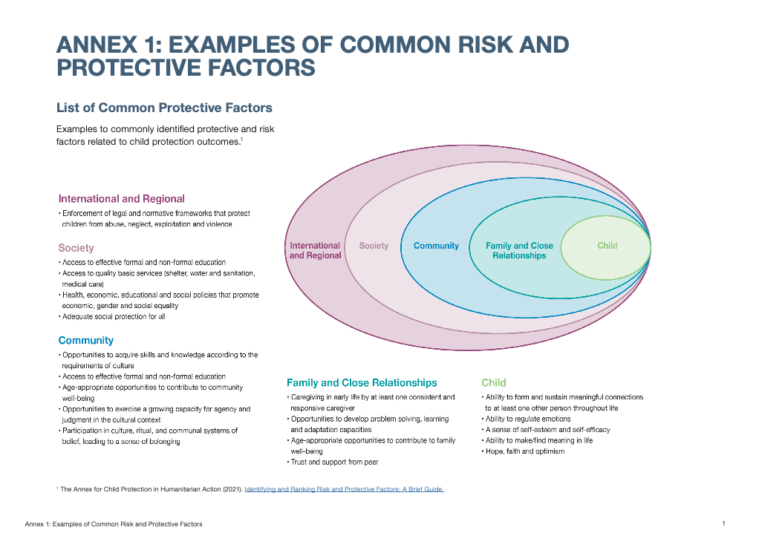
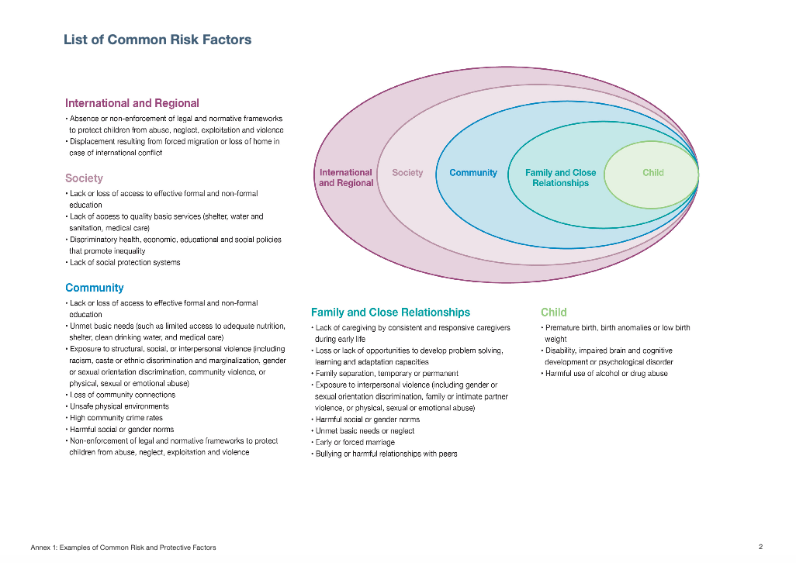
- Additional Resources
Understanding Risk and Protective Factors in Humanitarian Crises: Towards a Preventive Approach to Child Protection in Humanitarian Action, Alliance for Child Protection in Humanitarian Action, 2020
Promoting Children’s well-being and development, Disaster Ready/Save the Children, 2019

Promoting Children’s Development and Wellbeing, Save the Children, Disaster Ready, 2021
Promoting Children’s Development and Wellbeing, Save the Children, Disaster Ready, 2021

