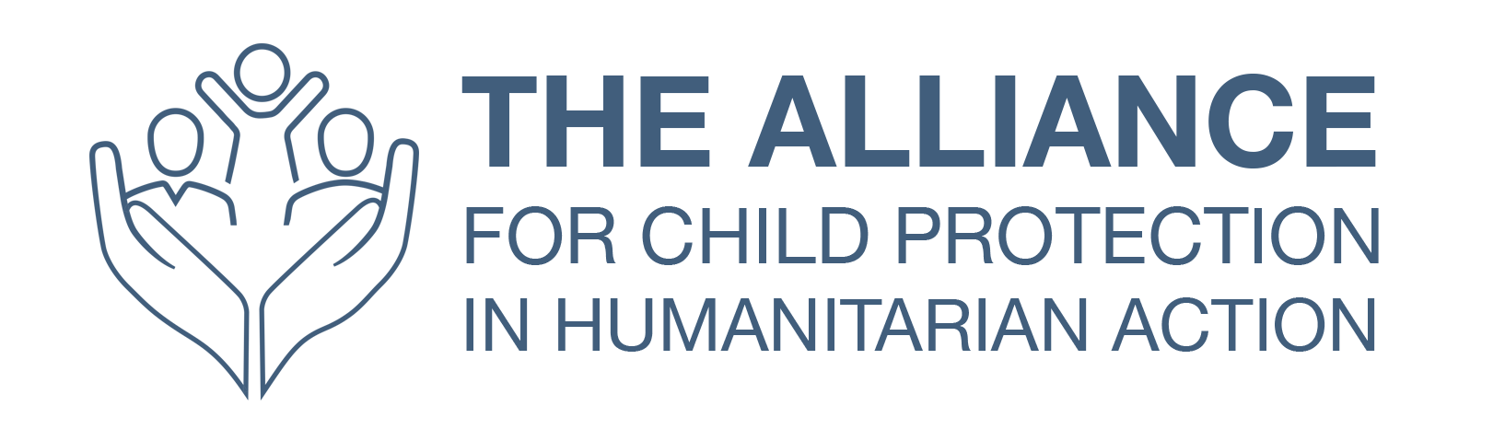
L&D Template

Participant 3-6 month follow-up
Note: response rates for follow up surveys tend to be low. It may be more effective and useful to schedule a short phone call with a sample of participants to ask questions such as those below.

Event title: |  | Location:
Event dates: |  | Facilitator:

To what extent has your confidence and competence changed since the course/programme, in relation to the course/programme objectives?
 | Significant decrease | Slight decrease | No change | Slight increase | Significant increase
Insert objective 1 confidence
Insert objective 1 competence
Insert objective 2 confidence
Insert objective 2 competence
Insert objective 3 confidence
Insert objective 3 competence

Have you been able to implement your learning from the course/programme?

If yes, please provide examples

If no, what obstacles have prevented you from doing so?

How do you intend to continue using the learning from the course/programme?

Can you identify anything which could have been done during the course/programme to increase your ability to apply the learning?

What could the [insert L&D team/project team name] do now to support the application of your learning?

Have you used the resources shared during/after the course/programme?
Course/programme materials
Contact with facilitators
Contact with other participants
Comments

Do you have any additional feedback on the course/programme at this time?

