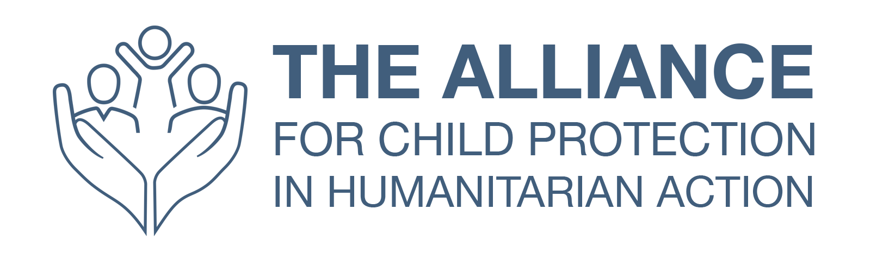
L&D Template

Facilitator Evaluation Report
Note: this template is a suggested structure for collecting feedback from the facilitation team at the end of a learning event or programme, such as a training course, blended learning programme, or workshop. The intention is to capture what went well and less well about the event, from the perspective of the facilitators. This should then be used in conjunction with the participant feedback to inform any changes to the sessions or programme. We recommend to capture feedback from all facilitators, either through individually completing this report, or by working together on a shared document. Share the format with your facilitators in advance of the programme starting, so they can make relevant notes during the programme delivery.

Event title: |  | Location:
Event dates: |  | Facilitator:

Were the learning objectives met?
If any objectives were not met, or only partially met, please explain why:

Are there any sessions which do not contribute to the course/programme objectives? If yes, please specify which, and provide your view on the relevance of these sessions to the course/programme.

If any session did not run as written, please note this here and provide a brief description of what was changed and why.

Do any sessions or materials require updates? If so, please outline which ones and briefly describe what is needed.

Please provide any comments on the structure and logic of the course/programme:

Was the course/programme appropriate for the participants? If not, why not?

Were the roles and responsibilities of the course/programme team clear and appropriate? If not, why not?

What was most successful about this learning event?

What suggestions do you have to improve this course/programme next time it runs?

