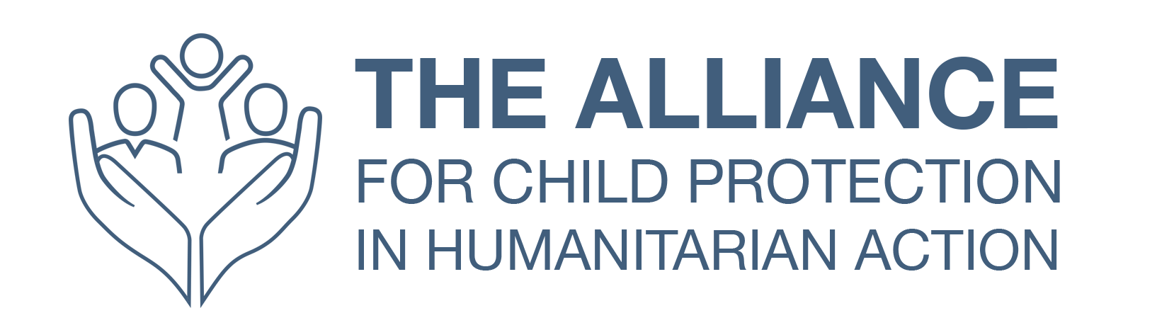
L&D Template

Participant Evaluation Form
Note: this template is a suggested structure for collecting participant feedback at the end of a learning event or programme, such as a training course, a mentoring programme, or a workshop. You may wish to add or edit questions, but we strongly recommend keeping the questions related to learning objectives, change in knowledge/skills and relevance, and facilitation.

Event title: |  | Location:
Event dates: |  | Facilitator:

Were the learning objectives met?
 | Yes | No | Partly
Insert objective 1
Insert objective 2
Insert objective 3

If any objectives were not met, or only partially met, please tell us more:

Please rate the following statements:

 | Excellent | Good | Fair | Below expectation | Poor
Improvement in your knowledge as a result of the event
Improvement in your skills as a result of the event
Relevance of the course to your role

Please list up to three ways you will use learning from the event in your work:

Please rate the facilitation of the course overall:
Excellent | Good | Fair | Below expectation | Poor

Please rate the following statements:
 | Excellent | Good | Fair | Below expectation | Poor
The pre-course learning was relevant
The facilitators created an inclusive learning environment
The facilitators supported my learning
The facilitators gave instructions clearly
The course/programme was engaging
The pace of the course/programme was appropriate
The length of the course/programme was appropriate

Do you have any specific feedback for the facilitators?

What was the best aspect of the course/programme?

What changes would you expect to the course/programme?

Any other comments?

