ICE BREAKER – 20 – CPMS JEOPARDY
TIME | OUTLINE – 20 - 30 MIN
BACKGROUND FOR FACILITATOR
 | This IB is an energiser… but also a mini assessment / quiz
ACTIVITY STEPS
 | Ensure the scoring card for Q (Slide 3) is large on the wall. As you ask the question you can cross the points card or remove card from wall.
 | Ensure you have a team score board
 | Using the participant small groups as teams. Make sure each team has a sound.
 | How much does everyone remember on the CPMS? This is a jeopardy game on the CPMS and the points will correlate with the points on a jeopardy board.
 | Go through each of the question and answer slides, allocating points for correct answers.
ADAPTION | Questions could be adjusted for the whole training and / or another key topic to be highlighted.
PRESENTATION

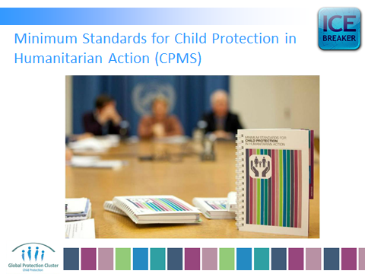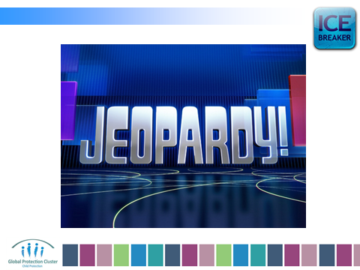

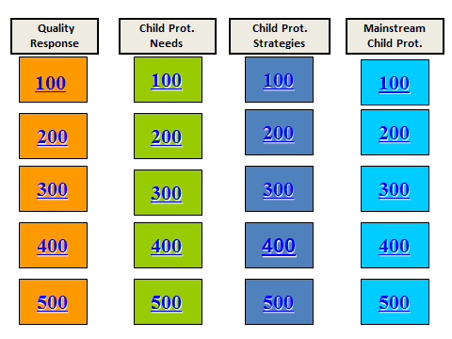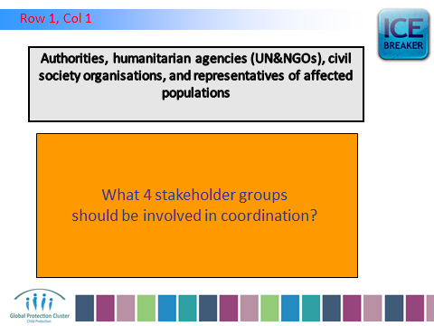

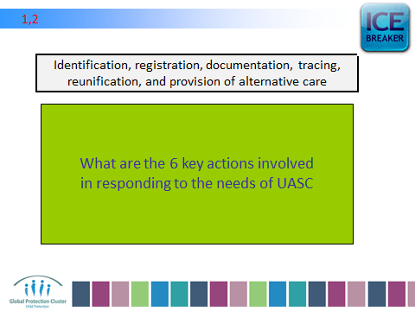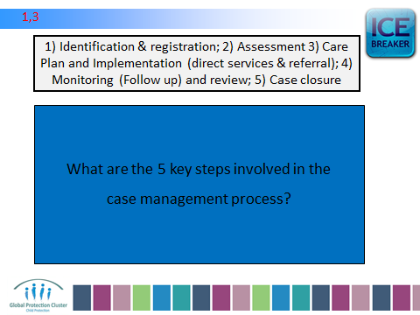

ETC ETC…

