

LESSON PLAN –
REFLECTION AND HOMEWORK FROM DAY 1

TIME | OUTLINE – 40 MIN
INTRODUCTION
2 min | - Who will be the volunteers for the day? Timekeeper, eyes and ears…  - This session is a fun revision of Day 1.
BODY
5 min | Handout the Bingo template. Explain the rules.
15 min | The Bingo Game.
10 min | OPTIONAL – Honey and Mumford Self Reflection
CONCLUSION
3 min | O | The day has begun and we have really learnt a lot already from Day 1.
3 min | F | Great job with the quiz. Also good to see people self-reflect and see what that means in a coordination environment.
3 min | F | Next session we will begin to look at Function 2

NOTES FOR TRAINER – REFLECTION AND HOMEWORK FROM DAY 1

LEARNING OUTCOMES
- Revise day 1 learning in a fun active way
- Demonstrate day 1 learning in a fun and active way

BINGO – QUIZ

HANDY HINT – Make sure you have the Bingo Handout printed in advance – One for each participant.

Welcome participants to Day 2 – Today we will mostly focus on Function 2 and 3.

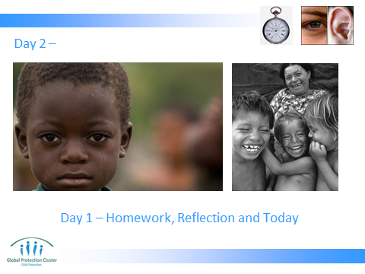

To start the day we need our volunteers again. Make sure you have a time keeper volunteer and the eyes / ears before you start anything.

Now time for BINGO! We are going to test what you remember from yesterday in a fun way.

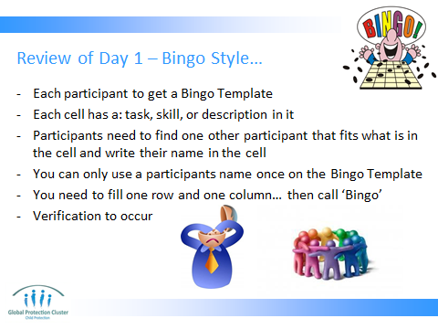
Handout the final Bingo template for each participant.

Explain the rules of the game clearly. That they have to find someone in the group that knows the answer to the question or fits the description. They can only use that person once.

Participants need to answer all the questions in one row – either horizontal or vertical.

We will check answers when you call ‘Bingo’.

When checking answers be tough… if it is not exact in answer or name of person who said they know it, tell them all to keep going. This gives more chances for all to challenge themselves.

Advantage of this activity is they get to know each other even better and gets them moving around. Energy will up.

HOMEWORK TIME – Who completed the Honey and Mumford Questionnaire?

What did you find out about yourself? Give time to complete if they didn’t do it.

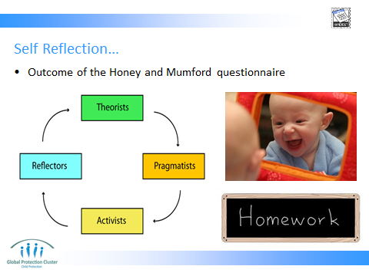

Share what you found out on your table in your small groups.

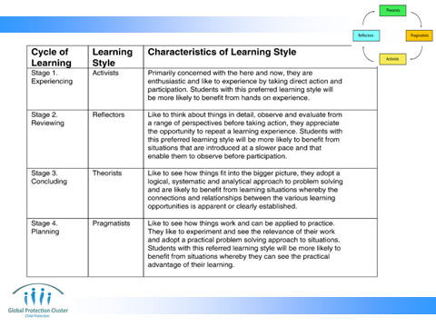
What does it mean in perspective of how you are, react in meetings?

What does it mean looking at others in the group… how would you best coordinate together?



