

MODULE 3 – SESSION 3 – LESSON PLAN –
RUNNING YOUR CFS PROGRAM – CFS EXIT STRATEGIES

TIME | OUTLINE – 2 hour 20 min
* RESOURCES REMINDER *
Flipcharts with headings:
- “Who do we engage in transition process?”
- “Transition options”
Hand-outs:
- Have enough copies of the hand-out “Transition Process Guidance” to be able to give one to each participant
- Helper to give you a pretend phone call at the beginning of activity 3 and to do the pretend hand over of the training. They must keep this activity secret from other participants.
Resources:
- CPWG, Global Education Cluster, INEE, & IASC (2011) Guidelines for child friendly spaces in emergencies
- CPWG (2012) Minimum Standards for Child Protection in Humanitarian Action
- Save the Children, 2008, Child Friendly Spaces Handbook
- UNICEF, 2008, A practical guide for developing child friendly spaces
- The Good Enough Guide: How to say goodbye
INTRODUCTION
3 min | Introduce the session
BODY
5 min | Introduction and defining key terms
10 min | Principles underlying transition
45 min | Transition process
15 min | Who to involve in the transition process
20 min | Transition options
30 min | How to say goodbye
5 min | Close session
CONCLUSION
3 min | O | Outcome revisited
3 min | F | Positive thought and reinforcement
3 min | F | Next session

MODULE 3 – SESSION 3 – NOTES FOR TRAINER – CFS PREPAREDNESS – RUNNING YOUR CFS PROGRAM – CFS EXIT STRATEGIES

Introduce the Module and the sessions it contains.

LEARNING OUTCOMES
By the end of the session participants will …
- Be able to state when we should start planning for transitioning out of CF Space programmes
- Know steps and stakeholders to be involved in the process of planning transition
- Identify a range of options for transition relevant to the context in which they work

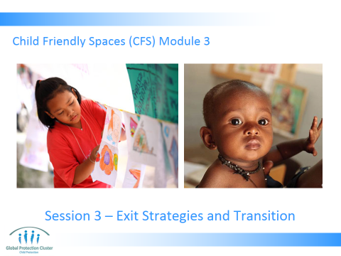

- INTRODUCTION & KEY TERMS
- Present Slide 2 & 3

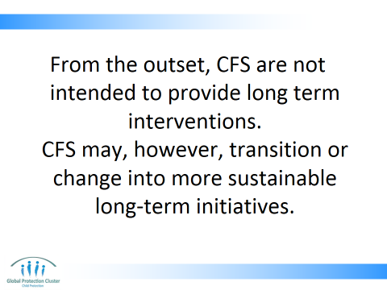

“Unless there is strong community support, local capacity & available infrastructure, it is not recommended to pursue a long term community-based child friendly space or environment. Do not allow CFSs, or structures that they transition into, to compete with schools.”

This statement is taken from CF Space Guiding Principles

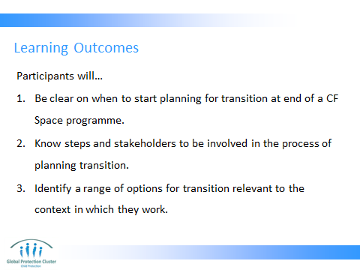

Run through Slide 3 explaining the learning outcomes
Note: This session focuses on the activities other activities children engage in whilst at the Child Friendly Space

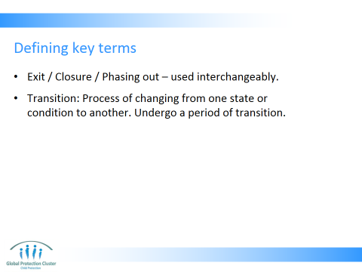

- Exit: To go out of, leave or depart a place
- Close / closure: End of an event or period of time or activity
- Phasing out: To end gradually, to bring to an end, one stage at a time
- Transition: Process of changing from one state or condition to another. Verb: Undergo or cause to undergo a process or period of transition

We are choosing to use the term transition as it covers all options, where we leave location, handover or the activities stop. It also gives a sense that whatever change is chosen we believe the work will not be fully coming to an abrupt end, but rather it will be leading into and contributing to full recovery process

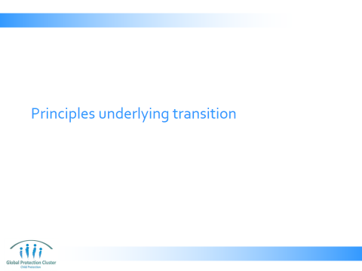

- Explain why we are using term transition in this session using Slide 5
- We are choosing to use the term transition as it covers all options, where we leave location, handover or the activities stop. It also gives a sense that whatever change is chosen we believe the work will not be fully coming to an abrupt end, but rather it will be leading into and contributing to full recovery process
- Review with participants the key project cycle stages & how Child Friendly Spaces, need, from the outset, to be planned with end transition in mind

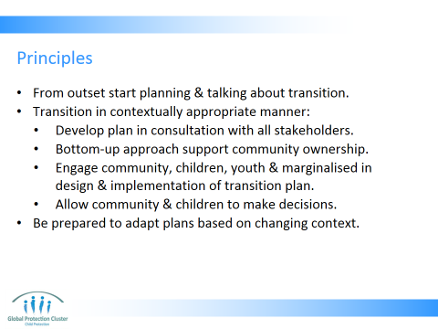

- Ensure that the community is aware from the outset that a phase‐out period and/or handover will take place, and provide information as soon as possible about when the phase out or transition will occur.
- Transition in contextually appropriate manner
  - Develop in close consultation with the community and other stakeholders a phase‐out or transition plan that links with broader recovery planning
- Use a bottom‐up approach that will support ownership and also transition of the CFS to the community
  - Engage community, children, youth & marginalised groups in design & implementation of transition strategy
  - Allow community & children, to make key decisions about transition
- Be prepared to adapt plans on basis of changing context

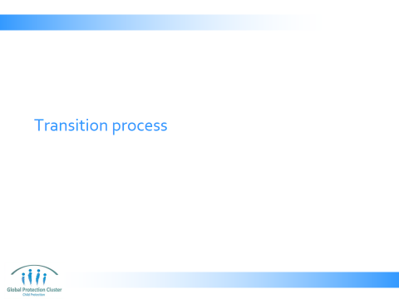

- PRINCIPLES UNDERLYING TRANSITION
- Run through and present Slide 7 - 9

Key message:
- Transitions represent the movement from what is familiar and secure (the present moment) to what is unknown (the future). Fear may escalate during transitions for all children, families and communities. Play the role you can in easing this apprehension, by being transparent, open and supportive to community and children. Engaging all stakeholders in the process of planning the transition from the outset.

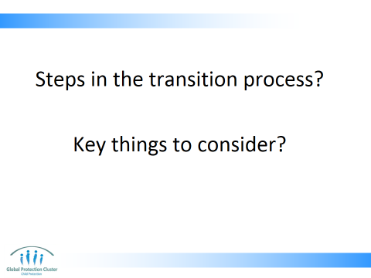

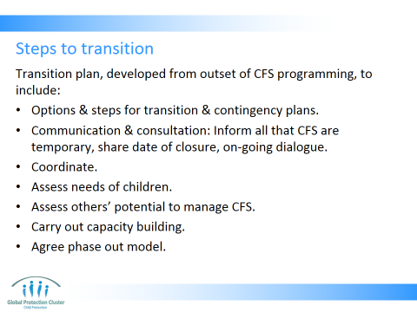

- Planning from the outset:
  - Include options for transition and steps of the process in your initial plans. Align these with broader recovery planning.
  - Contingency plans - How will you deal with unforeseen developments or unintended consequences? What do you do in case the CFS is attacked? Or if there is an outbreak of a communicable disease?
- Communicate and consult:
  - Inform all stakeholders (staff, partners, government, community & religious leaders, community members, families & children) that CFS are temporary - in first phase of emergency & during early recovery; not a long-term substitute for community / family care or school
  - Consult with children, parents & community leaders on how they would like to transition the work of the CFS from outset & throughout the monitoring process. Senior staff should meet with community at an early stage. Community & religious leaders and others can be involved in planning meetings to discuss how to close or transition the CFS. Establish a constant dialogue with community members about the plans and future of the CFSs
- Coordinate with other CFS implementing agencies on time-line for phase out. Have discussions with social services on support they can give to vulnerable children. Coordinate with other sectors and agencies. Health providers to see what activities they will maintain for distressed children & families. Education to know their plans. Camp management and OCHA regarding population movements, camp transition plans & dates for closure etc.
- Assess:
  - Community members, community based organisations, local NGO, government agency & school capacity to take on next phase of project or management of CFS
  - Assess the support needs of children and capacity of long-term stakeholders to meet needs - Ensure that the needs of children will continue to be met
- Reinforce capacity in line with needs identified in assessment
- Agree model for phase out with all stakeholders – communicating what the chosen model is to all
- Share date of closure with all stakeholders – children and adults as soon as it has been agreed.

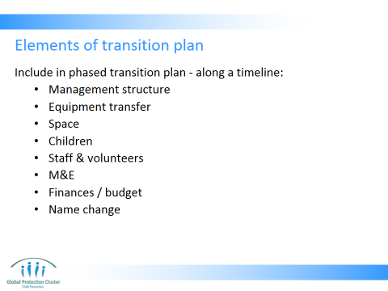

All these elements need to be included in your plans
- Management structure: can be managed by local NGO, other INGO, government, community, older children, community volunteers, etc. The possible ownership of center & materials, & arrangements for management once your agency withdraw should be a priority throughout the use of the CFS. The role of children & young people in new set up is possible and should be explored.
- Equipment transfer – was discussed in resourcing session – consider donor requirements, M&E, maintenance, and transparency
- Space – ensure the current space does not have to be returned to someone post emergency
- Children – Be clear on what will happen to the children once you withdraw your support. Caution and care needs to be exercised in particular with regards to extremely vulnerable children (disabled, certain ethnic minorities, specific age groups, etc) who will not be able to so easily reintegrate into previously existing services. Consider what can & should be done to support them
- Staff & volunteers need to be made aware of next steps, other opportunities for staff, volunteers, others engaged in the running of the CFS. They must have early warning & consultation on process
- M&E – system for monitoring what happens could be set-up where funding is available, thus enabling you to see the impact of your programming. Visits after you are gone looking at how skills learnt are being used, how children are now, how materials and space is being used, what DRR activities are being implemented, etc would all provide valuable lessons for future programming
- Finances and budget – children, communities, partners or government agencies taking on the on-going management of activities need to be clear on budget requirements and have plans on how they will raise the necessary funding. In addition there may be specific costs associated with transition, such as movement of materials, payment for closing ceremony etc, these things must be budgeted for
- May require name change: It is appropriate to call these by names other than ‘CFSs’ in order to avoid confusion and recognize that emergencies require a distinctive way of working.

- TRANSITION PROCESS
Facilitator Activity (5mins) Slide 10
- At the beginning of this section you need to have someone in the room that can dial your phone number. Then you need to pretend to receive a phone call. You must say in a loud voice, so the whole room can hear, things that indicate you need to leave immediately for a matter of urgency. Possibly that the flight booking was wrongly done or that the flight the following day has been cancelled, so it is the last flight for a few days.
- Hang up the phone then say to the group you need to leave. You are leaving the country now and cannot continue doing the training. Do try to make it seem like you have a personal emergency, not that there is an urgent situation that could affect everyone or anyone else in the room. The objective is to make people feel the discomfort of rapid unplanned exit, not to distress them.
- Look confused as if you are not sure what to do. Then hand-over your facilitator’s guide printouts to someone else you discussed this with beforehand. Pass them your phone, your pens, and say they can keep your laptop, but they must run the training.
- Leave the room for at least 30-60 seconds.
- Come back into the room and say it was a hoax. Give the group 5 mins to discuss the following questions in plenary:
- How did this make you feel?
- Was it clear why I chose the person I did to hand-over the equipment to?
- How did you think that person felt given they didn’t know the training, how to use the computer, or the PowerPoint presentations etc and were not familiar with the training materials, and had never run this training before?
- Did you feel it was clear what you should all do next and how?

Wrap-up this warm-up activity by saying:
- NGOs can leave in a rush and not clearly hand over the equipment and responsibilities. If someone is handed responsibility without knowing what to do with it and how to use it, it can be a challenge. Other stakeholders may feel disgruntled that it is not clear why they were not given the management role, or may not like the choice made and not feel engaged in the process.
- People may feel sad that they were not able to say goodbye the way they wanted to. Maybe they had hoped for photographs, a party, a chance to say thank you

We will be talking about how you can make it smoother so everyone “owns” the transition, understands it, and knows what to do once the transition has taken place. Maybe even turning what can be a sad occasion into an opportunity for celebration

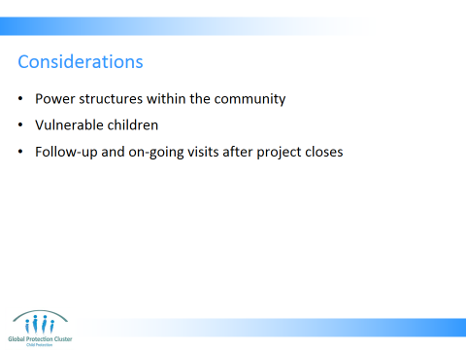

- Power structures within the community - Need to be aware of existing power structures and power imbalances (remember earlier session on communities) within the community when you are transferring management
- Vulnerable children – need to explore options for handing over case management responsibility and or on-going activities focussed on those who will not be receiving other forms of on-going help (e.g. not able to attend formal schooling)
- How will you carry out on-going support and follow-up? Will there be future visits? Can other sectors maintaining operations in the area visit?

Group Activity (35 mins)
- In small groups of 5-6 people, ask participants now to brainstorm how to prepare for transition, what it is they need to do to make transition as smooth as possible? Leave Slide 11 up whilst they discuss so they can see these guiding questions (10 minutes)
- Get each group to feedback – give them a maximum of 3 mins per groups

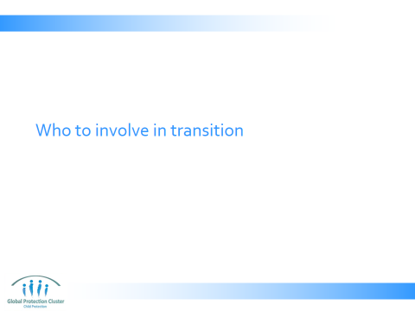

- Run through and present Slide 12, 13 & 14 to debrief the activity
- Ask the group to feedback any additional steps noted by participants when they were brainstorming
Key messages:
- Plan transition from the start. Throughout life-cycle of project reassess plans
- Communicate and consult with all stakeholders so everyone owns the decision and is aware of final choices made as soon as possible

- WHO TO INVOLVE IN THE TRANSITION PROCESS
- Ask the group to brainstorm in plenary … (5 mins) Slide 16
- Who needs to be involved in the transition process?
- How will you involve them?

Resources:
- Flipchart with title “Who do we engage in transition process?”

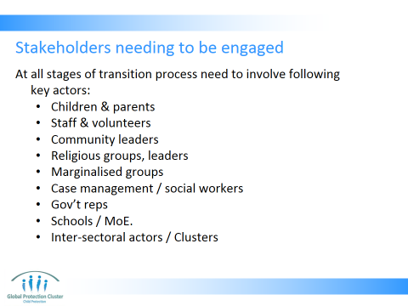

- Children – those attending CFS and those who do not attend the CFS who may wish to engage in post-CFS activities
- Parents – including reaching out to the most marginalised so they receive information in a suitable and appropriate fashion
- Staff and volunteers – so they know well ahead of time when their work will end
- Community leaders
- Religious groups and leaders
- Marginalised groups – who may be able to support or work with vulnerable children attending the CF Spaces on an on-going basis
- Case management / social workers – allowing full transfer of most vulnerable children already receiving referral and support
- Government representatives
- Schools / Ministry of Education – so that school opening or on-going closure is taken into account when making plans
- Inter-sectoral actors / Clusters – including health, education, gender, protection, camp management as well as long-term service providers working in these fields

Key messages:
- All stakeholders need to be communicated with and consulted about the CF Space transition from the very beginning and throughout the life-cycle of the CF Space
- Ensure to discuss with all parties to any conflict so that transition does not exacerbate or cause tensions
- Engage representatives of marginalised groups in the process of transition by using methods that reach out to them

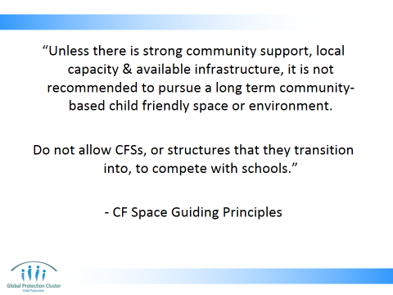

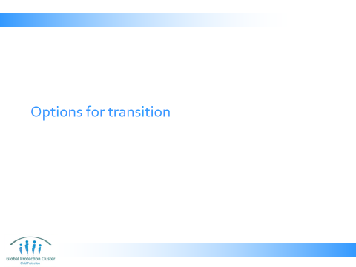

Consider range of options when making choices about transition:
- Materials and kits provided to be held by trained community members for use to set up child friendly spaces again in the future in case of another disaster in the area.
- Transfer materials to schools, so that teachers can integrate recreational and physical activities into their lesson plans. They can be used in lunch breaks or after school. (Once schools re-open)
- Transition the CFS to an Early Childhood Development centre with support from education sector
- Set up of children’s clubs, where older adolescent children or trained facilitators volunteer to be responsible for the materials and run activities out of school hours with younger children. Children may also like to use the space for: music group, choir, sports teams (competitive and non-competitive), sewing/knitting, art, crafts, woodwork/metalwork, environment, debating groups, language lessons, study support, book boxes/library, IT, discussion group, health promotion (child-to child), mines awareness activities, peace building group, youth/children’s committee, volunteer group, children’s rights groups/clubs.
- Communities fund-raise to maintain CFS activities outside of school hours, communally covering the cost of salaries and maintenance, so children have on-going recreational and physical activities supervised by the trained facilitators.
- Community centre or site: Other community activities such as women‐friendly spaces, community centers, spaces for children’s/youth clubs, literacy initiatives, or vocational training activities
- Activities focussed on most vulnerable, excluded children who cannot be reintegrated into formal schooling, who have no other supports in the setting and who have on-going needs for learning, development, and psychosocial support they cannot find elsewhere could be considered.

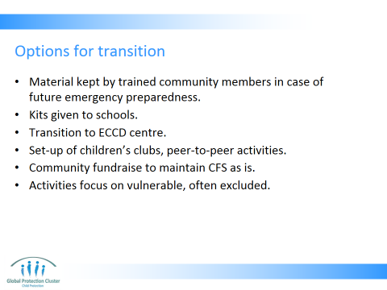

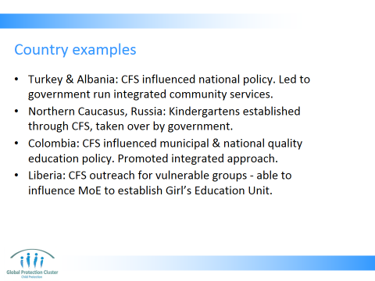

- In Turkey and Albania, CFS have influenced national policies and facilitated the negotiations for the implementation of integrated community service models with the governments.
- In the Northern Caucasus, Russia, the kindergartens that were established through the CFS, by UNICEF and partners, were effectively taken over by the government.
- In Colombia, the CFS initiative has influenced municipal and national policies on the quality of schools and has promoted a more integrated approach to education.
- In Liberia, due to an effective outreach effort for vulnerable groups in the CFS, UNICEF was able to influence the Ministry of Education to establish a Girl’s Education Unit to create incentives for girl’s enrolment in education.

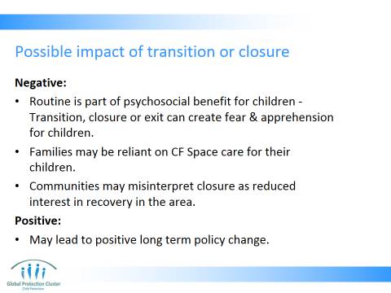

- Routine is part of psychosocial benefit for children
- Transition / closure or exit can create fear and apprehension for children whose wellbeing was improved by presence of CFS (Transitions represent the movement from what is familiar and secure (the present moment) to what is unknown (the future). Fear may escalate during transitions for all children, families and communities. Many different forms of support provided by range of agencies and actors responding to the emergency may be coming to an end. Play the role you can in easing this apprehension, by being transparent, open and supportive to community and children.)
- Families may have grown to be reliant on CF Space care for their children for part of the day
- Communities may misinterpret closure as reduced interest in recovery in the area
- May lead to positive policy change - a well-planned transfer of CFS programming can greatly contribute to the transition efforts in a country from an emergency to reconstruction phase. Improving long term programmes being implemented: e.g. 1. Can enhance integration of services (as happened in Chechnya and Colombia) 2. Can create more services for vulnerable children, e.g. incentive’s for girl’s education in Liberia

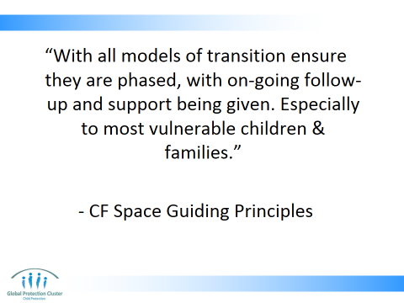

“Unless there is strong community support, local capacity & available infrastructure, it is not recommended to pursue a long term community-based child friendly space or environment. Do not allow CFSs, or structures that they transition into, to compete with schools.”
This statement is taken from CF Space Guiding Principles

- TRANSITION OPTIONS
- Present Slides 19 – 22
Activity: Slide 23
- Ask the group to brainstorm in plenary on ideas of how Child Friendly Spaces could transition in this context? Or how they have transitioned in previous emergencies? What could they become after international or local NGOs withdraw their support? (10 mins)
- Note any responses or ideas down on flipchart
- Examples may include:
- Early Childhood Development Centres
- After school clubs
- Youth groups
- Vocational training courses
- Parenting courses
- Sports clubs
- Child-to-Child clubs/activities
- Underscore that the only options to explore are those that are suitable in this context and setting, given society, religion, community, government structures, etc

Key message:
- Any transition options should be based on context, on the specific needs, outcome of discussion with stakeholders, service provision, capacity to deliver, etc. There is no one model that fits all contexts

Resources:
- Flipchart with heading “Transition options”
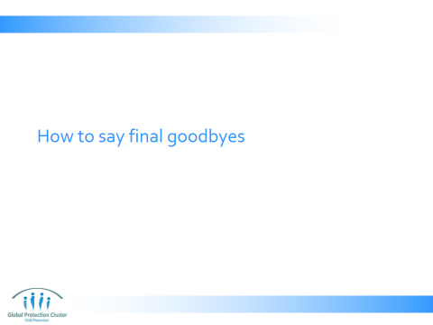

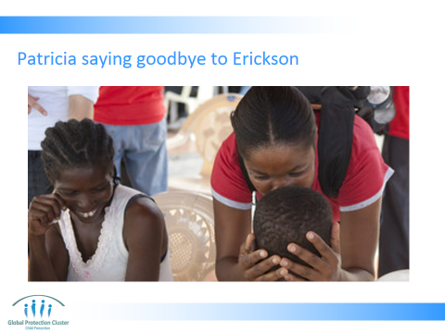

Save the Children family tracing and reunification case worker Patricia says goodbye to Erickson, eight, after helping reunite him with his parents in Leogane, Haiti, 2010

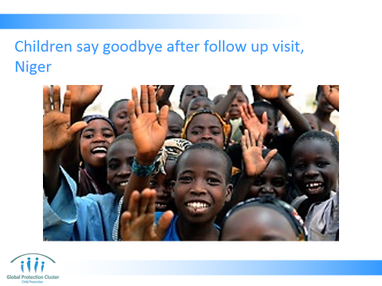

Children from Mia Farou village waving good bye after a visit to see how Appoua was doing having been discharged from the Save the Children supported stabilization clinic in Aguie, Niger. 2010

- HOW TO SAY GOODBYE
- Show slides 25 – 27 explaining the context in which these photos were taken. Ask the following questions if you have time:
- What they think the child is feeling?
- What they think the people running the programmes feel?
- Could this be improved?
- Are there things that could make it worse?

Song Activity:
- Ask participants if they can quickly think of a song, in English, that uses the word goodbye in lyrics or the title. The first one to think of a song and stand up and sing it wins a prize
- Then ask someone to think of a song with word goodbye in another language. Again if they are will to sing it too they get a prize
- Ask if goodbye songs are always sad? Can anyone think of a happy goodbye song?
- Is it possible to make goodbyes happy?
- We are trying to make goodbyes as positive as possible, reflecting on what has been achieved, and fact CF Spaces or the external supports, are no longer necessary

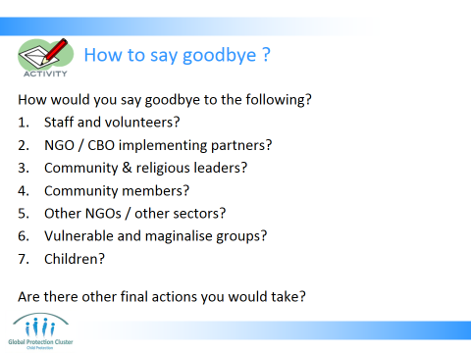

Activity: Ways to say goodbye to different people:
- Break participants into 7 groups
- Ask them to in each group (numbered 1 – 7) to brainstorm 2-3 actions for how they would say goodbye to the following groups of people: (5mins)
- Staff and volunteers?
- NGO / CBO implementing partners?
- Community & religious leaders?
- Community members?
- Other NGOs / other sectors?
- Vulnerable and maginalised groups?
- Children?
- Give them 5 minutes
- Get each group to present their 2-3 actions in turn (15 mins)

- Present Slide 29 & 30, which show possible responses including the following:
Staff:
- Write a letter to staff followed by group and individual meetings
- NGOs & CBO Partners (including those from other sectors)
- Discuss transition plans and any final decisions made in regular meetings
- Have face-to-face briefings and meetings explaining programme closure procedures.
- Write a letter to implementing partners (NGOs & CBOs) explaining programme closure procedures.
Leaders:
- Write an official letter about project closure for regional, district, and village leaders, including elders and informal leaders.
- Follow letters with face-to-face briefings.
- Put a copy of the letter to village leaders on information boards.
Community members:
- Conduct exit meetings with representatives of different strata and sections of the community
- Support appropriate cultural activities or celebration when projects are handed over to the community
Other NGOs and other sectors
- Discuss transition plans and any final decisions made in Cluster and inter-Cluster meetings
Vulnerable & marginalised
- Hold focus groups and/or house-to-house visits to reach women and vulnerable groups who may be unable to attend formal meetings
Beneficiaries / children:
- Use a Question & Answer sheet to guide staff when communicating with beneficiaries about end of project
- Support and facilitate special closure activities for children, such as games, theatre, dance, or song. Let them have the time to say goodbye to their new friends and the facilitators in their own way and separate from the rest of the community, if they wish
Other closure actions:
- Collect stories about successful work and positive community interaction. Give these back to the community; for example have a photo exhibition during handover.
- Evaluate the exit communication activities and record any lessons learned, both positive and constructive
- Use posters and leaflets, including formats appropriate for less literate people, in various languages, etc.
- Report on project achievements and learning.
- Invite feedback/comments on project activities.

- Refer participants to the tools relating to Transition Process Guidance, Transition: Questions to Consider and How to say goodbye in the participants’ toolkit say goodbye”

Key message:
- Any final farewells and goodbyes are an important ritual or rite of passage and should be based on local custom and traditions
- We are trying to make goodbyes as positive as possible, reflecting on what has been achieved, and fact CF Spaces or the external supports, are no longer necessary. They can be a celebration, rather than causing distress

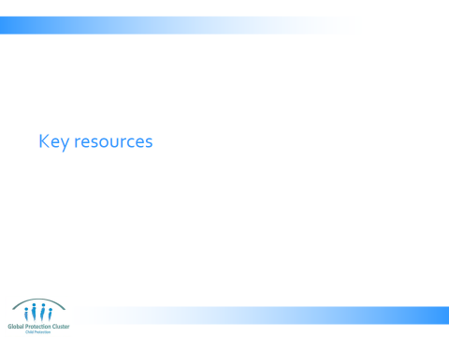

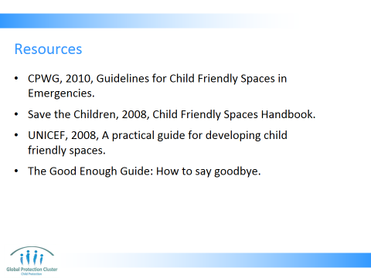

Good Enough Guide available at: http://www.ecbproject.org/tools/tool-14-how-to-say-goodbye

- CLOSE
- Present Slide 33 which shows the content of the Minimum Standards for CP in Humanitarian Action points with regards to transition of CF Spaces
- Finish off with Slide 33 running through the session’s key messages – check if there are any final questions
- Use the Resource Slide 35 to indicate which are key documents they should refer to on these subjects showing participants samples of each of the materials.

Wrap –up with the key messages:
- Early on, in close consultation with the community and others with an interest, develop a phase-out or transition plan that links with broader recovery planning.
- Provide information as soon as possible about when the phase-out or transition will take place
- Transitions represent the movement from what is familiar and secure (the present moment) to what is unknown (the future). Fear may escalate during transitions for all children, families and communities. Many different forms of support provided by range of agencies and actors responding to the emergency may be coming to an end at the same time. Play the role you can in easing this apprehension, by being transparent, open and supportive to community and children

Caution and care needs to be exercised in particular with regards to extremely vulnerable children (disabled, certain ethnic minorities, specific age groups, etc) who will not be so readily able to reintegrate into previously existing services. Consider what can and should be done to support them

Resources:
- Have at least 1 copy of each of the different resources listed in the reference list on the facilitator’s table to show to participants
- Have enough copies of the hand-out “Transition Process Guidance” to be able to give one to each participant



This slide is for the end of each session… prompts for questions, check in and even a 5 minute break, ice breaker as needed.

Adapted from “How to say goodbye” From T. Gorgonio (2006) ‘Notes on Accountable Exit from Communities when Programmes Close’

