

MODULE 3 – SESSION 1 & 2 – LESSON PLAN –
RUNNING YOUR CFS PROGRAM – MONITORING, EVALUATION, ACCOUNTABILITY & ADMINISTRATION

TIME | OUTLINE – 1 HOUR
* RESOURCES REMINDER *
- Rubbish bin / trash can for Activity 2 positioned near the facilitator at the front of the room, visible to all participants
- One copy of answer sheet for the facilitator for Activity 6
- Cards with: words “M&E,” “Admin,” “Accountability,” “M&E, Admin & Accountability” for Activity 7
- Select the 3-4 statements you will discuss for Slide 45, depending on context and participants, what you kinds of issues you feel they need to discuss most
- Read the reference material on Save the Children’s Child Friendly Accountability Mechanism in Dadaab (see references below)
- If you have an in-country M&E Adviser who is available to come to the session, consider asking them to run or be present during the M&E part of the session (Activities 3 – 5)
Key References:
Accountability:
- Oxfam, 2007, Good Enough Guide
- Active Learning Network for Accountability & Performance in Humanitarian Action (ALNAP) http://www.alnap.org/
- Humanitarian Accountability Partnership (HAP) http://www.hapinternational.org/
M&E:
- Child Protection Monitoring & Evaluation Reference Group: http://www.cpmerg.org/
- UNICEF, (2011) Inter-Agency Guide to the Evaluation of Psychosocial Programming in Emergencies
Save the Children’s Feedback Mechanisms in Dadaab:
- Save the Children (2011) “Guide to a child friendly complaints system. Lesson learnt from Dadaab Refugee Camps” a case study highlighting how a child-friendly system has been set up in Dadaab Refugee camps in northern Kenya.
- For guidance on the 10 steps to setting up a Complaints Response Mechanisms, see the video available at: http://aimstandingteam.wordpress.com/2012/03/08/save-the-childrens-short-video-on-complaints-and-response-mechanisms/
- www.hapinternational.org/pool/files/guide-to-a-child-friendly-crm-lessons-from-dadaab-kenya-final-draft.pdf
INTRODUCTION
3 min | Introduce the session
BODY
10 min | Introduction
30 min | Accountability
5 min | M&E – Purpose, Principles & Key Steps
35 min | Developing indicators
40 min | M&E – Data Collection Methods
10 min | Administration
15 min | Wrap-up activity
5 min | Close session
CONCLUSION
3 min | O | Outcome revisited
3 min | F | Positive thought and reinforcement
3 min | F | Next session

MODULE 3 – SESSION 1 & 2 – NOTES FOR TRAINER – RUNNING YOUR CFS PROGRAM – MONITORING, EVALUATION, ACCOUNTABILITY & ADMINISTRATION
Introduce the Module and the sessions it contains.

LEARNING OUTCOMES
By the end of the session participants will be able to …
- Define the following terms: monitoring, evaluation, baseline, control group & accountability
- Understand the importance of participatory monitoring, evaluation and accountability mechanisms to ensure respect, dignity and rights of affected populations
- Understand the links between administrative systems and M&E and accountability mechanisms

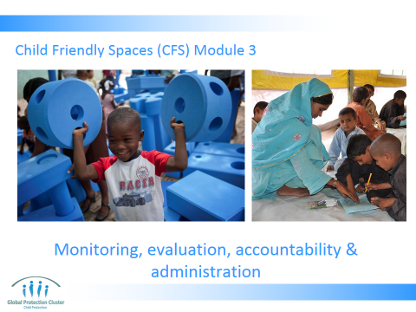

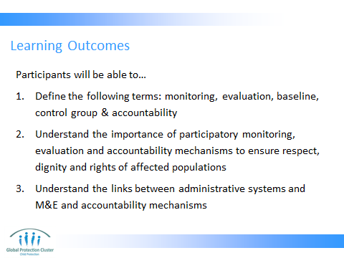

- Present the learning outcomes as on Slide 2

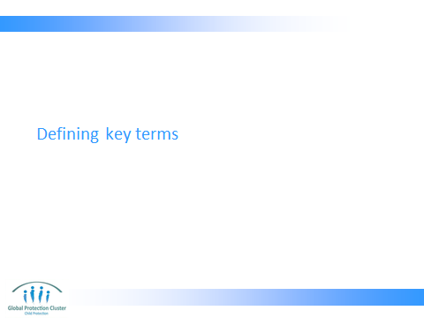

- Run through Slides 3 – 5 that define key terms that will be used during this session
- Confirm everyone understands the difference between monitoring and evaluation, as well as value of having baseline and control group

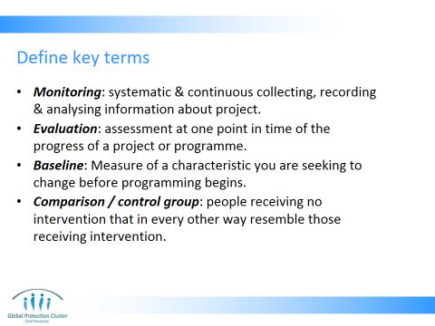

- Monitoring is systematic & continuous collecting, recording & analysing information in routine systematic way. Information that is about the progress of a project or programme over time. Enables us to check progress against plans. It is useful for identifying strengths and weaknesses in a project or programme and for providing the people responsible for the work with sufficient information to make the right decisions at the right time to improve its quality. Enable evaluations at intervals
- Evaluation: assessment at one point in time of the progress of a project or programme. Somewhat like a review. An evaluation usually more formal than a review, often carried out by external researchers for independence. It is an assessment at one point in time that can have different purposes, including verifying whether objectives have been achieved, what impact project had on different stakeholders & how it can improve in the future
- Baseline: A baseline is a measure of something before programming begins. Good baseline measures provide a basis for measuring these same things at the end of the project, and seeing what change has occurred
- Comparison group / control group: a group of people that receives no intervention that in every way — except their not receiving an intervention — is as similar as possible to those receiving the intervention – this allows comparison and enables us to draw conclusions as to the way in which programme contributed to change. There are ethical considerations with regards to control groups / comparison groups if engaging them in your work does not lead to them having programme benefit but does incur costs such as using their time, or raises hopes and expectations

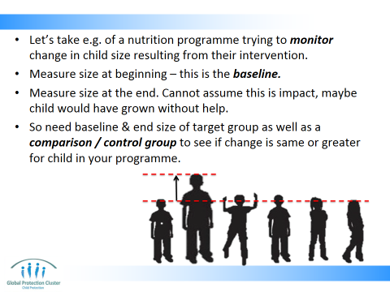

- Let’s take e.g. of a nutrition programme trying to monitor change in child size resulting from their programme intervention
- They would measure the size of all the children taking part in their programme at the beginning of intervention – before they receive any treatment or support – this is the baseline
- Then they would measure the size of the children at the end of their programme intervention.
- The challenge is they cannot assume that the change over time is 100% a result of their programme. That this is the impact of their work, maybe the children would have grown without their programme’s help
- So they need baseline data, end size data for the children targetted & beginning and end size data for a comparison / control group to see if the change over time is the same or greater for children in their programme

Reference:
- UNICEF, (2011) Inter-Agency Guide to the Evaluation of Psychosocial Programming in Emergencies

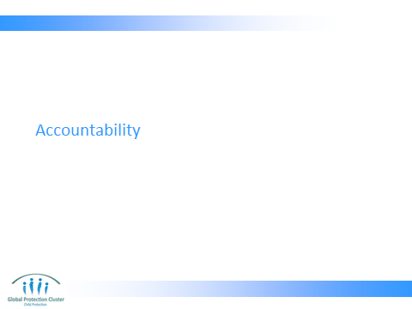

- Present Slides 7 – 8 that explain what accountability is and some possible components of accountable programmes

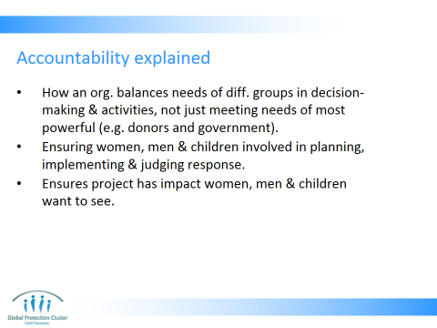

- How an organisation balances the needs of different groups in its decision-making and activities. Most NGOs have processes in place that will meet the accountability requirements of more powerful groups such as project donors or host governments
- However, accountability also means making sure that the women, men, and children affected by an emergency are involved in planning, implementing, and judging our response to their emergency too
- This helps ensure that a project will have the impact they want to see

References:
- Active Learning Network for Accountability & Performance in Humanitarian Action (ALNAP) http://www.alnap.org/
- Humanitarian Accountability Partnership - The HAP Principles of Accountability
- Established in 2003, Humanitarian Accountability Partnership – HAP – International is the humanitarian sector's first international self-regulatory body. Members of HAP are committed to meeting the highest standards of accountability and quality management. 87 INGO members, globally from Africa, Americas, Asia, Europe and Middle East

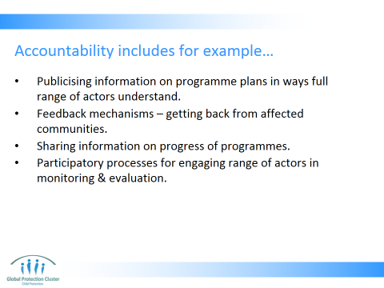

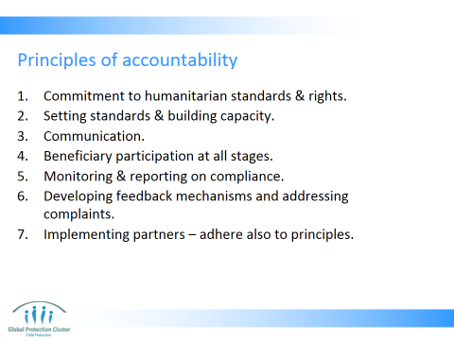

- Present Slide 10 which gives the principles of accountability as set out by HAP – the Humanitarian Accountability Partnership
- Commitment to humanitarian standards and rights - Members state their commitment to respect and foster humanitarian standards and the rights of beneficiaries
- Setting standards and building capacity - Members set a framework of accountability to their stakeholders* - Members set and periodically review their standards and performance indicators, and revise them if necessary - Members provide appropriate training in the use and implementation of standards
- Communication - Members inform, and consult with, stakeholders, particularly beneficiaries and staff, about the standards adopted, programmes to be undertaken and mechanisms available for addressing concerns
- Participation in programmes - Members involve beneficiaries in the planning, implementation, monitoring and evaluation of programmes and report to them on progress, subject only to serious operational constraints
- Monitoring and reporting on compliance - Members involve beneficiaries and staff when they monitor and revise standards, Members regularly monitor and evaluate compliance with standards, using robust processes, Members report at least annually to stakeholders, including beneficiaries, on compliance with standards. Reporting may take a variety of forms
- Addressing complaints - Members enable beneficiaries and staff to report complaints and seek redress safely
- Implementing Partners - Members are committed to the implementation of these principles if and when working through implementation partners

Reference:
- Taken from Humanitarian Accountability Partnership - The HAP Principles of Accountability available at:
- http://www.hapinternational.org/pool/files/principles-of-accountability-and-members-poster-english-jan-2010.pdf

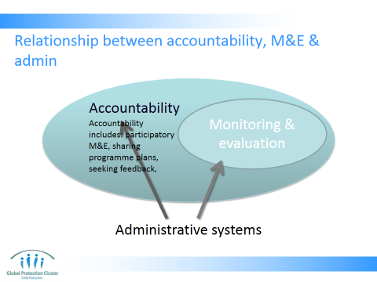

- Slide 10 gives a visual representation of how M&E fits into Accountability and how Admin supports accountability and M&E. Note the following:
- Accountability is essential to ensure quality programming that meets needs of all
- Stakeholder and beneficiary participation in all stages of the project cycle, and M&E process is an important aspect of accountability
- Administrative systems put in place provide information that can support both accountability and M&E as well as ensure smooth running of your programme

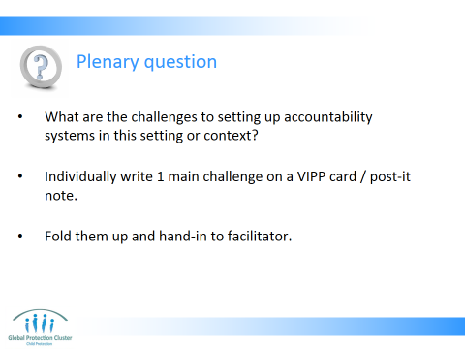

- Ask the question on Slide 11.
- Ask participants to each write one idea or thought on a VIPP card, meta card or post-it note, then fold it up.
- Collect the ideas as they are written. Do not explain what you will do with them. Pile them up on your desk or on a table so that all the participants can see them

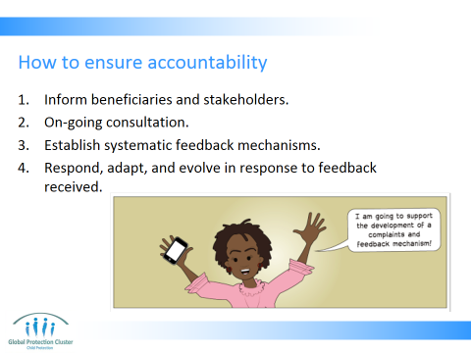

- Present Slides 12 – 16 – ensure you have read the Dadaab Case study before the session, so you can address any questions raised
- Provide public information to beneficiaries and other stakeholders on their organisation, its plans, and relief assistance entitlements.
- Conduct ongoing consultation with those assisted. This should occur as soon as possible at the beginning of a humanitarian relief operation, and continue regularly throughout it. ‘Consultation’ means exchange of information and views between the agency and the beneficiaries of its work.
- Establish systematic feedback mechanisms mechanisms that enable:
- Agencies to report to beneficiaries on project progress and evolution
- Beneficiaries to explain to agencies whether projects are meeting their needs, or if not, how they can be improved
- Beneficiaries to explain to agencies the difference the project has made to their lives
- - Methods include through the M&E system and through complaints and feedback mechanisms
- Respond, adapt, and evolve in response to feedback received, and explain to all stakeholders the changes made and/or why change was not possible.

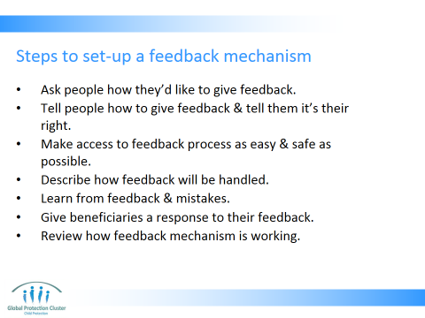

- Ask people how they would like to complain/provide feedback
- Tell people how to complain & tell them it is their right to do so
- Make access to the complaints process as easy and safe as possible for all groups of the population – literate, illiterate, men, women, children, disabled, old, etc etc. Ensure there are differing techniques to reach out to different groups.
- Describe how complaints will be handled – tell the population what will happen after the submit feedback
- Learn from complaints and mistakes – make sure you act on and adapt programming according to feedback and complaints received
- Give beneficiaries a response to their complaint – if it was given anonymously, share feedback broadly, explaining what the feedback was and what changes have taken places accordingly
- Review how complaints mechanism is working – at intervals review who is giving feedback, how, where? Adapt your complaints system if you see some groups are not inputting or some locations are not getting input. You may need different systems in different locations
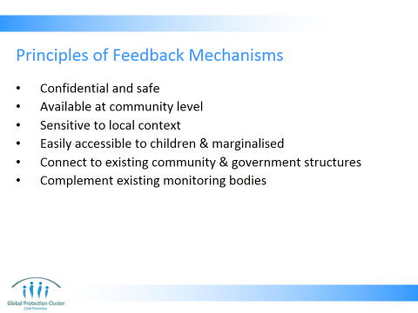

- Be confidential and safe, recognising the many risks associated with reporting allegations in situations of extreme vulnerability
- Handle any complaint of sexual exploitation and abuse against children and adults, regardless of whether the perpetrator is a representative of an international organisation or from the local community
- Be available at the community level
- Be sensitive to the local context and build upon positive local norms, values and structures
- Be easily accessible for children and young people, as well as reaching out to marginalised groups
- Connect to existing community and government structures as much as possible
- Complement and build upon existing related monitoring bodies associated with the international community

Participants should understand that their feedback or complaints will not have an impact on their continued receipt of program services. Complaint and response structures must also be culturally-sensitive and situation-appropriate, and be sensitive to unequal distributions of power and cultural norms. For example, it may not be easy for a female to disclose a complaint to a male and vice versa.

Taken from Save the Children UK (2008). No One to Turn To: The under-reporting of child sexual exploitation and abuse by aid workers and peacekeepers,

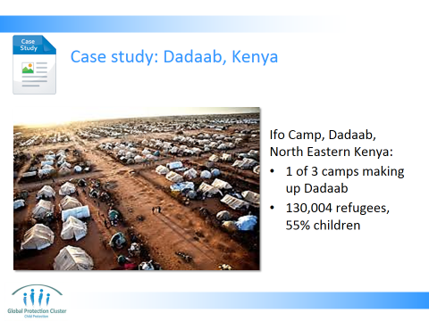

Dadaab Refugee camps, Kenya - Dagahaley, Hagadera and Ifo camps - host 372,551 refugees from Somalia (97%), Ethiopia, Sudan and small populations from other neighbouring countries. The majority of refugees reside in Ifo. Ifo Camp has a population of 130,004. Approx. 55% children. Save the Children is the only child-centred organization in Dadaab. Piloted feedback mechanism in Ifo to learn lessons before roll out

Reference:
- Save the Children (2011) “Guide to a child friendly complaints system. Lesson learnt from Dadaab Refugee Camps” a case study highlighting how a child-friendly system has been set up in Dadaab Refugee camps in northern Kenya.
- For guidance on the 10 steps to setting up a Complaints Response Mechanisms, see the video available at: http://aimstandingteam.wordpress.com/2012/03/08/save-the-childrens-short-video-on-complaints-and-response-mechanisms/
- www.hapinternational.org/pool/files/guide-to-a-child-friendly-crm-lessons-from-dadaab-kenya-final-draft.pdf

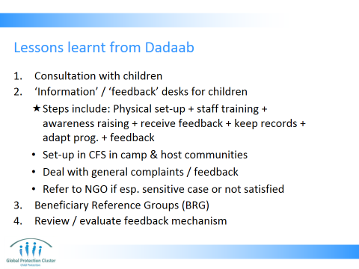

- Consultations with children - Asked children how felt comfortable to feedback
- Set up “Information or “Feedback desk,” named that way to make them more approachable to children and acceptable to community
- Physical set-up – train staff – raise awareness – receive feedback – keep records
- These were to be set up in all Child Friendly Spaces (CFS) in the camp and host community; at the new arrival registration point and the SC camp offices.
- Earmarked to deal with general complaints mainly project related complaints and/ or information e.g. operations, beneficiary targeting etc. – about all programming (FSL, CP, etc)
- Beneficiaries referred to Save the Children if: sensitive complaints, mainly: PSEA/GBV and staff misconduct, or if someone is not satisfied with the way feedback was dealt with
- Beneficiary reference groups (BRG) established: attached to each information desk. Group consists of 9 members: 4 camp leaders (2 male and 2 Female), 3 religious leaders and 2 teachers. Meeting for religious and camp leaders to select representatives. After explaining purpose of BRG, leaders are requested to elect their representatives to the group.

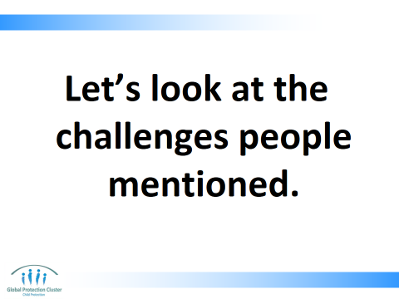

- Once on Slides 17 suggest you would now like to look at some of the challenges noted by participants when we were on Slide 12
- Select 3-4 of the issues noted on bits of paper – unfold them one by one and read them out loud. With one of the post-it notes say, “hmmm, that’s not very relevant” or “that’s not very interesting” or “that person has very bad handwriting” and throw it in the bin. Ensure everyone heard you say this and saw your reaction to the comment. With the other two – three challenges picked out, discuss the challenge, ask if others agree and have also seen this challenges

- Cultural issues can prevent people talking or complaining
- It may be that certain groups of people, especially most vulnerable, are not used to being asked for their views
- The way you are asking people to give feedback can prevent them from inputting
- Many more challenges maybe identified in your context. Review the way your system is working at intervals and work on trying to find ways to address these challenges

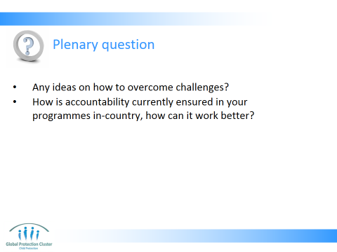
- Ask the plenary questions on Slide 18 with regards to the selected 3-4 “challenges” written down by participants.
- When done with those 3-4 challenges picked out, in front of everyone throw the rest of the post-it notes meta cards with other participants thoughts and idea on them into the bin whilst saying “Ok, we don’t have enough time to look at all of those, so we won’t need those anymore”

- One way of ensuring accountability is a participatory M&E system
- Another key methods is a functioning and effective complaints mechanism

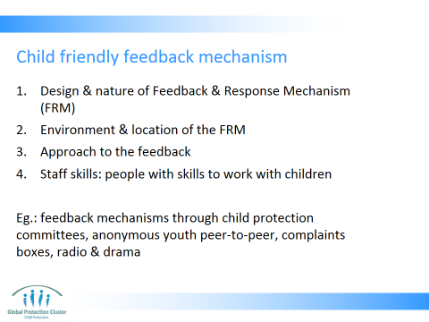

- Present Slide 19
- Now ask the following questions:
- Did everyone feel on Slide 12 they could share their inputs, their thoughts?
- How did you all feel when I did not deal with the inputs and ideas given with regards to challenges straight away? What did you think was happening with the pile of feedback you had given me?
- On slide 18 did everyone feel their concern was taken seriously? How do we think person who had written the post-it note felt when I said “this is not a good idea”?
- What did you feel and think when I threw other comments in the rubbish?
- Discussion points:
- It is not nice to have your comments and feedback ignored
- It is always good to know how long, when and how people will address your feedback
- Note the facilitator did not have the time to address all the challenges handed in, but in real life complaints mechanism should not ignore any feedback received. If not making changes to the programme according to a piece of feedback, you should explain why that is the case
- Some people may not have good writing or spelling, some are not even able to write, not everyone is comfortable with a written medium - the way you are asking people to give feedback can prevent them from inputting – always have a variety of ways to seek feedback on your programmes so that different people feel comfortable and able to engage

Key messages:
- Full accountability is both upwards (to donors and governments) and downwards (to full range of beneficiaries)
- Participatory M&E is a key way to ensure accountability
- Have a variety of ways of seeking feedback from different people, even the most vulnerable and “powerless”
- Review the way your complaints mechanisms are working at intervals
- You need to encourage trust among beneficiaries and stakeholders. Reassure them that their participation in monitoring and evaluation systems, and providing feedback or complaints will not have an impact on their continued receipt of programme services

- Design and nature of the Complaints & Response Mechanism (CRM): The mechanism is informed by children’s ideas and needs about what is preferable to them.
- Environment and location of the CRM: this needs to be a place known to children, easily accessible, safe for them and where confidentiality is guaranteed. A place where they are treated with respect, understanding and calmness; allowing children to freely share their concerns.
- Approach to the Complainant: child friendly language and approach need to be used, this means you should keep it simple, clear and understandable
- Staff and skills: the CRM needs to be led by people with skills to work with children. This includes: child friendly ‘interviewing’ skills, active listening, tolerance and patience. Staff need to give time to children to communicate or make a point; to be happy and positive and show kindness to the child and a willingness to help; using visual materials or images on the desks so that younger children understand.

This guidance is based on work done in Dadaab camp in Kenya.

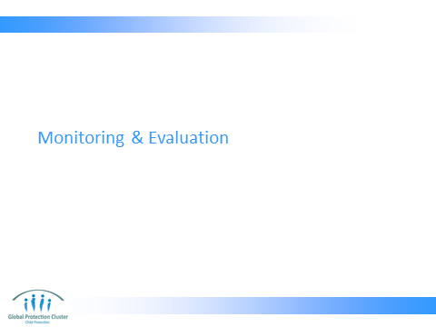

- MONITORING AND EVALUATION – PURPOSE, PRINCIPLES AND KEY STEPS
- Run through Slides 21 - 23 explaining the purpose, principles, and steps, for M&E CF Space programming
Key messages:
- The M&E plan needs to be set-up from the outset so that you are gathering the data you need to monitor and ensure quality of your programme from the outset
- The purpose of your M&E data gathering activities needs to be known by all those gathering the data, at all levels of CF Space programme, so they understand needs and can actively contribute
- All stages of the M&E process must use participatory and ethical data collection methods - Participation in all stages of M&E (planning, design, collection of data, analysis, and implementation of learning) is essential way of ensuring accountability of your programme

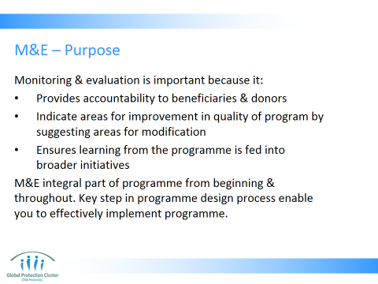

Monitoring and evaluation is important because it:
- Provides accountability to beneficiaries & donors
- Can indicate areas for improvement in the quality of the program by suggesting areas for on-going modifications
- Ensures learning from the programme is fed into broader initiatives

M&E integral part of programme from beginning & throughout. Key step in programme design process enable you to effectively implement programme

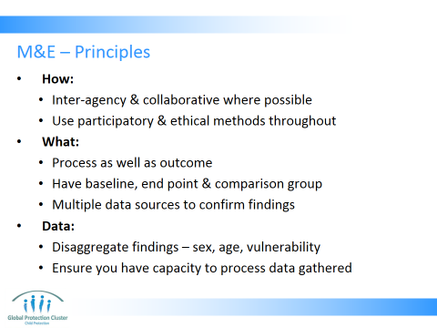

How:
- When possible, conduct inter‐agency, collaborative evaluations, which can improve coordination and yield conclusions that apply more widely. These should be inter-agency and inter-sectoral
- Use participatory methods of monitoring and evaluation that engage children and youth and invite community members’ views. – e.g. when setting and developing objectives and indicators, get children and families to support development of wellbeing indicators
- Data collection methods must be ethically implemented -
  - Ensure you have informed consent & conduct interviews appropriately
  - Respect privacy and confidentiality
What:
- Evaluate not only process (output) indicators such as the number of children who participate regularly but also outcome indicators such as children’s psychosocial well‐being that are relevant, measurable, and developmentally appropriate.
- Have baseline and end‐point measures of outcomes concerning changes in children’s lives,
- Where possible, use a comparison group to enable comparisons with other interventions or sites where no CFS had been implemented. To manage the ethical issues that can arise in making comparisons, consider strategies such as wait‐list comparisons (e.g., compare girls and boys who participate in CFSs with children who have not had CFSs but are about to begin participating in CFSs) or roll out process comparison – may not be feasible in emergency
  - Draw on multiple sources to confirm findings – talk to variety of people, adults, children, leaders – this is called “triangulation of data” - this enables you to confirm views of individuals – and reduces the possibility of bias or subjective views you may get influencing the results and conclusions you come to
Data:
- Whenever possible, collect sex‐ and age‐disaggregated data, as well as looking at information with regards to other forms of vulnerability and exclusion
- Ensure that you have the capacity to process and assess all the data gathered

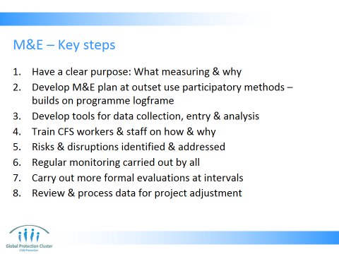

- Have a clear purpose – clarify aims & procedures with all those involved (staff, beneficiaries, partners, volunteers, etc) – what it is you are measuring and why
- Develop at outset / early in the project a monitoring and evaluation plan. Use participatory methods to establish the goal, objectives and indicators. This will help shape your programme
- Develop suitable tools for data collection, entry & analysis – ensure they are clear and usable (by those who will be using them) as well as harmonised across the whole programme
- Train selected CFS workers and staff on how & why to monitor program activities effectively.
- Potential risks & disruptions identified & addressed
- On a regular basis monitor …
- …Via animators the registration of children, parental consent, children’s informed consent attendance, behaviour during the activities, follow‐up of children who missed activities, activity planning and whether activities include girls as well as boys and highly vulnerable children.
- …Via supervisors through site visits monitor and check: staffing, schedules, stocks, activities, facilities, etc (CFSs should be monitored on an ongoing basis to track development of CFS & to identify gaps in levels of community mobilization, quality of activities, safety, logistical support, etc ).
- …Via agency staff the quality of the activities, animators’ skill levels, adequacy of supplies and logistics supports, protection threats in the area, and the implementation of the code of conduct, etc.
- CFSs should be evaluated periodically by senior staff or independent people who are experienced in monitoring, to determine whether the activities are producing meaningful improvements in the lives of the children
- Findings from all these various forms of monitoring and evaluation should continuously be reviewed and processed to ensure learning is leading to adjustments in programming

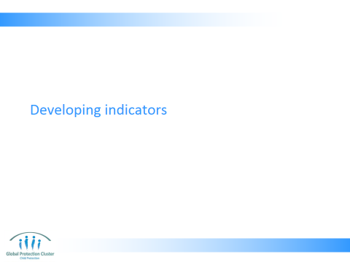

- DEVELOPING INDICATORS
- Present Slide 26 – 27 (5 mins)
Key Messages:
- You need to be clear on the objective of your programme before you can establish progress.
- You need to establish and define what a child who is “well” psycho-socially look like in this context as this is probably the ultimate goal of your programme
- It is important to get input on development of indicators from children, communities, parents, teachers, etc

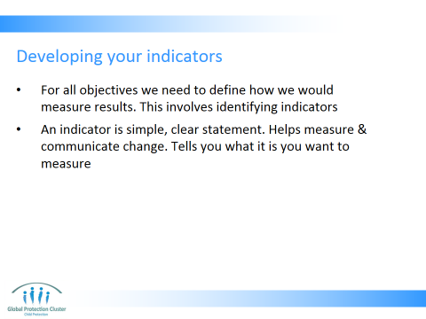

- For all objectives we need to define how we would measure results. This involves identifying indicators
- An indicator is a simple, clear statement that helps measure and communicate change. It tells you what it is you want to measure
- These need to be:
    - Consistent with the social and cultural context
    - Relevant to all the different groups involved
  - Can use methods such as problem tree to identify indicators – problem tree is a process of drawing a diagram of a tree to help people brainstorm the root causes (roots of the tree), the issues to address (the trunk of the tree) and the outcomes of the issue (the branches) – it can help you identify the actions that need to be taken to address the root causes not only respond to the outcomes

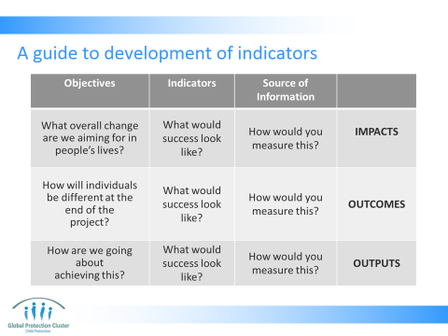

Reference:
- UNICEF, (2011) Inter-Agency Guide to the Evaluation of Psychosocial Programming in Emergencies

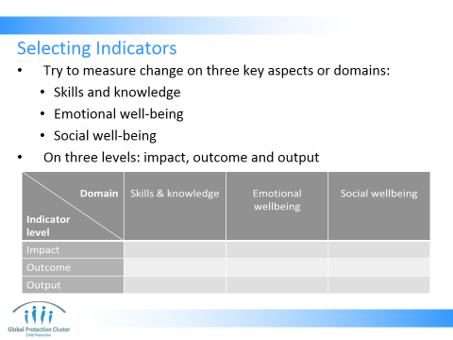

Try to measure change in three key areas: skills and knowledge (Some measure of acquisition of skills), Emotional well-being (Some measure of improved emotional adjustment) and Social well-being (Some measure of improved social functioning)

Reference:
- UNICEF, (2011) Inter-Agency Guide to the Evaluation of Psychosocial Programming in Emergencies

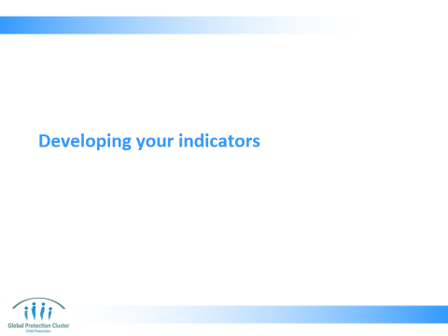

Activity:
- Use Slide 28 – 30 to describe the activity on developing indicators to the group
- Break the room into 6 groups
- Each group take one of the Objectives of CFS (2 groups will each do same Obj.)
- Identify 2-3 indicators for the objective you have been assigned – 10 mins
- Do you have at least 1 for output & 1 for outcome? – 5 mins
- When 10 mins is up, ask them to share their indicators with the group, without repeating indicators that have already been mentioned – 10 mins
- Ask them for each indicator which domain (skill / knowledge, emotional wellbeing or social) it measures at which level (outcome, output or impact)?
- Underscore that this is Step 1 of developing your M&E plan

Note: If the CF Space programme they are working on already has…
- Objectives: get them to develop indicators for those country specific objectives
- Indicators: You can ask the group to establish either sub-indicators or milestones. The components or questions you need to ask yourself in order to be clear if the indicators are being achieved.
- If either of these is the case adjust the PowerPoint slides beforehand and amend the activity accordingly

- Room break into 6 groups
- Each group take one of the Objectives of CFS (2 groups will each do same Obj). Note these are the specific objectives from the CFS Guidelines. If there is a joint Inter-agency strategy for CFS in-county you may want to take the objectives from that strategy instead
  - Mobilize communities around the protection & wellbeing of children, incl. vulnerable children;
  - Provide opportunities for children to play, acquire relevant skills & receive social support;
  - Offer inter‐sectoral support for all children in the realization of their rights
  - Identify 2-3 indicators for the objective you have been assigned

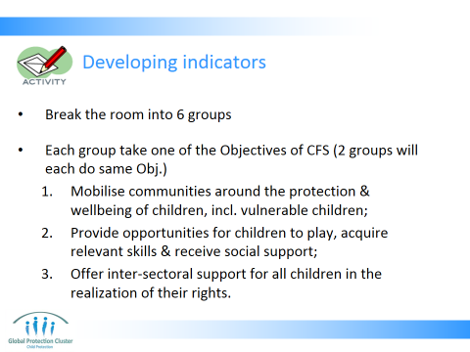

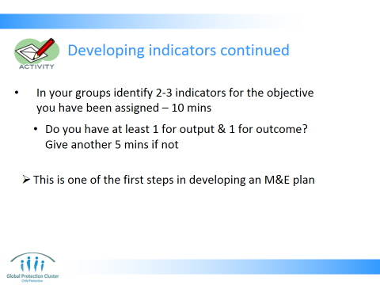

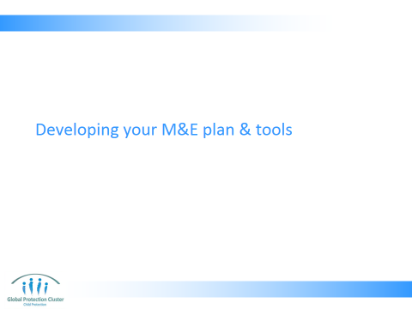

- MONITORING AND EVALUATION – DATA COLLECTION METHODS
- Present Slides 32 – 34

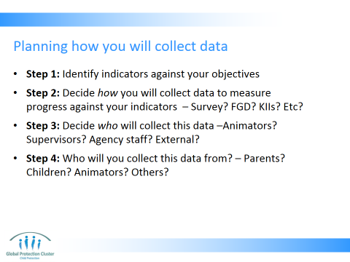

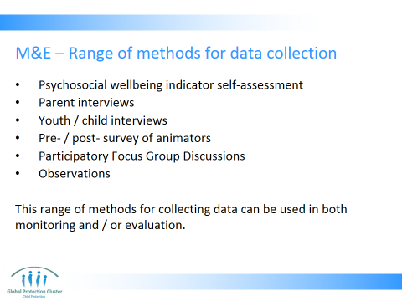

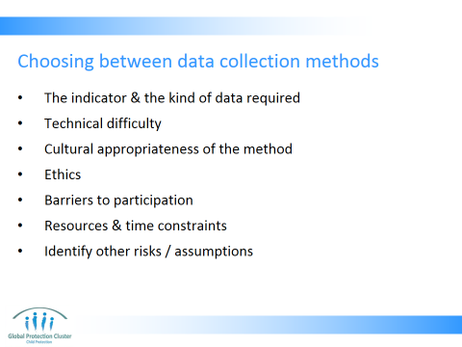

- Indicator & kind of data required – what the indicator & objectives are determine forms of information you need to be able to measure progress towards achieving those objectives – whether you need quantitative or qualitative information etc - Based on the problem (your objective) you established your indicators. Then based on these you can draw out the questions you need to answer to establish progress against your indicators - this then enables you to decide the data you will gather
- The technical difficulty & adaptability of the method to a particular level of expertise of staff you have in-country - Ensure staff and participating individuals have necessary skills and competencies to carry out M&E methods you have identified
- Cultural appropriateness of the method - will it make people feel comfortable learning, communicating, and interacting?
- Ethics – what are the pros and cons of the method you are considering with regards to ethics. Will children and community members have raised expectations of support if they are asked to give further detail on needs, or will the method for data collection take so much time so as to create opportunity cost? Etc?
- Barriers to participation - e.g., levels of literacy, command of language used, social class, physical challenge, age, and time constraints
- Resource & time constraints: What resources are available? Logistical, staffing, technological (data base, etc) and financial. Example: Quantitative methods are often on a larger scale, and so more costly in terms of assets (eg, computers and vehicles), human resources (eg, paid enumerators) and time. Clarify any time constraints – e.g. funding or reporting deadlines
- Identify other risks or assumptions - access & security constraints – choose method which has challenges you are able to overcome

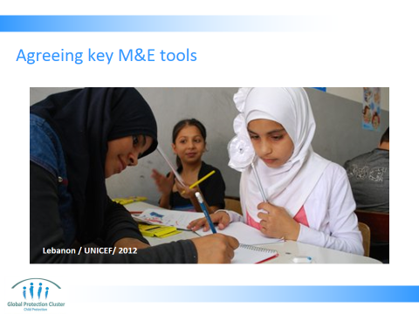

Activity: (20 mins)
- Use slide 35 & 36 to describe the activity
- Ask the participants to break into five groups
- Each group is assigned a topic
- How will we count children coming to child friendly space?
- How will we monitor wellbeing? How will you determine your wellbeing indicators?
- How will you determine the baseline against which we are monitoring progress?
- How will you agree minimum standards for CFS in this context?
- What steps can we take to put in place a child friendly feedback mechanism?
- Produce written record of steps you will take
- 20 mins

Debrief: (15 mins)
- Bring the group back together in plenary and discuss how they can agree and finalise the next steps to be taken to finalise these M&E tools. Agree who will document the next steps identified and if they should be supported by inter-agency work or agency specific activities

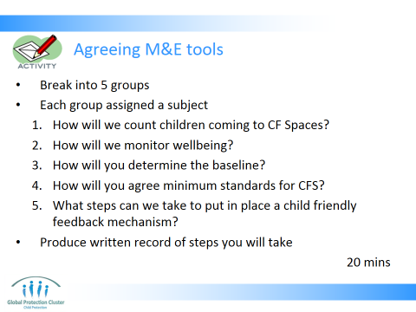

- Break into 5 groups
- Each group assigned a subject
- How will we count children coming to child friendly space?
- How will we monitor wellbeing? How will you determine your wellbeing indicators?
- How will you determine the baseline against which we are monitoring progress?
- How will you agree minimum standards for CFS in this context?
- What steps can we take to put in place a child friendly feedback mechanism?
- Produce written record of steps you will take
- 20 mins

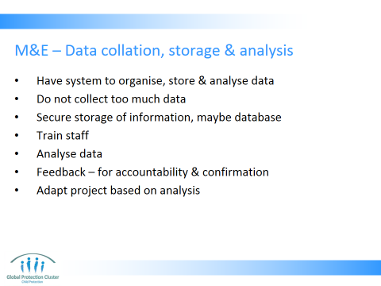

- Present Slide 37 to explain what systems you need in place once you have the data collected

Key Messages:
- It is always recommended to develop a monitoring and evaluation plan or framework before the implementation of the CFS.
- The plan generally involves the monitoring activities, key stakeholders, time period, assumptions, & potential risk
- You must think about how data will be used once collected. Only collect information you will be processing and analysing. Do not overwhelm yourself with data that you will not have the time or skills to collate and analyse.
- You need to triangulate your data – get information using a variety of different methods from variety of different sources, in order to differentiate between what is fact, opinion or rumour
- Systems & procedures to properly organize, analyse & store data collected is part of M&E plan. Need clear & understandable system to file, code & secure data. This is an area that needs expertise and/or further training
- Do not collect more info./data than can be entered into system or process for analysis
- You must store data about project and children securely. A storage system of file folders (paper - hard copies) can be kept in a locked filing cabinet and/or an electronic computer-based filing system can be kept in password-protected files. Security & confidentiality is required for any child-specific data - child’s name, personal details & other sensitive information. Only staff with permission should have access to the information. Note this has resource requirements in terms of filing cabinets and designated computer to ensure security of the information
- -- May set-up database. If you have large amount of data from different locations. If well done it also helps with confidential storage of the data
- Trained staff should be involved in analysing data. If quantity of data is very high, or scale of programme is very large, you may need a staff member whose job is 100% support to development of M&E system, data processing & analysis
- Analysis - You should analyse all the data you collect & collate regularly, at pre-agreed intervals. Analysed & consolidated information from data can be presented in written reports, data tables, in presentations or verbally
- Feedback - Give feedback to stakeholders. They have right to information (accountability) & information needs confirmation. Conduct meetings to discuss data & findings with children, community & staff so they can confirm findings, give inputs on how to address challenges being faced or ways to continue good work
- Change, adapt or modify project based on analysis of on-going M&E data collected.

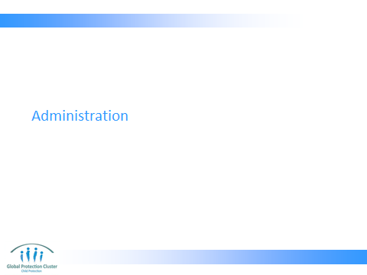

- ADMINISTRATION
Present Slide 38 – 41

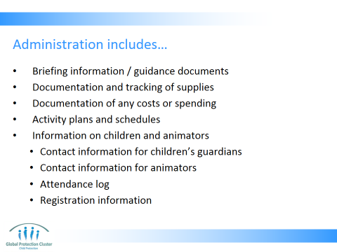

- Activity plans and schedules
- Documentation and tracking of supplies
- Documentation of any costs or spending
- Information on children & animators
  - Contact information for children’s guardians
  - Contact information for animators
  - Attendance log
  - Registration information
  - Clarify that here we are not referring to a certain group of individuals within an organisation, but the function of administration that all staff are engaged in in one way or another

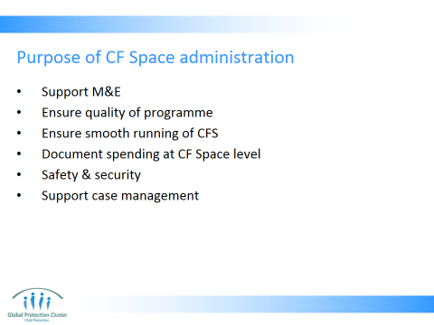

- Support M&E – data and information collected can feed into reporting, can help supervisors monitor information such as ratio of animators to children, number of children occupying the space, etc – all indicators of quality
- Quality of programme – ensure adult: child ratios suitable, that activities are designed appropriately for ages and genders attending, that range of activities addressing different development needs are being included, etc
- Ensure smooth running of CFS – schedules and registers of children and animators ensures that everyone knows where they should be when, ensure sufficient supplies are available on time, schedules are planned, etc
- Document information on spending at CF Space level – feeding into budgeting and reporting on financial aspects of the programme
- Safety & security – ratio of staff to child, security & health incidents can be tracked, as well as stock levels of first aid materials etc can be monitored through admin, which ensures safety and wellbeing of children. Contact information for parents enables you to be in touch in case of harm or injury. Can give indicators, red flags for areas of concern, so if you have high drop out rates maybe there is physical punishment. Or maybe security issues are preventing children from attending.
- Can support case management process – indicators for wellbeing can include presence, attendance, behaviour, which is noted in CFS administrative processes

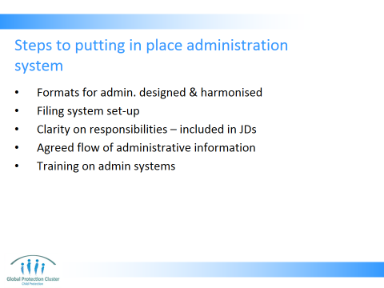

- Formats for administration (registration, stock monitoring, etc) need to be designed and harmonised across CF Spaces and agencies as far as possible
- Filing system set-up – for on-site confidential and safe filing of administrative information, for copying and then for filing in centralised locations
- Clarity on roles and responsibilities: There needs to be clarity on who is responsible for which aspects of daily administration
- Agreed flow of administrative information - Agreed way that information will be collected, collated and processed – so everyone knows when they need to submit, how, who to and in what format – document this and display in CFS
- Training on admin system given to all animators and staff – this should cover all of the above (forms, filing system, roles and responsibilities, and flow of information)
- Staff, volunteers and parents should have a designated time to conduct administrative duties
- If possible, a space, which is separate from children, should be allocated to enable privacy for official tasks - Separate admin space allows the staff to carry out both official and non-official tasks without disturbing the children at the CFS. It also helps ensure privacy when carrying out some more sensitive and confidential duties
- Feedback to those inputting so they can understand the purpose of the information they gather – they can see the value of their work and can also have a sense of progress, issues etc.

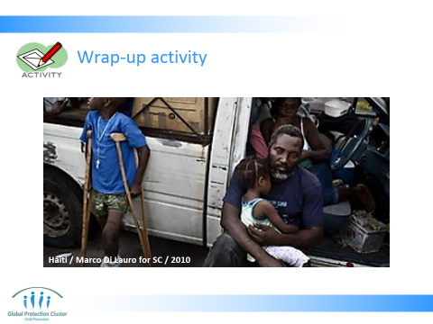

- WRAP-UP ACTIVITY
Activity: Slide 42 (10 mins)
- Place cards labelled “M&E”, “Admin”, and “Accountability” on the floor in a triangle. With 1 card in the middle labelled “M&E, Admin & Accountability”
- Outline the activity as explained on Slide 43
- Participants are to consider each question on Slide 44 in turn
- Participants decide if they think the question would be used for administrative purposes, for M&E or as part of an accountability mechanism
- Participant to stand by card they think this question fits into
- They are allowed to say it fits into more than one option, in which case they can stand between the 2 items it fits into or if it is all 3, they can stand in the middle of the triangle
- After each question facilitate a discussion about why participants have placed themselves where they have. Use answer sheet to help you discuss where you think people should be standing and how each question or item of information supports either accountability, M&E or admin systems
- Ask participants to comment if they have anything different or queries / clarifications
- Note other responses may be justifiable, get the participants to explain if they feel the question could provide information for a different category

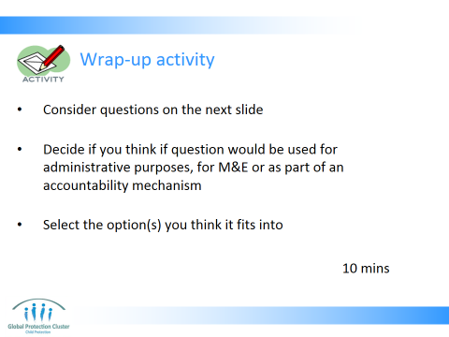

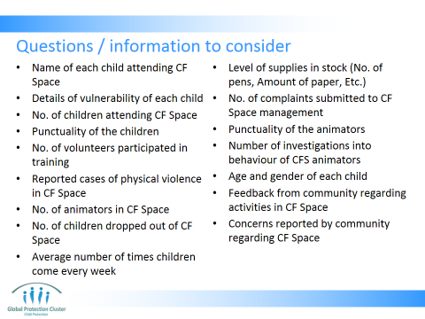

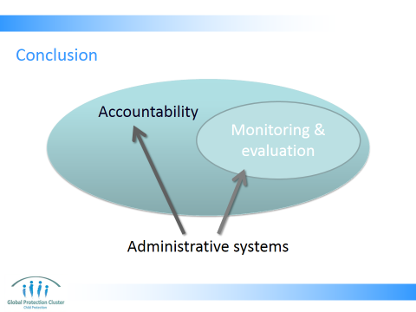

- Show how there is overlap as on slide 45
Key points to note:
- Accountability is essential to ensure quality programming that meets needs of all
- Stakeholder and beneficiary participation in all stages of the project cycle, and M&E process is an important aspect of accountability
- Administrative systems put in place provide information that can support both accountability and M&E as well as ensure smooth running of your programme

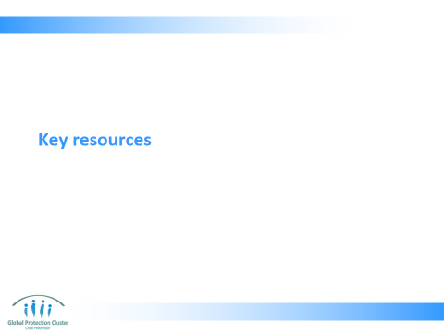

- CLOSE
- Use the Resource Slide 47 to indicate which are key documents they should refer to on these subjects showing participants samples of each of the materials.

Resources:
- Have at least 1 copy of each of the different resources listed in the reference list on the facilitator’s table to show to participants
- Have enough copies of the hand-out “Monitoring, Evaluation, Accountability & Learning” to be able to give one to each participant

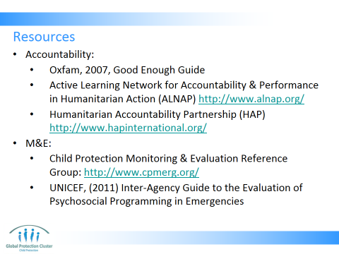

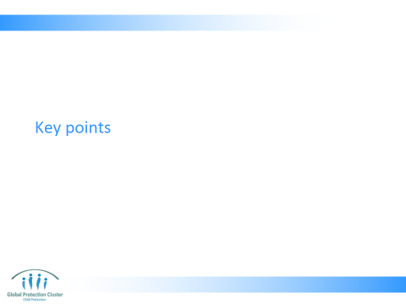

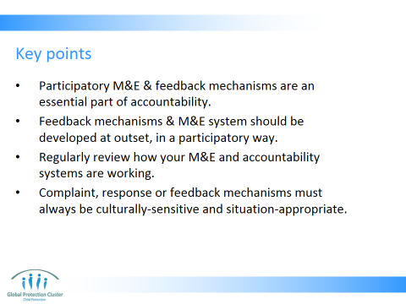

- Finish off with Slide 49 running through the session’s objectives and summarising how these have been met – check if there are any final questions

- Participatory M&E and feedback mechanisms are an essential part of accountability, ensuring programme success, enabling agencies to meet needs of affected populations appropriately, and ensuring respect of dignity and rights of those targeted by programmes
- Feedback mechanisms & M&E system should be developed at outset of CF Space programming in a participatory way (involve volunteers, staff, affected population, community members & leaders, donors & governments)
- Regularly review how your M&E & accountability systems are working involving all stakeholders in the review of the system
- Complaint, response or feedback mechanisms must always be culturally-sensitive and situation-appropriate, and be sensitive to unequal distributions of power and cultural norms



Wrap –up with the key messages:
- Participatory M&E and feedback mechanisms are an essential part of accountability, ensuring programme success, enabling agencies to meet needs of affected populations appropriately, and ensuring respect of dignity and rights of those targeted by programmes
- Feedback mechanisms & M&E system should be developed at outset of CF Space programming in a participatory way (involve volunteers, staff, affected population, community members & leaders, donors & governments)
- Regularly review how your M&E & accountability systems are working involving all stakeholders in the review of the system
- Complaint, response or feedback mechanisms must always be culturally-sensitive and situation-appropriate, and be sensitive to unequal distributions of power and cultural norms

Refer participants to their handbooks / toolkits the section titled “Monitoring, Evaluation, Accountability & Learning”

This slide is for the end of each session… prompts for questions, check in and even a 5 minute break, ice breaker as needed.

MEAL Activity – Answer sheet for facilitator

Question / information |  | Accountability | Admin | M&E | Specific notes
 | Name of each child attending CF Space | x | x |  | This is confidential information that could put children at risk. You may keep the details of this information for administrative or case management purposes. In this case it must be coded or kept in lockable, password protected files. The details of names should not need to be passed on to other departments or teams within the organisation, as this may risk exposure of vulnerable children. If investigating a specific case for accountability reasons it may be needed. Most of the time details of children’s names should not be used or needed in M&E reports. You may want to have a case study with a name and information about a specific child in a report. This requires special permissions.
 | Details of vulnerability of each child | x | x | x | This can help monitor programme inclusiveness, which is important to ensure accountability to all affected by the emergency. As well as help with admin to ensure equipment, activities, facilities and staffing are suited to the needs of the children attending. Can help with case management system, and indicate need for referral of child to other forms of support
 | No. of children attending CF Space | x | x | x | Can help ensure you have correct staff to child ratio for management purposes as well as quality assurance. Help you with resource ordering and planning. Ensure that quality and necessary services are being provided. EG. If there is a sudden drop in participation it could be a sign of inappropriate activities or treatment.
 | Punctuality of the children |  | x | x | This can help in management of CF space, maybe you need to consider changing the timing of sessions if all are consistently late, or maybe location is not suitable. But this does not necessarily indicate concerns about quality of activities in CF Space.
 | No. of volunteers participated in training |  | x | x | Admin – helps you to ensure you reach all volunteers when planning project, helps with budgeting. M&E – contributes to measure of output, but does not indicate outcome, what is the quality of CF Space facilitation after training – we cannot tell from this data
 | Reported cases of physical violence in CF Space | x |  | x
 | No. of animators in CF Space |  | x | x | As for question 4
 | No. of children dropped out of CF Space | x | x | x | This is useful information for all 3. If children are dropping out in high numbers it can indicate there are issues of quality in the CFS. It can show a need to reduce resource ordering if there is a steady decline in participation. It could indicate children are being abused and thus intervention is needed on part of supervisors.
 | Average number of times children come every week | x | x | x | As for question 8 above
 | Level of supplies in stock (No. of pens, Amount of paper, Etc.) |  | x | x | This is useful for administration purposes as it indicates the need to reorder supplies. It can also be an indicator for quality - if supplies are always low, or never being used then children are not engaging in quality activities as they should be.
 | No. of complaints submitted to CF Space management | x |  | x | Useful information for accountability and M&E purposes. The CF Space is not necessarily being run badly if there are many complaints, or an increase in the number of complaints, it can be an indicator of a very open and efficient feedback system. It may not be suitable to include details of all complaints in an M&E report depending on the nature and sensitivity of the complaint. Does not really link with administrative systems or needs, unless complaints are about lack of supplies.
 | Punctuality of the animators | x | x | x | Lack of punctuality can be a concern if animators are consistently late and children are unsupervised. It may be that the supervisor needs to take disciplinary action, it could be that the hours of CFS activity are not suitable. It may be that new volunteers should be recruited.
 | Number of investigations into behaviour of CFS animators | x |  | x | As for question 12
 | Age and gender of each child | x | x | x | This helps ensure inclusivity of the CF Space. Enables accurate purchasing of equipment to suit the different age groups attending. And allows us to report accurately to donors and the cluster system about our gender reach.
 | Feedback from community regarding activities in CF Space | x |  | x | Useful information for accountability and M&E purposes, enabling us to ensure we are meeting our objectives and meeting the expectations of the community.
 | Concerns reported by community regarding CF Space | x |  | x | As for question 12

