

MODULE 2 – SESSION 4 – LESSON PLAN –
RESOURCING & LOGISTICS

TIME | OUTLINE – 1 HOURS 45 MIN
* RESOURCES REMINDER *
- A number of CF Space kits showing the types of resources in kits available and used in-country
Hand-outs:
- Enough copies of the hand-out “Logistics considerations for CFS” to be able to give one copy per participant
- A few copies of the Sample Kit lists
Other
- For activity 5 delete either Slide 19 or 20. If CF Space programming has not yet started, do the activity as outlined on Slide 19. If CF Space programming has already started do the activity as outlined on Slide 20
- Categories of beneficiaries written on to A4 / letter paper including: Girls & boys – 0 – 6, Girls & boys – 6 – 12, Girls 13 – 18, Boys 13 – 18, Children with disabilities, Pregnant women
- In-country logistics or procurement adviser if available / possible – they should be present throughout and address specific questions
References
- Save the Children, Child Friendly Spaces Handbook

INTRODUCTION
3 min | - Introduce the session
BODY
5 min | Introduction
5 min | Defining key terms
40 min | Site selection and CF Space set-up
35 min | Lay-out of the CF Space
30 min | Equipment needs to run CF Spaces
5 min | Close session
CONCLUSION
3 min | O | Outcome revisited
3 min | F | Positive thought and reinforcement
3 min | F | Next session

MODULE 2 – SESSION 4 – NOTES FOR TRAINER – RESOURCING & LOGISTICS

Introduce the Module and the sessions it contains.

LEARNING OUTCOMES
By the end of the session participants will …
- Be able to name 9 factors affecting site selection
- Be able to name the 6 categories of equipment need for CF Spaces
- Know the factors influencing choices with regards to equipment for the CF Space (CAGeD SPORT)

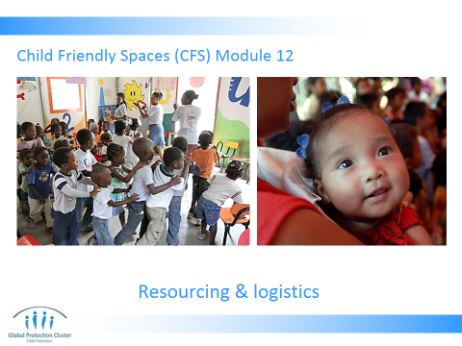

- Slide 1: Have the slide on the screen as participants arrive and settle down.

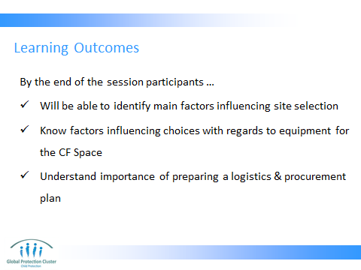

- Present the learning outcomes as on Slide 2

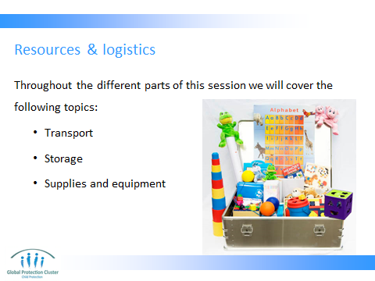

- We will discuss the issue of costs and financing your programme supply needs throughout this session across all these subject areas. As well as what human resources you need to support these elements of logistics.

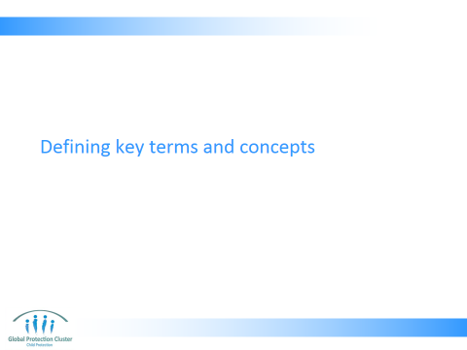

- DEFINING KEY TERMS
- Run through and present Slides 4 – 5, allowing time for questions and discussions
Key message:
- Logistics are a vital support function to the delivery of CF Space programmes
- Collaboration with logistics teams must happen through the programme

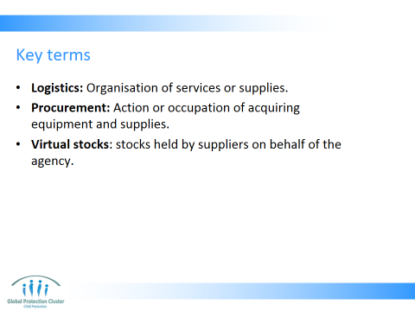

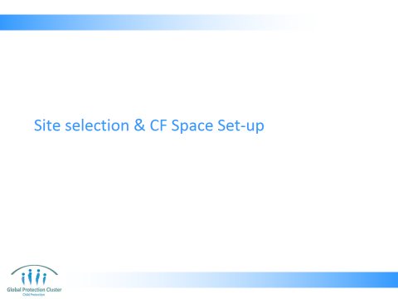

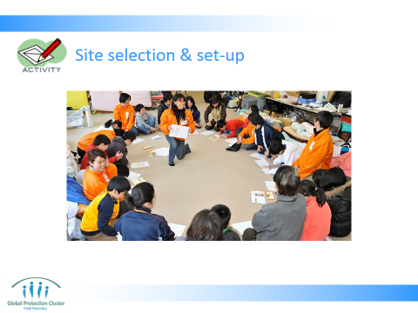

- SITE SELECTION & SET-UP
Steps:
- Divide the participants into 5 equal sized groups and give each group a large piece of flipchart paper and markers.
- Ask the groups to draw a picture for each of the things that they need to consider or look for when selecting the site for a Child Friendly Space where they can set up the space:
Examples:
- Drawing of school building or tent: locally available structures that could be used for the space
- Drawing of tree: shaded places outside to prevent children getting too hot
- Drawing of water tap: nearby access to safe or portable water
- Drawing of latrine: nearby facilities for children to use, with gender and adult separation
- Drawing of ramp: access for children with disabilities
- Note we want them to think about the space itself, not the equipment inside that children will use
- Give them 15 mins for this activity

- Give each group 3 mins to present their drawings – 15 mins total
Facilitate a plenary discussion to wrap-up
- Have a 10 min discussion in plenary so that groups can share major comments on their drawings, key questions you may want to ask the group to generate discussion include:
- What did you think you needed to do on the site to ensure safety?
- What was need for wellbeing?
- What about marginalised groups, do they have specific needs?
- Wrap up and that explains 9 factors to be considered when selecting your site
Discussion points:
- Remember to work with the logistic teams when selecting locations for Child Friendly Spaces. They will be able to help with procuring materials and setting up the space, as well as adapting the Child Friendly Spaces so that they meet the Sphere standards.
- Discuss with other sectors, children and community to make sure you have considered all concerns, and mitigated them
- Needs and risks are different when you are setting up a temporary space (tent) versus using a pre-existing structure. Explore all the risks given the current emergency, and taking into account the views of children and communities
- Prior to using any pre-existing structures, a civil engineer must check the facilities. If there is any question about the safety of the building, use a tent or temporary shelter until an engineer can identify works needed and ensuring necessary repairs have been made.

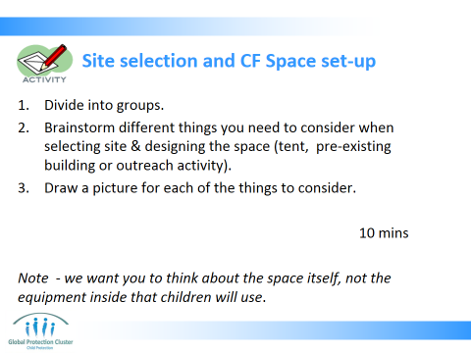

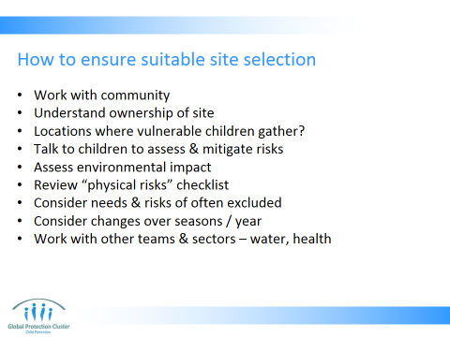

- Work with community to ensure site selection & set-up is appropriate
- Understand ownership of site / land being considered - Does it have particular owners who only occupy it certain times of the year?
- Note if there are locations where vulnerable children already congregate
- Talk to children to assess risks and mitigate them
- Is there a water source and are there health facilities near by?
- Assess environmental impact – if building using wood, consider including budget to replant trees
- All of the above does depend upon what is available and what is appropriate

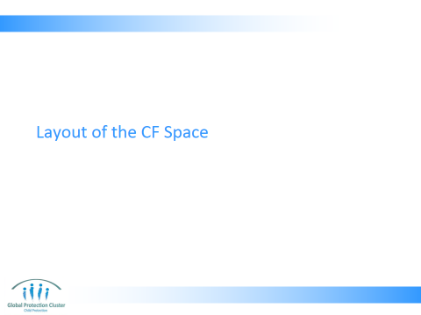

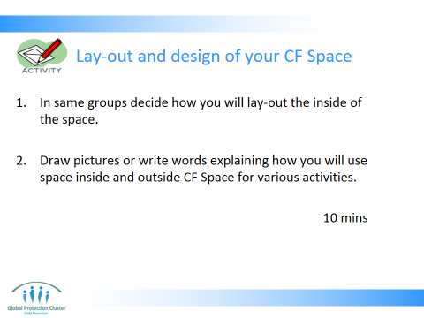

- CF SPACE LAY-OUT
- Use Slide 11 to explain the next activity (15 mins)
- Groups now need to think about how we use the space inside the CF Space. What lay-out it is we want
- Give them 10 minutes to draw what they think the inside needs to look like
- Now give them further 5 minutes to think if they may want to change this lay-out at different times of the day?
Facilitate a plenary discussion to wrap-up (10 mins)
- Debrief asking the following questions:
- Did they consider different uses by different groups of children?
- Did they consider use of the space by parents and the community?
- What space do the facilitators / animators and supervisors need?
- How will they store equipment and supplies?

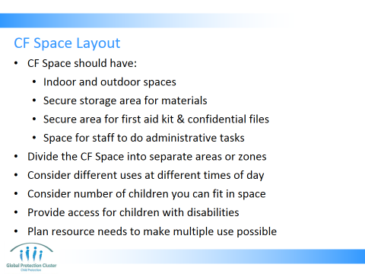

- If possible have indoor and outdoor spaces to allow for team games and sports activities, as well as space for activities such as reading and facilitated sessions.
- A secure storage area for the materials; if a secure area is not available, night guards or security personnel are required to ensure that materials are not damaged or stolen.
  - Secure area for first aid kit & confidential files
  - Space for staff to do administrative tasks
- You should divide the Child Friendly Space into separate areas or zones by marking out areas for different activities or for different groups with ropes, curtains, etc. By dividing your space, you can conduct a number of different activities at the same time. Child Friendly Spaces can be divided and cordoned off according to ages, gender specific areas, or types of play that will be conducted – quiet play, active play, and structured activities.
- Consider different uses at different times of the day – will this be used by different age groups in morning, afternoon or evening? Will parents and community use it?
- Consider number of children you can fit in space you have available to you – what is safe
- You must think of how you can provide access for children with disabilities (for example, by providing ramps for wheelchair access in addition to or instead of steps).
- Plan resource needs to make multiple use of the space possible - e.g. enabling community meetings or parenting classes

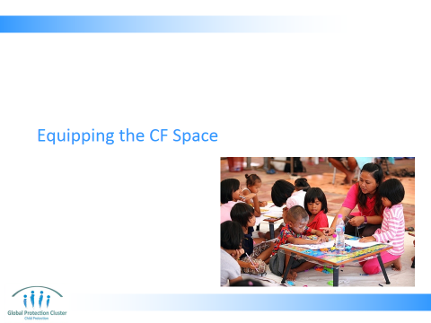

- EQUIPMENT NEEDS TO RUN CF SPACES

Activity: Slide 18 OR Slide 19
- If CF Space programming has not yet started, do the activity as outlined on Slide 19. If CF Space programming has already started do the activity as outlined on Slide 20
- Participants are to work in the same groups if they have not yet been implementing CF Spaces
- They must think of equipment needs for activities for the category of children they have been assigned, as well as considering the space the drew earlier in the session
- For Slide 19, participants who have not yet been implementing CF Spaces they should answer the following question:
- List top 10 items of equipment will you need to deliver activities for the following categories of children?
- For Slide 20, participants who have not yet been implementing CF Spaces they should answer the following question:
- What have you been doing with equipment you have so far for this group?
- List top 10 items of equipment will you need to deliver activities for this category of children?
Facilitate a plenary discussion about the lists they have prepared:
- Debrief asking the following questions:
- Did they all think of all these categories or types of equipment?
- Are there gaps in the equipment provided in the standard kits?
- What are the main gaps?
- What do they have that they don’t really need, or what are there too many of?

Resources:
- A few copies of the Sample Kit lists
- Sample CF Space kits if possible
- Enough copies of the hand-out “Logistics considerations for CFS” to be able to give one copy per participant

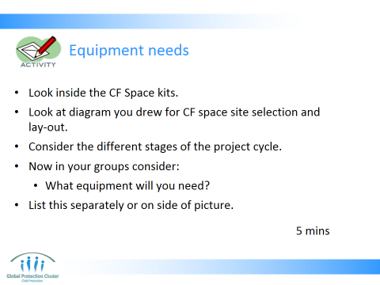

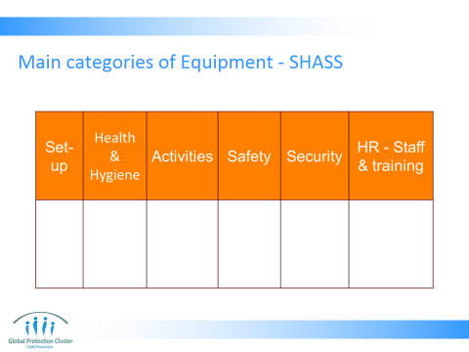

- There are many ways to categorise the different types of equipment you buy. Here main categories we have identified for the acronym SHASS which can help us remember
- See kit lists of individual agencies for details of what they should order:
- SHASS: Set-up of space, Health and Hygiene, Activities, Safety, Security, Staff & training

- Show slide 20 and talk the group some of the example items you have listed
- Staff should see and consider kit lists of individual agencies for details of what they should order. Examples of kits and standards that need to be met can be found in the following Handbooks and guidelines:
- SC Child Friendly Spaces Handbook,
- World Vision children in Emergencies Manual
- UNICEF Practical Guide to Developing Child Friendly Spaces
- CCF Starting up child centred spaces in emergencies: A field Manual
- Hand out a few copies of the Sample Kit lists. Not enough for one copy per person, but ask the group to circulate them so they can see the number of items, and the variation in listings

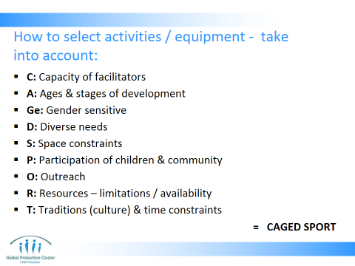

ST: Take into consideration space & time constraints
T: Traditional and culturally relevant
A: Age appropriate
Ge: Gender, activities that appeal to boys & girls
D: Consider diverse needs
C: Capacity of facilitators
P: Participation
Many of the factors affecting equipment selection also come into play here, so think of a reduced CLASHING MG, here it is CP STAGeD

- Run through slide which shows some of the key areas of consideration
- Run through slide to under-score and remind people that there will be on-going supply needs throughout the life of the project. Some replenishing should be automatic, some will need to be punctual orders for specific events. Resource planning needs to accompany your programme implementation plans
- The concerns if you do not do resource planning are the following:
- Logistics & procurement teams will be busy doing other work
- Resources & equipment will arrive to site late delaying programme activities
- You will have unplanned and unforeseen costs and delays
- Budgets will not be accurate and you may not have necessary funding
Key Summary Point
- All the various resource and equipment needs, identified when deciding lay-out and content of the CF Space, need to be documented in a procurement plan, which should be developed in collaboration with other programme teams and the logistics / operations team
- It is IMPORTANT TO NOTE that factors on slide 22: CAGeD SPORT. Many of these factors influence site selection and layout and design of the site too
- Give all participants a copy of the hand-out “Logistics considerations for CFS”

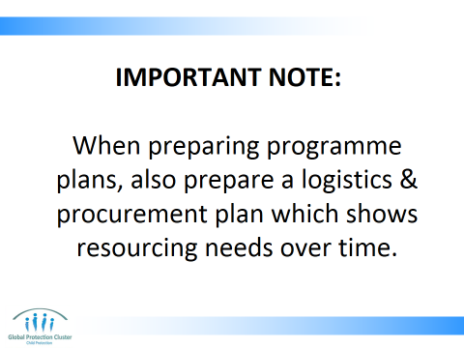
IMPORTANT NOTE:
When preparing programme implementation plans, also prepare a logistics & procurement plan which shows resourcing needs over time. This should cover supplies and equipment that are recurrent and one off, as well as staff to support that (support time needed from logistics team, drivers, guards etc), transport and storage. This enables you to clearly know your costs and budget flows too.
If you don’t:
- Logistics and procurement teams will be busy doing other work when you need them
- Resources and equipment will arrive to site late (if at all) delaying all your programme activities
- You will have unplanned and unforeseen costs and delays
- Budgets will not be accurate and you may not have necessary funding

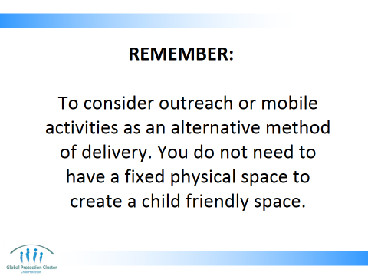

- CLOSE
- Outline the elements of the CP Minimum Standards relating to Resources and Logistics

Wrap –up with the key messages:
- Discuss site selection with children and communities, ensuring potential risks and advantages of different locations are taken into account. Consider using sites that already exist
- As far as possible prepare equipment and procurement processes for CF Space programming prior to any emergency. Procurement plans need to be developed along with implementation plans – these should indicate phasing of purchases and logistics
- Collaborate from the outset with teams including logistics, operations, security, finance and HR who will support you to ensure your programme is correctly resourced

Finish off with Resources to indicate which are key documents they should refer to on these subjects showing participants samples of each of the materials.

Resources:
- Have at least 1 copy of each of the different resources listed in the reference list on the facilitator’s table to show to participants



This slide is for the end of each session… prompts for questions, check in and even a 5 minute break, ice breaker as needed.

Print copies for all participants for Activity 6

Sample kit lists

Save the Children
What is in a Child Friendly Spaces kit?
Provision of Child Friendly Spaces in emergencies often forms a key strategic organizational response. The 12 kits are designed to provide a fast, effective response where local market conditions and resource constraints make purchase and assembly of equipment unrealistic in the short time frame of first phase response.
- Six 27m² and xo 41m² multipurpose tents
- 12 toy/education kits
- 12 safe play equipment/furniture
- 12 rolls of shade netting to protect tented or outdoor spaces from sunlight
- 12 water filters to provide safe drinking water
- 12 rolls of barrier fencing to provide rapid boundary demarcation

Children’s play kit
Items and quantities
Jumbo size trunk – strong, but lightweight aluminum construction, with easy-carry metal handles, metal corners for added strength and high-impact plastic edging

1 padlock aluminum container | 2 packs of 12 standard pencils
1 padlock for above | 5 pencil sharpeners
4 footballs | 10 packs of 10 triangular crayons
1 compact and lightweight double action pump | 5 glue sticks
4 volleyballs | 4 skipping ropes
6 badminton rackets sets (2 rackets per set) | 5 beach balls
2 tubes of 12 plastic indoor shuttlecocks | 1 pack of 5 toy cars
1 net set | 4 play tea sets
10 tennis balls | 2 packs of 40 plastic wild animals
4 cricket bats | 2 dolls – culturally mixed, female
2 boxes of marbles | 2 dolls – culturally mixed, male
40 story books | 4 baby dolls – mixed
5 slate chalkboards | 10 cuddly toys
4 ludo | 4 wooden brick sets
2 abacus | 10 packs of 12 coloring pencils
100 chalk sticks | 10 white paper pads
5 pencil erasers | 5 sticky tape
5 small metal scissors

Pakistan Child Friendly Spaces Kit
Child Friendly Spaces Materials/Equipment Kits:
Example from Pakistan

Item | No.
Battery-powered lamps | 2
Large rug to fit the tent. If rugs are not appropriate or available, consider other options of floor cover such as carpet or woven mats. Depending on the weather, other options to consider: wooden pallets, plastic sheeting, canvas, raised flood-safe flooring, wood sheets, and rubber – waterproof carpets. | 1
Small cushions (2 x 2 or 1 x 1) for reading/drawing time | 50
Large cushions (4 x 4) | 6
Banner/Logo – Child Friendly Spaces in local language and English | 1
First aid kit | 1
Cleaning kit | 1
Fire extinguisher | 1
Blankets | 6
Waterproofing – depending on weather (trenches should be dug around the tent to help with this) | 1
Save the Children-UK tabard for supervisors | 2
Laminated information for children on a poster (local language) | 4
Laminated information for the community on a poster (local language) | 4
Children’s tables and chairs | 4 sets
Children’s Play Kits (see Annex 16) | 1 – 2 per center
Small water tanks with filters and glasses/cups | 1
Basic latrine equipment
Poles and tarp for demarcation (10m x 10m)

INSERT UNICEF / WORLD VISIONS OR CCF KIT LIST WHEN GET WORD COPY

Print copies for all participants for end of session

Logistics considerations for CFS
Emergency preparedness
Resources / Supplies
- Agree a kit list adapted to context so items are culturally relevant and appropriate. Ensure this takes into account needs of children with range of different vulnerabilities and at different ages and stages of development
- Items and quantities planned based on various scenarios
- Be clear on what can be bought in-country (locally, regionally, nationally) and what needs to be sourced internationally
- What will you do if you are offered Gifts in Kind (GIK)? Will you be able to manage distribution and storage of items? What items would you accept, what would be unsuitable?
- Turn around time for order from supplier to delivery to the point of use should be identified
- Have a list of possible suppliers for the items you will need
- Standard suggested kit lists are available from agencies such as Child Fund, Plan International, Save the Children, UNICEF and World Vision

Emergency stock/ stand-by supply:
- Have stand-by supply of a certain number of kits, based on scenarios you have planned for
- Stock items should not have expiry date or become technically obsolete
- Tents are a universal programme supply, that is they can be used for child friendly spaces or emergency schools, health centres or emergency warehouse/accommodation, ensure enough are allocated for all sectors
- With regards to emergency stocks: be aware of the costs for storage, holding items in-country may be more costly than order internationally in case of an emergency. Need to consider this before you buy and store supplies.
- Consider procurement time when you are choosing between different options (international procurement, local emergency stock, etc)

Virtual stock:
- Agree with a supplier that you will make a purchase in case of an emergency. Ensure they know what items you will purchase, how many and the cost you will pay. This should be documented.
- This allows you to follow procurement policy (such as open tenders, getting quotes, from certain number of different suppliers, etc), prior to an emergency, thus speeding up the process of acquisition once an emergency hits

Transport
- Plan for and have an idea of the transport needs for staff and materials to support the programme you would implement.
- For supplies consider the transport needs from supplier to agency and then out to field sites where programmes will be implemented
- If transport by road is likely to be disrupted by emergency scenario (e.g. floods, cyclone) what would implications be for your programme and what would your contingency plans be?

Security
- Plans must consider need for security equipment, such as radios and satellite telephones
- Must also factor in risks to sites of work and how you will make these secure as well as how you will store your CF Space materials to keep them safe

Staff related to logistics
- Plan for staffing needs to deliver and set-up the CF Spaces
First Phase, Set-up
Resource / Supplies
- Work with engineer to assess pre-existing buildings and assess works to be done and thus resource needs
- Submit procurement plans to logistics team as soon as possible
- Plan for storage and transport of your supplies from supplier to end user point

Transport
- Transport plans for equipment and staff need to be put in place with logistics teams

Security
- Potential security issues for children, communities, materials and staff. Contingency plans with security risk mitigation actions (e.g. night security guards, materials to be locked up

Staff related to logistics
- Budget for a percentage of logisticians time as they will need to support sourcing of supplies for your CFS
- If setting up your own storage facilities or tents, budget for guards to ensure safety of equipment
- Plan who will physically transport the goods to the final point where materials will be used. Who will set-up the space? Who will manage the stock?

Programme implementation
Resource / Supplies
- On-going procurement of perishable or consumable items (such as cleaning products, water filters, paper, pens and pencils)

Transport
- On-going transport of staff (visiting sites for supervision or capacity building purposes) or shipping of supplies

Security
- On-going security needs of the equipment on site, storage facilities and staff needs to be maintained. Radio equipment, someone staffing radio facilities, guards on site, all need to be considered and budgeted for if needed
- Lighting of the site may be need at night to ensure the area is safe and secure

Staff related to logistics
- Your programme may need drivers and guards, you should budget for these dedicated staff and also for contributions to salaries for logisticians, operations managers, and security staff who are supporting the work of all programme sectors

Exit
Supplies:
- Transfer of assets should be done in a clear and accountable way, where appropriate this should involve the whole community targeted or affected by the programme.

