

MODULE 2 – SESSION 3 – LESSON PLAN –
STARTING UP A CFS – COMMUNITY MOBILISATION

TIME | OUTLINE – 1 HOUR 30 MIN
* RESOURCES REMINDER *
Flipcharts with headings:
- “Strategies to address challenges”
Hand-out:
- Printed copies of the scenario you chose to use with the group in activity 5, enough for one copy per participant
- Copies of Hand-outs “Table of Characteristics of community-based approaches” and “How to mobilise communities: initial visits” one for each participant
Other:
- Write character descriptions for Activity 3 on cards, with character “name” on one side and details of character’s situation on the other side
- Facilitator to establish if they will be able to have enough balloons blown up for all participants to be able to run Option 1 for activity 4, alternatively, is there enough space to run Option 2. Note, the preference is Option 1 wherever possible.
- Blown up balloons for activity 4 – enough for one per participant
- Facilitator to select and edit the case study examples on Slides 24 – 29. Choose those that are most relevant to the context, or may bring valuable learning to the group
Key References:
- Mike Wessells, Mike (2009) What Are We Learning About Protecting Children in the Community? An inter-agency review of the evidence on community-based child protection mechanisms in humanitarian and development settings
- IASC Guidelines to mental health and PSS – Section on Community mobilization & support, Action sheets 5.1, 5.2, 5.3 and 5.4
- CPWG (2012) Minimum standards for child protection in humanitarian action
- Grabman, Lisa and Snetro, Gail (2003) How to mobilize communities for health and social change, available at: http://www.jhuccp.org/hcp/countries/usa/trusa1464.pdf
INTRODUCTION
3 min | - Introduce the session
BODY
5 min | Introduction
5 min | Defining key terms
30 min | Why we mobilise communities
20 min | How we mobilise communities: Approach
10 min | How we mobilise communities: Key Actions
20 min | How we mobilise communities: Case study examples
15 min | Challenges
5 min | Close session
CONCLUSION
3 min | O | Outcome revisited
3 min | F | Positive thought and reinforcement
3 min | F | Next session

MODULE 2 – SESSION 3 – NOTES FOR TRAINER – STARTING UP A CFS – COMMUNITY MOBILISATION

Introduce the Module and the sessions it contains.

LEARNING OUTCOMES
By the end of the session participants will …
- Understand what we mean by “community” and “community mobilisation”
- Identify factors that promote or that limit the effectiveness of community-based approaches
- Understand the challenges of working with communities

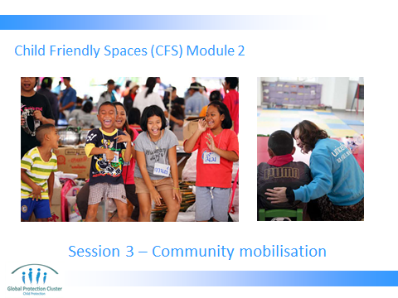

- INTRODUCTION &EXPECTATIONS
- Slide 1: Have the slide on the screen as participants arrive and settle down.

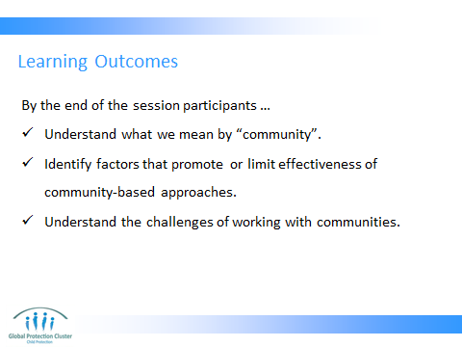

- Present the planned objectives as on Slide 2

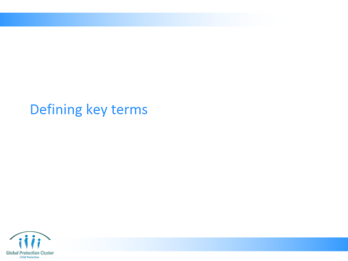

- DEFINING KEY TERMS
- Run through and present Slides 3 – 7, allowing time for questions and discussions
- Present Slide 9 that shows the Minimum Standard for CP in Humanitarian Action relating to working with communities
Key message:
- Communities are not homogenous groups
Get people to think back to session on day 1 about impact of emergencies on children and communities, under-score that communities can change a lot during and after an emergency

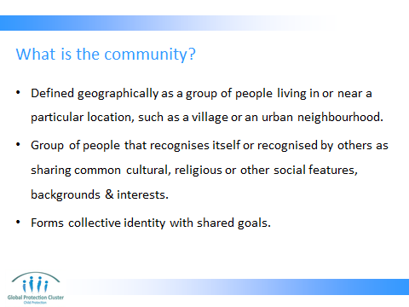

- Defined geographically as a group of people living in or near a particular location, such as a village or an urban neighbourhood
- Community refers to group of people that recognises itself or is recognised by outsiders as sharing common cultural, religious or other social features, backgrounds and interests, and that forms a collective identity with shared goals

Reference:
- CPWG (2012) Minimum Standards for Child Protection in Humanitarian Action & CPiE Face to Face training

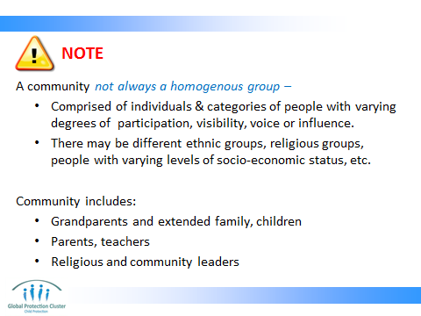

A community not always a homogenous group –
  - Comprised of individuals & categories of people with varying degrees of participation, visibility, voice or influence
  - There may be different ethnic groups, religious groups, people with varying levels of socio-economic status, etc.
Community includes:
  - Grandparents and extended family, Children
  - Parents, Teachers
  - Religious and community leaders
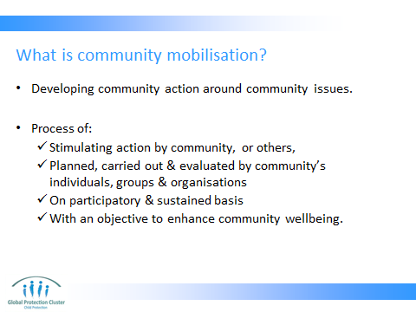

- Developing community action around community issues
- Process through which action is stimulated by a community itself, or by others, that is planned, carried out, and evaluated by a community’s individuals, groups, and organizations on a participatory and sustained basis with objective to enhance the overall wellbeing of the community

Note: Communities can provide significant ways of preventing and responding to child protection risks. Even in situations of mass displacement where no ‘community’ is easy to see, groups of people can organise themselves to support children at risk.

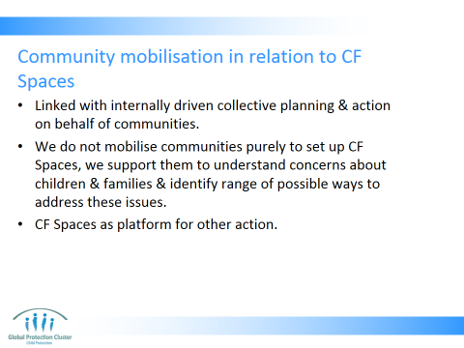

- Community mobilisation is linked with collective planning and action – internally driven process of communities seeing a problem and organising themselves to take action to prevent, respond, mitigate, etc.
- We don't want just to mobilise for participation in and support of CFSs. Instead we want a wider process in which people support and participate in CFSs and take steps to become aware of, discuss, and address other risks facing children and families. CFS are one option among many. Communities can also decide to have committees or focal points for identification of children and provision of support, they can become part of referral pathways, they may support awareness raising activities, they may wish to support initiatives to ensure child wellbeing in schools, or improve health services for children, etc., etc.
- CFSs can serve as a platform for wider, on-going community mobilisation which can be a valuable platform for other child-focused programming. For example, the establishment of CF Spaces, may in the long term lead to children’s centres, or committees continuing after the emergency phase is over

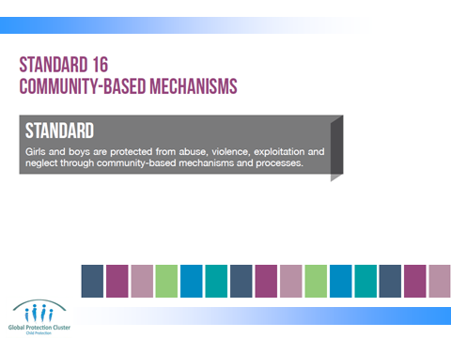

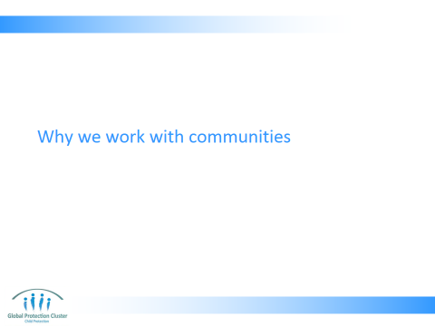

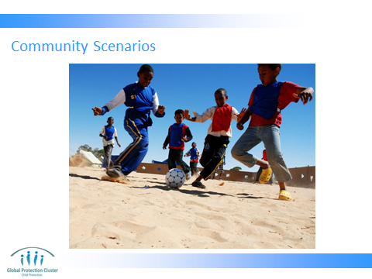

- WHY WE MOBILISE COMMUNITIES
Scenarios activity: Slide 10 (15 mins)
- Ask for 8 volunteers, ask them to come to the front of the room and break them into two groups of four
- Give each volunteer a “character card” (see end of this session plan)
- Ask them to hold cards with character name facing the room and character situation details facing themselves
- Ask each person from group 1 to read out their character details
- After they have all read out their character details run through the following questions:

- Ask the child what they will do to try to prevent the protection issue? Ask their friend?
- Ask all the volunteers?
- Ask all participants who will help and how?
- What they think an international NGO would do in this context?

- Now ask each person from group 2 to read out their character details
- After they have all read out their character details run through the following questions:

- Ask the child what they will do to try to respond to the protection issue? Ask their friend?
- Ask all the volunteers?
- Ask all participants who will help and how?
- What they think an international NGO would do in this context?

- Ask what is the difference in the two scenarios?
- Do external actors trying to address child protection concerns act differently in the two situations? Should they?
- What is the difference between prevention and response action? What is difference between situation where someone is trained to act and where there is no one who is officially responsible for child protection? Can non-child focussed people help? Who has power to help? Do people react to prevent incidents?

- Resources: Give the character descriptions to each of the volunteers

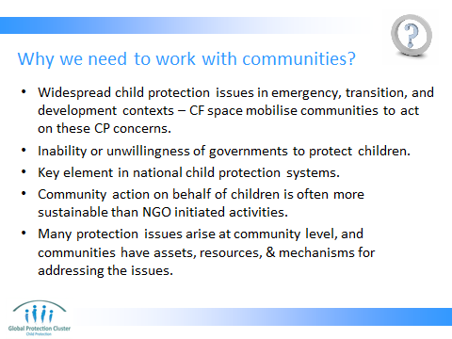

Debrief presentation: (Key points to underscore if they do not come up in the plenary discussion are) (15 mins)
- Present slides 11 – 12 key points to underscore are:
- This activity should highlight how even untrained individuals who are not designated responsible to help children will often be motivated to do so. We cannot assume that because a structure is not officially mandated to address child rights or protection concerns that they will not do so. It is often the non-formal resources such as natural helpers (religious leaders, grandmothers, youth leaders) who can offer some of the best help even if they have not been trained. These are the people we would like to learn from and then capacitate further, eventually having them help staff the CFS or spread messages in the community about its value and how ordinary parents and others can participate
- Engaging pre-existing groups or individuals in management process makes them more durable (e.g. of the trained CP Focal Point)
- Having support from grass-roots means that CP issues are heard about early and can be prevented fast (working with neighbours and community members)
- Identifying structures that already hold meetings and have power (such as the Fisheries Group) means that they can act, and momentum for meeting will be maintained. Maybe they need a place to meet, or a place to safely store their fishing equipment. You can explain how supporting the set-up of CFS could be way to meet their needs and yours.
- A useful step in mobilisation occurs when communities give something (space, small resources) to the development of the CFS. It starts to become 'theirs,' and the sense of ownership is crucial for effectiveness
- Community based work improves sustainability, resource effectiveness, prevention of CP concerns and an ability to respond early
- The structures or people you work with do not have to have the aim of addressing CP issues before you start to work with them. You should be able to demonstrate that CP concerns are important to them as they are important to the whole community.

- Widespread child protection issues in emergency, transition, and development contexts – we cannot tackle all these issues alone, we cannot reach the scale required to support all children - CFS can be an entry point for wider engagement of the community in child protection issues
- Inability or unwillingness of governments to protect children – lack of resources and or will on behalf of the government – the key duty bearer – means we seek other ways to help children
- Key element in national child protection systems – well functioning child protection systems include community supports and awareness – this is thus a way to build that into the system
- Community action on behalf of children is often more sustainable than NGO initiated activities. We want concern and action to continue even after the CFSs have transitioned.

Note: CFS Guidelines state first objective of CFS is to: “Mobilise communities around the protection and wellbeing of all children”
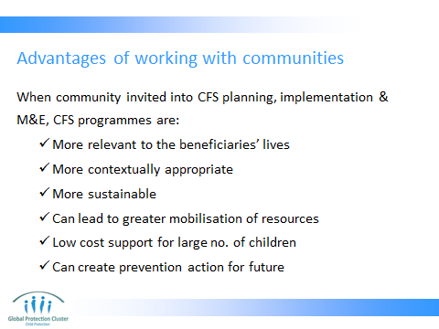
When communities are invited into CFS planning, implementation, monitoring, and evaluation, the programs are:
- Relevant to the beneficiaries’ lives – based on their values, reflecting their needs
- More sustainable as beneficiaries are empowered, invested, and engaged in the program processes – possibility of handover
- Can create prevention action for future emergencies
- Can lead to greater mobilisation of resources
- Engaging community resources, values & support
- Developing contextually appropriate, sustainable supports
- Low cost means of supporting large numbers of children

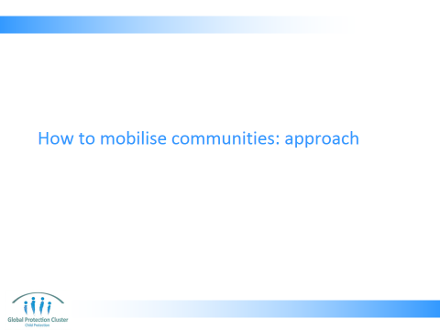

- HOW WE MOBILISE COMMUNITIES: APPROACH
There are two alternative activities depending on the venue and materials available.

OPTION 1: 'Balloon game' Slide 13 (15 mins)
Objective: To have participants understand the importance of collaboration. It also helps to energise the group.

Methodology:
- You need as many inflated balloons as you have participants.
- Advise the group that each balloon represents a vulnerable child. Participants have to keep balloon in the air e.g., by tapping it upward using their hands, or using their feet. When the balloon is kept in the air it means the child is protected. Eventually, some balloons touch the ground, meaning those children are harmed
- Initially hand each participant one balloon and tell them they must focus on keeping their own balloon in the air. You may advise the group initially that they can only use their feet, or only use their torsos and head. (This could represent agencies operating without the assistance of communities.) Give them 2-3 mins
- Then advise them they can use their hands too. (This demonstrates increased efficiency when families and communities are involved.) Give them a further 2-3 mins
- Finally advise them they can all help each other to keep the balloons off the ground however they like. Give them a final 2-3 mins
- Altrenatives include: The facilitator can introduce certain challenges, for example by having some small balloons or balloons that have small stones inside, this makes them harder to keep in the air. These represent children that require extra attention, especially vulnerable children.
- Observe if participants help each other out by also catching balloons of others that are close to hitting the ground

Debrief questions:
- What was hard about that activity?
- When did most balloons hit the ground?
- Did anyone help anyone else in the first 2 rounds of the activity?
- What made things easier?

Key points to underscore:
- Collaboration and cooperation makes things easier and more effective. If we see the hands and other participants as community and family members as well as other agencies we can see the task of keeping the balloons up (or the vulnerable children protected) is easier.
- We must use all the resources we have available. If we only use our feet the task is harder.
- If someone was observed helping someone else out in the first 2 rounds of the activity, state that it is individual’s natural instinct to help someone out when they need support, we must build on this rather than undermine it.

OPTION 2: The Longest Line Activity Slide 13 (15 mins)
- Objective of this activity is to develop a sense of need to share and cooperate between participants, and need to build on the resources you have available in a creative fashion.
- You will need a large space, you may need to take the group outside. Ensure that the different groups can work along-side each other.
- Methodology
- Divide the participants into 3 - 4 groups of equal size.
- Tell each group that they will have 5 minutes to make the longest line they can, with what they have right now.
- Do not directly tell them they can take off clothes (such as belts and jewelry), but if they ask you if it is allowed, tell them that they can.
- The group with the longest line will win.
- After completing the line declare which group made the longest line.
- When the game ends, bring everyone back together in plenary to process and discuss the activity.
- Some ideas for questions to guide the group discussion are:
- What happened during this activity?
- How did each group make their lines?
- Which group worked most effectively? How and why?

Key points to underscore:
- The winning group owned the objective, all the members of the group wanted to achieved the objective
- They used all the resources they had available to them.
- They did not need additional resources to make what seemed an impossibly long line before they started, they relied on what they had

Resources:
- Blown up balloons for activity 4 – enough for one per participant
- Enough copies of the hand-out “Table of Characteristics of community-based approaches,” for one for each participant

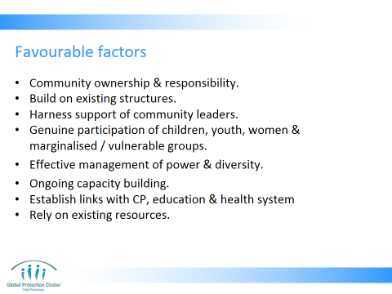

Most effective community based work is founded on the following favourable factors
- Community ownership, responsibility and engagement at all levels of all groups. Ensuring wide range of different members representing various elements of community are participating in the processes, this means women, men, children, government, communities, etc
- Incorporating and building on existing resources & structures – building on pre-existing ways of organising and mechanisms for protection
- Harnessing support of community leaders
- Genuine participation of children, youth, women and marginalised / vulnerable groups
- Effective and ongoing management of issues of power, diversity, inclusivity
- Ongoing training & capacity building
- Establishing linkages – engagement with formal and non-formal, as well as traditional systems
- Rely on existing resources – Do not raise expectations of external resources or funding

Bearing in mind need to limit the following:
- Early introduction of large sums of money
- Agency oriented engagement with community
- Didactic, top-down approaches
- Failure to build on local ideas and resources

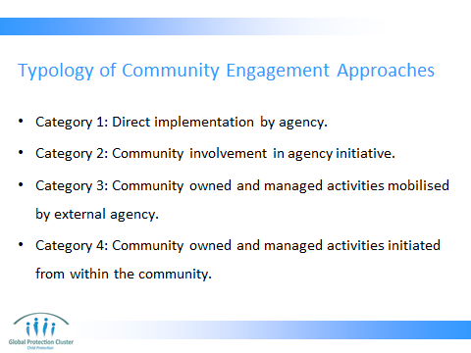

Research has shown that there are 4 ways in which communities are engaged in post-emergency settings:
- Category 1: Direct implementation by agency: The agency is a service provider; community members are beneficiaries.
- Category 2: Community involvement in agency initiative: The agency is a promoter of its own initiative, a planner and a trainer, and community members are volunteers and beneficiaries.
- Category 3: Community owned and managed activities mobilized by external agency: The agency is a catalyst, capacity builder, a facilitator of linkages, and a funder after community ownership has developed. The community members are analysts, planners, implementers, assessors, and also beneficiaries.
- Category 4: Community owned and managed activities initiated from within the community: The agency is a capacity builder and funder, and community members are analysts, planners, implementers, assessors, and also beneficiaries.

Ask participants to turn to the relevant page of the participants’ toolkit, showing the Table of Characteristics of Community Based Approaches. As you go through the following slides have a discussion about what form of Community Based Approach each example uses, and pros and cons in each case

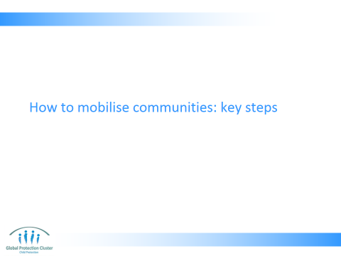

- HOW WE MOBILISE COMMUNITIES: KEY ACTIONS
Presentation: (10 mins)
- Present slides 16 –

Key points to note:
- Mapping and power analysis are important
- Allowing groups to determine their main objectives themselves, how they wish to structure their group and what their actions will be to achieve objective are important
- You can create parallel groups for more marginalised groups like women, children and the disabled, but ensure that they are also organised the way they wish to be, and that their views are influencing community strategy as a whole

Hand-out the “How to mobilise communities: initial visits,” one to each participant

Resources:
- Printed copies of the scenario you choose to use with the group
- Copies of Hand-out “How to mobilise communities: initial visits” one for each participant

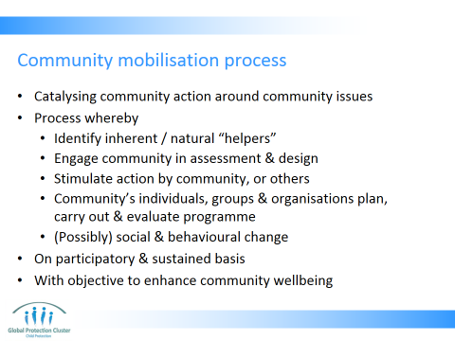

- Catalysing community action around community issues
  - Process whereby:
    - Identify natural “helpers” – individuals who volunteer and support community on a regular basis – they can then be included in planning and implementation (as CFS workers, for example).
    - Engaging communities in designing the activity and analysing what needs to be done, through which action is
    - Stimulated by a community itself, or by others,
    - That is planned, carried out, and evaluated by a community’s individuals, groups, and organizations on a
    - (Possibly) catalyse social and behavioural change – it may require social change and thus some forms of social and behaviour change communications
    - Participatory and sustained basis
    - With objective to enhance the overall wellbeing of the community
    - It is extremely important that in all phases the (representatives of the) community can and will take the lead and external agencies take a facilitative role in the process.

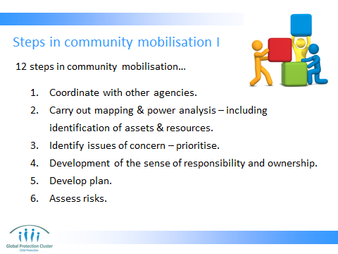

Not a definitive list, some of these actions may be broken down into several steps, or merged into one. Several actions may take place at same time.
- Coordinate with other agencies and other sectors. Use CP working group or sub cluster & Inter-Cluster meetings – make sure you’re working together, not duplicating efforts
- Mapping & power analysis: Map pre-existing structures & systems, leaders & focal points for actions that support children or other parts of community: PTAs, children’s clubs, youth groups, women’s groups, village elders, etc. This should include identification of assets & resources such as natural helpers would be an important step as well. What actions are they doing? How are they organising themselves? Can this be built on to support children’s needs? Power analysis: Identify groups/segments of society with ability to influence or those excluded from decision making. Excluded may be: women, youth, adolescents, girls, disabled children, marginalised ethnic, religious or social groups. They can have parallel systems for organising. Over medium/ long term can seek to directly incl. in existing community structures. Forcing immediate participation can be negative
- Identify issues of concern and prioritise them. During needs assessment ask communities what primary concerns for children are. During initial meetings work with existing groups to identify priorities (objective). Recognition by community members that they have a common concern and will be more effective if they work together (i.e. ‘We need to support each other to deal with this’). Based on this identify priority issues (‘What we’re really concerned about is…’).
- Develop a sense of responsibility and ownership that comes with recognition by community members that they have a common concern and will be more effective if they work together
- Plan what they want to do to address concerns & how they propose to do this. Implement response based on this, don’t impose your vision on them. For excluded groups identify ways they’re organised or would like to be & support these efforts. Don’t raise expectations of financial/ material support
- Assess risks – against each step of your plan try to identify any risks or assumptions and means of mitigation. In some contexts creating committees or groups may put community members at risk, ensure you consider this before putting systems in place

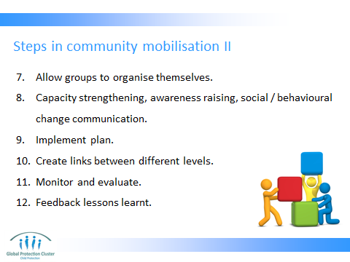

- Allow groups to organise themselves & set up management structure way they wish to. Present alternatives that may challenge power dynamics, but let them recognise these concerns & find solutions. E.g. imposing a rule that 2 children must attend meetings may frustrate children (forced to attend in silence) & won’t change concern
- Carry out capacity strengthening or awareness raising activities where necessary – work with these groups to identify their training needs. Support this.
- Develop a plan: implement plan as developed together.
- Create links between the different groups at diff. levels. Try to tie structures identified & supported into wider support systems established at regional or national level
- M&E: Monitor progress against plans continuously. Check for levels of participation of marginalised groups. Engage communities (and children) in the M&E process
- Feedback lessons learnt – ensure that any lessons learnt are shared with all stakeholders and fed into the next round of activity planning and implementation

These 12 steps are based on and adapted from:
- Donahue and Williamson (1999), Community Mobilization to Mitigate the Impacts of HIV/AIDS, Displaced Children and Orphans Fund cited in IASC Guidelines to Mental Health and Psychosocial Support,
- Wessells, Mike (2009) What Are We Learning About Protecting Children in the Community? An inter-agency review of the evidence on community-based child protection mechanisms in humanitarian and development settings
- IASC Guidelines to mental health and PSS – Section on Community mobilization & support, Action sheets 5.1

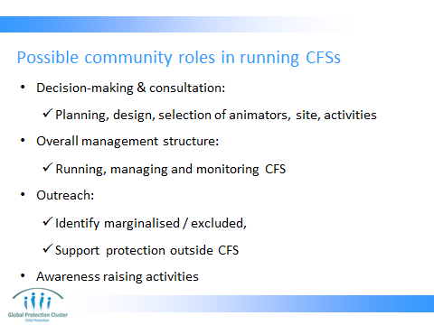

If mobilised correctly, communities can be involved in the following key roles in the day-to-day management and running of CFSs
- Decision-making and Consultation: Setting objectives, planning, designing the programme, Selection of animators, site & activities
- Overall management structure: Running, managing and monitoring CFS
- Outreach:
  - Identification and inclusion of marginalised / excluded groups
  - Support protection activities outside of the CFS – e.g. identification and referral of vulnerable children or those surviving specific child protection abuses
  - E.g. Natural helpers who staff the CFS could reach out to parents who do not send their children to the CFS. Or they could help organise discussions for parents on how to address particular child protection issues and concerns
- Awareness raising activities – for parents etc e.g. can help organize discussions for parents on how to address particular issues
- Supporting social change activities – engaging individual community members in stimulating discussion and behavioural change among others
- Peace-building and conflict sensitivity
- Potential roles for community members:
  - Facilitators, Supervisors, Management committee, Trainers

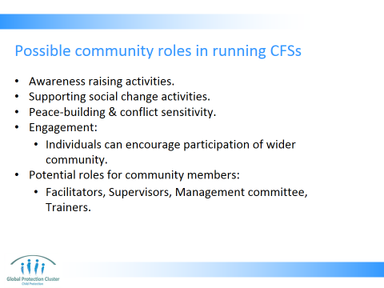

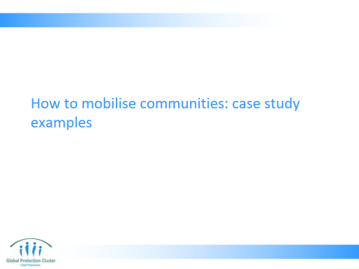

- HOW TO MOBILISE COMMUNITIES: CASE STUDY EXAMPLES
Presentation: (10 mins)
- Present slides 22 – 26
Discussion: (10 mins)
- Ask the group if they have any community mobilisation experiences they wish to share? Slide 27
- Or alternatively, Slide 28, “What existing community structures can be built upon in this context and how?”

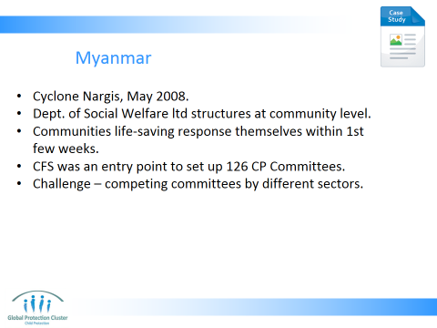

- Myanmar –
  - Cyclone Nargis May 2008 - few child protection services and the Department of Social Welfare had few resources and was not staffed at township and community level in many areas.
  - Township level, mandated Committees on the Rights of a Child to protect inactive in most areas.
  - In first few days, when access by international agencies was very limited, communities themselves leading life-saving activities.
  - Despite severe weakening of the existing community mechanisms after the cyclone they were nevertheless a significant asset upon which to build child protection mechanisms.
  - The establishment of child-friendly spaces (CFSs) was one of the entry points for CP work in new geographical areas of operation. The mobilisation of communities for CFS led to the establishment of 126 CP Committees by SC, UNICEF and WVI. These were ‘Child protection committees’, ‘community watch groups’ or ‘child protection support groups’ sometimes part of multi-sectoral committees. Some existing community groups excluded most vulnerable. Some agencies thus felt need to set up new systems. This contributes to wider efforts of Child protection system building. Note this is not the only way they were supporting CP at community level, and in other settings establishing CFS may not be the best route to establishing, committees. Often community mobilisation or committees may indeed come before the CFS are established. Other ways in which wider Child Protection mechanisms could be promoted with CFS as entry point include for example more attention in education to promoting safer, supportive schools, raising awareness of parents of children’s protection rights, etc
  - One challenge noted, was that there were too many different sector specific committees. Thus competing for volunteer time and community attention, and taking attention away from any possible focus on CP. People may be more engaged in voluntary work that supports more visible / tangible sectors such as FSL and WASH

Reference: Save the Children (2010) Strengthening National Child Protection Systems in Emergencies Through Community-based Mechanisms: A Discussion Paper

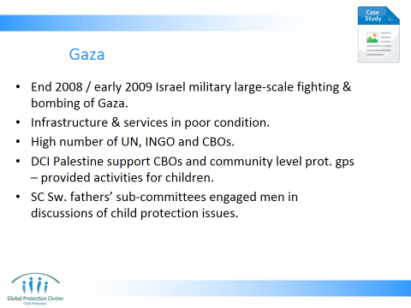

- Gaza –
  - End 2008 / early 2009 - Israeli-led military operation Cast Lead brought a large-scale round of fighting and bombing to Gaza.
  - Much of the infrastructure and key services that were already in poor condition through years of fighting and unrest were further damaged or destroyed by military action.
  - INGOs and UN agencies restricted ability to operate due to donor “no-contact” policies with the de-facto government in Gaza making system building difficult.
  - Gaza and the West Bank had a strong civil society, with numerous UN agencies, INGOs, NGOs, CBOs and voluntary organisations present and responding to both emergency and development issues prior to Operation Cast Lead. Many of these, particularly at community level were inactive, without resources, time or capacity, or they faced political constraints on their activities.
  - Most referral pathways and services for child protection cases were damaged.
  - Defence for Children International Palestine (DCI) support 60 CBOs and 15 community-level protection groups, including supporting Palestinian Network for Children’s Rights (PNCR).
  - After emergency groups provided activities for children to help them express themselves and conducted advocacy and campaigns on the protection of children’s rights - within the first few weeks of the emergency response, existing PNCR and protection groups were able to support 5,186 children with debriefing and psychosocial workshops.
  - CP committees set up by SC Sweden had sub-committees (children’s, fathers’, emergency and community workers’). Most useful was fathers’ sub-committee as historically men were not engaged in discussions of child protection concerns

Reference: Save the Children (2010) Strengthening National Child Protection Systems in Emergencies Through Community-based Mechanisms: A Discussion Paper

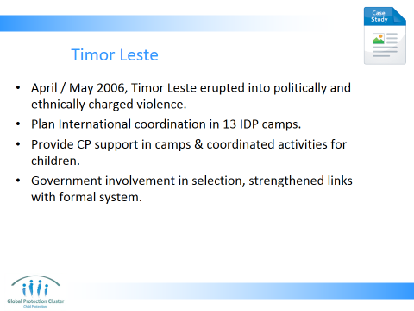

- Timor Leste -
  - April and May of 2006, Timor Leste erupted into politically and ethnically charged violence
  - PLAN International’s emergency response activities included taking responsibility for coordination in 13 camps for internally displaced persons (IDPs). After initial few months, became clear people would remain in IDP camps for some time. The structure initially focused on the work of community-level child protection focal points (CPFPs).
  - Discussions with the Division of Social Services (DSS), camp managers and the IDP community and its leaders led to the nomination of volunteers (trusted adults such as teachers and youth workers) who were trained for the role of CPFP in each block of every camp, focusing on activities and protection in their block. Each camp commonly had around eight blocks, and each block focal point made up part of the CPFP team, with one person from each team being nominated as a representative across all the camps.
  - All the camps were supported by three child protection support teams (CPSTs), comprising staff from the Ministry of Labour and Community Reinsertion (MLCR), the DSS, international and national NGOs. The CPST would regularly visit the camps and CPFPs to provide technical support and training, undertake monitoring of camp activities and engage with the camp management.
  - The role of the CPFP is to help families look after their children’s wellbeing and safety in the camp environment, by providing information, coordinating activities for children and caregivers, and helping to promote children’s participation. Coordinated volunteers, animators, health workers – responses to CP issues. Weak initial referral until capacity strengthening on pathways in 2008
  - Government authorities, helped in selection of volunteers and participated in the child protection support teams and coordination meetings, helped bridge the gap between camp-based and district and national systems

Reference: Save the Children (2010) Strengthening National Child Protection Systems in Emergencies Through Community-based Mechanisms: A Discussion Paper

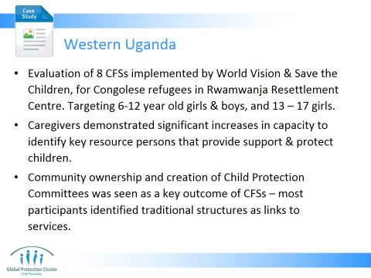

- Western Uganda -
  - Evaluation of CFS programmes for Congolese refugees in Rwamwanja Resettlement Center. Ongoing and escalating conflict in and around North Kivu, in Democratic Republic of Congo (DRC), refugees crossing the border into neighboring countries, including Uganda. By February 2013, the Office of the Prime Minister (OPM) estimated around 35,000 refugees within the resettlement center. CFSs were implemented across the resettlement area in coordinated operations by World Vision Uganda and Save the Children from late 2012. All CFSs consisted of a tented activity area, latrines, a store and a variety of playground equipment. CFS activities included literacy and numeracy, local dialect and English language acquisition, traditional song and dance, art, storytelling, organized sports, and unstructured free play. They also offered group discussion times where children were able to share experiences with the group or give peer-to-peer support. CFSs were mainly targeted to younger children, older children – mostly girls - participated in vocational activities of sewing and dress design. Each CFS typically provided a four-hour session for children aged 6 to 12 in the morning and a two-hour session for children 13 to 17 in the afternoon. The number of children enrolled varied from 65 children to 651 children registered at any one CFS.
  - Eight CFSs implemented by World Vision Uganda and Save the Children in Uganda response teams were evaluated
  - Caregivers of children aged 6 to 12 demonstrated significant increases from baseline to follow-up in their capacity to identify key resource persons in the community that provide support and protect children. There were similar increases for both caregivers of children attending and not attending CFSs (from 0.47 to 1.12 and from 0.66 to 1.25, respectively).
  - Community ownership and creation of Child Protection Committees was seen as a key outcome of CFSs in Rwamwanja Resettlement Center. As protection concerns for children and the stresses of caregivers decreased over time, there was little mention of formal structures as a resource or support and referral mechanism. Instead, most participants identified traditional structures of support, such as nyumba kumi and village leaders, or formal coordination structures as key links to services and referral networks. This suggests the value of CFS programmes supporting existing structures of protection and strengthening local ability to provide referrals and services for survivors of physical and sexual violence.

Reference:
Columbia University, World Vision, Save the Children, UNICEF (July 2013) Evaluation of Child Friendly Spaces: Uganda Field Study Summary Report

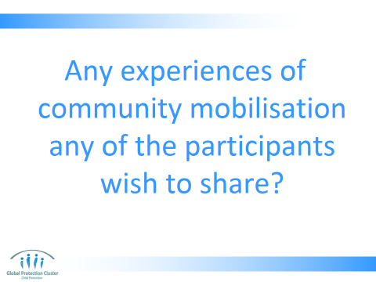

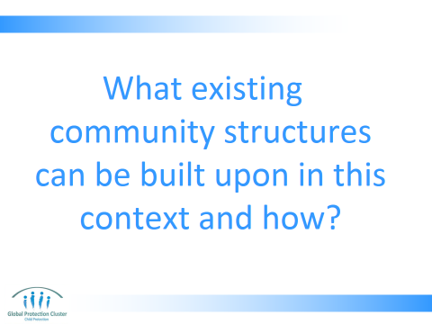

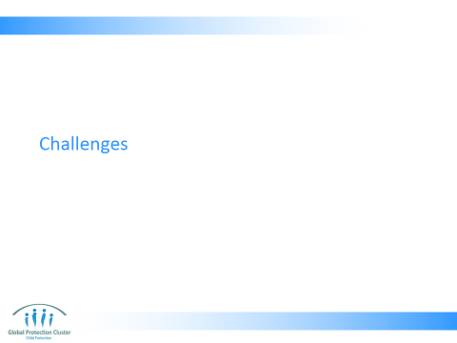

- CHALLENGES
- Present slides 29 – 31 (5 mins)
- Engage in discussion with group:
- Have they seen some of these challenges in their working context
- How have they overcome these challenges?
- Note some key strategies for addressing challenges on flipchart
- Present slide 32
Key message:
- Each scenario different, you have to learn by doing and ensure your approach fits with the context
- Remember that approach may even different from one community (village / town) to the next within the same country

Resources:
- Flipchart with heading “Strategies to address challenges”

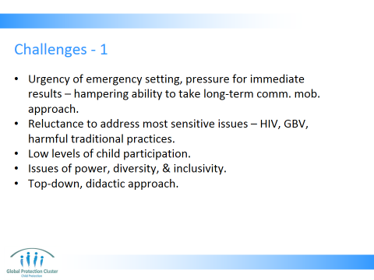

There are challenges and drawbacks to community engagement:
- Urgency of emergency setting, pressure for immediate results – hampering ability to take long-term community mobilisation approach – Need for rapid outcomes, lead to rushing rather than taking the slower process required to appropriately engage communities. The initial community engagement process is the key. The process of mobilisation is ongoing and can and should be deepened over time (as outlined on the next slide).
- Community groups may be reluctant to address the most difficult or sensitive issues
- Levels of child participation were low to moderate, yet child perspectives and creativity contributed to effectiveness
- Too little is done typically to manage issues of power, diversity, and inclusivity. This is especially the case with children who may be vulnerable to marginalization – e.x. Children with disabilities.
- Child rights are often introduced to communities using a top-down, didactic approach that is ineffective and elicits backlash – it is important to discuss the rights of children in the community within the framework of the local culture and existing positive mechanisms and culture around the protection and rights of children.

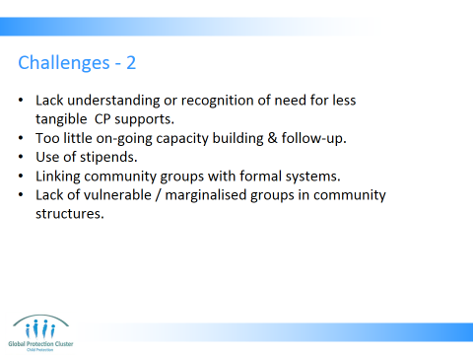

- Lack understanding or recognition of need for less tangible CP supports – PSS does not have tangible outputs, in the way that say food distribution or shelter programmes do, so at first community may be reluctant to engage
- Ongoing capacity building is an issue — too little follow-up and mentoring after initial training(s).
- Stipends: The evidence regarding the use of stipends is mixed and highly contextual – For volunteers you may want to give stipends, these must be harmonised across sectors and with other agencies – they should not exceed teachers’ salaries. For meeting attendance, per diems are best avoided, try to find other ways to compensate for the time spent supporting CFS set-up and management. Cash-for-Work projects can all be set up in collaboration with Food Security Livelihoods teams that compensate for work in setting up a CFS. Discuss with national staff and other sectors what is standards practice in this context, will not disrupt the labour market, but is considered appropriate & fair
- Effective linkage of community-based groups with formal systems of child protection / education boosts the effectiveness and scale of response yet may reduce the sense of community ownership. E.g. Establishing links with formal education authorities and helping them with eventual transition of CFSs as schools re-open, can be difficult to achieve when schools are closed and Ministry of Education representatives are not present. Linking with formal CP system can be difficult when community level presence of social workers or formal social welfare structures is limited
- Lack of representation of vulnerable / marginalised groups in community structures – disabled, women, children, ethnic, religious or linguistic minorities, child-mothers, etc

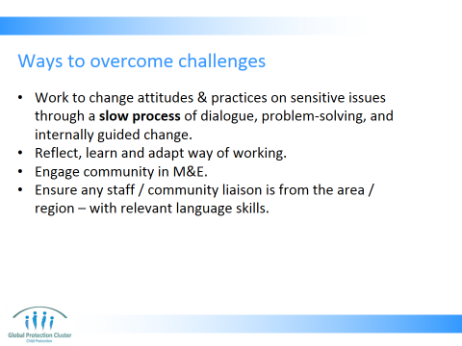

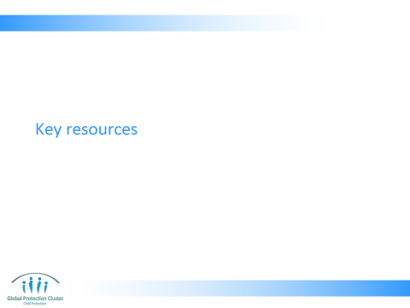

- CLOSE
- Use the Resource Slide 33 to indicate which are key documents they should refer to on these subjects showing participants samples of each of the materials.
- Finish off with Slide 34 running through the session’s key messages – check if there are any final questions

- Resources: Have at least 1 copy of each of the different resources listed in the reference list on the facilitator’s table to show to participants

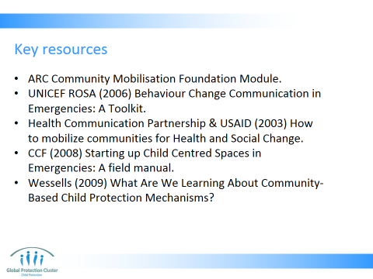

- ARC Community Mobilisation Foundation Module
- UNICEF ROSA (2006) Behaviour Change Communication in Emergencies: A Toolkit
- Health Communication Partnership & USAID (2003) How to mobilize communities for Health and Social Change - http://www.jhuccp.org/node/1256
- CCF (2008) Starting up Child Centred Spaces in Emergencies: A field manual
- Wessells (2009) What Are We Learning About Community-Based Child Protection Mechanisms?
- Save the Children (2010) Strengthening National Child Protection Systems in Emergencies Through Community-based Mechanisms: A Discussion Paper

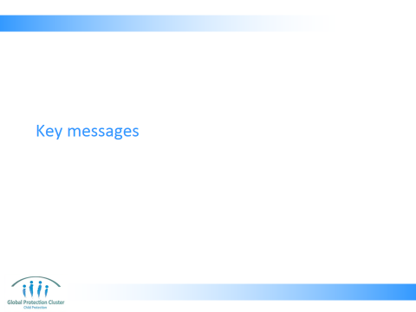

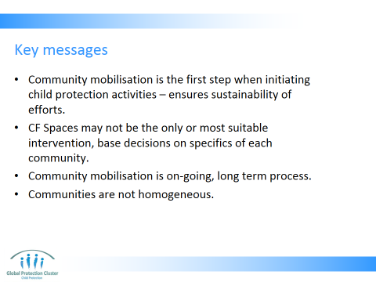

- Community mobilisation is the first step when initiating any child protection activities. This includes mapping of community level individuals and structures that support children and other community level activities, jointly identifying needs, risks, resilience, etc. If no pre-existing child-focussed structures are present, we can work with community structures and groups that are not initially child-focussed; this will be more sustainable than setting up parallel structures
- Child Friendly Spaces may not be the only or most suitable response to the needs identified by the community, they are one in a wide range of options available to address child wellbeing issues in emergency settings
- Community mobilisation is an on-going process, that takes times, and requires relationship building. Top-down approaches are not sustainable, and are resource heavy. Taking your time in process of setting up the CFS through a community based approach will reduce challenges further down the line
- Communities are not homogenous groups, you need to address power imbalance and inclusion issues when you work with them



This slide is for the end of each session… prompts for questions, check in and even a 5 minute break, ice breaker as needed.

Wrap –up with the key messages:
- Community mobilisation is the first step when initiating any child protection activities. This includes mapping of community level individuals and structures that support children and other community level activities, jointly identifying needs, risks, resilience, etc. If no pre-existing child-focussed structures are present, we can work with community structures and groups that are not initially child-focussed; this will be more sustainable than setting up parallel structures
- Child Friendly Spaces may not be the only or most suitable response to the needs identified by the community, they are one in a wide range of options available to address child wellbeing issues in emergency settings
- Community mobilisation is an on-going process that takes times, and requires relationship building. Top-down approaches are not sustainable, and are resource heavy. Taking your time in process of setting up the CFS through a community based approach will reduce challenges further down the line
- Communities are not homogenous groups, you need to address power imbalance and inclusion issues when you work with them

