

MODULE 2 – SESSION 2.1 – LESSON PLAN –
CHILD FRIENDLY SPACES PROGRAMME PLANNING

TIME | OUTLINE – 30 MINS
* RESOURCES REMINDER *
Flipchart paper with heading:
- Information needed
For the river crossing activity, Activity 4:
- 20 inches x 20 inches - 50cm x 50cm squares of cardboard, paper or newspaper – you will need about two-thirds as many squares as there are people in the group
- Something to demarcate two sides of a river… can be 2 pieces of rope, masking tape, tables, chairs
INTRODUCTION
3 min | - Introduce the session
BODY
5 min | - Introduction
35 min | - Planning activity
5 min | - Planning process
20 min | - Information you need to develop your programme plan
5 min | - Elements of your plan
5 min | - Close session
CONCLUSION
3 min | O | Outcome revisited
3 min | F | Positive thought and reinforcement
3 min | F | Next session

MODULE 2 – SESSION 2 – NOTES FOR TRAINER – CHILD FRIENDLY SPACES PROGRAMME PLANNING

Introduce the Module and the sessions it contains.

LEARNING OUTCOMES
By the end of the session participants will be able to name …
- The five steps in the planning process
- The five main elements of their CFS programme plan and
- The five categories of activities that will help them meet their CF Space programme objectives

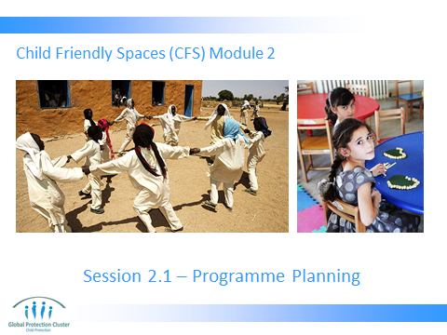

- INTRODUCTION
- Slide 1: Have the slide on the screen as participants arrive and settle down.

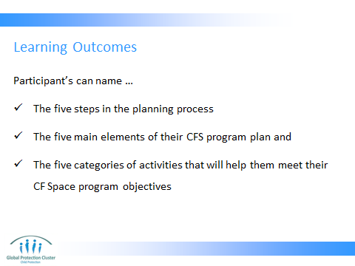

- Present the planned learning outcomes as on Slide 2

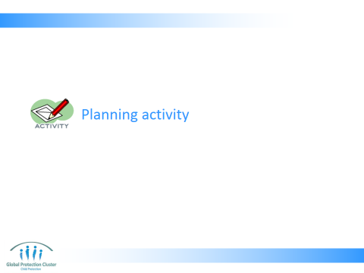

- PLANNING ACTIVITY
River crossing activity Slide 4
Objective:
This will generate discussion about how you plan an activity, need to discuss among many to generate ideas and need to review plans on a regular basis so you can identify ways to overcome unforeseen challenges.
Resources:
For the river crossing activity:
- 20 inches x 20 inches - 50cm x 50cm squares of cardboard, paper or newspaper – you will need about two-thirds as many squares as there are people in the group
- Something to demarcate two sides of a river… can be 2 pieces of rope, masking tape, tables, chairs

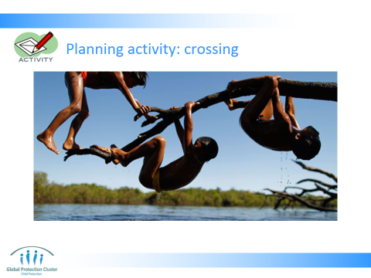

Set Up: Slide 4
- Create a river by marking two riverbanks with rope, masking tape, chairs, etc. Make the river wide enough to be a challenge for the groups to get from one side to the other (look at about 10 ft. – 4m).
- Divide the participants into 3 groups
- Spread the groups evenly along the length of the “river”
- Distribute the cardboard or paper squares. Each group must have the same ratio of squares of paper to no. of people in the group. Suggest 2/3 as many squares as there are people

Activity instructions:
Objective:
- The objective of the activity is to get all members of their group safely across the river together as fast as possible
- First group to get across the river wins
Rules:
- They must go as one big group, not multiple smaller ones.
- Everyone must be on the river before anyone can get off the river
- Participants cannot touch the water (floor/grass) and therefore must use rafts (cardboard squares) to cross.
- The water is filled with piranhas. If a person completely comes off the raft they are eaten and since this is a team exercise everyone must start over: "start as a team end as a team.”
- No scooting or sliding on the squares
- Rafts must be in contact with a human at all times or they will be swept away with the current
- Once the group has started the process, the facilitator’s role is to take cardboard squares that are “swept away by the current” and to watch for safety issues
- If one group crosses quickly and there is enough time, consider allowing the groups the time to attempt the challenge again. Suggest they can use a different strategy this time, they can discuss the process they used first time, and how it could be improved. Then try the activity again. See if a different group wins.

- TOTAL TIME FOR THIS ACTIVITY SHOULD NOT EXCEED 15 MINS

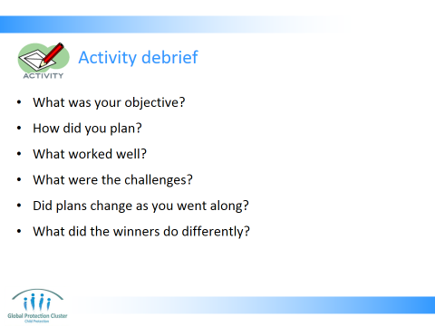

Activity debrief:
- Ask the group the questions on Slide 5 (10 mins)

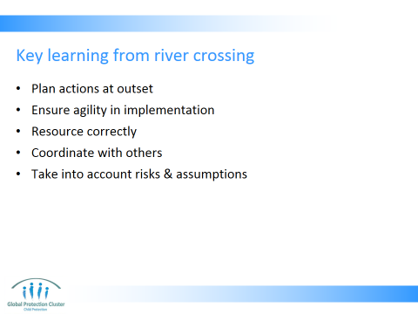

- Highlight some key learning from the river crossing activity as outlined on Slide 6…
- Planning before you start helps you to achieve goals and objectives. Taking the time to think through steps needed will save you time later down the line
- Be agile: You may want to revisit your plans, and change the way you are working if you find you are not progressing as you would like to. When you face challenges it is good to step back and revisit your plans.
- Resource correctly: Resources being staff, materials, space, etc. Assess the resources you have (no. of people, number of squares, distance to cross), and the resources you need. How will you fill the gaps between the two. [We will discuss resourcing in detail later in the workshop]
- Coordinate: Learn from others and what they are doing. You could have looked at other teams strategies and improved your technique. Include other teams, agencies and sectors in your planning stage so you can be more efficient with resources and learn from different approaches.
- Take into account any risks and assumptions and develop a contingency plan on how you will respond if these threats arise.

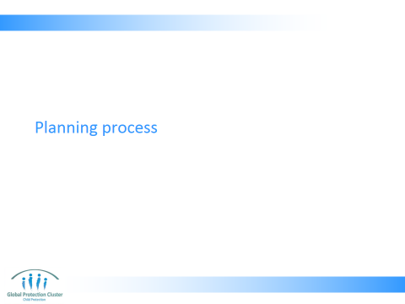

- PLANNING PROCESS
- Present slides 8 – 10
- Allow time for questions. Encourage participants to also share experiences about their involvement in planning processes in the past.

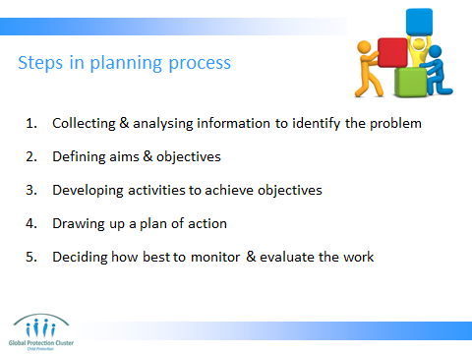

- Collecting & analysing information to help you identify the problem you need to address
- Defining aims and objectives
- Developing activities that will achieve those objectives
- Drawing up a plan of action (who, will do what, where, when and how) -
- Selecting appropriate indicators for measuring progress, and deciding how best to monitor and evaluate the work – come back to this in later session

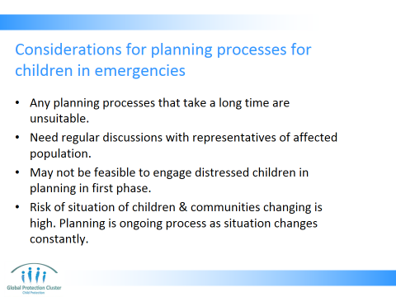

- Any approaches that take a long time are unsuitable, eg, there may be no time to organise workshops for in-depth participation, or to conduct large surveys early on.
- Regular discussions with representatives of the affected population are essential in order to keep up-to-date and the community up to date with changes in the situation and the programme.
- It may not be feasible to engage distressed children in the first phase
- Risk of situation of children & communities changing is high and the implications on possible strategies should be considered. Planning is an ongoing process when the situation is changing daily.

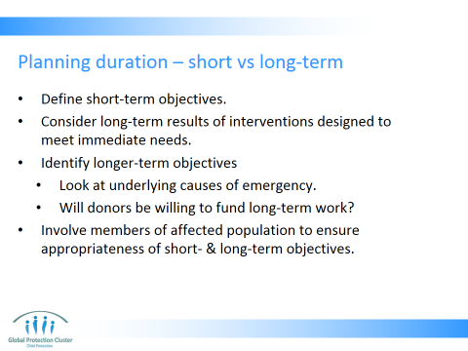

- Define short-term objectives: what do you intend to achieve?
- Consider long-term results of interventions designed to meet immediate needs.
- Identify longer-term objectives for involvement in an area.
- Look at underlying causes of emergency, try to prevent situation becoming so bad again.
- Will donors be willing to fund more long-term work in the area?
- Members of the affected population should be actively involved in planning to ensure that both short- and long-term objectives are appropriate.

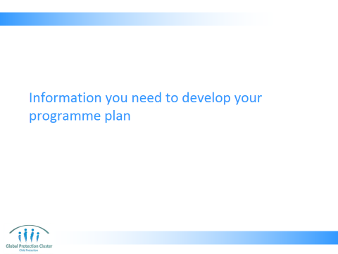

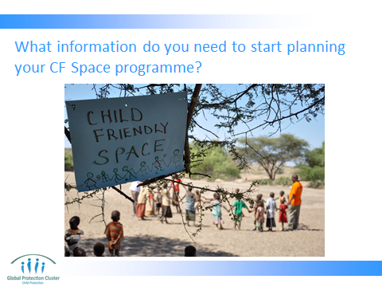

- INFORMATION YOU NEED TO DEVELOP YOUR PROGRAMME PLAN
Activity: What information do you need to start planning your CF Space programme? Slide 12
Objective: This should start participants thinking about the range of information they need to gather so they may start planning their programme

Activity instructions:
- Ask participants to stay in the 3 groups they were in for the river crossing activity
- They must brainstorm as quickly as possible all the information they will need to be able to start planning – writing down responses on flipchart paper as they go along
- Give them 3 minutes
- Get all the groups to call out the items they have listed as you write them on flipchart paper

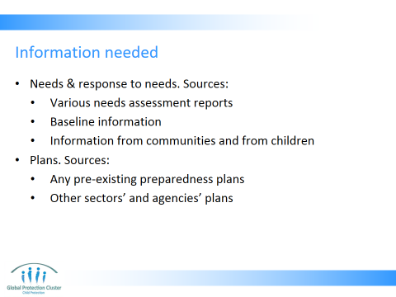

Activity debrief:
- Use Slides 13 & 14 to debrief on the forms of information you will need for planning purposes

Needs and response to needs – reflected in your needs assessment report. Sources of this information:
- Needs assessment reports – CP, PSS, Education and health needs assessments as well as any multi-sector needs assessment reports. These should contain information you require about what the needs are and the scale of needs
- Baseline information – any baseline data on the population in the affected area
- Information from affected communities, about their needs and resources
- Information on children’s needs, resilience & coping strategies
- Plans. Sources of this information:
- Any pre-existing preparedness plans – there may be emergency preparedness plans developed against similar scenarios to the one that is currently being experienced. Using these will prevent you from having to “start from scratch,”
- Other sectors’ and agencies’ plans – so you can see how you can create integrated programming and maximise resource efficiency

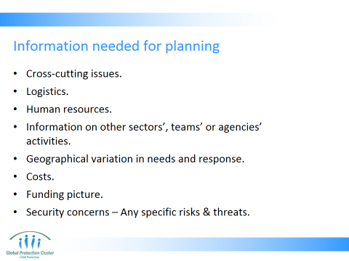

- Cross-cutting issues need to be included in the actions? Gender, HIV/AIDS, children with disabilities, ECD, adolescence, etc
- Logistics:
  - Vehicles – how long for, where, when, rent or buy? To move staff, equipment or resources?
  - Storage - how long for and where?
  - Materials – availability, costs, time it will take to procure them
  - Distribution of materials – how frequently? From where to where?
- Human resources - Availability & skills
- Information on other sectors’, teams’ or agencies’ activities – so you can ensure you maximise impact
- Geographical variations in needs and response – ensure there are no gaps or duplication
- Costs – What are costs of supplies needed? What are costs of staffing? Etc? How can you keep costs down and ensure value for money?
- Funding picture - What funding do you have available? Or are you likely to get?
- Security concerns – Any specific risks & threats

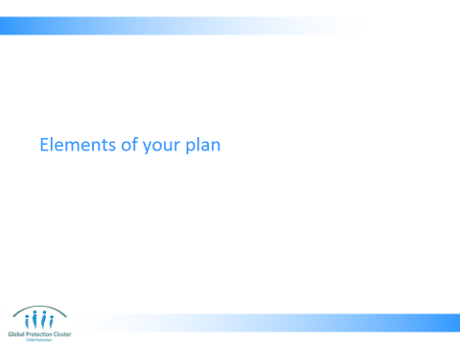

- ELEMENTS OF YOUR PLAN
Present slides 16 & 17 explaining the main elements of a CF Space programme plan. This covers the five core elements of the programme plan, and under the activities sections, this includes 5 categories of activity you should consider implementing

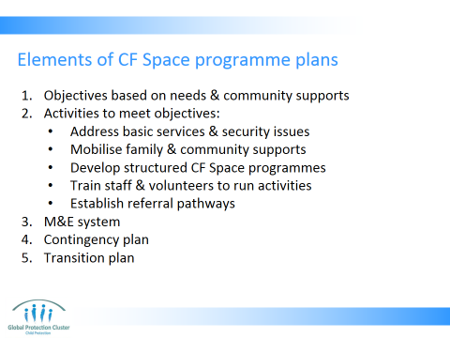

- Set objectives based on assessment and to meet the needs of the affected population as identified by themselves. Also taking into account & community responses and actions
- Plan activities to meet the programme objectives:
  - Address basic services and security issues that impact on psychosocial well-being
  - Mobilize family and community support
  - Develop structured child protection, psychosocial, health and / or education programmes (if needed/possible). Note not in all cases are CF Spaces essential
  - Train staff to run CF Space activities – be
  - Establish referral pathways to other services, such as to child protection & education teams, appropriate mental health services as well as other departments, teams or organisations such as those addressing food, health & shelter needs, so as to ensure that the response is meeting the needs of children holistically
- Monitor and evaluate – set up an M&E system at the beginning and use on a regular basis – clarify roles and responsibilities with regards to monitoring and evaluation
- Contingency plan – think through and plan for any possible risks, or threats to the programme. What will you do if these arise? Ensure you have documented any assumptions, if assumptions are not met programme plans will have to change. You may like to have some Indicators in your M&E plan to create an early warning flag that risks are arising.
- Project transition – think about exit strategy from the outset – be clear with community, other NGOs, government on purpose of the activities, how long they will last for and what role you will play in their delivery

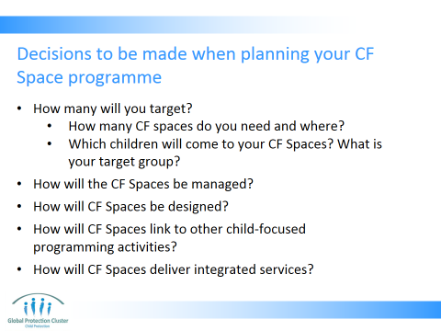

- How many will you target?
- How many CF spaces do you need? Where do you need to have CF Spaces? How many children can come to each space? How many hours will you operate each day?
- Which children will come to your CF Spaces? What is your target groups? How will you identify and reach out to widest range of children? How will you reach most vulnerable? Which children will you focus CF Space activities on
- How will the CF Spaces be managed?
- Who are the key partners for implementing CF Spaces?
- What are government agencies doing?
- What local NGOs, and Community Based Organisations exist with experience of working with children? What community level individuals are present who may be able to work in or run CF Spaces?
- What are community groups doing? How would they like to be involved in the CF Spaces?
- How will CF Spaces be designed
- In a building? School? Health centre? In a tent?
- As mobile outreach services?
- How will CF Spaces link to other child-focused programming activities?
- How will they link and refer to education, GBV, protection and PSS programmes?
- How will CF Spaces deliver integrated support?
- How will you link with other sectors such as WASH, Food Security, Camp Management, Health to ensure you meet all children’s needs?

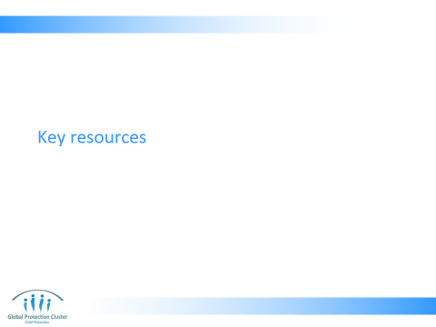

- CLOSE
- Use the Resource Slide 19 to indicate which are key documents they should refer to on these subjects showing participants samples of each of the materials.

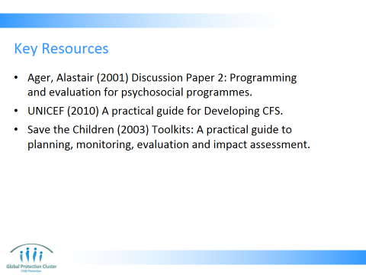

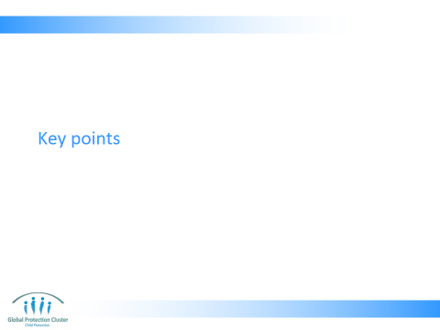

- Finish off with Slide 21 & 22 key learning points – check if there are any final questions

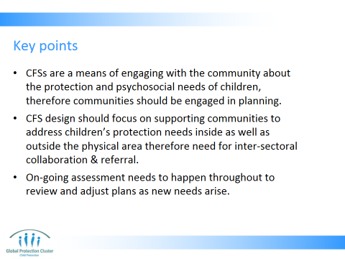

- CFSs are more than just a physical space; they are a means of engaging with the community about the protection and psychosocial needs of children. Therefore communities should be engaged in planning
- The CFS design should focus on supporting communities to address children’s protection needs inside as well as outside the physical area. Therefore need for inter-sectoral collaboration & referral systems
- On-going assessment needs to happen throughout to review and adjust plans as new needs arise



This slide is for the end of each session… prompts for questions, check in and even a 5 minute break, ice breaker as needed.

Wrap –up with the key messages:
- CFSs are more than just a physical space; they are a means of engaging with the community about the protection and psychosocial needs of children. Therefore communities should be engaged in planning
- The CFS design should focus on supporting communities to address childrens’ protection needs inside as well as outside the physical area. Therefore need for inter-sectoral collaboration & referral systems
- On-going assessment needs to happen throughout to review and adjust plans as new needs arise

Indicate the sample planning tools - the logical framework and GANNT chart – to be found in their participant’s packs. These are examples of how you document the plans you develop.

Refer to the tools below which can be found in the participant’s toolkit, during the closing session

Logical Framework (logframe) Template

 | SMART Outcomes / Expected results | Outcome, output or process Indicators | Means of verification | Milestones /  Key Performance Indicators | Baseline | Assumptions / risks
Project Goal: | To xxxxx
Objective 1:
Outcome 1.1:
Outcome 1.2:

Outcome 1.3:

Activities: |  |  | Inputs /resources: | Materials: | Staff: | Costs:
Objective 2:
Outcome 2.1:
Outcome 2.2:
Outcome 2.3:
Activities: |  |  | Inputs /resources: | Materials: | Staff: | Costs:
Objective 3:
Assumptions / Risks:

 | Assumptions / Risks |  | Means of mitigation
Logical Framework (logframe) – Definition of Terms
OBJECTIVES  (What we want to achieve) |  | INDICATORS  (How to measure change) |  | MEANS OF VERIFICATION  (Where / how to get information) | ASSUMPTIONS / RISKS  (What else to be aware of)
Goal  The long-term results that an intervention seeks to achieve, which may be contributed to by factors outside the intervention. |  | Impact Indicators  Quantitative and/or qualitative criteria that provide a simple and reliable means to measure achievement or reflect changes connected to the goal. |  | How the information on the indicator will be collected (can include who will collect it and how often). | External conditions necessary if the Goal is to contribute to the next level of intervention.
Outcomes  The primary result(s) that an intervention seeks to achieve, most commonly in terms of the knowledge, attitudes or practices of the target group. |  | Outcome Indicators  As above, achievement as connected to the stated outcome. |  | As above | External conditions not under the direct control of the programme, though necessary if the outcome is to contribute to reaching intervention goal.
Outputs  The tangible products, goods and services and other immediate results that lead to the achievement of outcomes. |  | Output Indicators  As above, connected to the stated outputs. |  | As above | External factors not under the direct control of the programme that could restrict the outputs leading to the outcome.
Activities  The collection of tasks to be carried out in order to achieve the outputs. |  | Process Indicators  As above, connected to the stated activities. |  | As above | External factors not under the direct control of the programme that could restrict progress of activities.

Programme Planning Tool – Gantt chart

COMPONENTS OF  PROGRAMME | LOCATION |  |  |  | MONTH 1 |  |  |  | MONTH 2 |  |  |  | MONTH 3 |  |  |  | RESOURCES REQUIRED (Item & no.) | COST (USD) | TARGET GROUP - NUMBER OF CHILDREN | MONITORING  INDICATORS | STAFF FOCAL POINT | IMPLEMENTING PARTNER
COMPONENTS OF  PROGRAMME | DISTRICT |  |  |  | WEEK |  |  |  | WEEK |  |  |  | WEEK
COMPONENTS OF  PROGRAMME | S | E | N | W | 1 | 2 | 3 | 4 | 1 | 2 | 3 | 4 | 1 | 2 | 3 | 4
0. Example
i. Buy tents |  |  |  |  |  |  |  |  |  |  |  |  |  |  |  |  | 5 tents | 1000 | - | 5 tents set-up by week 4 | xyz | -
ii. Set-up tents |  |  |  |  |  |  |  |  |  |  |  |  |  |  |  |  | 1 vehicle | 200 | - | 5 tents set-up by week 4 | xyz
1.Coordination
i.
ii.
iii.
2. Initial set-up of spaces
i.
ii.
iii.
3. Staffing
i.
ii.
iii.
4. Activities in CFS
i.
ii.
iii.
5. M&E
i.
ii.
iii.
6. Phase out
i.
ii.
iii.

Print copies for all participants for activity 4

List of activities
Coordination:
- Mapping NGOs working on child protection, education, and mental health and psychosocial support
- Collaboration with relevant government line Ministries – especially Education, Health and Social Services
- Memorandums of understanding between relevant parties
- National level coordination meetings
- District level coordination meetings
Staffing:
- Develop staffing structure
- Identification of volunteers
- Identification of local NGOs or civil society groups who will implement programme
- Staff and volunteer training
- Repeat / in-depth subject specific volunteer training
- Supervisory support to staff and volunteers
Initial set-up of CFS:
- Identification of sites – meetings with community members and leaders
- Security assessment of short-listed sites
- Securing and clearing of the site – mobilisation of community for support to rehabilitate site
- Establish composition of recreational, artistic and sport kits
- Ordering tents
- Distribution of tents
- Installation of tents
- Installation of water points and latrines
- Identification of vulnerable children
- Set-up storage space for kits
Running activities in the CFS:
- Identify locally relevant and appropriate activities
- Develop schedule of activities for different abilities and age groups
- Collaborate with other sector staff for integrated activities (e.g. public health messages, nutrition assessments, etc)
- Set-up system for identification and referral of most vulnerable children for other services
- Replenish stocks of materials used
- Engage community in other activities in the space – e.g. parenting classes, committee meetings, etc
- Ensure child protection outreach activities are taking place, such as cash transfers for vulnerable, messaging on prevention of worst forms of child labour, support to foster carers, etc
Monitoring and evaluation:
- Develop monitoring and evaluation tools
- Train on use of monitoring and evaluation tools
- Supervisory site visits
- Collation of M&E results
- Analysis of M&E data
- Repeat assessment of needs
- Mid-term evaluation
- Final evaluation
- Weekly meetings
- Phase out
- Communicate with community and government about phase out plans
- Hand-over materials to community / local NGO / government
Phase out:
- Inform community of phase out plan
- Assess others’ capacity to take on responsibility to run CFS
- Identify an agreed model for phase out
- Coordinate with other CFS implementing agencies on time-line for phase out
- Hand-over or withdraw materials used in CFS
- Let staff and volunteers go
- Carry out final evaluation

Taken and adapted from logical framework guidance produced by the International Federation of Red Cross and Crescent Societies (IFRC)
When there is more than one outcome in a project the outputs should be listed under each outcome
Activities may often be included in a separate document, e.g. activity schedule / Gantt chart, for practical purposes. The example here is called a “Programming Planning Tool”

