

MODULE 1 – SESSION 1 – LESSON PLAN – CFS BACKGROUND AND HISTORY

TIME | OUTLINE – 45 MIN
* RESOURCES REMINDER *
 | - Prize for introduction activity
INTRODUCTION
3 min | - Introduce the session
BODY
5 min | CF Spaces defined
20 min | History of your life
5 min | History of CF Spaces
10 min | Your experiences with CF Spaces
15 min | Findings regarding use of CF Spaces to date
5 min | Close session including key messages and key resources
CONCLUSION
3 min | O | We now have the basis of where the CFS’s have come from.
3 min | F | This is a great foundation for us to build this training.
3 min | F | Next session

MODULE 1 – SESSION 1 – NOTES FOR TRAINER – CFS BACKGROUND AND HISTORY

Introduce the Module and the sessions it contains.

LEARNING OUTCOMES
By the end of the session participants will:
- Demonstrate understanding of the history of Child Friendly Spaces / Places (CFS)
- Recognise some of their own as well as other participants’ experiences with Child Friendly Spaces / Places (CFS)

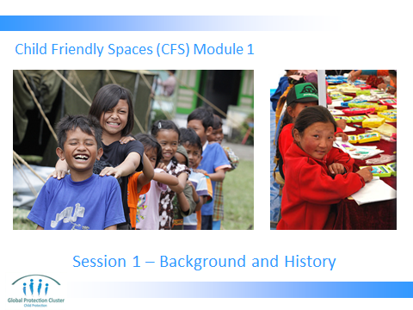

Go through the learning outcomes for this session.

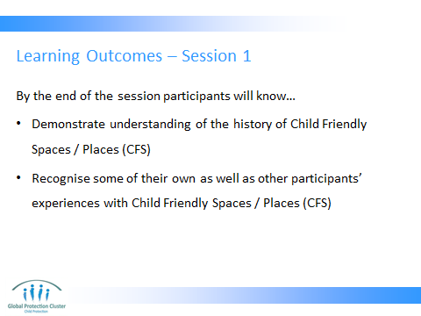

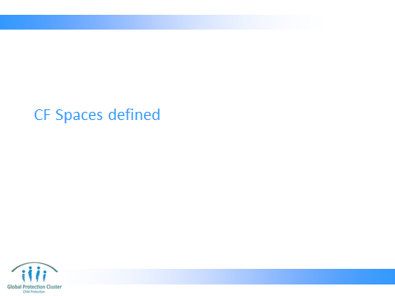

Introduce the subject of the workshop – clarifying the definition of CF Spaces. This is based on information contained in the CP Minimum Standards (CPMS).

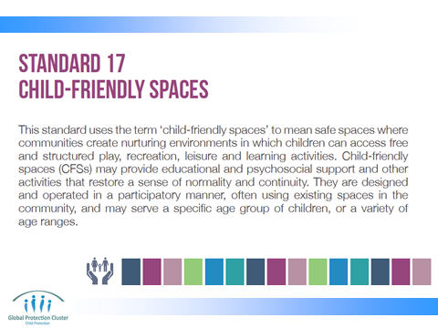

Ask participants to think about their experience and what they understand a CFS to be?

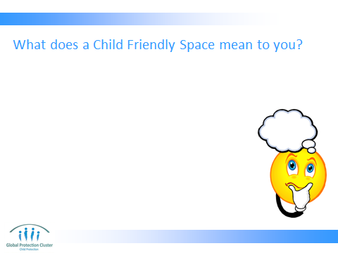

Ask participants to think on their own and write down some thoughts on what they think a CFS looks like?
What would you see if you saw a quality CFS?
Discuss in plenary and trainer to push back on use of jargon etc. eg: psychosocial support: what does that look like? Get the group back to basics.

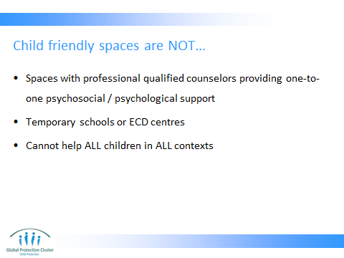

FURTHER INFORMATION FOR TRAINER – Trainer may need to explain further. If so use information below.
- Child Friendly Spaces are not spaces with professional qualified counselors providing one-to-one psychosocial or psychological support.
- They are not temporary schools or Early Child Care and Development centres – though they may refer children to these other services, or support children who are also going to these other facilities
- They are not designed or able to help all children in all circumstances
  - In some cases children with certain disabilities, those with especially violent temperaments, or children with extreme psychosocial support needs for example may be better helped in other ways.
  - In addition it may be that you cannot help all children in community who need help due to sheer numbers - vulnerability and selection criteria can be established with communities at inter-agency level to prioritise needs
  - In some settings they may pose a threat or danger, e.g. by gathering children together may attract attack from armed forces or groups who are seeking recruits

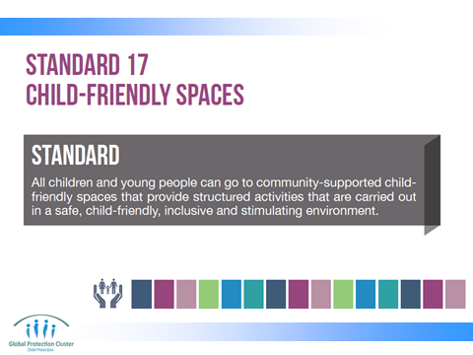

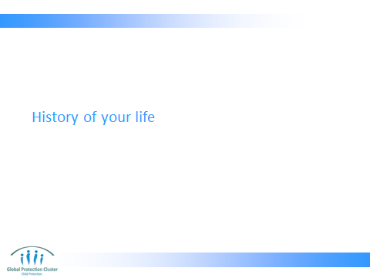

In order to get to know each other better ask participants to draw a history of their lives, mapping different stages of their life journey. This is based somewhat on the Journey of life activity, which can be done with children to identify sources of distress or to identify information that can help with family tracing and reunification. A resource explaining this in detail is on their USB sticks / CDs.

Explain that they need to only draw a history of key events in your life. It can be a mix of personal and professional facts. Need to use only drawings, symbols or colours. Only share things you are happy to talk about with the whole group.

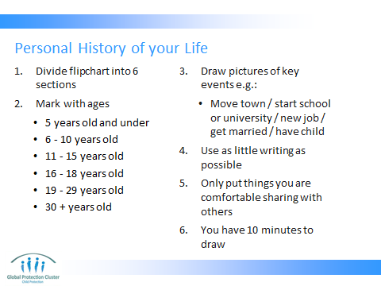

- Divide flipchart into 5 sections
- Mark with ages: 0-5, 6- 10, 11 - 15, 15 - 18, 18 years old +
- Draw pictures of key events, examples might include:
  - Move town
  - Start school or university
  - Change job
  - Get married or have children
  - Use as little writing as possible
  - Only put things on paper that you are comfortable talking about in the group, these will go on the wall at the end of the day
  - You have 10 minutes to draw

These need to be kept throughout the day as we will be adding to them, and then at the end of the day we will put them on the wall.

Let participants know that they can do a similar activity with children in CFS called “Journey of Life” this can help with addressing distress, and can also help with FTR.

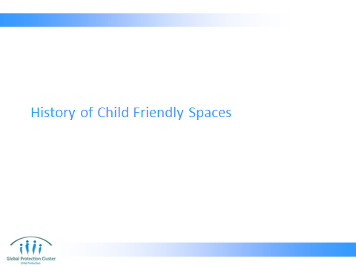
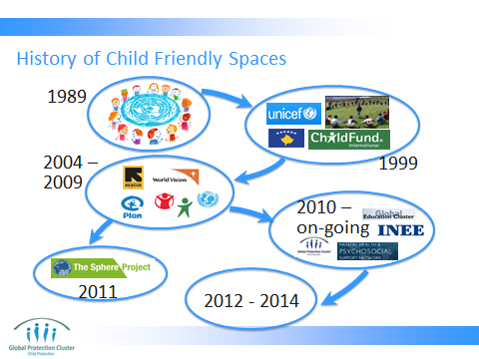

- Present the slide outlining the global level history of the use of Child Friendly Spaces in Emergency responses.
- Check with the group if there are any questions as you go along
- Emphasise that Child Friendly Spaces are quite a new form of intervention in emergency settings, because of this we are still very much in a stage of learning

FURTHER INFORMATION FOR TRAINER –
Just to put in context the work that is happening now… this is a pictorial representation of the history of CFS:
- 1989: The United Nations Convention on the Rights of the Child (UNCRC) is a comprehensive, internationally binding agreement on the rights of children, adopted by the UN General Assembly in 1989. (Includes right to play – Article 31, freedom of expression – Article 13, right to education – Article 28, right to rehabilitation and psychosocial support, etc)
- 1999: UNICEF and ChildFund (then Christian Children’s Fund) both set up “Safe Spaces” in Kosovo
- Recently been able to make interagency advances to increase harmonisation and set standards – with increased recognition of work being done
- 2004/5: Hundreds of CFS established in Aceh, Indonesia, Sri Lanka, and Southern India after the Indian Ocean Tsunami by child-focused agencies including: IRC, UNICEF, Save the Children, World Vision, etc
- 2006: World Vision’s “Children in emergencies manual.” includes chapter on CFS
- 2007: INEE - Draft INEE Good Practice Guide on Emergency Spaces for Children (ESC)
- 2008: ChildFund and Save the Children both publish CFS Handbooks
- 2009: UNICEF (2009) publish: “A practical guide for developing child friendly spaces”
- 2011: Protection principles, including mention of set-up of CFS, included in SPHERE manual
- 2010 – 2012: The Global Education Cluster, INEE, Child Protection Working Group, IASC Reference Group on Mental Health and Psychosocial Support and GBV Area of Responsibility support a process of inter-agency reflection, analysis and learning that aims to improve practice concerning CFSs as part of a wider program of learning for the strengthening of practice that interconnects CFS, school-based psychosocial support and peace-building.
- 2010 Draft CFS Toolkit
- 2011 Draft CFS Guidelines,
- 2012/2013 Training module development
- 2012 CPWG Produce "Minimum Standards for Child Protection in Humanitarian Action" In the minimum standards there is a section on CFS in the section on "Standards to develop adequate child protection strategies"
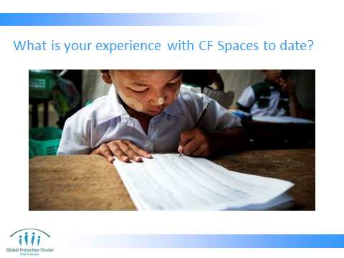
Taking participants back to the picture they painted earlier of a high quality CFS… Ask participants what is their experience with CFS to date?

Good and Bad.
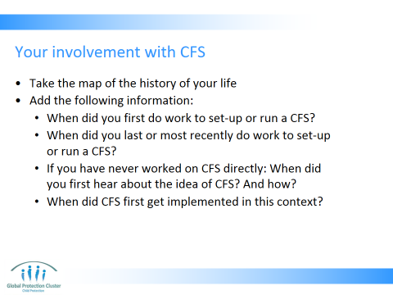

- Take the map of the history of your life we did during the introductory session
- Add the following information:
- When did you first do work to set-up or run a CFS, or facilitate activities within a CFS?
- When did you last or most recently do work to set-up or run a CFS, or facilitate activities within a CFS?
- If you have never worked on CFS directly: When did you first hear about the idea of CFS? And how?
- When did CF Spaces first get implemented in their country of work?

EXTRA – Now add the following information:
- When did you first use a CFS? What year was it? Which country were you in? What kind of emergency? Who were you working with? If you have never directly worked on or with a CFS note on the history map when you first heard about CFS?
- When did you mostly recently use a CFS? Where? What for? What was your role?

From what you have seen in CFS you have worked with:
- What do you think is positive about CFS?
- What do you think are the challenges in working with CFS?

WRAP-UP
- We will be sharing some of those experiences you have had throughout the workshop
- We will discuss what works well and some of the challenges we confront along the way
- Together we will try to generate ideas for finding solutions to the challenges appropriate to the context we are working in here

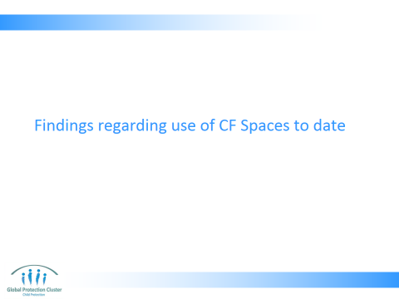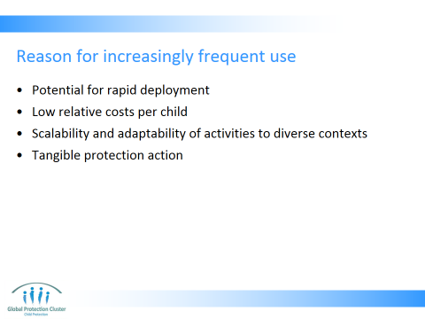
REASON FOR INCREASINGLY FREQUENT USE OF CFS

Ask the group what they think are some of the reasons for increasingly frequent use of CFS

There are a number of factors that have contributed to the frequent adoption of a CFS model in humanitarian emergencies. These include:
- potential for rapid deployment;
- low relative costs;
- Scalability and adaptability of activities to diverse contexts (UNICEF, 2009);
- They are also an especially visible and tangible action on behalf of protection actors. Child protection is something other sectors often struggle to understand, and CFS are a visible product of the work, which those in other sectors see the value of more clearly

The inherent flexibility of a CFS model, although originally intended for children aged 7 to 13, potentially accommodates children of all ages.

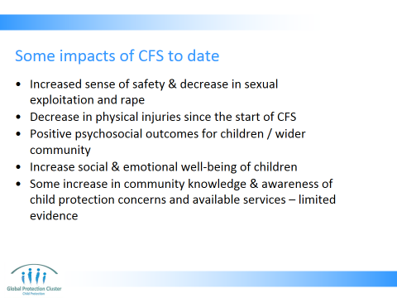

Lack of overall rigour in M&E for CFS impact, but following are some initial findings from 2012 review of evidence:
- Increased sense of safety and decrease in sexual exploitation and rape, were documented in 5 cases
- Some studies noted a decrease in physical injuries since the start of the CFS intervention
- All ten studies reported positive psychosocial outcomes for children and/or the wider community
- Eight studies indicated increases in social and emotional well-being of children, although in only four studies was this documented by difference between baseline and follow-up (rather than through retrospective judgments). In only one of these did the design allow such change to be reliably attributable to CFS.
- There was generally little documentation regarding gender differences in social and emotional well-being of children. However, one study reported girls having more difficulty accessing CFS services due to culturally inappropriate activities and the layout of the CFS compound acting as a deterrent to engagement
- Increased community knowledge & awareness of child protection concerns and available services was noted in 3 studies – though evidence and robust documentation of impact in support of community engagement and/or involvement in CFS activities is limited. The influence of CFS on increasing community capacity for the protection and support of children was seldom reported on in detail.
- There are other outcomes reported – such as improved understand of rights, assisting in process of identifying especially vulnerable children or children who have survived CP incidents – but we lack rigorous evidence

EXTRA TRAINERS NOTE:
- The slides show outcomes for which there is a strong evidence base. There are other outcomes reported – such as improved understanding of child rights, assisting in process of identifying especially vulnerable children or children who have survived CP incidents – but we lack rigorous evidence for these outcomes
- Outcomes for children depend on the nature of the emergency, and the form of the CF Space used in response

REFERENCE: Alastair Ager and Janna Metzler, (2012), Child Friendly Spaces: A Structured Review of the Current Evidence-Base

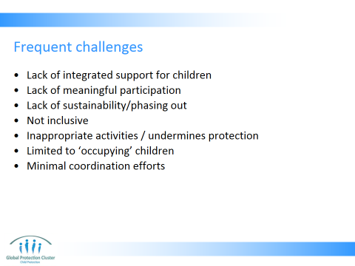
FREQUENT CHALLENGES:

Ask participants what do they see as some of the frequent challenges to the CFS?
Answers could include:
- Lack of integrated support for children – not linking with other sectors, not covering the WASH, Health, Nutrition, etc. needs that could be addressed in CFS
- Lack of meaningful participation – children are coming but not involved in decision making
- Lack of sustainability/phasing out
- Not inclusive – certain groups excluded – certain levels of ability, ages groups, gender, ethnic groups, etc.
- Inappropriate activities / undermines protection – reinforcing gender discrimination or social tensions etc.
- Limited to ‘occupying’ children – not achieving all it could in terms of life-skills, learning, dealing with distress, etc.
- Minimal coordination efforts – gaps and duplication, lack of harmonisation

REFERENCE: UNICEF, 2009, A Practical Guide for Developing Child Friendly Spaces, with additional inputs from inter-agency review team

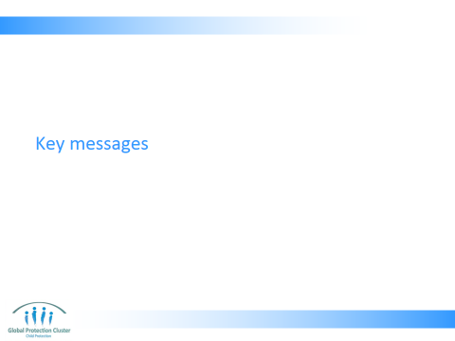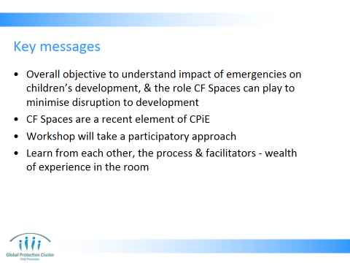

KEY MESSAGES

Wrap up by under-scoring the following:
  - Child Friendly Spaces are a recent element of child protection programmes in emergencies – we are thus still in a process of learning and improving activities
  - Wealth of different experience and involvement with CFS in the room, we should draw on this during the course of the workshop

Remind people of key points regarding Ways of Working for the week:
  - Participatory and experience sharing
  - Positive and solution focused
  - Equality and respect
  - It is most important that people should feel free to ask questions as we go along
  - Remind participants of the different ways to give feedback, evaluate the workshop and the parking lot for issues arising

- The overall objective is to understand the impact of emergencies on children’s development, the role CFS can play in helping them to minimise disruption to their development and reach their full potential
- Child Friendly Spaces are a recent element of child protection programmes in emergencies – we are thus still in a process of learning and improving activities
- The workshop will take a participatory approach to flexible learning, and thus requires participants to contribute actively and respectfully
- Learning should be from each other and the process not just from the facilitators. There is a wealth of different experience and involvement with CFS, working with children and programming in emergencies in the room, we should draw on this

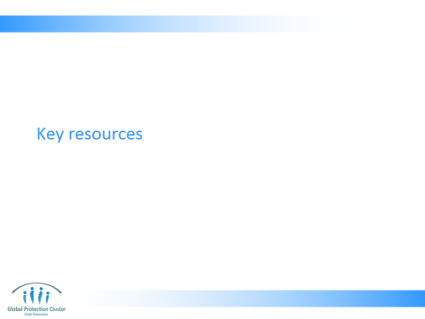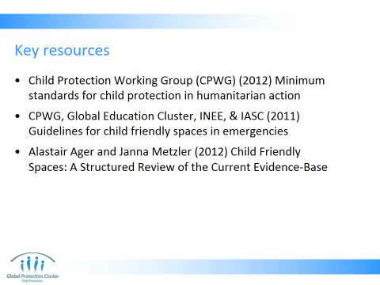

Run through the key resources for this module with the group.
  - Child Protection Working Group (CPWG) (2012) Minimum standards for child protection in humanitarian action
  - CPWG, Global Education Cluster, INEE, & IASC (2011) Guidelines for child friendly spaces in emergencies
  - Alastair Ager and Janna Metzler (2012) Child Friendly Spaces: A Structured Review of the Current Evidence-Base

** Where possible have copies of the resources to hand to circulate among the group. **



This slide is for the end of each session… prompts for questions, check in and even a 5 minute break, ice breaker as needed.

CONCLUSION
3 min | O | We now have the basis of where the CFS’s have come from.
3 min | F | This is a great foundation for us to build this training.
3 min | F | Next session

