

MODULE 1 – SESSION 1 – LESSON PLAN –
CHILD FRIENDLY SPACES: PURPOSES & PRINCIPLES

TIME | OUTLINE – 45 MIN
* RESOURCES REMINDER *
Materials:
- Coloured cards
- Coloured small stickers for voting (stars or dots) cut up into pairs or threes for distribution to participants
- Have enough copies of the Guidelines for Child Friendly Spaces to be able to give one copy per participant
- Have at least 1 copy of each of the different resources listed in the reference list on the facilitator’s table
Flipcharts with headings:
- A flipchart with principles listed
Other:
- Edit slides 19 – 23, selecting only 1 or 2 case studies that may stimulate conversation in the context in which you are facilitating the training.
References:
- CPWG, Global Education Cluster, INEE, & IASC (2011) Guidelines for child friendly spaces in emergencies
- UNICEF (date unknown) Early Child Development Kit: A Treasure Box of Activities: Activity Guide – Especially the sections entitled “The Power of Play” and “Learning through Play” page i – ii
- Stuart Lester and Wendy Russell (2010) Children’s right to play: An examination of the importance of play in the lives of children worldwide

INTRODUCTION
3 min | - Introduce the session
BODY
5 min | Introduction to the session
5 min | Defining key terms
10 min | Purpose: Child Friendly Spaces’ Support to Children and their Families
45 min | CF Space activities contribution to child development
5 min | CF Spaces influencing the wider humanitarian response
10 min | Examples of CF Spaces in different contexts
30 min | Child Friendly Spaces Guiding principles
5 min | Close session
CONCLUSION
3 min | O | Outcome revisited
3 min | F | Positive thought and reinforcement
3 min | F | Next session

MODULE 1 – SESSION 4 – NOTES FOR TRAINER – CHILD FRIENDLY SPACES: PURPOSES & PRINCIPLES

Introduce the Module and the sessions it contains.

LEARNING OUTCOMES
By the end of the session participants will…
- Know the three main objectives of CFSs
- Be able to name the five guiding principles of CFS
- Identify 5 actions that enable realisation of principles

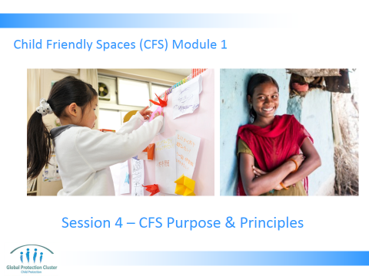

- Slide 1: Have the slide on the screen as participants arrive and settle down.

- INTRODUCTION TO THE SESSION
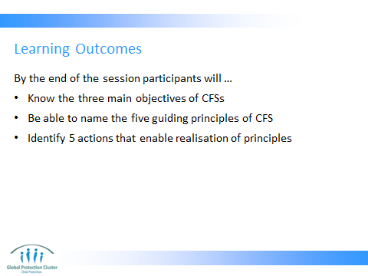

- Present session learning outcomes as on Slide 2

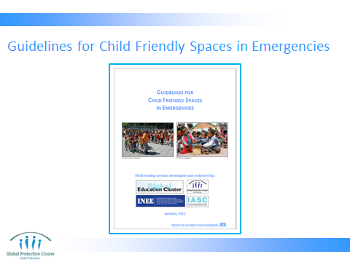

- Slide 3: The purpose of these principles is to give practical guidance to the field teams that establish CFSs in different types of emergencies and contexts. They are also intended to guide advocacy efforts and donor practices in emergency settings where protection and well-being ought to be high priorities.

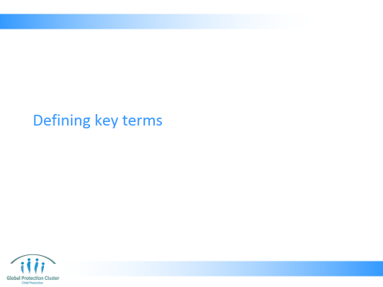

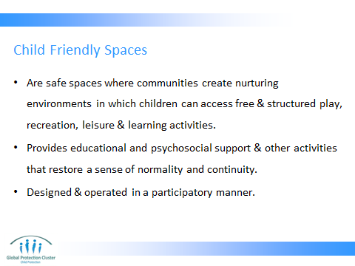

- DEFINING KEY TERMS
- Present Slide 5, Reminder of the definition of what a Child Friendly Space is:
  - Are safe spaces where communities create nurturing environments in which children can access free & structured play, recreation, leisure and learning activities
  - May provide educational and psychosocial support and other activities that restore a sense of normality and continuity
  - Designed & operated in a participatory manner, often using existing spaces in the community and may serve a specific age group of children, or a variety of age ranges
  - Child Friendly Spaces (CFS) are implemented under many different names such as ‘Emergency Spaces for Children’, ‘Spaces Spaces’ and ‘Child Centered Spaces”. All these programs have the same focus and activities, and are part of the larger humanitarian protection response. CFSs are not a collection of activities focused on one specific area only but rather a community program to create a larger protective environment for children during emergencies. They are initiated through rapid support to communities to provide physical safety, psychosocial activities and educational assistance for children and they are a key programmatic intervention to protect children and youth during the acute response phase of an emergency or in areas of continuing crisis.
- Although different agencies call CFSs different things — for example safe spaces, child centered spaces, child protection centers or emergency spaces for children — the interventions are all part of a common family of supports for children and young people.
- For the purpose of this training we will mostly use the term “child friendly spaces” or CF Spaces. We write CF Spaces rather than CFS to be clear and not cause confusion with the abbreviation CFS which can also mean Child Friendly Schools

- PURPOSE: CHILD FRIENDLY SPACES’ SUPPORT TO CHILDREN AND THEIR FAMILIES

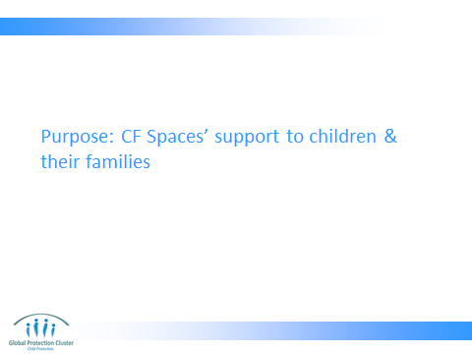

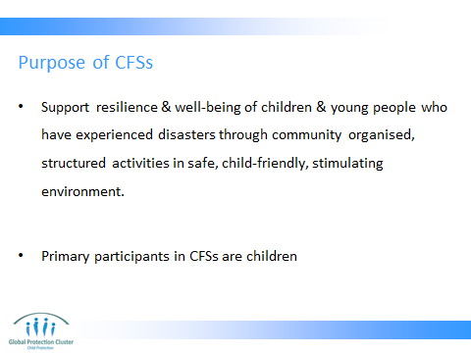

Present purpose of CFS as on Slide 7
- The purpose of CFSs is to support the resilience and well‐being of children and young people through community organised, structured activities conducted in a safe, child friendly, and stimulating environment. (Note, that whilst agencies attempt to ensure safety by vetting staff, setting up structures that are suited to context and should not cause injury or harm, carrying out protective activities, no one can guarantee 100% safety, and CFS can be attacked, vulnerable to natural disasters, etc, as anywhere else in an emergency context)
- The primary participants in and beneficiaries of CFSs are children (people under 18 years of age), although in some contexts, CFSs may also engage and benefit young people who are beyond 18 years of age. And the space may be used to support parents and community members at certain times of the day.

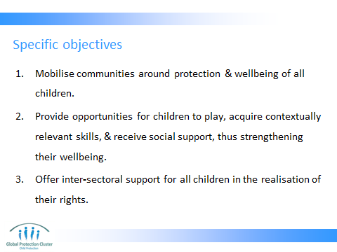

Present the specific objectives, as on Slide 8

- Building on the thinking we did in the session on Child Development in Emergencies and the session on Psychosocial Support, Slide 9, 10 & 11 tell us why CFSs are important response elements in emergencies, enabling stress response system to returns to baseline levels
- Guidelines for Child Friendly Spaces – based on idea of building consensus across three different communities of practice: the IASC Reference Group on Mental Health and Psychosocial Support in Emergency Settings, the global Child Protection Working Group, and the global Education Cluster.
Have found certain objectives are shared by all CFS, in different contexts after different types of emergencies, implemented by full range of agencies.
The specific objectives are to:
- Mobilise communities around the protection and wellbeing of all children, including highly vulnerable children – strengthening already existing community level protection mechanisms
- Provide opportunities for children to play, acquire contextually relevant skills, and receive social support, thus strengthening their wellbeing - emotional well-being, social well-being, and/or skills and knowledge
- Offer inter‐sectorial support for all children in the realisation of their rights.
- We will talk later in training about how CFS tackle specific and different protection risks
- Allow time for questions as you go through these slides.

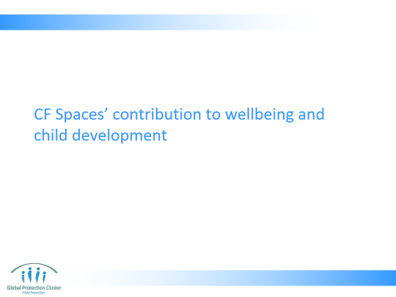

- Although different agencies call CFSs different things — for example safe spaces, child centered spaces, child protection centers or emergency spaces for children — the interventions are all part of a common family of supports for children and young people.
- For the purpose of this training we will mostly use the term “child friendly spaces” or CFS

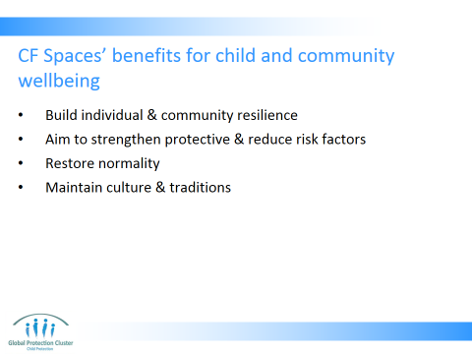

- CF SPACE ACTIVITIES CONTRIBUTION TO CHILD DEVELOPMENT
- Present Slides 10 that outlines how CF Spaces contribute to child and community wellbeing and development
- Resources:
- Blank coloured cards for participants
- Coloured cards with following headings on them:
- Physical development
- Social & emotional development
- Cognitive: Intellectual
- Cognitive: Communication & speech

- Basis / foundation for programming:
- The notion of individual and community resilience – CF Spaces support mobilisation of communities to protect their own children - Build resilience through learning of ways to protect themselves, understanding risks facing them, increasing awareness of themselves and their communities
- Aim of strengthening protective and reducing risk factors provide – e.g. through life-skills activities for children, behavioural change communication and awareness raising on certain concerns and issues
- Restoring normality is a prime concern - Restoring opportunities for normality, such as establishing trusting relationships in safe places with predictable routines and also strengthening community networks is most beneficial for children and their families.
- Maintain culture & traditions – CF Spaces allow for transmission of traditions, stories, songs and cultural celebrations. Allowing children to feel a link with their community, culture and heritage in disrupted contexts

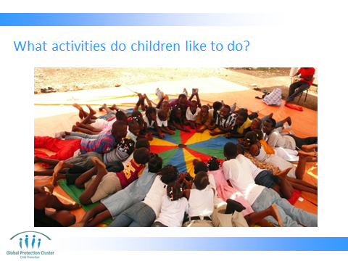

Children’s activities: Slide 11
- Objective: to get participants to establish how child friendly spaces activities contribute to child development. This activity should make clear the link between the activities children enjoying doing, the activities that happen within a child friendly space and the child development outcomes that are achieved

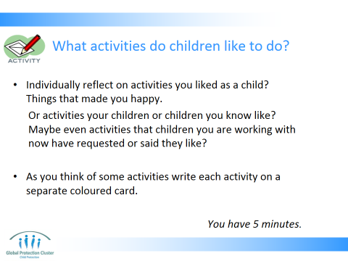

- Use Slide 12 to explain the activity to the participants.
- Ask them to individually reflect on activities they liked as a child? Things that made them happy, that they enjoyed doing
- Alternatively, maybe it easier to think of activities their children or children they know like? Maybe even activities that children they are working with now have requested or said they like?
- As they think of activities they should write each activity on a separate piece of coloured card – give them 5 mins for this
Refer participants to this resource in their toolkits during the CF Space activities contribution to child development session, activity 4
How Play Contributes to Child Development
Extracts from Stuart Lester and Wendy Russell (2010) Children’s right to play: An examination of the importance of play in the lives of children worldwide

Building resilience: Play has an essential role in building children’s resilience across adaptive systems – pleasure, emotion regulation, stress response systems, peer and place attachments, learning and creativity. These benefits arise from play’s unpredictability, spontaneity, nonsense and irrationality, and also from children’s sense of control. Adults need to ensure that the physical and social environments in which children live are supportive of their play; otherwise their survival, well-being and development may be compromised.
Protection: Children’s play can be seen as a self-protecting process that offers the possibility to enhance adaptive capabilities and resilience. The experience of play effects changes to the architecture of the brain, particularly in systems to do with emotion, motivation and reward (Burghardt 2005), leading to further playing. Play acts across several adaptive systems to contribute to health, well-being and resilience. These include: pleasure and enjoyment; emotion regulation; stress response systems; attachments; and learning and creativity.
Building neural architecture: Play offers the opportunity to develop and try out a range of responses without serious consequences. This process may contribute to shaping neural architecture, enhancing the integration of systems that support emotion and cognition.
Dealing with stress: In some circumstances, the experience of moderate stress or adversity can strengthen resistance to later stress, or “stress inoculation.’ The experience of stress under playful conditions, with associated temporary elevations of cortisol (an important neurochemical involved in responding to stress), leads to neural reorganisation. This enables new connections that will be able to cope with the demands of an unpredictable environment (Flinn 2006) and energise activity. This is achieved through for example play fighting, or a game of chase. Or for example if a child hurts themselves or gets hurt by others in play, while the pain is ‘real’ it may matter less than in non-play contexts as, after all
Increasing psychological wellbeing through play in nature: Contact with nature may help in the restoration of psychological well-being and improve mental health (Korpela et al. 2002, Douglas 2005, Faber Taylor and Kuo 2006, Milligan and Bingley 2007). Also, a number of studies suggest that playing in natural space as a child helps to establish environmental knowledge, awareness, and the foundations of adult sensibilities. and respect for nature and the environment (Bixler et al. 2002, Wells and Evans 2003, Wells and Lekies 2006).
Physical wellbeing: There is evidence that there are benefits of improved physical fitness, coordination, balance and agility from playing and moving in landscapes that offer challenge and unpredictability, rather than controlled and structured play. In addition physical exercise (sports) develops endurance, control of body movements and perceptual-motor integration
Relationship building and attachment: Feelings of joy and pleasure generated by play are associated with more flexible and open responses to situations and with effective problem-solving, self-control, forward-looking thinking and caution in dangerous situations. is also likely to build enduring resources, in particular through developing strong social relationships.

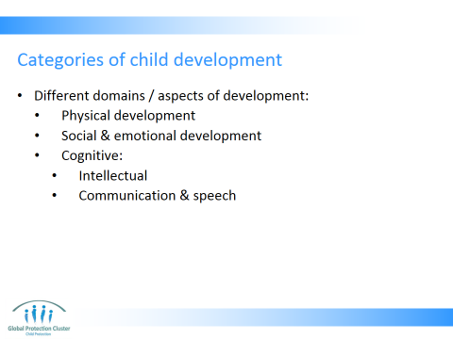

- Slide 13: Put up the following 4 categories of child development (as discussed in Child Development sessions earlier in the day) on the wall:
- Physical development
- Social & emotional development
- Cognitive: Intellectual
- Cognitive: Communication & speech
- Ask participants to come up and stick the activities they have brainstormed on to the wall, clustering them around the form of development to which they think they contribute (5 mins)
- Facilitate a discussion on the responses put up on the wall, asking in plenary, as you are all still standing looking at the responses: (15mins)
- Does anyone want to explain why he or she put a certain activity in a certain place?
- Do all the activities you thought of contribute to at least one form of development?
- Do some contribute to more than one form of child development?
- Some example responses might include:
- Physical development this refers to the body increasing in skill and performance and includes:
  - Gross motor development – e.g. sports, running, skipping, jumping and dancing
  - Fine motor development – e.g. drawing, building blocks, & puzzles
- Social and emotional development:
  - Story telling and joint play with adults can contribute to bonding with adults – reestablishment sense of attachment
  - All forms of play with peers (role play, play fighting, with dolls or puppets, sports, etc) can contribute to relationship building with peers and learning about conflict resolution.
- Cognitive:
  - Intellectual development: memory games, puzzles, strategy games (Ludo, chess, etc)
  - Communication & speech development: reading, talking, group discussions

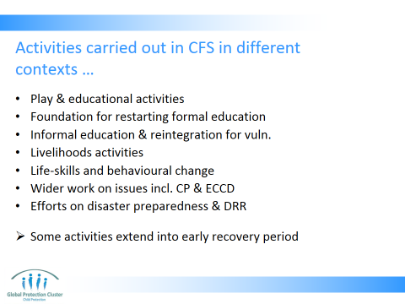

- Present Slide 14 that outlines some broad categories of activities that can take place in CF Spaces

We need to overcome community, other sectors and even CPiE/ education / gender actors misconceptions of who is welcome in CFS and what CFS are for in order. This will enable us to ensure they have the greatest impact possible on the lives of the most vulnerable children
Depending on the context, CFSs have been used for a variety of purposes such as:
- Play activities – including creative play, imaginative play, drawing, sport & exercise, collaborative games, strategy games, etc
- Laying a foundation for restarting formal education and supporting national education systems
- Informal education and reintegration activities for vulnerable children
- Livelihoods activities – though should be used with caution as must not reduce ability of children to have full access to other rights (e.g. education and health rights should not be limited by engagement in dangerous forms of income generating activities)
- Life-skills building and behavioural change – encouraging more positive behaviours among girls and boys
- Enabling wider work on issues such as child protection, WASH, livelihoods and early child development
- Stimulating efforts on disaster preparedness and disaster risk reduction
Some of these activities extend beyond the emergency context into the early recovery period or even into longer‐term development.
Don’t forget they can be used in non-emergency settings, including developed and developing countries

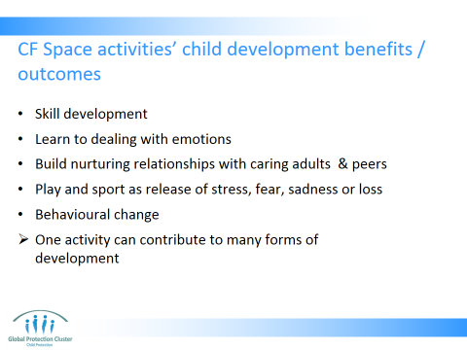

- Run through and present Slide 15, explaining the child development benefits and outcomes achieves by these kinds of activities
- Skill development - life-skills, motor skills, etc. Public health messages through games, behavioural change through participatory and fun life-skills activities. Building blocks, drawing & puzzles can contribute to fine motor skills.
- Social and emotional development - We do this because we know that self-directed or imaginative play is very important in children’s social and emotional development - Children will ‘act out’ events they have experienced in their play, it can help them heal and recover after traumatic events (more about this on the next slide).
- Attachment and relationship building - Children can establish nurturing and positive relationships with caring adults and peers - They can build positive relations with peers, learning to negotiate, deal with conflict, develop skills for contributing to peace-building when they are grown up. Story telling and joint play can contribute to bonding with adults. All forms of play with peers can contribute to relationship building with peers.
- Opportunity to play – be it dance, plays sports, sing, or draw, which release of stress, reduces cortisol levels, and ensures stress levels return to normal - Express fear, sadness, loss in safe environment – dealing with the emotions they have been feeling and overcoming the events they have lived through - Sport important for motor control & cognitive ability. Reduce anxiety & cortisol levels. Individual activities such as running, skipping, jumping, dancing. Or group sports such as football, handball, volley ball, basketball, etc
- Behavioural change – public health messaging, life-skills building on issues such as sexual health, games that integrate messaging (e.g. WASH use a version of Snakes and ladders that conveys public health messages) etc
- Strategy games can contribute to intellectual development.
- Reading –
- Note that one type of activity (e.g. sport - football) can contribute to many forms of development (e.g. sport – football – can improve motor skills, strategic thinking, conflict resolution, etc)

Refer participants to the “How Play Contributes to Child Development” resource in the participants handbook.
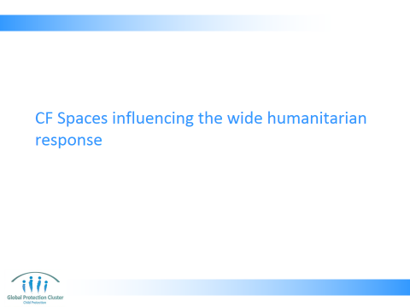

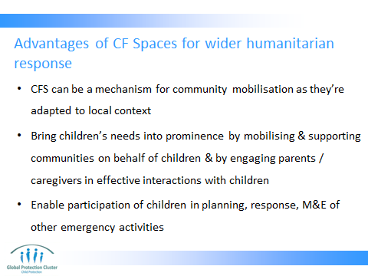

- CF SPACES INFLUENCING THE WIDER HUMANITARIAN RESPONSE
Present slide 17 explaining how the presence of CF Spaces can support humanitarian interventions in sectors other than Child Protection, Education and Mental Health and Psychosocial Support
- CFS can be mechanism for community mobilization, as they use participatory methods that are adapted to local context & culture
- Bring children’s needs into prominence by mobilizing & supporting communities on behalf of children & by engaging parents / caregivers in effective interactions with children
- Enable participation of children in planning, response, monitoring & evaluation of other emergency response activities. For example the CF Space children can influence the design of shelter, water, health or food security programmes, by creating children’s clubs who input their views and thus change design of other sector plans. Or children from the CF Space can be involved in awareness raising activities covering topics relating to sectors other than CP, Education or MHPSS.

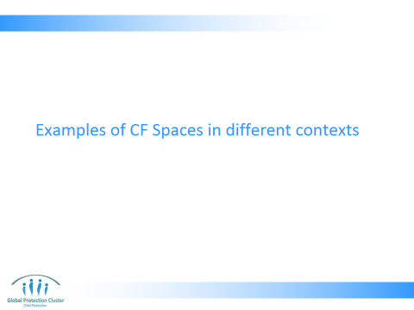

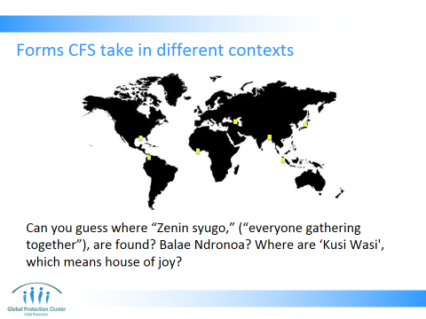

- EXAMPLES OF CF SPACES IN DIFFERENT CONTEXTS
- Slide 19 lists some examples of different forms CFS have taken. Start by asking
- “Can you guess where “Zenin syugo,” (“everyone gathering together”), are found?”
- Balae Ndronoa?
- Centre Sociaux Educatif et Récréatif, meaning: Socio, educational, recreation centres?
- Where are ‘Kusi Wasi', which means house of joy?
- ANSWERS: ZS – Japan, BN – Indonesia, CSER – Ivory Coast, KW – Peru - This exercise shows adaptation of the concept to context
- Explain the different ways the concept has been implemented in different locations all over the world

- Present the case studies on slides 20 – 24. You may want to select only 1-2 of these examples to ensure it does not take too much time.
- If you have spare time, you can see what the participants’ reactions are to the following questions:
- Is a website for children, where they can share and express concerns, share thoughts and ideas, play games and learn a Child Friendly Space?
- There is no right or wrong answers to this, just different views.

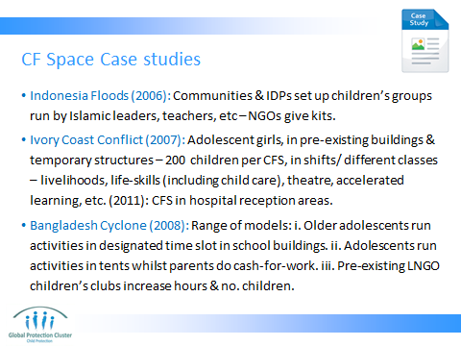

- Indonesia Floods (2006): Communities & IDPs set up children’s groups run by Islamic leaders, teachers, etc – support from humanitarian agencies came in form of supplies
- Ivory Coast Conflict (2007): Adolescent girls (ex-associated with armed forces & groups, child-mothers, disabled, etc) - a group otherwise excluded from humanitarian activities - in pre-existing buildings & temporary structures – 200 children per CFS, in shifts/ different classes – livelihoods, life-skills (including child care), theatre, accelerated learning, etc. In 2011: child friendly spaces in hospital reception areas
- Bangladesh Cyclone (2008): Range of models tailored to community needs and actions: i. Activities in designated time slot in school buildings run by older adolescents. ii. Adolescents running activities in tents for small children whilst parents do cash-for-work. iii. Pre-existing children’s clubs increase hours & no. children with additional facilitators
- Japan Tsunami (2011): 5-12 year old children. ~25 in a group. High tech materials and games (computers, screens, videos)

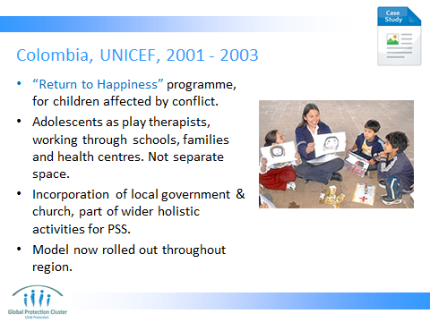

- Colombia: 2001 – 2003 “Return to Happiness” programme, for children affected by conflict. Adolescents as play therapists, working through schools, families and health centres. Not separate space. Incorporation of local government & church, part of wider holistic activities for PSS

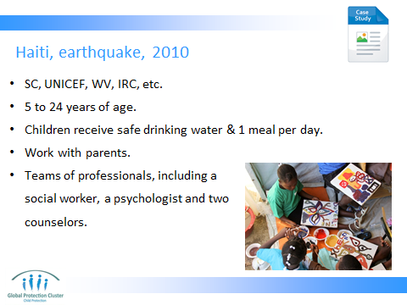

- SC, UNICEF, WV
- 5 to 24 years of age
- Children receive safe drinking water & 1 meal per day
- Work with parents - They attend sessions on how to determine when their children are at-risk, and they learn skills to prepare them for possible future disasters.
- Teams of professionals, including a social worker, a psychologist and two counsellors

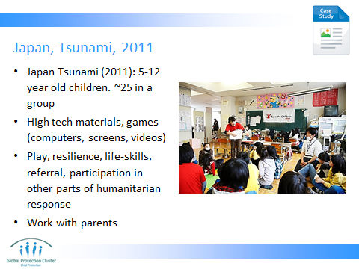

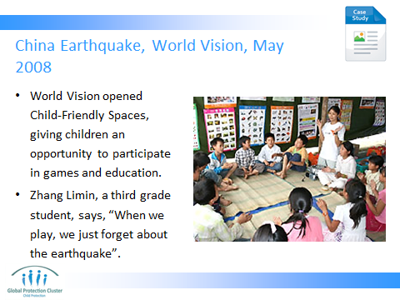

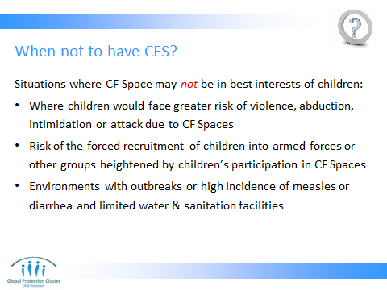

- Using slide 25 explain some scenarios when CF Spaces may NOT be suitable. You may want to ask the group if they have other ideas of when it is best not to have a CF Spaces:
  - Situations where a Child Friendly Space may not be in the best interests of children include:
  - environments in which there are outbreaks or high incidences of measles or diarrhea and limited water and sanitation facilities;
  - risk of the forced recruitment of children into armed forces or other groups which might be heightened by children’s participation in Child Friendly Spaces (through abduction on the way to the space or recruitment of children perceived to be skilled because of their participation in the space); and
  - situations in which children would face greater risk of abduction, intimidation or attack due to the presence of Child Friendly Spaces
- Reference: Save the Children (2008) CFS Handbook

Key message:
- We can and should be creative in order to meet the specific needs, resilience and existing community based mechanisms in the context in which we are working.
- We should make commitments to ensure our CF Space adapt to the context we are working in and specific needs identified in the emergency response.

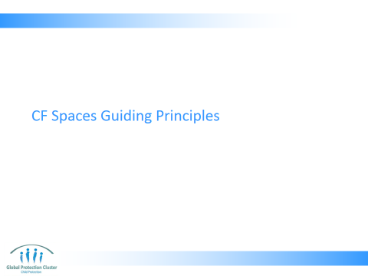

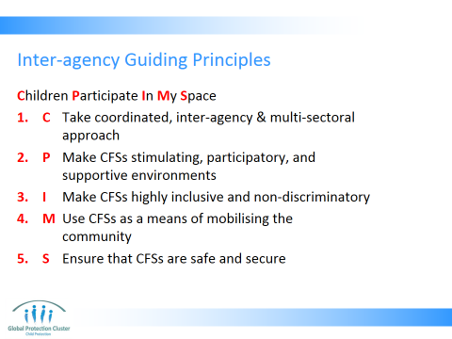

- CHILD FRIENDLY SPACES GUIDING PRINCIPLES
- Present Slide 27, which shows the Guiding Principles, which have been established through interagency research. They are discussed in the document “Interagency Guidelines for child friendly spaces in emergencies”
- Children Participate In My Space is a mnemonic (pronounced newmonic), a trick developed to help them remember these 5 principles

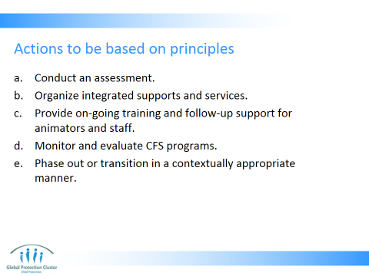

- Present Slide 28 outlining the actions that must be informed by these principles.
The five principles are essential and should be built into all the actions outlined here. We will over the course of the next three days go into detail on how we can ensure we take this PRINCIPLED approach to each of these actions.
- Conduct an assessment – coordinate and inter-agency – identify community strengths and children’s resilience as well as the psychosocial needs
- Organize integrated supports and services – work with other sectors and with other CP, education and GBV teams to ensure the support you provide through the CFS is integrated
- Provide on-going training and follow-up support for animators and staff – based on needs
- Monitor and evaluate CFS programs – continuously monitor, evaluate and learn, putting lessons learnt into practice, identifying ways to overcome challenges you encounter
- Phase out or transition in a contextually appropriate manner

Facilitate a discussion in plenary on the following two questions:
- Why do you think these principles and guidelines would be important?
- How do they influence how we work?

Ranking activity (5mins)
- Indicate the list of principles on flipchart on the wall
- Hand-out two stickers (stars, dots, or other shape) per person, & ask participants to come and place their two stickers against the principle that is the weakest
- Underscore that this is not a problem. In the first few days and weeks of a response / emergency programme implementation is very rushed and the aim is primarily to set up activities and ensure services are started. Over time we ensure quality improves and this (now) is the right time to put in place actions to address gaps in reaching principles

Action planning to achieve principles: (15 mins)
- Reflecting on the votes put on the flipcharts, the facilitator should identify the 2 principles that participants have identified as needing the most work
- State which two principles you will tackle
- Note a “title” for the principle on flipchart
- Run through the questions for the specific principle as outlined below (note again, only go through the two principles presenting the biggest challenge, you will not have time here to go through them all)

- If achieving a coordinated, inter-agency & multi-serctoral approach is the biggest concern:
- Get the group to brainstorm on which sector needs to be integrated most? What are the challenges in coordination and integration? Which agencies are being excluded from coordination? What about inter-agency coordination mechanisms is failing? Which sector have you not been coordinating with enough that is essential to ensuring quality programming in CFS?
- List the responses on flipchart.
- Identify 4-5 actions / commitments from the group to address gaps with the sectors most often cited
- Can everyone commit to these actions going forward? Is there the budget, skill and resource level required? Is there variation across the affected area?

- If community mobilisation is the main concern discuss in plenary:
- What has been done in order to mobilise communities to date? How are links being made with community based structures and committees?
- Identify 4-5 actions / commitments from the group to improve community mobilisation.
- Can everyone commit to these actions going forward? Is there the budget, skill and resource level required? Is there variation across the affected area?

- If inclusion is the biggest problem:
- Who is not included in other activities such as education, cash for work, psychosocial support activities?
- Get the group to brainstorm on which children might be being excluded from majority of humanitarian activities. Ask: Who is most excluded? Age? Gender? Ability? Religion?
- In plenary identify 4-5 actions / commitments from the group to address the challenges of inclusion
- Can everyone commit to these actions going forward? Is there the budget, skill and resource level required?

- If the main concern is how to ensure that CF Spaces are safe and secure:
- What are the security and safety concerns with regards to CF Spaces in this context?
- Note these concerns down on flipchart
- In plenary identify 4-5 actions / commitments from the group to address the challenges of safety and security
- Can everyone commit to these actions going forward? Is there the budget, skill and resource level required?

- If making CF Spaces stimulating, participatory and supportive is a challenge:
- What are the challenges in ensuring CF Spaces are stimulating, participatory and supportive environments for children?
- Note these concerns down on flipchart
- In plenary identify 4-5 actions / commitments from the group to address the challenges of stimulation, participation and supportiveness in the CFSs
- Can everyone commit to these actions going forward? Is there the budget, skill and resource level required?

NOTE: Keep any challenges noted on flipcharts and the ranking of the principles for later sessions. Cross-reference these flipcharts when you are having discussions that go some way to contributing to addressing these challenges in meeting principles. (e.g. M&E & staff capacity strengthening sessions can flag need for inclusion & can help address staff capacity to meet needs of all & help them to use child-centred methods)

Resources –
  - Coloured small stickers for voting (stars or dots) cut up into pairs or threes for distribution to participants
  - Flipchart with principles listed

- CLOSE SESSION
- Use slide 30 to remind the group of the key messages we have learnt through this session

Key points:
- Agencies may have their own ways of working, and implementing child friendly spaces, yet research has shown that all agencies seek to meet the 3 objectives and follow the 5 guiding principles outlined in the Interagency “Guidelines for Child Friendly Spaces in Emergencies”
- Activities that take place in CF Spaces (play, sport, creative activity, self expression, socialisation with peers and support from caring adults), all help children to overcome their stress and return to a path of positive childhood development
- CF Spaces can take many different forms though often they are narrowly perceived as physical spaces where children aged 6 – 12 come to play. We should challenge this misconception and seek to address needs of all children, especially the most vulnerable and those excluded from other programmes.

- Hand-out copies of the “Guidelines for Child Friendly Spaces in Emergencies” and also refer participants to the “Functions of Child Centred Spaces” resource in in the participants handbook

- Resources:
- At least 1 copy of each of the different resources listed in the reference list to show participants
- Copies of “Guidelines for Child Friendly Spaces in Emergencies” to hand-out to all participants

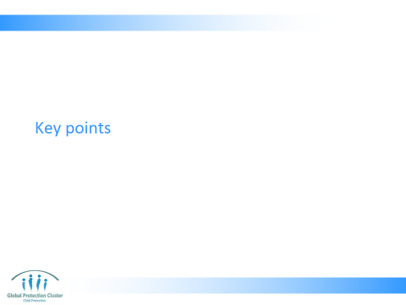

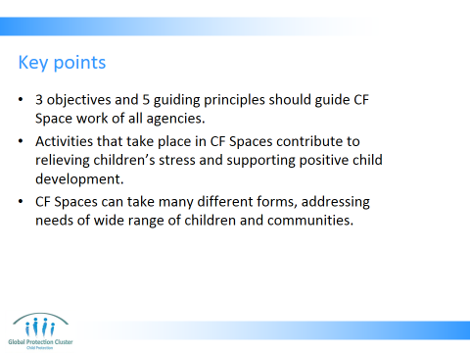

- Agencies may have their own ways of working, and implementing child friendly spaces, yet research has shown that all agencies seek to meet the 3 objectives and follow the 5 guiding principles outlined in the Interagency “Guidelines for Child Friendly Spaces in Emergencies”
- Activities that take place in CF Spaces (play, sport, creative activity, self expression, socialisation with peers and support from caring adults), all help children to overcome their stress and return to a path of positive childhood development
- CF Spaces can take many different forms though often they are narrowly perceived as physical spaces where children aged 6 – 12 come to play. We should challenge this misconception and seek to address needs of all children, especially the most vulnerable and those excluded from other programmes.

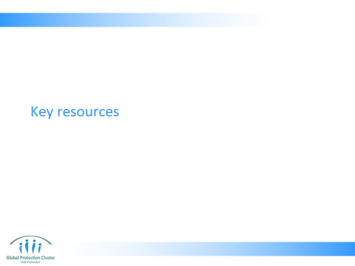

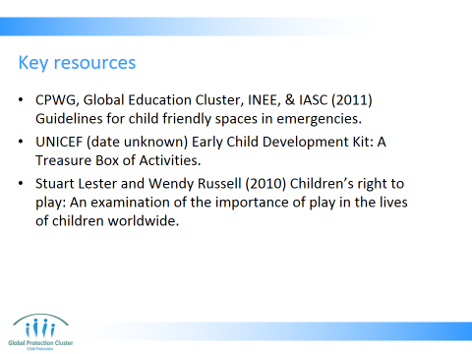

- Use the Resource Slide 32 showing participants samples of each of the materials.
Refer participants to this resource in their toolkits during the closing session, activity 7

Functions of Child Centred Spaces
by Kathleen Kostelny for Child Fund International

Child Friendly Spaces promote children’s protection and well-being in the following ways:

Children receive immediate protection and security: The CFS helps to prevent exploitation & abuse of children by providing adult-supervised activities for children in a safe space. The CFS also helps reduce the risks of harm to children in their environment (such as landmines, vehicular accidents, and fighting) by providing information to children about these risks.

Children are helped to regain a sense of normalcy, stability, and hope: It is important for children whose lives have been disrupted to regain a sense that life is returning to normal again. Structured activities and routines in a familiar place that they come to everyday provide safety, order, comfort and reassurance in children’s lives.

Children engage in expressive activities that help mitigate negative impacts: Opportunities for children to express themselves through creative activities, such as play, drawing, and story telling, are useful in helping them release bottled up feelings. Expressive activities also help children understand and make sense of stressful events.

Children engage in social integration with peers and receive support from caring adults: Relationships with peers and caring adults are crucial for children’s social and emotional development. They help foster resilience and positive ways of coping with stressful experiences.

Children are provided opportunities for non-formal education: Non-formal education is an important way to socialize and learn together with other children. Through non-formal education, children build competencies for resilience, develop life-skills and can learn about life saving subjects such as hygiene and sexual and reproductive health.

Children receive health support: Following emergencies, children are more vulnerable to sickness and disease, both immediately as well as long term. Children may be malnourished, or lack important nutrients for their development. CFSs provide important health and hygiene information and support for children and their caregivers, and can allow for referral of child cases needing extra assistance.

Children engage in cultural activities: Cultural activities, such as song, dance, and rituals, are important for children, helping to restore a sense of identity and belonging.

Children who are severely affected are referred for appropriate services: Some children may be severely affected by the emergency and need specialized assistance. Adults are trained to identify and refer these children.

Communities are mobilized on behalf of children: CFSs are a platform for community mobilization and capacity building around child care and protection. Engaging families and communities rapidly around the needs of children helps to protect and support them. Giving communities and carers a role in children’s recovery.

Children’s needs are able to be assessed and programs planned on their behalf: Through community assessment, as well as through on-going monitoring and evaluation, communities can identify goals for their children & programs that help build a positive future.

Community needs are addressed: CFSs can be used as a central meeting point for families and community leaders to organize around the needs of children, and to begin the planning process to address other critical needs for the community.


This slide is for the end of each session… prompts for questions, check in and even a 5 minute break, ice breaker as needed.

- CLOSE WORKSHOP FOR THE DAY
- Remind volunteer evaluators to make themselves available to hear any feedback on how the day went
- Remind participants to fill in the feedback / evaluation forms and the comments / feedback flipchart
- Select individuals to do a recap in the morning
- Remind the participants of the time they should arrive tomorrow
- And confirm any logistics or plans for the evening

