

MODULE 1 – SESSION 1 – LESSON PLAN –
PSYCHOSOCIAL SUPPORT FRAMEWORK

TIME | OUTLINE – 1 hour 30 mins
* RESOURCES REMINDER *
- Post-it notes or VIPP / Meta cards in two different colours
Flipcharts with the following:
- Copy of MHPSS pyramid as on slide 30, drawn on to two sheets of flipchart paper taped together
Hand-outs:
- Different Age groups reactions to traumatic events
- Resilience and Coping
- Communication for Coping: Discussing the Emergency with Children
- The Basic Principles of Psychosocial Work
- Copies of Pages 9 - 13 of the IASC Guidelines on Mental Health and Psychosocial Support in Emergency Settings
Other:
- “Yes” and “No” written in large letters on pieces of coloured card or paper
- If you are not familiar with the song “If you’re happy and you know it clap your hands” watch the following You Tube video clip before running the session (http://www.youtube.com/watch?v=FrsM9WggCdo)
- Select between Slide 31 and 32 for Activity 6, Multi-Layered Supports
Resource (people):
- If there is a sub-Cluster / working group in-country on MHPSS it would be good to have representation at this session for co-facilitation purposes

INTRODUCTION
3 min | - Introduce the session
BODY
5 min | Introductory
15 min | Yes or no: Do you agree?
5 min | Defining key terms
30 min | Psychosocial Impact of Emergencies
15 min | Aims of Psychosocial Support Work
40 min | Multi-layered supports
10 min | Wrap-up and close PSS Session
CONCLUSION
3 min | O | Outcome revisited
3 min | F | Positive thought and reinforcement
3 min | F | Next session

MODULE 1 – SESSION 3 – NOTES FOR TRAINER – PSYCHOSOCIAL SUPPORT FRAMEWORK

Introduce the Module and the sessions it contains.

LEARNING OUTCOMES
At the end of this session participants will be able to:
- Participants are able to define key terms relating to Mental Health and Psychosocial Support (MHPSS)
- Participants know the four main categories of symptoms of distress
- Participants can identify at least 3 types of intervention, other than CFS, that support children and their families who are showing signs of psychosocial distress

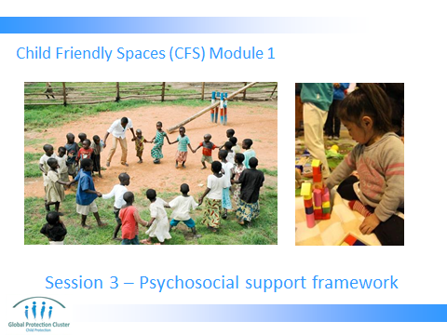

FEELING THE PSS CYCLE: PART 1
- Have Slide 1 on the screen as participants arrive and settle down.
- This is part of the activity “FEELING THE PSS CYCLE” activity, which will get participants to think through how disruption makes them feel, and how routine, play, etc, can make people feel better:
- Ideally have soft gentle calming music playing as participants walk into this session. As far as possible create a calm atmosphere that feels a bit different from during the previous session. Make the environment nice, maybe add some colour to the walls, open windows, have balloons. The music can be kept on whilst you do the Expectations / Objectives activity.
- Present the planned learning outcomes as on Slide 2

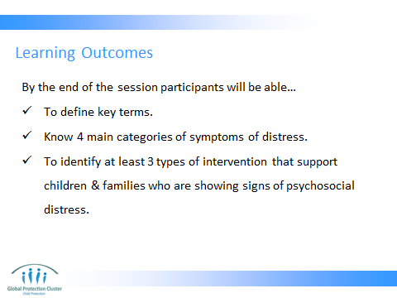

By the end of the session participants will …
- Be able to define key terms relating to Mental Health and Psychosocial Support (MHPSS)
- Know the four main categories of symptoms of distress
- Be able to identify at least 3 types of intervention, other than CFS, that support children and their families who are showing signs of psychosocial distress
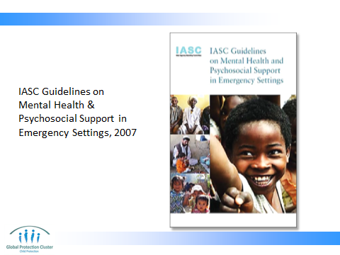

Underline that the IASC Guidelines on MHPSS is the key document guiding the content of this session, and supporting all psychosocial support work in emergencies.
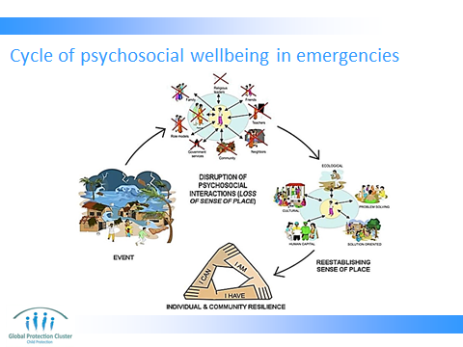

- Use Slide 4 as a visual summary representation of the outline of the session
- This is a diagrammatic representation of the session we will be doing
- Talk through the cycle quickly, pointing out that this session’s objectives are to understand what can cause psychosocial distress (event), impact of the event on people’s lives (what is disrupted by the event), how PSS works to re-establish order and finally leads to wellbeing, building on individual resilience and community capacity
- In previous session we looked at the wider impact of the disruptive event on the child and community, we will now look specifically at the psychosocial impact and how we respond to re-establish a sense of place and build on resilience

Reference: Diagram taken from: Nancy Baron for IASC Reference Group on Mental Health and Psychosocial Support in Emergency Settings (March 2009) Global Toolkit of Orientation and Training Materials: Used to disseminate and Implement the Inter-agency Standing Committee Guidelines on Mental Health and Psychosocial Support in Emergency Settings.

- YES OR NO: DO YOU AGREE?
Objective of activity:
- The discussions will start to open up a conversation about distress among children post-emergencies. It should introduce some ideas on how we react to and address issues of distress expressed by children.
Activity: (10 mins)
- Put a big “yes” and a big “no” on pieces of paper on the floor on different sides of the room.
- Run through the statements about the psychosocial situation of children after an emergency on Slide 5 – 6 one by one
- Ask participants to stand next to the YES or the NO depending on whether or not they agree with the statement. If they wish they can stand half way between the two
- Discuss each statement in plenary once participants have positioned themselves in response to it
- Depending on how talkative the group is either do all 4 statements (two on Slide 5, two on Slide 6) or just choose two statements. Spend a maximum of 10 mins on this activity
- Discussions about each statement should cover:
- Discuss participants’ responses and reactions to the statement. Have a few people comment who are by the Yes, who are by the No, and if there are people who are undecided / halfway between the two
- Summarise for each statement before moving to the next
- To sum up the activity explain that we will explore some of these questions and ideas during the course of this session and people can come back to them if they like
- You may wish to add some statements that challenge certain specific perceptions that have been demonstrated in the context.

Depending on how talkative the group is either do only these 2 or continue to the next slide and do all 4 (2 on this slide, 2 on the next). SPEND ONLY A TOTAL OF 10 MINS ON THIS ACTIVITY

Resources - “Yes” and “No” written in large letters on pieces of coloured card or paper

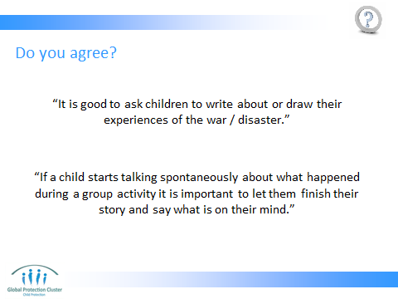

Slide 5:
“It is good to ask children to write about or draw their experiences of the war / disaster”
- NO: Trained professionals may want to directly ask children to write or draw about their experiences so they can give specialised care and support. Others, such as standard CP workers in the field, can give children the opportunity to draw or write, sing, dance or express themselves in ways they wish, but should probably not specify that these ways of expressing themselves must discuss their feelings and experiences of the distressing event. It may raise concerns we are not qualified to deal with. Note, if specific children when given the opportunity do draw or write about whatever they wish, express concerning emotions, fears or distress levels that are more disturbing than images generated by other children of their age, you may want to refer them to someone who can provide specialist support.

“If a child starts talking spontaneously about what happened during a group activity it is important to let them finish their story and say what is on their mind”
- PARTLY YES PARTLY NO: Whilst it is important to give them the opportunity to talk about their feelings and thoughts, we need to consider two things: 1. the story may upset other children in the group, and 2. the child may not have thought through the repercussions, risks and challenges of sharing their story. They may start their story, and only after starting to tell it realise that it will upset them to share it.
- It is best to state that whilst you want to give the child the opportunity to talk, maybe it is best if they want to do this one-to-one, so as not to upset others or get too upset themselves. Ensure you have someone you can refer the child to before offering this option. Make sure you address the child in a kind positive manner and tone, do not cut them off suddenly or be dismissive.

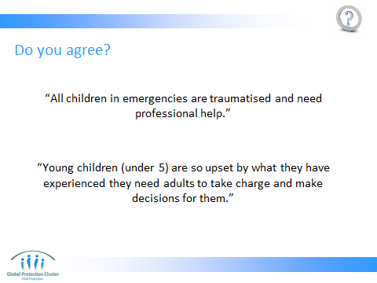

Slide 6:
- “All children in emergencies are traumatised and need professional help”
- NO: A very small minority of children are traumatised. Whilst children may have experienced a traumatic event, by far the majority of children will express distress, not trauma. They will be able to recover from the event with a return to routine, rebuilding of bonds (creating attachment) with peers, and family, and some community level support. A very small minority will be traumatised and will need professional help. We will come back to this later.

- “Young children (under 5) are so upset by what they have experienced they need adults to take charge and make decisions for them”
- PARTLY YES, PARTLY NO: There is not a straightforward yes or no answer to this question.
- Whilst children of all ages should be allowed to make certain decisions and participate in choices that affect them, this depends on their age and stage of development. Younger children will find it hard to make certain big decisions, even if these do affect them. For example, which parent to live with if the parents have to move apart. The choice between staying with an aunt or a grandfather if the parents have to flee. Whether or not to carry out a medical intervention that could save their lives, but that could pose a risk.
- After an emergency children may find comfort in certain decisions being made for them.

Parents, or guardians should make these big choices for the children when possible. This will give comfort to the child, making them feel cared for. Though it is important to KEEP CHILDREN INFORMED and let them know what choices and decisions have been made on their behalf so as not to cause further distress when there is sudden change without warning.
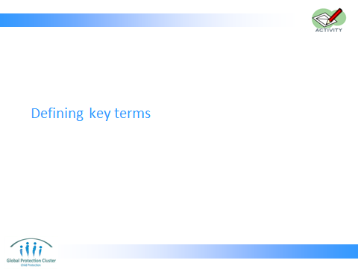

- DEFINING KEY TERMS
- Run through the definitions on slide, allowing participants to ask any key questions to clarify definitions
- Ensure you have read the key references listed above so as to be able to field any questions for more details on the definitions given

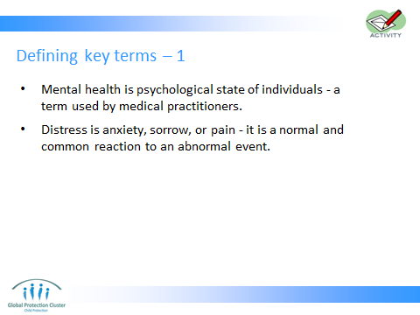

- Mental health is a term used by medical practitioners to refer to the psychological state of individuals. Being in good mental health is defined by WHO as: "a state of well-being in which the individual realises his or her own abilities, can cope with the normal stresses of life, can work productively and fruitfully, and is able to make a contribution to his or her community.” Health workers will refer to work they are doing to help address psychological concerns or mental health problems in the same way child protection or education workers refer to psychosocial problems. More clinical and severe concerns (e.g. post-traumatic stress disorder, schizophrenia and bipolar disorder) would be categorised as mental health concerns rather than psychosocial distress
- Distress: is anxiety, sorrow, or pain, is a normal and common reaction to an abnormal event. A type of stress that is experienced as unpleasant, and causes various stress reactions in the person.

References:
- WHO - http://www.who.int/mediacentre/factsheets/fs220/en/ - Definition of Mental Health

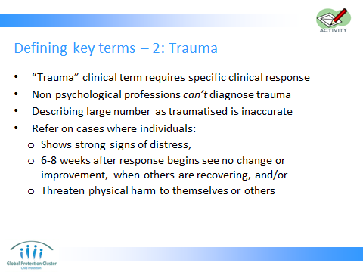

- “Trauma” – can refer to an event (a physical injury or something that has happened) or can be way to describe the emotional reaction an individual shows. When describing individual’s reactions, it is important to note it is a clinical term requiring specific clinical responses. Non psychological professionals can’t diagnose trauma. Describing large numbers of the population as traumatised is inaccurate. Its general use is counterproductive to healing as it infers individuals are too affected to recover.
Refer on cases where individuals:
  - Shows strong signs of distress,
  - 6-8 weeks after response begins you see no change or improvement, when others are recovering, and/or
  - Threaten physical harm to themselves or others

- Reference: IFRC (2003) Community-based Psychological support: A training manual – In particular paragraph titled “Care with terminology” on Page 28

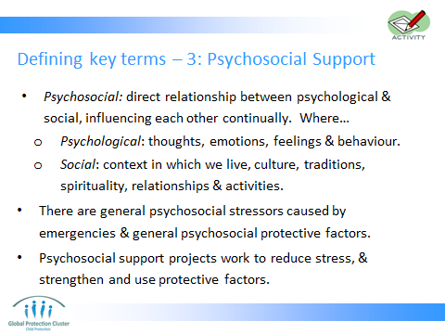

Psychosocial indicates direct relationship between psychological & social, each influencing the other continually. Where…
  - Psychological: mind, thoughts, emotions, feelings and behaviour
  - Social: context in which we live, culture, traditions, spirituality, relationships with immediate and extended family, community, school and professional activities
There are general psychosocial stressors caused by emergencies
  - E.g. Economic hardship, Social disruption (separation from family, disappearance of family members, downward change in social role), Physical/psychological violence, Ethnic persecution, Loss of home/ country/ family/ friends / material goods, Danger/abuse, Stress caused by flight / Uncertainty about the future/ etc
And general psychosocial protective factors also exist
- Individual coping abilities, Family strength and unity, Social network, Ideological/political/religious consciousness
Psychosocial support projects work as much as possible on the reduction of stress, as well as on strengthening and use of protective factors.

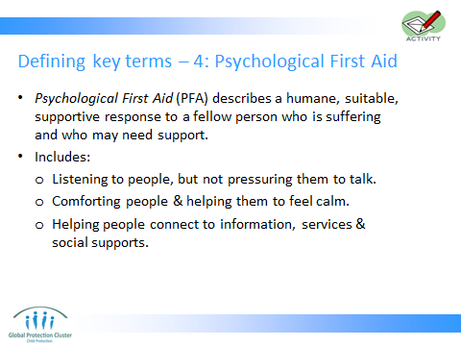

- Psychological first aid (PFA) describes a suitable, supportive response to a fellow person who is suffering and who may need support. (IASC, 2007) It is a communication tool, a way of communicating and supporting an individual to help them to get better
PFA involves the following:
- providing practical care and support, which does not intrude;
- assessing needs and concerns;
- helping people to address basic needs (for example, food and water, information);
- listening to people, but not pressuring them to talk;
- comforting people and helping them to feel calm;
- helping people connect to information, services and social supports;
- protecting people from further harm.
PFA is NOT:
- It is not something that only professionals can do.
- It is not professional counselling.
- It is not “psychological debriefing” in that PFA does not necessarily involve a detailed discussion of the event that caused the distress.
- It is not asking someone to analyse what happened to them or to put time and events in order.
- Being available to listen to people’s stories, but not pressuring people to tell you their feelings and reactions to an event.

- Reference: WHO (2011) Psychological first aid: Guide for field workers

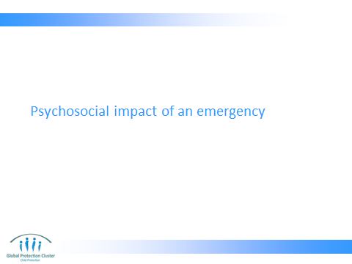

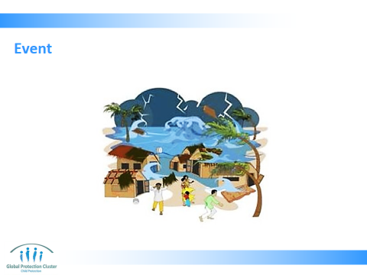

Feeling the PSS Cycle: Part 2 (3mins)
As you turn to Slide 13:
- The possibility of carrying out this activity depends on the context and the experiences of the participants in the room. It must be adapted to context and consideration needs to be made to ensure it does not cause distress for participants.
- Just before turning to this slide find a way to create a disturbance, it could be someone outside the room calling out to someone else, the door being opened and closed, a chair being knocked over, someone walking in clapping hands, music suddenly coming on very loudly or the facilitator dropping a pile of books. Alternatively ask a co-facilitator to leave the room suddenly so that everyone sees or hears as they move and this causes a disruption. The disruption should create some form of surprise or confusion but not distress. Try to make sure it is not a noise that resembles either gunshots or bomb-blasts as participants may have lived through those noises recently. The aim of this exercise is not to create real distress, but just to make us think about reactions to surprise events.

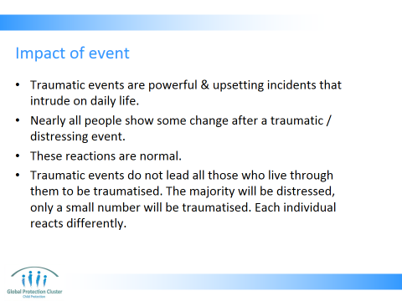

When on Slide 14: Discuss with the group:
- Traumatic events are powerful & upsetting incidents, experiences that are life threatening or with significant threat to physical or psychological wellbeing, that intrude on daily life.
- A traumatic event involves a single experience, or an enduring or repeating event or events, that completely overwhelm the individual's ability to cope or integrate the ideas and emotions involved with that experience
- Distress and / or trauma are normal reactions to a traumatic event. Traumatic events do not lead all those who live through them to be traumatised. The majority will be distressed, only a small number will be traumatised.
- Examples of traumatic events include: a flood, cyclone, drought, earthquake, tsunami, mass displacement, conflict, fighting, political violence, civil unrest. Acts of violence such as an armed robbery, war or terrorism, interpersonal violence such as rape, child abuse, or suicide of a family member or friend, involvement in a serious motor vehicle accident
- Other less severe but still stressful situations can trigger distress or trauma in some people. Intensity of the event doesn’t necessarily determine degree to which someone is affected, each individual reacts differently. Pre-existing stressors/conditions; the current daily stressors; & traumatic event the individual lived through as well as individual resilience all play a part in the degree to which someone shows distress
- Each individual can react differently. The intensity of the event does not necessarily determine the degree to which someone is affected. Pre-existing stressors/conditions; the current daily stressors; and the traumatic event the individual lived through as well as individual resilience all play a part in the degree to which someone shows distress

References: Action by Churches Together Intl (2005) COMMUNITY BASED PSYCHOSOCIAL SERVICES IN HUMANITARIAN ASSISTANCE: A FACILITATOR’S GUIDE

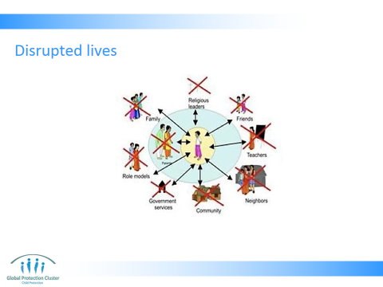

Feeling the PSS Cycle: Part 3 (5 mins)
- When you turn to Slide 15 ask everyone to get up and walk around, no need to bring their things with them, then ask them to sit in a different place to where they started. Act as if you are going to restart the session. But then, pause, reconsider, and look at them and ask them to get up again and move around again, so they sit elsewhere (still not their original seats). Again, pretend you are going to start session, then seem to change your mind again. Finally ask them to stand up one final (third) time to come back to their original places. Seem undecided and unsure each time you ask them to change position.
- If asked do not explain what you just did, but explain it will all come clear at the end of the PSS session.

Still on Slide 15, when everyone is back in their original places explain the following:
- When there is a traumatic event, a child’s environment is disrupted
- The child’s psychosocial supports and interactions are disrupted and change. They do not have the things they are used to or need.
- This leads to a loss of sense of place.
- Daily stressors can exist prior to emergency, but can also result from the event (poverty, loss of home and livelihoods, lack of services, etc.) and also contribute to distress or even potentially trauma
- The humanitarian response itself may cause distress (the way distributions are targeted or given out, presence of strangers in the community, etc). Efforts should be made to keep this form of stress to a minimum
- Each child reacts differently, to different sources of stress that come before, during or after the event

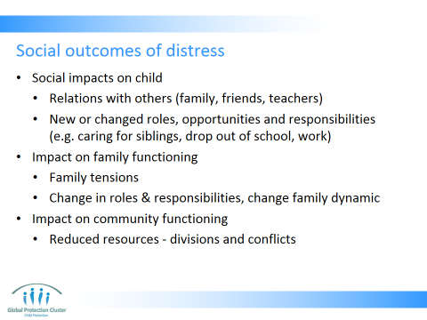

- Run through Slide 16 outlining the outcomes of stress on society and children

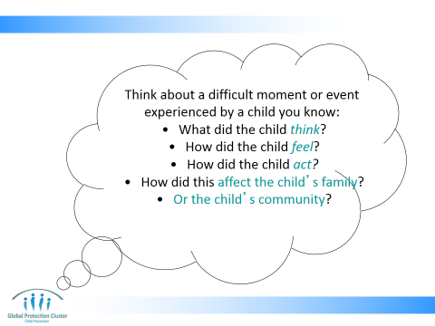

Reflection: Part 1 (5mins)
- For Slide 17 ask participants to close their eyes and think back to the situation of a child they know who lived through an emergency or difficult event
- Remind participants not to think of a situation that is too difficult for them to think about, we do not want to cause distress during the course of this workshop
- Assure them that they will not share this with anyone here today
- Read the questions below aloud and then give the participants some time after each question to consider the answers in their own minds
- Ask participants to take a few moments to think back to that situation and remember the child’s
- Feelings?
- Thoughts?
- Actions?
- How the experience affected their families? Their friends? Their community?

IMPORTANT NOTE: Remind participants that it is very important that they are careful not to think of things that may distress them, it is better to think of a situation that will not upset you.
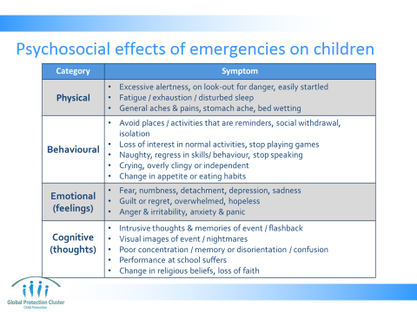

- Slide 18 Present the slide explaining the different categories of symptoms of distress – the different ways children show their distress.
- Refer back to the child development session, mention that the way distress manifests itself differs by age
- Some signs of distress are universal, others vary from one context to another depending on culture
- Give participants the opportunity to ask questions, comment, give additions, and / or discuss after each category of symptoms
- Ask the group if they can identify certain “signs” listed here that they think would not happen in this culture?
- Are there additional signs that happen in this context that are not listed?

The way distress manifests itself differs by age – refer participants to the relevant handout

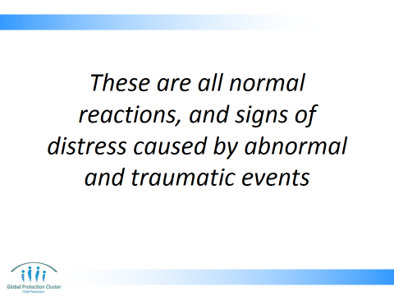

- Present Slide 19

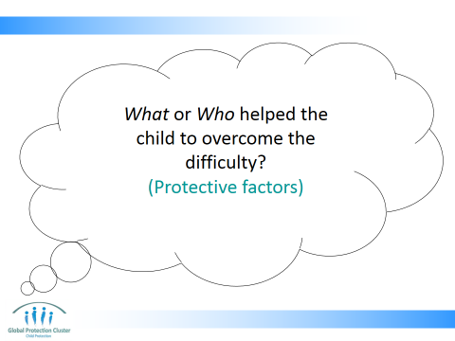

Reflection: Part 2 (5mins)
Slide 20
- Ask participants to think back to the child’s case they thought of earlier
- Ask participants to now think of what or who helped the child get through this difficult experience
- Something within the child themselves (ideas, beliefs)
- Other people
- Outside supports available in the community
- Risk and protective factors were discussed in the last session… are there any additional ones to add now you have a specific example in mind?
- Explain that our work focuses on providing / delivering or encouraging the existing protective factors, whilst reducing the risks

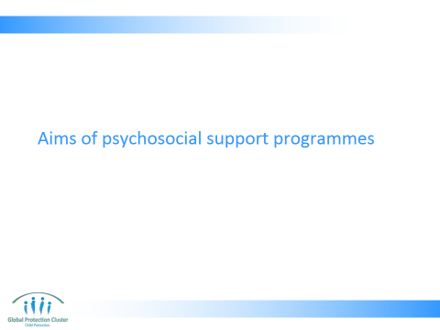

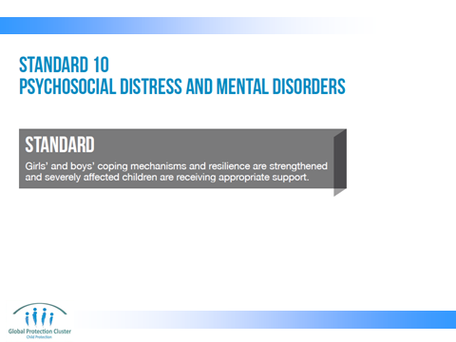

- Use Slide 22 to present the CP Minimum Standard 10, on Psychosocial Distress and Mental Disorders

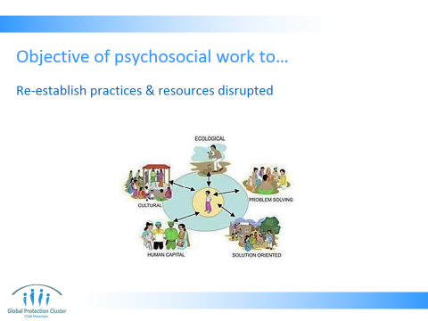

- Use Slide 23 to explain how our work aims to:
- Establish a sense of place for the child within the new community by creating a new sense of order, structure and routine – building on what is familiar, what exists, and the child’s own resilience, as well as giving other new supports.

We need to assess the sources of distress (pre-event stressors, traumatic event, post-even daily stressors), and then tailor our responses so they address these sources of distress – this requires collaboration with other sectors.
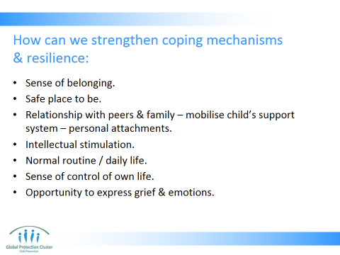

- Slide 24 lists some of the outcomes we can achieve by strengthening community and children’s coping mechanisms and resilience
- A sense of belonging
- A safe place to be - Ensure child is in a stable and nurturing family style environment
- Relationship with peers
- Personal attachments
- Intellectual stimulation
- Normal routine / daily life - Enhance routine and structure in children’s lives. Re-establishing age and gender appropriate daily routines, including schooling, recreational activities, community activities
- Sense of control over one’s life
- Opportunity to express grief and other emotions – not to be forced

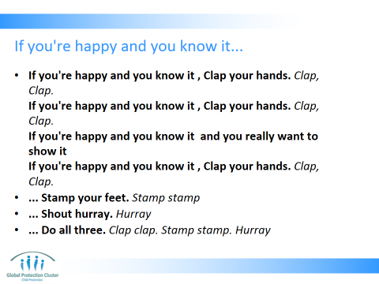

Feeling the PSS Cycle: Part 4 (2 mins)
- Slide 25 – get the group to stand up quickly and sing along with you. If you are not familiar with the song “If you’re happy and you know it…” watch the YouTube clip at http://www.youtube.com/watch?v=FrsM9WggCdo

If you're happy and you know it
Clap your hands. Clap, Clap.
If you're happy and you know it
Clap your hands. Clap, Clap.
If you're happy and you know it
and you really want to show it
If you're happy and you know it
Clap your hands. Clap, Clap.
If you're happy and you know it
Stamp your feet. Stamp stamp
If you're happy and you know it
Stamp your feet. Stamp stamp
If you're happy and you know it
and you really want to show it
If you're happy and you know it
Stamp your feet. Stamp stamp
If you're happy and you know it
Shout hurray. Hurray
If you're happy and you know it
Shout hurray. Hurray
If you're happy and you know it
and you really want to show it
If you're happy and you know it
Shout hurray. Hurray
If you're happy and you know it
Do all three. Clap, clap, stamp stamp, hurray
If you're happy and you know it
Do all three. Clap, clap, stamp stamp, hurray
If you're happy and you know it
and you really want to show it
If you're happy and you know it
Do all three. Clap, clap, stamp stamp, hurray
[End with round of applause]
[http://www.youtube.com/watch?v=FrsM9WggCdo]

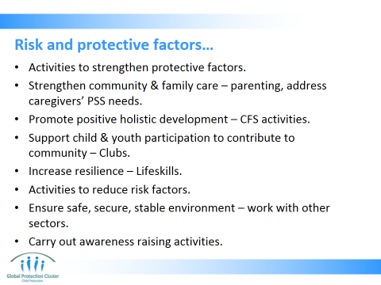

- Slide 26 – Present the specific activities that can help achieve PSS outcomes we seek. Refer back to the exercise done and definitions presented in the session on Child Development and Emergencies to clarify what protective and risk factors are
- You may want to ask participants to provide concrete examples of programming responses which they know or have experience of
- Refer participants to PSS Resource “Resilience and Coping” in the participants handbook

Psychosocial support work contributes to reduction of risk and promotion of protective factors by…
- Strengthen family and community care-giving structures for children - Strengthen local networks that enable child protection, care, and wellbeing, such as women’s groups or religious networks
- Promote children’s holistic development and age-appropriate physical, cognitive, and emotional competencies - Reduce long-term negative psychological effects
- Support children’s and youth’s voice and full participation in all phases of programming
- Improve person’s ability to function under stress
- Foster a secure and stable environment for children - Reducing risks to children’s safety and emotional well-being while promoting an environment conducive to positive development, effective coping, and resilience
- Carry out awareness raising activities so adults (parents, teachers, other adults in contact with children) understand risks to children and how to prevent these
All the above contribute to restoration of practices & resources disrupted by crisis, or even possibly a process of building back better

Resources - Copies of the hand-out “Resilience & coping”

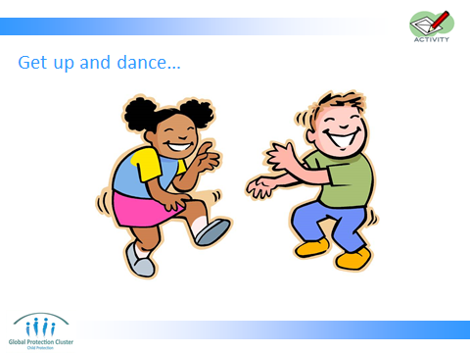

Feeling the PSS Cycle: Part 5 (5 mins)
- Slide 27: Ask participants to get up and dance on the spot
- Play some energetic, lively, fun and happy music and ask participants to get up and dance on the spot
- For those who are less comfortable doing this, tell them they can sway on the spot, jump, skip, walk around the room, clap, whatever movement makes them feel comfortable.

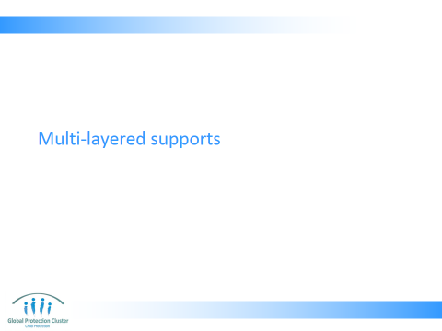

Activity: Multi-layered supports (15 mins) Slide 29
- Divide the participants into 4 groups
- You can either assign each group with:
- (A) One of the four levels of the PSS pyramid (“specialised services”, “focussed non-specialised support”, “community and family supports”, “basic services and security”) (Slide 30)
- (B) A category of actors – e.g. CP workers, Education workers, Community based organisation, Camp Management Cluster, teachers, CF Space manager, etc) (Slide 31)
- Ask the groups to consider their level of the pyramid / category of actors only
- They need to answer the following two questions:
- If groups according to categories (A) (Slide 30)
- From your experience, identify WHAT interventions or activities we can do at that level of the pyramid. Write these on green cards (5 mins)
- Think about WHO should conduct the different activities at that level? Write these on red cards (5mins)
- If in groups according to categories (B) (Slide 31)
- What PSS activities can they do for children and communities?
- Which level will these activities fall into?
- Have the groups pin their cards on to the pyramid on the wall

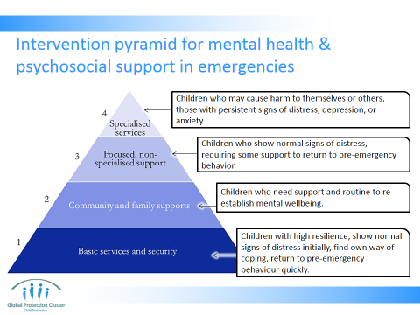

- MULTI-LAYERED SUPPORTS
- Talk through the diagram on Slide 29
- Summarise key things to consider:
- War and natural disasters cause distress for individuals & societies, most individuals & societies are able to cope
- Sometimes levels of distress reach such great proportions people struggle to cope, trauma happens when an individual cannot cope
- The likeliness of speedy recovery increases when appropriate support is provided at an early stage, and the risk of long-term mental health problems is reduced dramatically

- Ask the group to vote for which level they think most children fall into? What level of supports most children need to recover?

- Resources - Two different coloured cards
Copy of MHPSS pyramid as on slide 30, drawn on to two sheets of flipchart paper taped together

Talk through the diagram above. Highlight the following:
- War and natural disasters cause distress for individuals & societies
- Most individuals & societies are able to cope
- Sometimes levels of distress reach such great proportions people struggle to cope
- Trauma happens when an individual cannot cope
- The likelihood of speedy recovery increases when appropriate support is provided at an early stage, and the risk of long-term mental health problems is reduced dramatically
- All children (and communities) need level one support, this will help PSS wellbeing
- All the levels build on each other. Each level needs to be in place for a community to support all children who have varying needs, including helping them to access specialised help

Ask the group to vote for which level they think most children fall into? What level of supports most children need to recover?

- IASC Guidelines on Mental Health & Psychosocial Support in Emergency Settings, 2007

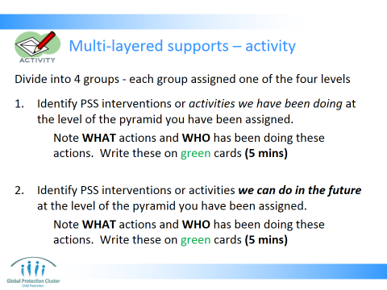
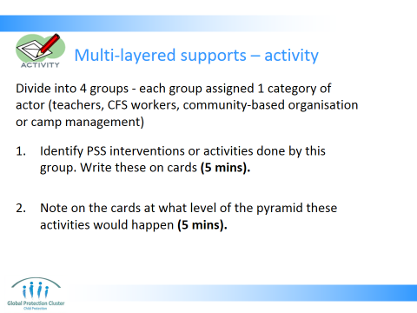

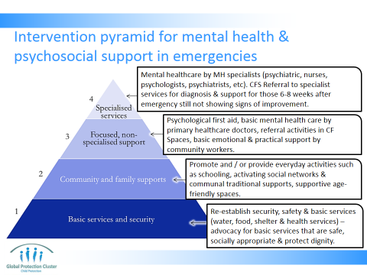

Level 1: The majority need support which addresses daily stressors. The kinds of response activities for this include: Re-establishing security, safety and basic services (water, food, shelter and health services) for the whole community across all sectors of the response & advocacy for basic services that are safe, socially appropriate & protect dignity.

Level 2: Support needed by smaller number of children. Promote and / or provide everyday activities such as schooling, activating social networks & communal traditional supports, supportive age-friendly spaces. Process for helping children to access supports they would normally get from community and family. (Support which is disrupted by the emergency). Social and recreational activities for children, including theatre, dance, play, art,

Level 3: Support needed for the still smaller number of children (for example, survivors of gender-based violence or recruitment) who also need more focused individual, family or group action from workers who have received some training in specialised care (e.g. para-social workers). This layer includes psychological first aid – this enables children to find a safe space in which to discuss the experiences they lived through, should they want to. basic mental health care by para-social workers and structured psychosocial groups with children or parents

Level 4: Small percentage of the population who, despite the support already mentioned, cannot bear their suffering and who may have significant difficulties in their basic daily functioning. These children may have pre-existing mental health disorders not related to the disaster but worsened by it. CP actors role is the referral to more specialist services for diagnosis and support. Treatment for this level of trauma and distress require long-term extended, professional and trained support. Starting a counselling process without completing it poses a danger to mental health.

- Reference: CPWG (2012) Minimum standards for Child Protection in Humanitarian Action

Plenary discussion: Run through the following questions on to facilitate a debrief on the activity
- What types of activities have you included? Are there activities that are:
- Specifically child protection activities?
- Activities integrated with other sectors?
- Why did you chose the activities you did?
- Where is focus of most activity? Why?
- Who is responsible for delivering these activities?
- Present Slide 32 – 33 to summarise your debrief

For the different levels points to raise include the following:
- Level 1: The majority will need support, which addresses daily stressors. The kinds of response activities for this include: Re-establishing security, safety and basic services (water, food, shelter and health services). These are supports to be provided by the whole community, and actors across all sectors of the response
- Level 2: Promote and / or provide everyday activities such as schooling, activate social networks & communal traditional supports, establish supportive age-friendly spaces. This can involve CP and education actors, CBOs and LNGOs, religious groups
- Level 3: Process for helping children to access supports they would normally get from community and family. (Support, which is disrupted by the emergency). Social and recreational activities for children, including theatre, dance, play, art, psychological first aid – this enables children to find a safe space in which to discuss the experiences they lived through, should they want to. It also allows them time to carry out “normal” pre-emergency activities which contribute to their learning and development include PFA and basic mental health care. CP and education actors, CBOs and LNGOs, religious groups who have received some level of training and capacity building
- Level 4: Referral to specialist services for diagnosis and support. This is for a minority of children. Treatment for this level of trauma and distress require long-term extended, professional and trained support. Starting a counselling process without completing it poses a danger to mental health. This is why we are not, as short-term humanitarian responders, able to provide these forms of services. The lack of skilled staff who can provide medium to long term support

Key points:
- The groups should recognize that psychosocial well-being for the largest proportion of the population, will be promoted by ensuring their security and access to services, and enhancing the abilities of the community and families to support each other. So lots of focus on level 1 and 2, as they help most people to get back to a state of psychosocial wellbeing
- “Counselling’ is inappropriate as a short-term intervention in an emergency setting, so we are not well positioned to provide this form of support
- Exposure to daily stressors after the traumatic event also makes children more vulnerable to further mental distress.

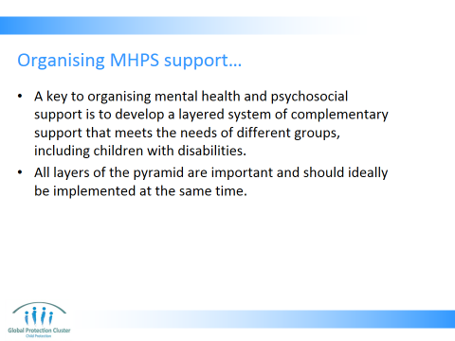
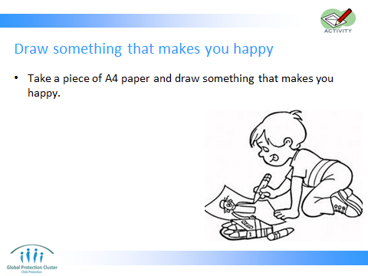

Feeling the PSS Cycle: Part 6 Slide 34 (2 mins)
- Ask participants to take a piece of A4 paper
- Ask them to draw something that makes them happy, something that makes them smile
- Tell them they will not have to share this with anyone else, so they can draw whatever they like

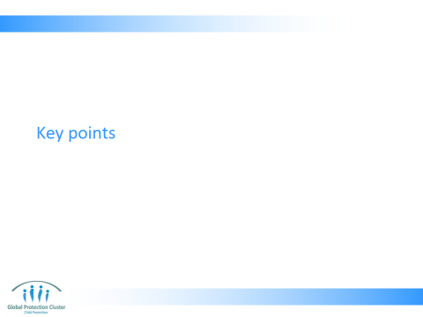

- WRAP UP & CLOSE THE PSS SESSION
- Using Slides 36 & 37 wrap up the discussion on PSS
- Underline that psychosocial support should seek to address a variety of these different forms of support to children and link with others to ensure holistic needs of children are being addressed – this will increase overall wellbeing.

Key messages:
- Child Friendly Spaces are one of a range of interventions that can be used to address the psychosocial support needs of children and their families in emergencies. Many other PSS options are not directly facilitated by child protection agencies, but are implemented by other actors. For example meeting basic needs for food, water, and shelter can reduce pressure on parents to provide for their families and thus reduce stress. Security services in camps can make people feel safer and reduce distress.
- Addressing PSS needs requires collaboration across sectors, most notably Child Protection, Education, GBV and Health, but also all other sectors contributing to the humanitarian response
- Only a small proportion of children are traumatised and need specialist care and support. They should be referred to medical professionals and continue to receive general community based support where suitable. Most child protection actors in emergencies focus a large proportion of their initial activities on levels 1 and 2 of the MHPSS Pyramid in coordination with other sector actors. Referral to specialist support providers enables children to access services at level 3 & 4 of the pyramid. As the programme response continues, they may start to provide more specialised services. Psychosocial support programmes help the majority of children recover. Few children need intensive specialised support.

- Resources - Copies of hand-out “Communication for Coping: Discussing the Emergency with Children”
- Copies of hand-out “The Basic Principles of Psychosocial Work”

Make copies as hand-outs of Pages 9- 13 of the IASC Guidelines on Mental Health and Psychosocial Support in Emergency Settings

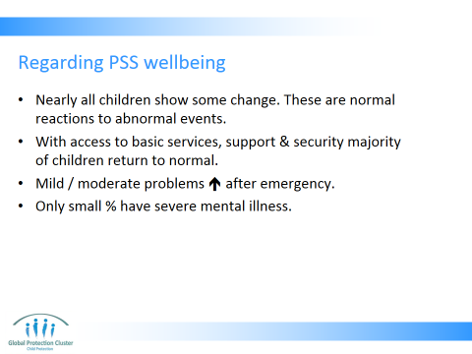

- Nearly all children will show some changes in emotions, behaviour, thoughts and social relations in the short term
- These reactions are normal, and with access to basic services, support and security the majority of children will regain normal functioning
- Mild or moderate mental health problems may increase slightly after an emergency
- A very small percentage of people will have severe mental illness or trauma - and need specialist care and support.

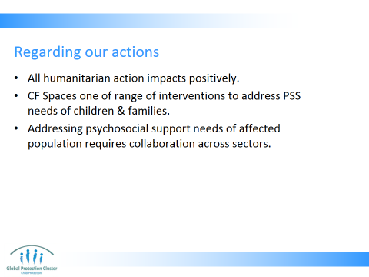

- All humanitarian interventions impact positively or negatively on MH and PSS well-being
- Child Friendly Spaces are one of a range of interventions that can be used to address the psychosocial support needs of children and their families in emergencies. Many other PSS options are not directly facilitated by child protection agencies, but are implemented by other actors. For example meeting basic needs for food, water, and shelter can reduce pressure on parents to provide for their families and thus reduce stress. Security services in camps can make people feel safer and reduce distress. Specialist counselling and support through trained mental health care providers.
- Addressing PSS needs requires collaboration across sectors, most notably Child Protection, Education, GBV and Health, but also all other sectors contributing to the humanitarian response

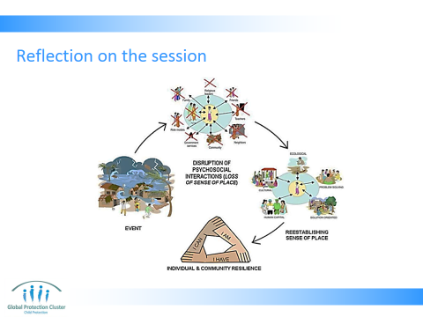

Feeling the PSS Cycle – Conclusion:
- Slides 38
- Ask participants to think back over the PSS session and consider the different feelings they had when there was… (Get 1 to 2 responses for each question, not more)
- The gentle calming music when they arrived?
- The sudden disruptive event?
- The exercise where we kept asking them to move from one seat to another?
- The singing?
- The dancing energiser?
- The drawing activity?
- Overall how did each of these activities make them feel? Take one or two comments from each group, not more
- Do they feel PSS work could help children after emergencies (the shock) and when dealing with daily stressors to feel better?
- Use these discussions to raise the point that to help children after a shock event and the following chaos, we need to use different methods to appeal to different children (talking, thinking and reflection, dancing, listening to music, sense of order and structure) in order to make them feel better (not everyone liked equally the drawing, singing or dancing)
- Wrap up by explaining that this process was meant to emulate an emergency and what PSS provides for children. Calm in normal life, event, disruption, then ability to express yourself, followed by re-establishing of calm and routine.
- Activities we are doing through the course of the workshop demonstrate how routine can be comforting: knowing what time we start, take breaks, have lunch, which group we work with, where we sit, all help us to feel at ease. We try to recreate this for children in PSS work we do

- After the conclusion of the discussions refer participants to tools in their toolkits:
- Communication for Coping: Discussing the Emergency with Children
- The Basic Principles of Psychosocial Work
- Photocopy or print out pages 9 - 13 of the IASC Guidelines on Mental Health and Psychosocial Support in Emergency Settings and give a copy to each participant as a hand-out.

Discussion in plenary:
- Ask participants to think back over the PSS session and consider the different feelings they had when there was…
- The gentle calming music when they arrived?
- The sudden disturbing “event”?
- The exercise where we kept asking them to move from one seat to another?
- The singing?
- The dancing energiser?
- The drawing activity?
- Overall how did each of these activities make them feel? Take one or two comments for each question, not more
- Do they feel PSS work could help children after emergencies (the shock) to feel better?
- Use these discussions to raise the point that to help children after a shock event (the sudden disturbing event) and the following chaos, we need to use different methods to appeal to different children (talking, thinking and reflection, dancing, listening to music, sense of order and structure) in order to make them feel better

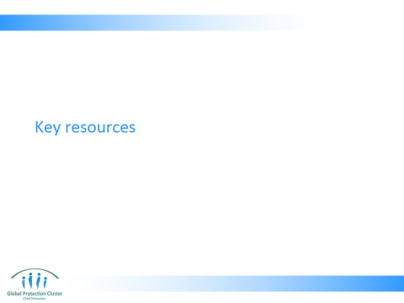

- Use the Resource Slide 40 showing participants samples of each of the materials.

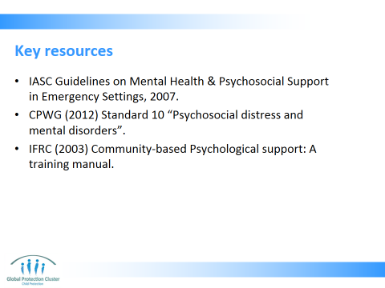


This slide is for the end of each session… prompts for questions, check in and even a 5 minute break, ice breaker as needed.

