Hand-out: Finding and telling stories in the data
Steps |  | Instructions
Find the story hidden in the data |  | - Use inductive or deductive reasoning and undertake visual analysis to start interpretation/identification of potential data stories.  - Use comparisons: categorical and proportions, ranking, values, range and distribution, context, hierarchies, etc.  - Find trends: up and down vs. flat, linear vs. exponential, steady vs. fluctuating, seasonal vs. random, change rate vs. steepness, etc.  - Find patterns, or lack of: Exceptions, outliers, intersections, correlation, connection, clusters, associations, gaps, etc.  - Pick an indicator and ask: What is the level and the rate of change for the considered area? How do different subgroups/regions etc differ? What is driving the change? How much changes affect other aspects of life? How does this compare with other countries?  - Define the storyline that readers would value from the visualization and what stories you wish to tell with what you are showing.  - Finding stories is using visualization techniques to familiarise, learn about and discover insights from data.
Tell the story |  | - Scientists start with details and build to a conclusion. Journalists start with the conclusion, and then give supporting details. Be like a journalist!  - Identify and present only key results, not details.  - Focus on what the numbers really mean for your audience.  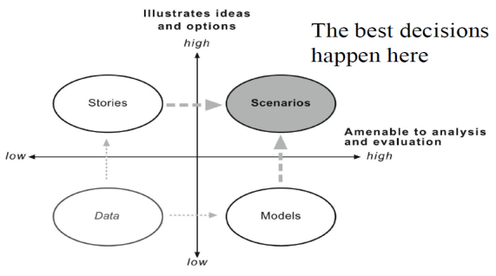  - Users need explanations, interpretation and comments. Reveal the unexpected, the relevant, the truth behind the data. Guide users along the journey to find their answers.  - Don’t confuse what’s countable with what really counts: Many of the most important things in life can’t be quantified, so don’t focus just on the numbers– they aren’t everything.  - Know the characteristics of message that stuck: Simple, unexpected, credible, concrete, and emotional.  - Telling stories is identifying and caring for the reader, taking responsibility to maximise their potential insight.

