

SESSION PLAN FACE SHEET

TRAINING COURSE: CPRA Training of Trainers |  |  | SESSION 14: Training of Trainers
TIMING: 2 HOURS 5 MINS |  | VERSION: 1 | AUTHOR:  CONTRIBUTORS:
Session Aim:
For participants who will be encouraged to train others, to learn the basics of training

LEARNING OUTCOMES:
- Understand how we learn as adults
- Self reflection on own learning via Honey and Mumford
- Understand how to plan and build a training session
- Illustrate capacity to train others

Activity:

child protection Minimum STandardS:

CPIE COMPETENCY FRAMEWORK: N/A

REFERENCE(S): N/A

RESOURCE(S): | Classroom and multimedia equipment, computer based information.  PowerPoint, Flip Charts, various coloured marker pens, VIPP Cards, prepared posters for: learning agreement; car park; and acronyms.  

SESSION 14 – LESSON PLAN – TRAINING OF TRAINERS

TIME | OUTLINE – 2 HOURS 5 MINUTES
** RESOURCE REMINDER **
 | Honey and Mumford Assessment
INTRODUCTION
2 min | - For participants who will be encouraged to train others, to learn the basics of training  - Go through the learning outcomes
BODY
10 min | The basics of training
10 min | Revisiting our learning styles / Honey and Mumford
30 min | Preparing for a training workshop
30 min | Running a training workshop
30 min | Dealing with the difficult ones
15 min | Practice Activity
CONCLUSION
3 min | O | We now have an understanding of how to train
3 min | F | How does everyone feel? Any comments and / or questions?
3 min | F | This is now coming to the end of our training

SESSION 14 – NOTES FOR TRAINER – TRAINING OF TRAINERS

LEARNING OUTCOMES
- Understand how we learn as adults
- Self reflection on own learning via Honey and Mumford
- Understand how to plan and build a training session
- Illustrate capacity to train others

Trainer - This session aims to assist participants who will be encouraged to train others, to learn the basics of training

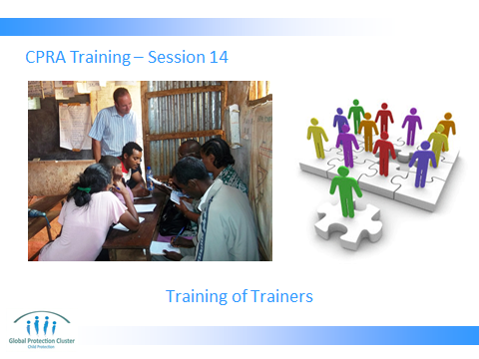



Using VIPP cards / flip charts to list all the words that come to mind.

Ask participants what comes to mind when they think of a high quality training?

What comes to mind when they think of a training that is not useful?

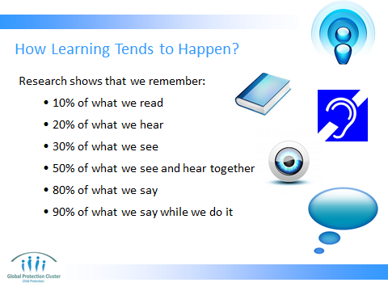

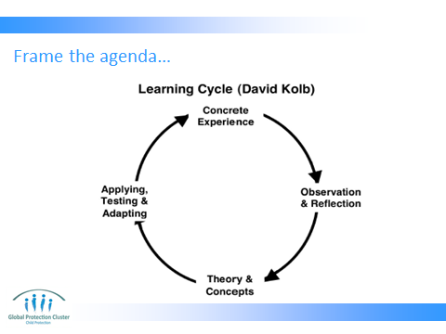

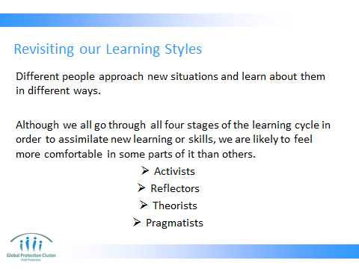

Ask them to again think of what learning style they had from honey and mumford?

Ask what this might mean for them as trainers?

