

SESSION PLAN FACE SHEET

TRAINING COURSE: CPRA Training of Trainers |  |  | SESSION 12: Data Management
TIMING: |  | VERSION: 1 | AUTHOR: Jean Merge  CONTRIBUTORS:
Session Aim:
For participants understand the various elements of data management and the tools available to them

LEARNING OUTCOMES:
- Understand how the data management tool works
- Adapt the data management tool:
  - Adding/removing a question
  - Replacing, adding and deleting an answer option
- Analyze and interpret data

Activity:

child protection Minimum STandardS:

CPIE COMPETENCY FRAMEWORK: N/A

REFERENCE(S): N/A

RESOURCE(S): | Classroom and multimedia equipment, computer based information.  PowerPoint, Flip Charts, various coloured marker pens, VIPP Cards, prepared posters for: learning agreement; car park; and acronyms.  

SESSION 12 – LESSON PLAN – DATA MANAGEMENT

TIME | OUTLINE –
** RESOURCE REMINDER **
 | Data Management Tools
INTRODUCTION
2 min | - For participants to understand the various elements of data management and the tools available to them  - Go through the learning outcomes
BODY
10 min | Data Management tools
25 min | Demonstrating how to modify the tools
5 min | Analysing and Interpreting Data
CONCLUSION
3 min | O | We now have an understanding of how to use the data management tools
3 min | F | How does everyone feel? Any comments and / or questions?
3 min | F | Next session we will be focused on our simulation

SESSION 12 – NOTES FOR TRAINER – DATA MANAGEMENT

LEARNING OUTCOMES
- Understand how the data management tool works
- Adapt the data management tool:
  - Adding/removing a question
  - Replacing, adding and deleting an answer option
- Analyze and interpret data

Trainer - This session aims to assist participants understand the various elements of data management and the tools available to them

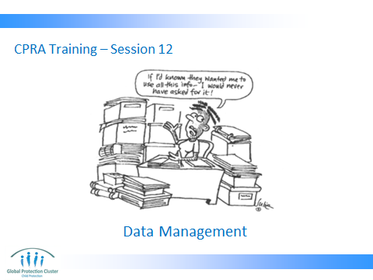

Trainer to go through the Learning Outcomes.

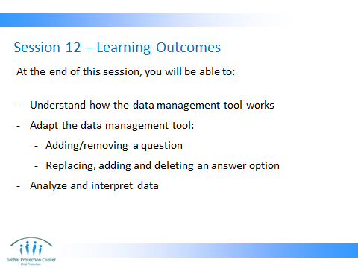

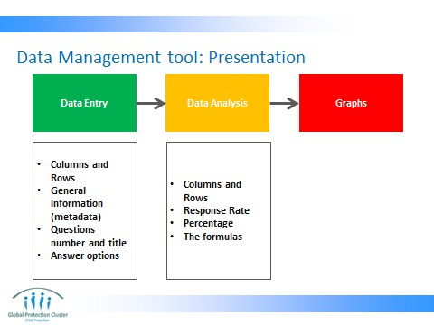

A tour of the data management tool: explaining what each worksheet contains and how each worksheet are linked together. Use the data management template – Questions at the end of each worksheet presentation

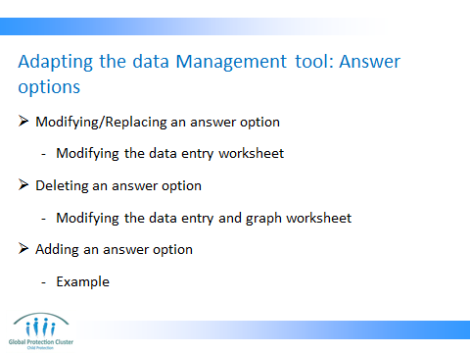

Show the participants how to modify the tool accordingly. If the facilitator is not familiar with adapting the excel tool, someone with advanced excel skills should be identified to teach this session. The facilitator should familiarize him/herself with the adaptation process (see pages 6 and 7 below – the short guide is also available within the excel file (sheet 2)).

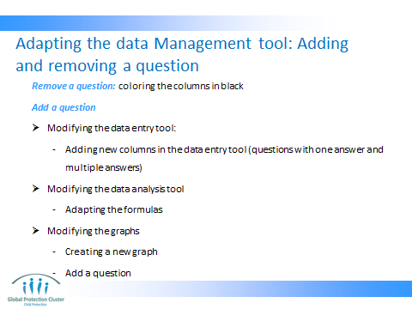

Show the participants how to modify the tool accordingly.

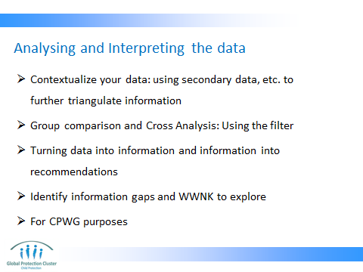

The reconciliation of primary and secondary data will reveal correlation, inconsistencies and information gaps.

Show them how to use the filter for group comparison and cross analysis. They should seek support for more complicated analyses as it requires analysis of the ‘thickness’ of the data; the robustness of the sampling design and data collection.

Identify information gaps and WWNK to explore: As it is a rapid assessment it should provide a way for further assessments and/or situational monitoring.

CPWG Purposes: OCHA Secondary data reviews, use in prioritisation, representing needs through a snapshot, choosing indicators for the sector for priority in the working group and the CAP/SRF



A short guide to the data management tool

1. The data management tool provides a platform for data entry and analysis. The source of data is the site reports. The analysis it provides is limited to basic frequency analysis. For more sophisticated analysis, please seek support from a data analyst.
2. This tool needs to match the headings, questions, answer options etc. you have used for the CPRA in your context. It is especially important that this tool matches the structure and questions in Tool 5: Site report as well as the answer options in Tool 2: Key Informant Interview Questionnaire (see Part 2: sample tools). If your data management tool does not match your adapted tools, it will not be possible to actually process the data you have collected through this excel file. You also have the option of developing your own data management tool/program if the necessary capacity exists in your context.
3. There are three main sheets in this tool: Sheet 1 - data entry; sheet 2 - analysis and sheet 3 - graphs. Data needs to be entered ONLY in the data entry sheet. Data analysis and graphs are automatically generated, based on the data in sheet 1.

4. The sheets are protected to avoid unwanted changes. However, you can un-protect the sheets, by going to the "review" tab at the top of your excel window and clicking on the "unprotect sheet" button.
5. If the changes you need to make are limited to the answer options, follow the steps 5.1 and/or 5.2 below:
(note: the answer options can be found underneath the main table on the data entry sheet in a grey font (row 107 and below).
5.1 if you are only modifying or replacing an existing answer option, you simply click on the respective answer option in the data entry sheet (grey font) and make your changes.
5.2 If you want to introduce a new answer option in addition to the existing ones (i.e. you need to add a row with a new answer option): you can simply add the new answer option to the bottom of the existing list of answer options for your respective question. In this case, you need to make modifications to the 'analysis' and 'graphs' sheets as well. See item 6 below for some explanation on how to do that."
6. If you need to make modifications to 'analysis' and 'graphs' sheets because you added additional answer options for existing questions, please follow these steps: (An example is presented to facilitate the explanation.)

Example: Imagine that during the adaptation, under question 1.1.1, you have added an option of "8. temporary community space". Now you need to add this to the list of existing answer options in the data management tool.
6.1. (step 1) right click on cell AP114 and click insert and then select ""shift cells down""
(step 2) add the new option (""8.temporary community space"") in cell AP 114 that is now empty.
(step 3) go to the 'analysis' sheet and highlight cells N20:N22 and right click. Then click insert and select "shift cells right". An empty slot opens from N20 to N22.
(step 4) click on N20 and press ""="". Then go to back to the data entry sheet and click on AP114 (the new answer option). This will link your new answer option to the anslysis sheet and you should see the option "8. temporary community space" in cell N20.
(step 5) select cell N21:N22 and drag both to the right to cover cell O21:O22. This way you have copied the formulas in those two new cells (O21 and O22).
(step 6) go to the 'graphs' tab. Find the graph that corresponds with the question you are modifying (Q1.1.1). If everything is done right, you will see the new answer option in the graph. If you don't, follow step 7.
(step 7) Right click on the graph and choose 'select data'. A new window will pop up that shows you where the data for that graph is coming from. You will see a formula in the box for 'chart data range'. You will see that the formula is only extended to column N (look closely. there are two letter 'N's in that box). You will have to change that letter N to also cover the new column that you added in step 2 and 3 above. To do so, you simply change both letter 'N's to letter 'O' and you click ok. Please note that you cannot use the right and left arrows in this box. You have to use your mouse to highlight the letter you want to change and type the new letter.

7. If you decide to add a new question, you need to properly code it in all three sheets If you are not sure how to do this, contact someone who is familiar with Excel databases. If you are doing an inter-agency CPRA, you may contact the child protection working group (CPWG) for technical support.

8. If you need to remove any questions, we recommend that you change the background colour of the column related to that question to black. You will have to do this in both the data entry and analysis sheets.

