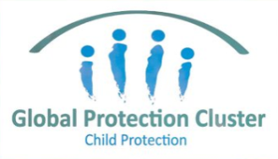

SESSION PLAN FACE SHEET

TRAINING COURSE: CPRA Training of Trainers |  |  | SESSION 11: Planning and Logistics
TIMING: |  | VERSION: 1 | AUTHOR: Hani Mansourian  CONTRIBUTORS: Natalie Mccauley
Session Aim:
For participants to demonstrate learning through planning a CPRA

LEARNING OUTCOMES:
- Describe the steps required for planning a CPRA;
- List the main items that should be included in an assessment plan;
- Explain the lessons learned from previous experiences with needs assessments.

Activity:

child protection Minimum STandardS:

CPIE COMPETENCY FRAMEWORK: N/A

REFERENCE(S): N/A

RESOURCE(S): | Classroom and multimedia equipment, computer based information.  PowerPoint, Flip Charts, various coloured marker pens, VIPP Cards, prepared posters for: learning agreement; car park; and acronyms.  

SESSION 11 – LESSON PLAN – PLANNING AND LOGISTICS

TIME | OUTLINE –
** RESOURCE REMINDER **
 | Desk Review Template
INTRODUCTION
2 min | - For participants to demonstrate learning through planning a CPRA  - Go through the learning outcomes
BODY
30 min | 6 Steps to Plan and Implement a CPRA
5 min | Data Collection teams
5 min | Daily Debriefing
5 min | Lessons Learned
CONCLUSION
3 min | O | We now have a clear idea of the steps we need to take to embark on a CPRA and the lessons learned
3 min | F | How does everyone feel? Any comments and / or questions?
3 min | F | Next session we will be focused on Data Management

SESSION 11 – NOTES FOR TRAINER – PLANNING AND LOGISTICS

LEARNING OUTCOMES
- Describe the steps required for planning a CPRA;
- List the main items that should be included in an assessment plan;
- Explain the lessons learned from previous experiences with needs assessments.

Trainer - This session aims to assist participants in the planning of a CPRA

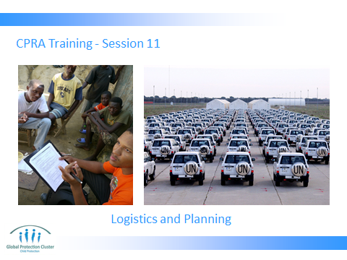

Trainer to go through the Learning Outcomes.

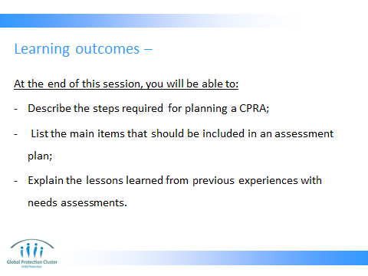

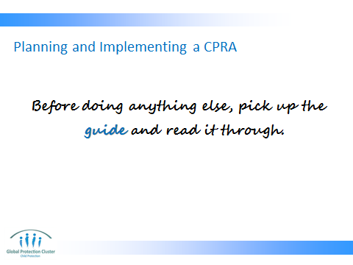

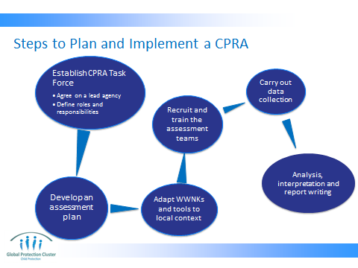

All these bubbles will be explained in detail in the following slides.

STEP ONE –
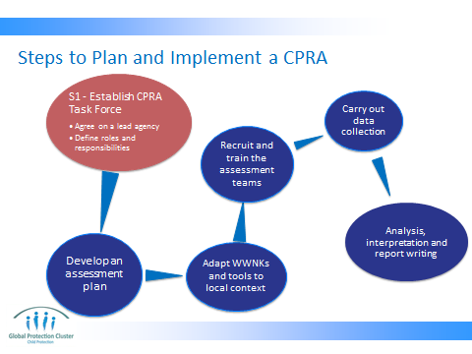

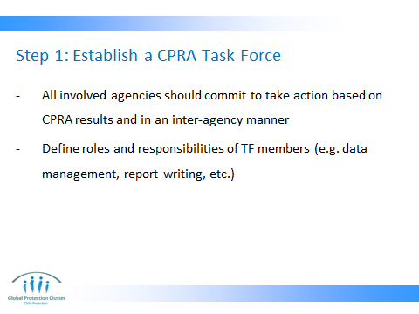

STEP TWO –
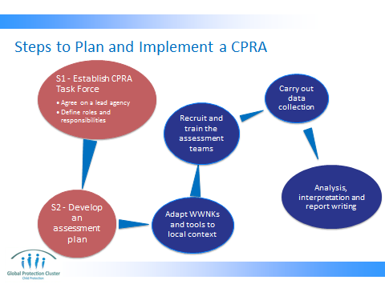

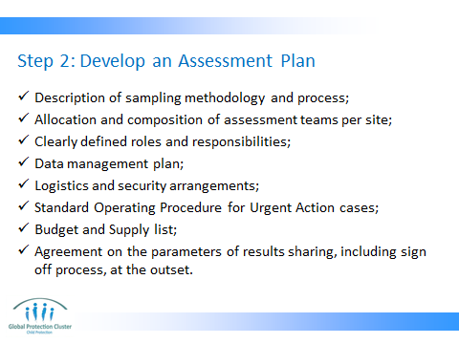

STEP THREE –

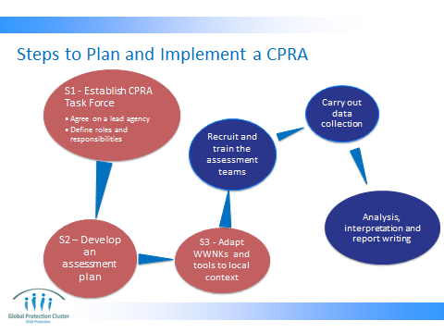

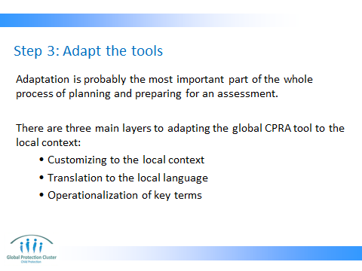

CUSTOMIZING TO THE LOCAL CONTEXT
- Requires thorough knowledge of the context and cultural issues
- Could sometimes mean taking a whole section out of the tool (for example sexual violence or association with armed groups have been taken out in some contexts).
- Often times it means adding or changing questions and/or answer options.

TRANSLATION TO THE LOCAL LANGUAGE
- In many cases, a translated version of the tool already exists. Make sure you ask the CPWG before spending the resources to translate.
- It is best to get help from people who were involved in adaptation of the tool for translation since they understand the reasons behind the questions.
- If the questions are translated by a non CP specialist, it is best to do a back-translation to makes sure the concepts are well reflected in the translation.

OPERATIONALIZATION OF KEY TERMS
- This is the process through which we ensure all key terms reflect the intended meaning. Terms such as child, violence, separation, foster care, child labour etc can have very different meanings in different languages. So simple translation is not always enough. Sometimes one word in a language needs to be translated into a whole sentence in another language.

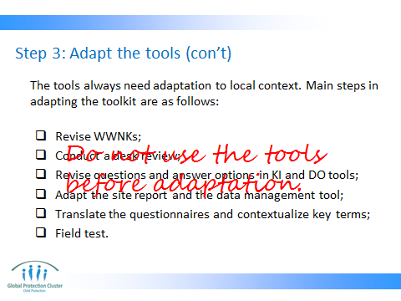

Field testing will provide the assessment team with invaluable information about the context that may not be available otherwise. This will ensure an effective adaptation of the tools that will in turn increase the reliability of the information collected during the assessment.

If time and resources do not allow for field testing it can be replaced with mock-interviews with individuals who have in-depth knowledge of the context.

STEP FOUR –

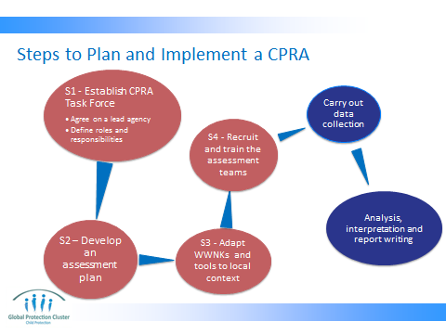
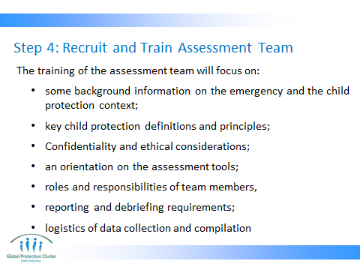
STEP FIVE –
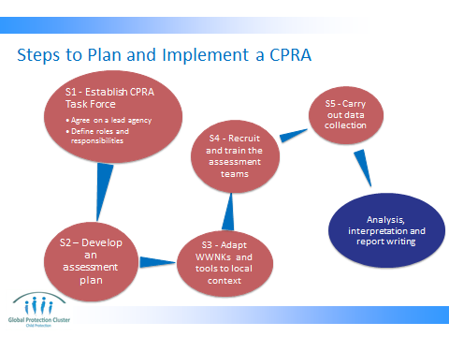

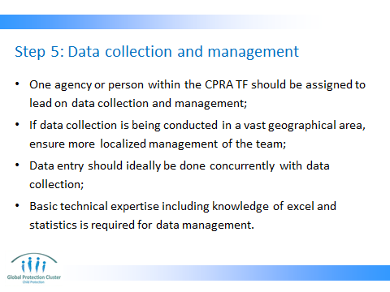
STEP SIX –

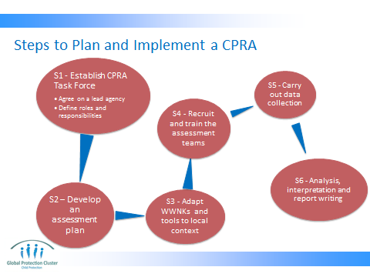

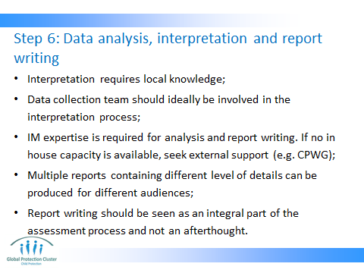

Remind the participants what interpretation is. You can do this by asking them or just telling them.

One way of explaining it is: “interpretation is the process of making sense of analysed data and connecting/translating them to programs”

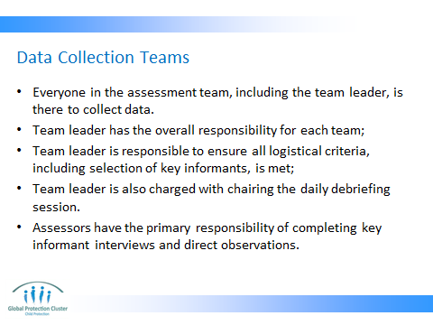

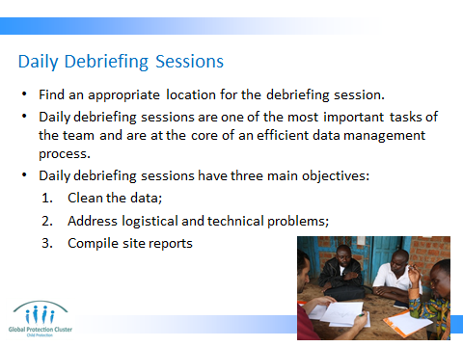

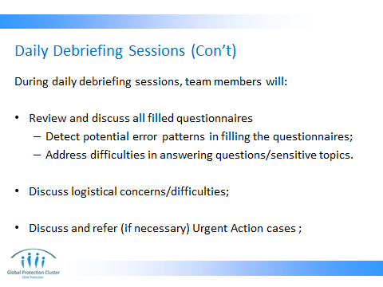

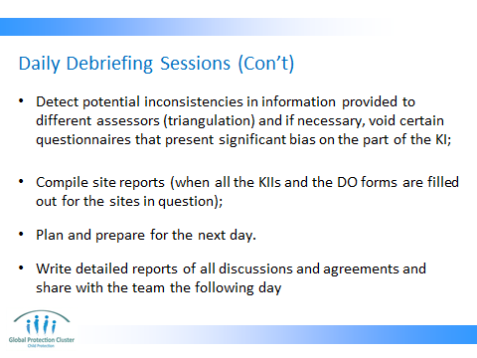

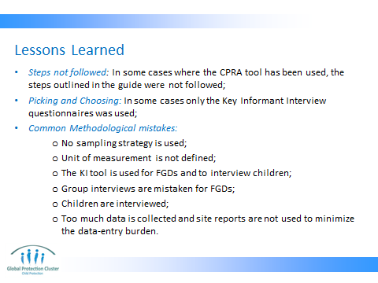

- STEPS NOT FOLLOWED: most such cases ended up having issues in analysis and report writing phase. Some had to abandon the process all together.

- PICKING AND CHOOSING: The CPRA toolkit has a coherent logic and should ideally be used as it is described in the guide. But there are situations where actors on the ground decide to only use parts of the CPRA toolkit. In such cases, it needs to be clearly mentioned in the report that the CPRA toolkit was not used as recommended for x and y reason. This will not only help the reader understand the methodology, but will also help the CPWG in adapting the CPRA toolkit in the long run.

- COMMON METHODOLOGICAL MISTAKES:
  - Due to time constraint and/or lack of capacity, in many occasions no systematic sample is drawn. This affects the reliability of the data for programming purposes. You can tell participants something to the effect of: ‘now that you are familiar with the sampling method, you have to make sure that a systematic sample is drawn for data collection’
  - Many practitioners are not familiar with the concept of unit of measurement. Therefore in many occasions data is collected at multiple levels and therefore it is not easy to compile and analyse them. You can say something to this effect: ‘as you know by now, defining the unit of measurement is necessary for a systematic sampling’.
  - The KI questionnaire is designed for individual interviews with adults. If you decide to conduct FGDs, you will have to develop a new questionnaire. The WWNKs can still be used for this purpose. Also, if you decide to interview children, an appropriate tool needs to be developed for that. The KI questionnaire on exceptions can be used for group interviews. But do not confuse that with a FGD.
  - Group interviews are different from FGDs. The main value added of FGDs is the natural flow of discussions and openness to emerging themes. But a good FGDs requires very skilled facilitators and a significant amount of time for organization and then analysis. Unfortunately, in most emergency contexts we do not have the time and human resources for this.
  - As said before, the CPRA does not encourage the use of children in the process. This is primarily to avoid any additional harm to affected children. You should only adopt this methodology if you have the means to ensure the ‘do no harm’ principle and also have the capacity to respond to any possible cases that may arise from the interview process.
  - There is a tendency to collect data without thinking about the time and energy it takes to manage the data and analyze it. It is important to have a clear analysis plan (as part of your assessment plan) to avoid collecting data that will not be analyzed.

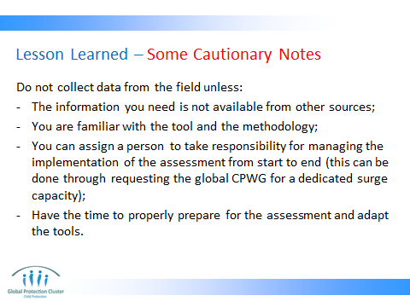

These are primarily repeats from things that have been discussed before. But it is important to remind the participants that assessments are heavy and time consuming processes. We should not embark on it unless it is necessary and unless we have thought the whole process through.



