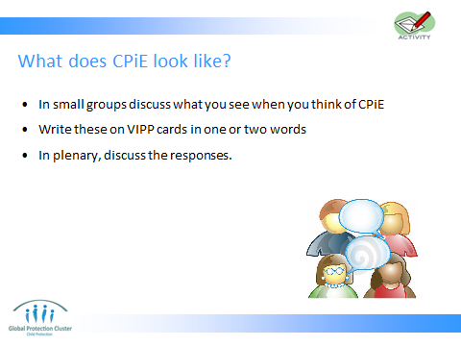
Using your words paint me a picture from your experience…
Paint me a picture of what child protection in an emergency setting looks like…
What would I be seeing?
Encourage strong visual descriptions rather than large words eg: if someone says ‘psychosocial support’ ask them, ‘what does that look like?
Ask what it looks like, what do I see?
Change the perspective – PHONE CALL ‘HOT SEAT’
- Put one participant out the front or prep one of the other facilitators / organisers with their back to the audience. They are now ‘grandma’.
- ‘Ring, Ring, Ring, Ring…’ – ‘Hello dear, lovely to hear from you… What is it again that you do?’
- Ask participants to describe their work to their granny.
- Granny is to respond as she would.
- Hot seat them – when one is struggling, replace them.
Key Messages –
- To be able to maximise our opportunities together, it helps if we are on the same page in understanding what we do in CPIE and what CPIE is.
- Emphasise the point that as a coordination group we need to understand each other.
- It’s actually not so much about explaining to others, but also about explaining to each other.
- It’s not always obvious even to each other what we mean by different interventions.
So… What is Child Protection in Emergencies?
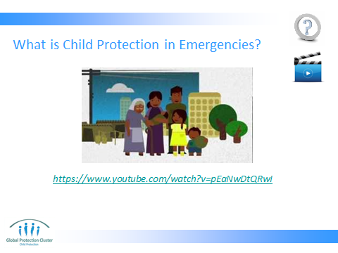
Play the “I am Samira” video.
*** Important to make sure technology, internet and speakers are all working prior to start of training ***
Unpack the video with participants.
What were the main CPIE issues?
What helped Samira? What did not?
Think about the elements of a CP system to address the issues she faced. Which actors were involved?
The session should end with a clearer understanding of what CPIE looks like and what we strive for it to look like – Laying a foundation of understanding on CPiE.


