

SESSION PLAN FACE SHEET

TRAINING COURSE: CPRA Training of Trainers |  |  | SESSION 1: INTRODUCTION
TIMING: 60 Minutes |  | VERSION: 1 | CONTRIBUTORS: Natalie McCauley
Session Aim:
To welcome participants and begin the process of creating a safe adult learning environment.

LEARNING OUTCOMES:
- Summarise the outline of the training
- Understand course purpose, objectives and agenda
- Develop clear participant expectations
- Establish a learning agreement

Activity:
- Introductions – getting to know each other – string game
- Development of a learning agreement
- Time keeper and eyes / ears volunteers

child protection Minimum STandardS: N/A

CPIE COMPETENCY FRAMEWORK: N/A

REFERENCE(S): N/A

RESOURCE(S): | Classroom and multimedia equipment, computer based information.  PowerPoint, Flip Charts, various coloured marker pens , VIPP Cards, prepared posters for: learning agreement; car park; and acronyms.  

SESSION 1 – LESSON PLAN – INTRODUCTION

TIME | OUTLINE – 60 MIN
INTRODUCTION
5 min | - This will be a quick hello and welcome, making sure all are ok, and the mood is good and introduction of the special guest speaker.
BODY
15 min | Special guest speaker. This speaker should be senior level from within a CPWG Member eg: UNICEF or SCA
10 min | To see the guest speaker away, if necessary
15 min | Participant introduction and expectations activity
2 min | Introduction of trainer(s)
10 min | Overview of training, methodology and learning outcomes
5 min | Develop learning agreement and introduce parking lot
CONCLUSION
3 min | O | So that session gives you a quick overview of the training to come and you have clearly communicated your expectations which we will do our best to meet.
3 min | F | This is a good start to the day recognising that this training is extensive and each day is packed full.
3 min | F | Next session we will look at humanitarian reform

SESSION 1 – NOTES FOR TRAINER – INTRODUCTION

LEARNING OUTCOMES
- Summarise the outline of the training
- Understand course purpose, objectives and agenda
- Develop clear participant expectations
- Establish a learning agreement


HANDY HINT – Remember as people arrive ask them to cut a piece of string for the introduction activity. The participant decides how long or how short the string is. Don’t explain the purpose.
HANDOUTS to be given on arrival: Folder with Day 1 HO; Pre-learning print outs; and a copy of the CPMS.

Welcome participants to the training.

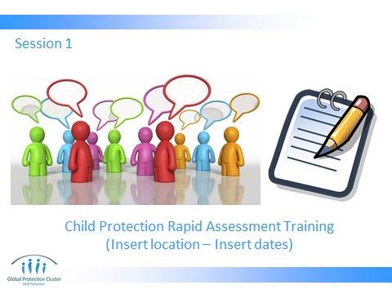

PART 1 – GUEST SPEAKER

Make the room feel relaxed and happy.

Introduce the guest speaker and / or organiser to introduce guest speaker.

HANDY HINT - Ensure you have met with both the organiser and speaker prior to the training to make sure it is clear how this introduction will proceed including if the guest speaker will stay for the entire introduction or will leave after their speech. Cultural considerations should also be discussed.



The guest speaker should be someone senior from UNICEF, Save the Children and / or the CPWG. The speeches should be motivational, stressing the importance of the training, and the expectations on the participants. The guest speaker(s) need to know that they have a very tight timeframe (5-10 mins) and it will need to be focused.

Once completed, kindly thank the guest speaker reiterating key messages to group and proceed as planned. See HANDY HINT above.
PART 2 – INTRODUCING ACTIVITIES

This is the beginning of the larger group introductions and expectations activity.

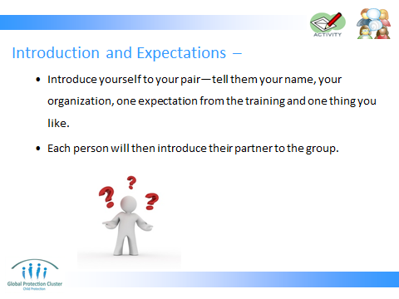

The slide is designed so that as you click each line appears. Work your way slowly through the slide using each point as instructions for the group.

HANDY HINT – Expectations flip chart / poster should already be up and placed in prominent place in room. As the participants go through their string if any expectations are raised, place on the flip chart.

Put participants in groups of 2. Ask them to introduce themselves to their pair (their name, organization, one expectation from the training and one thing they like). Then ask each person to introduce their pair to others.

If you, throughout this activity, see a theme that you are not addressing over this training you will need to say that we will do our best to cover all but the programme is very tight and we have a lot to get through.

Trainer will need to work with organisers to decide if a major theme raised in this activity needs addressing if missing from agenda.

All the training objectives will need adapting based on dialogue with organiser and the individual needs of each training delivered.

PART 3 – TRAINERS AND ORGANISING TEAM INTRODUCE THEMSELVES

At the end of the exercise after all participants have introduced themselves it is important for the trainers and organising group introduce themselves, their role, and especially emphasise their experience.



It is critical that the training group really emphasise their experience and why they are considered experts. The room will be full of amazing wisdom… What do you as facilitators bring to room? This helps create trust and authority in the training environment.

PART 4 – TRAINING OBJECTIVES AND LEARNING OUTCOMES
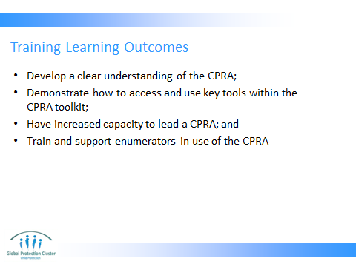


Throughout this process it is important to link back to the expectations activity and key themes of the group.

Again the next slides will need to be adjusted and adapted and is an example of what could be included.

All the above slides (4 to 5) can be covered quickly linking back to expectations.

PART 5 - AGENDA

Ask participants to look at the daily agendas. The agenda should be in the participant packs or on tables.

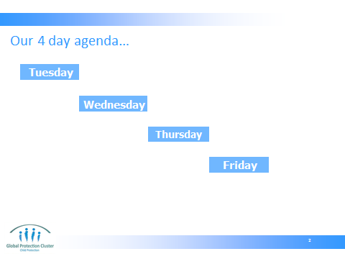

As each day headline appears the trainer can explain the agenda for each day.

Then briefly explain how we will conduct this learning – our training methodology.

PART 6 – LEARNING METHODOLGIES AND LEARNING AGREEMENT
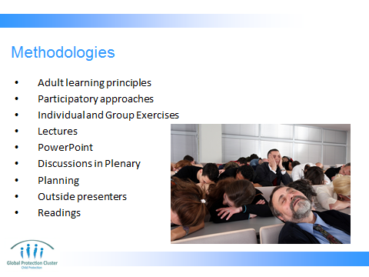

Now to develop a group learning agreement...



The learning agreement between trainer and participants provides a context to learning and facilitates a safe, open and transparent learning environment that is established through a mutually agreed set of expectations regarding individual and group learning and general behaviour throughout training.

Trainer to open discussions on what ‘rules’ the participants feel are important to foster a quality learning environment. As they make suggestions trainer to put up on flip chart paper. If you have two trainers, one trainer can write these on the prepared flip chart paper, while the second trainer facilitates discussion. If not ask a participant to assist.

Suggestions could include:
- Mobile phones off/silent and not to text or use social media during sessions
- Punctuality
- Commitment to break times
- Attendance at all sessions (unless unwell)
- Listening/no interrupting
- Respect other’s opinions
- Participation
- Take Risks
- Ask questions
- Computer use
- Confidentiality
- Self Care Message
- No smoking

Throughout the process, challenge ideas and concepts around these words so there is clear ownership and understanding. At the end ask participants again for any additional expectations they wish to add. Focus specifically on expectations they have of each other.

PART 7 – HOUSEKEEPING, VOLUNTEERS AND CAR PARK

At this stage ask for a time keeper volunteer from the participants to assist everyone to stay on time. We will ask for a different one each day.

Also ask for two eyes and ears volunteers to give us feedback at the end of the day when the participants are filling out their evaluations.

NB: It will be important to fully brief the eyes and ears in the first break so that their presentation is short, concise and relates to what they see and hear people reacting to. Highs and lows of the day.

DON’T FORGET to discuss any housekeeping / administration information. This is not part of the agreement but needs to be discussed at this stage. The organiser should also assist. Some areas to think of:
- Location of toilets
- Smoking areas
- Fire alarms and exits
- Breaks
- How lunch will be presented and where
- Coffee / tea
- Security cards etc.



Point out the parking lot which should be a pre-prepared flip chart in a prominent place.

To assist in keeping us all on time, key issues, questions and / or areas that are not being addressed or can’t be addressed in a session will be placed there so they are not forgotten and will be addressed by the end of the training.

Any further comments and / or questions…



Good start… and now it is time for a short 5 minute break.

