

SESSION PLAN FACE SHEET

TRAINING COURSE: CPRA Training of Trainers |  |  | SESSION 7: URGENT ACTION
TIMING: 30 min |  | VERSION: 1 | AUTHOR: Hani Mansourian  CONTRIBUTORS:
Session Aim:
To have an understanding of constitutes an urgent action and what this means in action

LEARNING OUTCOMES:
- Describe what constitutes an urgent action;
- List a number of considerations/techniques for direct interaction with children.

Activity:

child protection Minimum STandardS:

CPIE COMPETENCY FRAMEWORK: N/A

REFERENCE(S): N/A

RESOURCE(S): | Classroom and multimedia equipment, computer based information.  PowerPoint, Flip Charts, various coloured marker pens, VIPP Cards, prepared posters for: learning agreement; car park; and acronyms.  

SESSION 7 – LESSON PLAN – URGENT ACTION

TIME | OUTLINE – 1 HOUR
** RESOURCE REMINDER **
INTRODUCTION
2 min | This session will help you gain an understanding of constitutes an urgent action and what this means in action  - Go through the learning outcomes
BODY
30 min | Defining urgent action
10 min | SOP for Urgent Action
10 min | Direct contact with children
15 min | Developing Urgent Action SOPs
CONCLUSION
3 min | O | We now know how to consider some of the complex issues of Urgent Action when carrying out the CPRA
3 min | F | We are now at the end of the day but not quite finished yet
3 min | F | Next session we will reflect on the day and we have some homework… ‘boo!’

SESSION 7 – NOTES FOR TRAINER – URGENT ACTION

LEARNING OUTCOMES
- Describe what constitutes an urgent action;
- List a number of considerations/techniques for direct interaction with children.

Trainer - This session will help us gain an understanding of constitutes an urgent action and what this means in action
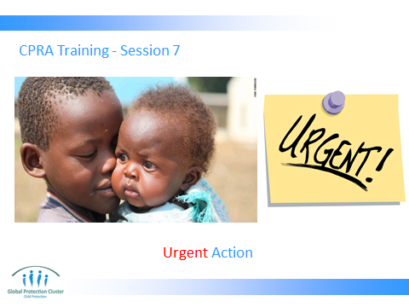

Trainer to go through the Learning Outcomes.

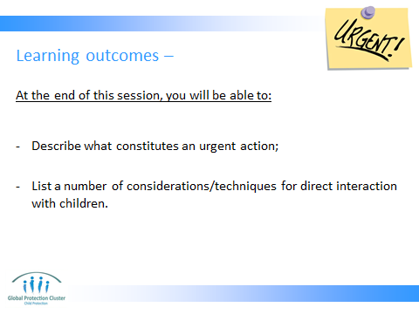

From the beginning of this session, emphasize that assessors should not be tasked to find cases. The urgent action procedure is only for cases that assessors might come across during their work. This is a very rare event, so assessors should not be alarmed. But we do have a responsibility to be ready in case we encounter a child that needs an immediate attention.

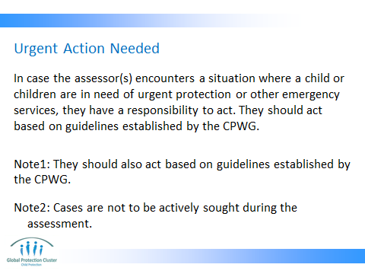

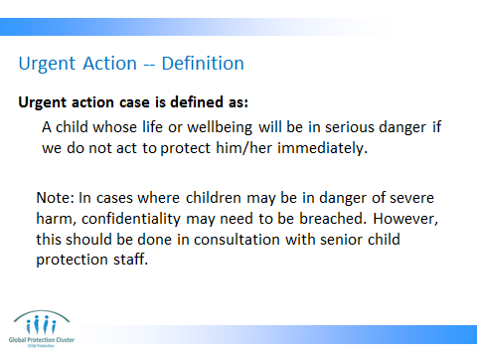

The definition can be further developed in consultation with participants in plenary.

Ask participants to write down on post its one word that comes to their head when they hear the term ‘urgent action case.’ Then you will collect them and organize them into groups. For example all words that related to urgency (e.g. immediate, soon, now, etc) will go into one group. Other words for example related to danger or threat will go into another group. Then based on the groups of words you have, you will construct the definition. It does not need to be exactly the same as the one in this slide, but often it ends up being very close.

The only exception to the confidentiality rule is when the life of a child is in immediate risk. But this needs to be discussed and agreed upon by the assessment coordinator.

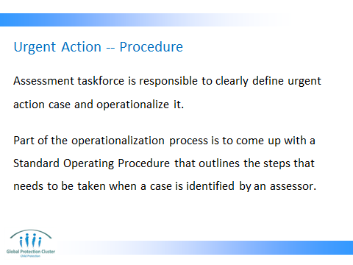

The SOP for urgent action is often very simple. In some cases it is merely a list of contact persons for different regions and or different types of issues. For example, if in region x you encounter an unaccompanied child who is being abused, contact Mr. Y.

There are two examples in the folder for supporting documents under session 7.

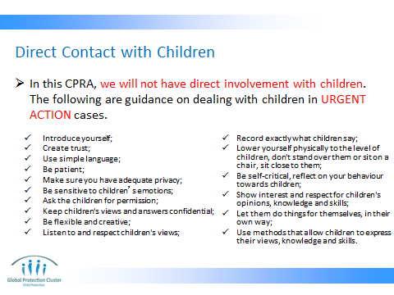

As mentioned before, urgent cases are very rare and assessors will normally not have to interact with children. But if it happens, they need to be aware of basic tenants for a responsible interaction with a child. So when you are training the assessors, make sure you layout these considerations so that they know the basic tenants of interacting with a child in an ethical manner.

Preparing for tomorrow’s exercise: do not forget to distribute the KI questionnaire and handout#1 before letting participants leave. See the slide for ‘end of the day and homework’ for day 1.


CONCLUSION
3 min | O | We now know how to consider some of the complex issues of Urgent Action when carrying out the CPRA
3 min | F | We are now at the end of the day but not quite finished yet
3 min | F | Next session we will reflect on the day and we have some homework… ‘boo!’

