

SESSION PLAN FACE SHEET

TRAINING COURSE: CPRA Training of Trainers |  |  | SESSION 3: INTRODUCTION TO THE CPRA
TIMING: 1 Hour 30 Minutes |  | VERSION: 1 | AUTHOR: Hani Mansourian  CONTRIBUTORS:
Session Aim:
To give an introduction to the CPRA and the CPRA toolkit

LEARNING OUTCOMES:
- Explain what a CPRA is and what it is not;
- Identify situations in which a CPRA should be conducted;
- Articulate key principles that guide a CPRA process;
- List the three main components of the CPRA toolkit;
- Explain the overall methodology used in the CPRA

Activity:

child protection Minimum STandardS:

CPIE COMPETENCY FRAMEWORK: N/A

REFERENCE(S): N/A

RESOURCE(S): | Classroom and multimedia equipment, computer based information.  PowerPoint, Flip Charts, various coloured marker pens , VIPP Cards, prepared posters for: learning agreement; car park; and acronyms.  

SESSION 3 – LESSON PLAN – INTRODUCTION TO THE CPRA

TIME | OUTLINE – 1 HOUR 20 MIN
** RESOURCE REMINDER **
 | CPRA Toolkit
INTRODUCTION
2 min | - This session will give you give an introduction to the CPRA and the CPRA toolkit  - Go through the learning outcomes
BODY
10 min | QQ – Why conduct an Inter-agency Assessment?
10 min | Background and What is the CPRA?
10 min | QQ – When to conduct an IA CPRA?
5 min | CPRA Lessons learned
20 min | Activity – Introducing the CPRA tool kit
5 min | Direct Observation
5 min | Site Report and daily debriefing
10 min | Data analysis and Urgent Action
CONCLUSION
3 min | O | We now have a good overview of the CPRA tool kit
3 min | F | It is not as complex as you thought… is it? You all did very well.
3 min | F | Next session we will look at WWNK

SESSION 3 – NOTES FOR TRAINER – INTRODUCTION TO THE CPRA

LEARNING OUTCOMES
- Explain what a CPRA is and what it is not;
- Identify situations in which a CPRA should be conducted;
- Articulate key principles that guide a CPRA process;
- List the three main components of the CPRA toolkit;
- Describe the difference between analysis and interpretation;
- Explain the overall methodology used in the CPRA

Trainer - This session will give you an introduction to the CPRA and the CPRA toolkit

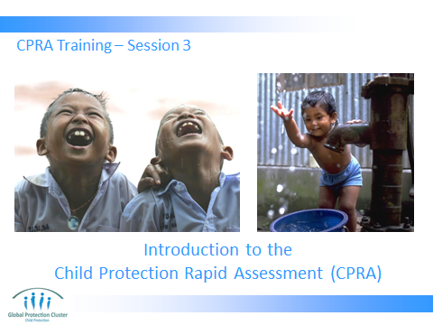

Trainer to go through the Learning Outcomes.
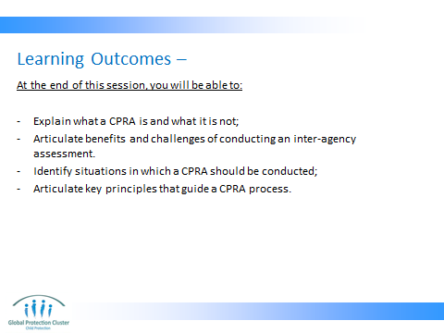

- Both in terms of timing and the context, participants should be able to tell: what is a situation that calls for a CPRA; and where other tools or approaches should be used.

- Like any other procedure that can have an effect on the population, development of the CPRA should follow a certain set of principles. We will look at these principles so that we can also employ them when adapting and using the CPRA.

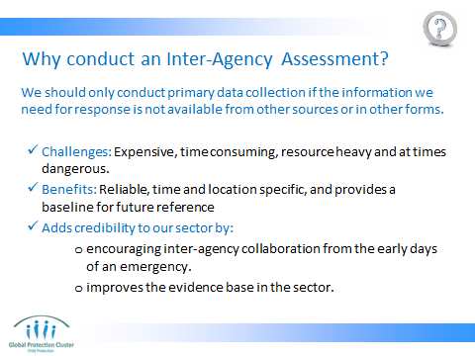

Discussion: Facilitator animates an honest discussion of the issues and challenges surrounding any assessment, including the CPRA.


It can be done in the form of a brain storming by asking participants what the pros and cons of assessments are and write them up on a flip-chart.

Be sure to present possible strategies and stress the inter-agency global buy-in and where to turn for help in presenting your arguments.

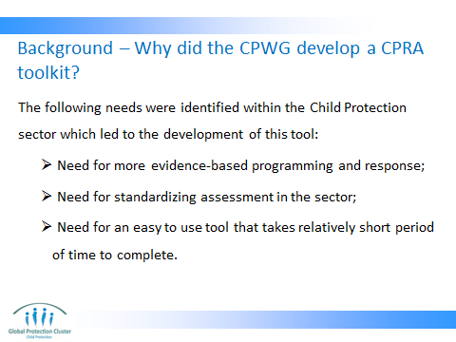

This tool was developed at the end of 2010 and has been tested in many different contexts since March 2011.

Another toolkit was developed before this one that ended up being too heavy for use in the field, and one of the lessons of that tool (now referred to as the ‘CP assessment resource kit’) has been that the CP rapid assessment toolkit needs to be coherent, short and easily adaptable.

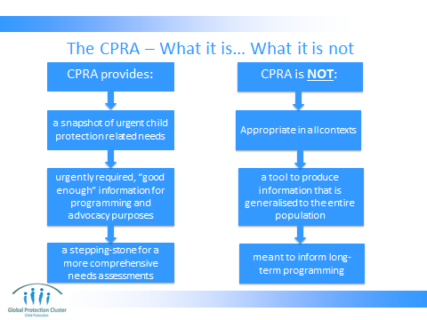

It is of utmost importance to make clear what the CPRA does not do so that we manage expectations.
Also very important to emphasize on the fact that CPRA is not the tool for all contexts. There are many contexts where CPRA may be either too detailed or not comprehensive enough. For example, if you have a refugee situation where all or most refugees are in the same camp and services are established, it is better to use the existing services to collect information on regular basis than do a CPRA. Another example would be where the main research question (or WWNK) is to know the number of separated children. In this case, CPRA methodology is not suited to provide the necessary information. A representative sample and a more qualitative approach will be more appropriate. Participants need to be clear that CPRA is not a magic bullet for all information needs they have.

On top of the components that are listed here, it might be worth mentioning that the CPRA does not produce case specific (i.e. incidence) data. Therefore it is not related to the CP IMS. However, the data that comes out of the CPRA can certainly be used to inform planner where to focus their case finding activities and/or incidence monitoring work.

NB: this is not the same as MRM. It can support MRM systems, but cannot replace them.

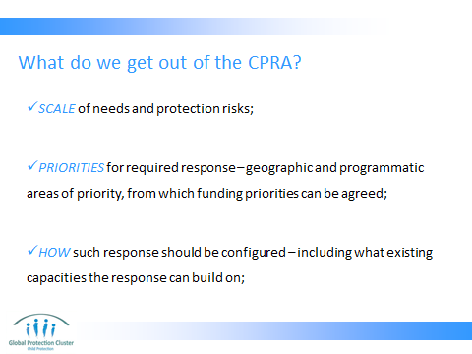

Depending on the context, the CPRA may also be useful for other purposes, such as:
- Creating an evidence-base for advocacy with stakeholders (armed groups, government etc);
- Providing some knowledge of where the main information gaps are; and
- Help to create a monitoring mechanism that can be used in long term.

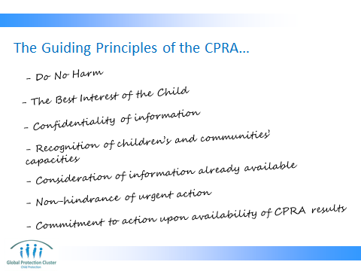

This slide will also appear in a later session, but due to its importance, we try to repeat it at least twice so that it settles. Try to be very brief when presenting it here since the second time it appears you will have more time to go into depth.

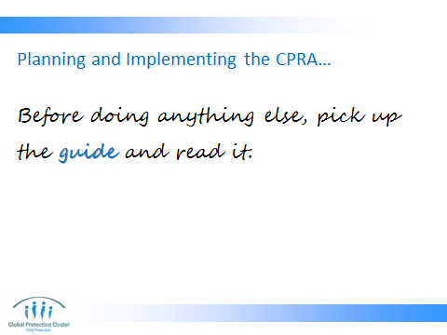

- The facilitators should have read the guide through before the ToT.
- The guide is not something that assessors (or numerators) should read. It is only useful for trainers and/or those who plan the CPRA
- This slide kind of becomes a joke as it keeps appearing in different parts of the package.

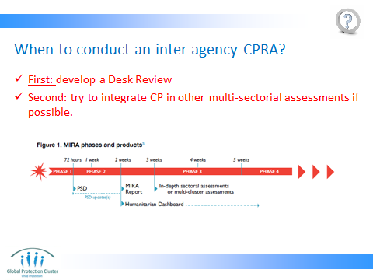

The picture presented here is from the MIRA guide (multi indicator rapid assessment—developed by OCHA). This shows that sector-specific assessments should only kick in from week three onwards. This is also an opportunity to discuss with the participants the fact that CPRA is not the only assessment model out there. It has its place and time. It is not a silver bullet that can be used in all and every context. For example, a CPRA is not appropriate for use in the first few days or even the first couple of weeks after the onset of an emergency.

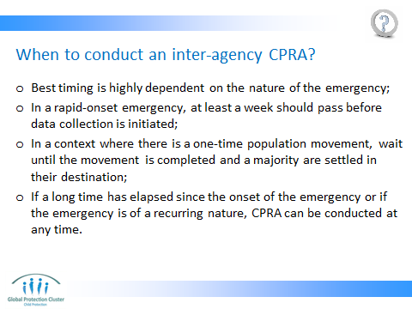
There is a very interesting discussion to be had here.

You can pose the question: What do you think the Rapid in CP Rapid Assessment means? Is it 24 hours? 72 hours? 2 weeks? 2 months?

FIRST STEP is to clarify that this question is more relevant to a rapid onset situation. Since slow-onset or chronic emergencies do not really have a specific time of start, we cannot have a very precise recommendation on when is a good time to start an assessment.

Then you should evoke a conversation regarding the fact that child protection is an area of work that is much more qualitative in nature. Therefore, most child protection issues are not something that would emerge on the day of the disaster (if we are talking about a rapid onset emergency). Few of the CP issues such as separation may occur at the time or immediately after the onset, but most others such as trafficking, increase in sexual violence, increase in early marriage or child labour, psycho-social issue, etc. will emerge over time. Therefore, there is not much use in asking the community about psychosocial wellbeing of children on day 2 after an earthquake hits.

SECONDLY, CP issues also have a rather subtle and discreet nature. For example water scarcity is something that can happen on the day of the emergency onset and continue on. And the population can feel it from day one. Same thing with food. But parents as well as the community need some time to start realizing that their children might be crying too much or wetting their bed every night. Or that there is a trend of people/groups coming to the village/camp to recruit children for work, trafficking or armed activities. Therefore, even if we go to an emergency affected community on day 2 of the disaster and start asking around, we probably won’t get very good answers to our questions since the community itself might not have yet observed systematic deterioration in protection of children.

THIRDLY, protection issues are often not at the top of priorities for a community that is struggling to survive. If food, shelter, and water are not yet provided, chances are the respondents will keep falling back to those basic needs during any interview or conversation. This is very natural and we should not be trying to change it. As an example, in February/March 2012, we were conducting an assessment in the Sahel region of Burkina Faso to assess the CP situation among Malian refugees that have recently arrived. Upon conducting an exploratory mission we realized that many of their very basic needs are not responded to, including food and water. We either had angry refugees threaten our team members that if they don’t come back with food, they may get in trouble. So we coordinated with WFP and UNICEF WASH colleagues to ensure that we deploy our assessors only after the food and water distribution was in place. This didn’t only ensure that the population was more ready to speak of what they may consider as a secondary need, but also helped us ensure the security of our assessors.

IN SHORT, we recommend that CP rapid assessments are done starting around 3 weeks from the onset of the emergency. This does not mean that we will merely wait around during the first 2 weeks. We can start the much needed preparatory work including desk review, adaptation, training and logistical arrangements.

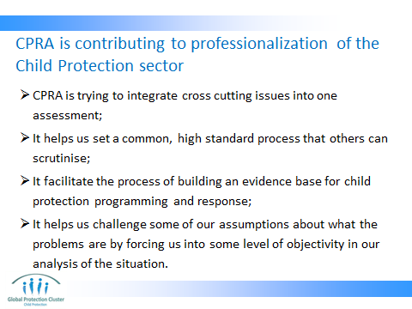

- Several cross cutting issues such as disability, communications and gender feature strongly in the CPRA toolkit.
- The CPRA sets a high bar in terms of methodology. Therefore, it allows others to look into our methodology and know what we have done and why.
- The data that comes out of different CPRAs around the world will help us generate an evidence-base that can help us run meta-analysis in the long run to see what common CP issues emerge in different contexts.
- Often times we rely on our knowledge and experience to predict what CP issues are likely to arise from emergencies. However, experience shows that we can be wrong in many of those predictions despite deep knowledge of the context. Using robust methods to collect objective data will help us challenge our assumptions and will give us a basis to defend our programmatic decisions in the longer run.

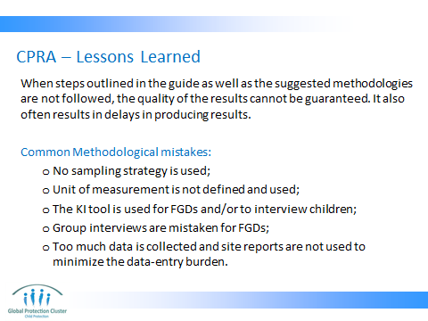

Facilitator explains why FGDs and interviewing children are not included in the CPRA methodology.

In short, while FGDs are a very useful methodology to get at the heart of qualitative issues, they are too demanding in terms of time to train facilitators and time to analyze the resulting data. Therefore it cannot be a useful methodology for a rapid assessment.

As for interviewing children, first recognize that it is linked to the principle of child participation and therefore it is generally a methodology we use in assessments. But it requires highly skilled interviewers, who are often not available in large enough quantity in post-emergency contexts. Therefore to respect the “do no harm” principle, we opted for not engaging with children directly during a rapid assessment exercise.

However, if a country coordination mechanism finds that they have highly skilled assessors for either or both of these methodologies, they should feel free to add them to the mix of methodologies used in the CPRA. However, they best fit within the CPRA methodology as an add-on (i.e. for validation and triangulation) rather than as part of the core methodology.

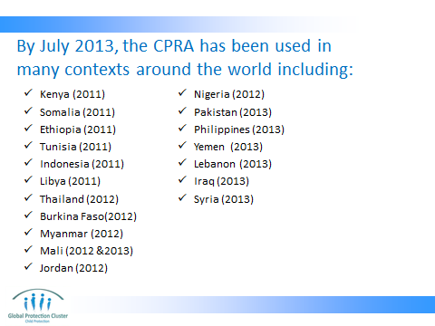

You don’t need to read this out loud, but such factual info on the tool gives it a bit more credibility in the eyes of the participants.



CONCLUSION
3 min | O | We now have a good overview of the CPRA tool kit
3 min | F | It is not as complex as you thought… is it? You all did very well.
3 min | F | Next session we will look at WWNK

