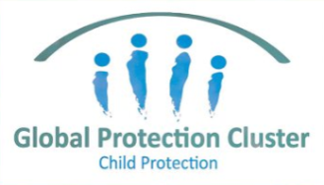

SESSION PLAN FACE SHEET

TRAINING COURSE: CPRA Training of Trainers |  |  | SESSION 2: INTRODUCTION TO CPIE
TIMING: 2 Hours |  | VERSION: 1 | AUTHOR: Hani Mansourian  CONTRIBUTORS: Natalie McCauley
Session Aim:
To give a brief overview and ensure a common understanding of Child Protection in Emergencies (CPIE)

LEARNING OUTCOMES:
- Work together using a common definition of “child”;
- Articulate the difference between child protection and child rights;
- Explain different ways in which emergencies can undermine the protection of children;
- Define Child Protection in Emergency (CPiE);
- Articulate emergencies that may happen in your context and their impacts on child protection

Activity:

child protection Minimum STandardS:

CPIE COMPETENCY FRAMEWORK: N/A

REFERENCE(S): N/A

RESOURCE(S): | Classroom and multimedia equipment, computer based information.  PowerPoint, Flip Charts, various coloured marker pens , VIPP Cards, prepared posters for: learning agreement; car park; and acronyms.  

SESSION 2 – LESSON PLAN – INTRODUCTION TO CPIE

TIME | OUTLINE – 1 HOUR 35 MIN
** RESOURCE REMINDER **
INTRODUCTION
2 min | - This session will give you brief overview and ensure a common understanding of Child Protection in Emergencies (CPIE)
BODY
10 min | Who is a child?
20 min | Group Work – Community, National Legislation and HRL
5 min | Types of emergencies…
5 min | Why an Emergency Response?
10 min | What are the impacts of this emergency on children?
20 min | What is CPIE?
10 min | The protective environment and systems building
10 min | Emergency Context chart
CONCLUSION
3 min | O | Review LO slide – “In Summary”
3 min | F | Good start to the day. I think we now are speaking with a common voice on CPIE.
3 min | F | Next session we will start looking at the CPRA

SESSION 1 – NOTES FOR TRAINER – INTRODUCTION TO CPIE

LEARNING OUTCOMES
- Work together using a common definition of “child”;
- Articulate the difference between child protection and child rights;
- Explain different ways in which emergencies can undermine the protection of children;
- Define Child Protection in Emergency (CPiE);
- Articulate emergencies that may happen in your context and their impacts on child protection

Trainer - This session will give you brief overview and ensure a common understanding of Child Protection in Emergencies (CPIE)
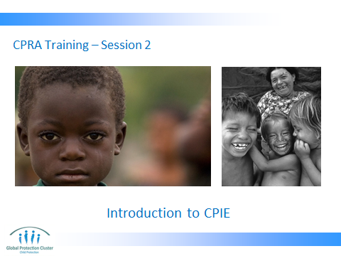

Read through the following slide with the session learning outcomes.

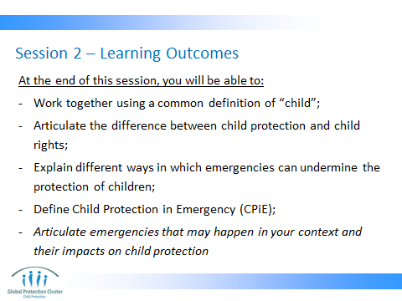

EXTRA TRAINERS INFORMATION THAT CAN BE SHARED –

- As you all know, there is a common global definition (i.e. children under 18 – does not include 18 itself). But the idea of local definition of a ‘child’ always comes back to us. This is particularly true during an assessor’s training where you ideally have local assessors who may not be as easily convinced by the CRC definition of a ‘child’. In the case of an assessment, we need to ensure that the respondent has the same definition in mind as the assessor. Therefore it is extremely important that all assessor accept this as a convention (not as truth necessarily) and convey this message to the respondents (i.e. key informants) before they start an interview.

- The line between child protection and child rights is blurry. But there is a line, at least in practical terms. These are not the same thing. Child Protection covers a subset of child rights, while health, education, shelter, nutrition, WASH and other sectors address the rest of them. A good example to clarify this is: access to health services is a right. It is the responsibility of the health sector to ensure that a health center with a child friendly environment is available in a reasonable distance from every person’s residence. However, if the parents of the child decide that their daughter is not worthy of getting access to health services (as opposed to their son), then it becomes the issue of access and discrimination, which is a child protection issue. Or if schools are made available by the state or education cluster actors, but a community decides that refugee children who live in their community cannot get access to it, it becomes a child protection issue. In short (and partly as a joke) I always say that the hardest part of the job is left to CP people .

- Three main ways in which emergencies affect children will be discussed.

- Global definition of CPiE will be introduced and discussed.

- For regional and global level trainings, this last item on the learning objective list may not be as relevant. But in a country context (especially for the assessor’s training) it is a good discussion to be had.

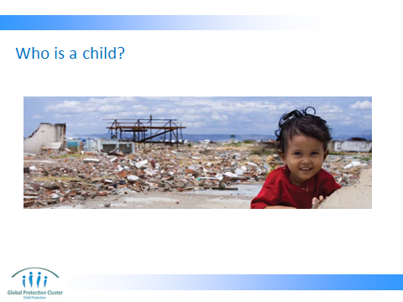
Facilitate a conversation on ‘Who is a child?’

FURTHER PROBES:
- What are the main characteristics of a child?
- Are these characteristics the same across regions, countries and continents?
- What determines the way communities define a child?
- Is such definition only related to age or also to social roles that a person may have to take on?
- What would you do if the government insist to use their definition for the age of majority (for example 15 years old)?

Pointers for the facilitator:
The CRC defines a 'child' as a person below the age of 18, unless the laws of a particular country set the legal age for adulthood younger. The Committee on the Rights of the Child, the monitoring body for the Convention, has encouraged States to review the age of majority if it is set below 18 and to increase the level of protection for all children under 18.

We have to have a clear definition of a child in an assessment. Need to be clear in own mind and able to communicate with the community, so we get accurate information in assessment.

If the government insist that we abide by their laws (for example below 16), we will have to negotiate a common ground. What is important is to find a wording for the questions that make it very clear for key informant what we mean by a child. Sometime we don’t even use the term ‘child’ but rather say ‘people under the age of ….’.

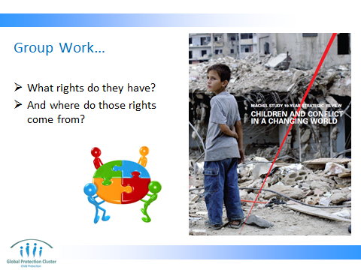

COMMUNITY, NATIONAL LEGISLATION AND HUMAN RIGHTS LAW (& IHL)
- Number off into 3 groups –
  - one looks at own family’s,
  - community’s, and
  - employer’s definition of a child
- Report back to plenary

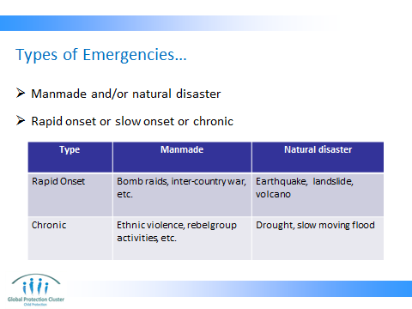

Pointers for the facilitator: There does not seem to be one single definition for different types of emergency. There is also slow-onset which can be the same or different form chronic.
Trainer to ask for types of emergencies that affect children in this country / context


Trainer to ask: How do these emergencies affect children?
Ask for a volunteer to write on flip chart the answers and brainstorming for you.

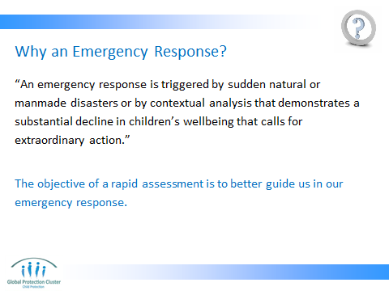

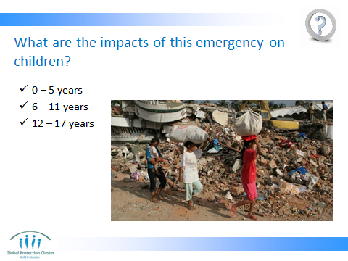

ACTIVITY – Break into same small groups.
- Brainstorm as specifically as possible.
- Write down on flipchart
- Important to consider that emergencies affect different ages differently. Might there be other factors to consider?

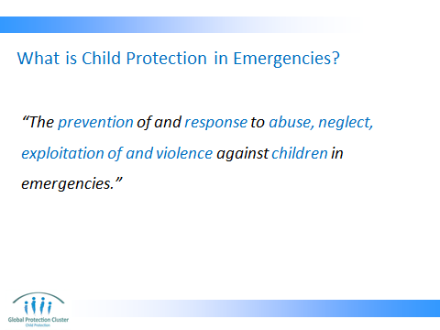

Trainer: emphasize on the 6 terms: ‘prevention’, ‘response’ on one hand and ‘abuse’, ‘neglect’, ‘exploitation’ and ‘violence’.

Trainer asks: Based on this definition, which of the threats you mentioned are protection issues?

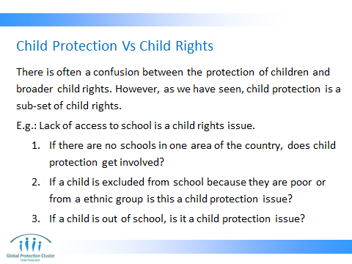

Trainer asks: is this a child protection or child rights issue?
1: no, this is a child rights issue, but not a child protection issue. Normally the education sector will deal with that.
2: this is discrimination which is another child rights issue. Child protection can get involved in this since it is an exclusion issue. This also falls predominantly under the education sector as well.
3: this is also a child rights issue, but child protection sector often deals with this since it is a case of exclusion.

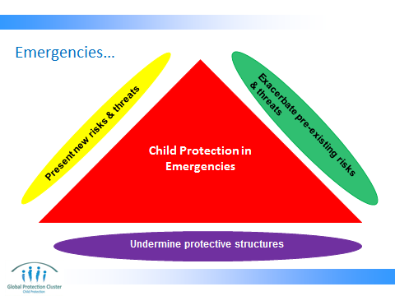

This triangle highlights the three ways in which children can be affected by emergencies.

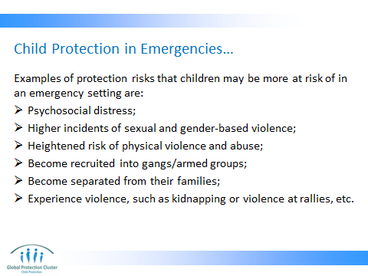

Trainer uses this slide to summarise the main types of impacts of emergencies.

Highlight those that may have not been identified by participants.

Refer back to the Minimum Standards (CPMS) too.

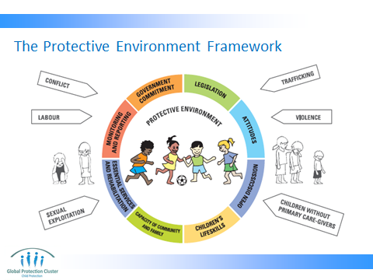

Trainer to ask participants who is familiar with UNICEF protective environment? If most of the participants know about this, the session can be done by eliciting explanations from participants and/or explaining it quickly.

Trainer may want to draw the image on flip chart paper, leaving out the words in the protective circle. Ask participants to guess what might be some of the elements of the protective environment.

Our approach now is to create a protective environment for children, that is, to emphasise the systems in place around children rather than, as a rule, targeting particular children or groups of children (big exception to this is has been in emergencies).

The environment includes family, community, society and the state.

A protective environment is one in which all elements individually and collectively work to secure children from violence, abuse and neglect, exploitation and discrimination.

Each element influences the environment -- and exists in a network/chain of responsibilities.

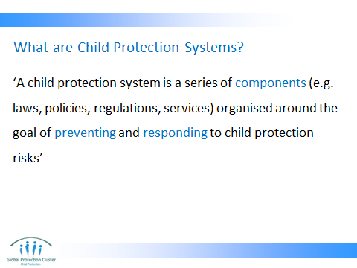

Part of the complexity of child protection is that it is nothing like immunization or other humanitarian interventions. There is no single action that keeps children safe. More over there is no single formula vaccine plus cold chain, which will work in every setting from Mali to Lebanon to Pakistan to Ecuador.

BUT we are able to identify and increasingly measure the elements of protection – the elements that need to be in place to protect children from violence, abuse, exploitation and neglect in all countries.

Strengthening systems, working with communities, to bring about change in attitudes, breaking silences round difficult issues.

*** DON’T FORGET THE CPMS PRINCIPLE OF SYSTEMS BUILDING ***

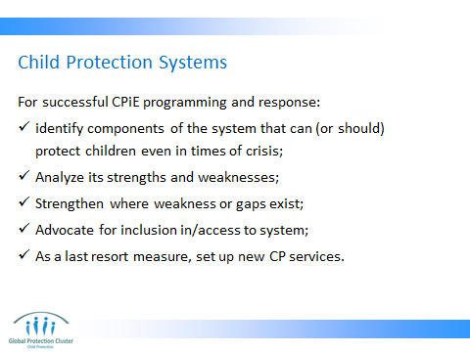

Facilitator: emphasize on the last point. We are not there to create parallel systems.
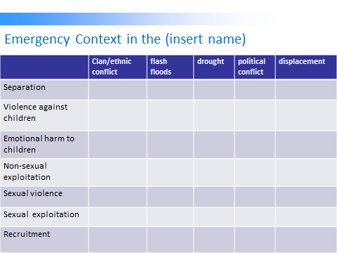

Fill this out with participants for their context. If people from different contexts are participating, form smaller groups and ask them to determine the common types of emergency and how they affect children. This will come handy at later stages when they are planning a CPRA on the 3rd day and when they are work-planning on the last day.

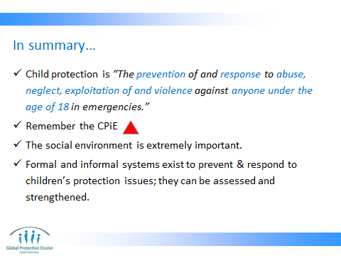



CONCLUSION
3 min | O | Review LO slide – “In Summary” above…
3 min | F | Good start to the day. I think we now are speaking with a common voice on CPIE.
3 min | F | Next session we will start looking at the CPRA

