

SESSION PLAN FACE SHEET

TRAINING COURSE: CPRA Training of Trainers |  |  | SESSION 9: Interviewing Techniques
TIMING: 2 Hour 15 Minutes |  | VERSION: 1 | AUTHOR: Hani Mansourian  CONTRIBUTORS:
Session Aim:
To enable participants to conduct interviews in line with CPRA principles and ethical considerations

LEARNING OUTCOMES:
- Articulate the main principles of an effective interview;
- Describe the main technique used in interviews.

Activity:

child protection Minimum STandardS:

CPIE COMPETENCY FRAMEWORK: N/A

REFERENCE(S): N/A

RESOURCE(S): | Classroom and multimedia equipment, computer based information.  PowerPoint, Flip Charts, various coloured marker pens, VIPP Cards, prepared posters for: learning agreement; car park; and acronyms.  

SESSION 9 – LESSON PLAN – INTERVIEWING TECHNIQUES

TIME | OUTLINE – 3 HOUR 15 MINUTES
** RESOURCE REMINDER **
INTRODUCTION
2 min | - This session aims to enable you to conduct interviews in line with CPRA principles and ethical considerations  - Go through the learning outcomes
BODY
5 min | Basic Principles of Interviewing
10 min | The Key Informant Interview
20 min | Probing
5 min | Answering Respondent Questions
1 hour 30 min | Activity – Interviewing in Practice
30 min | Debrief session
CONCLUSION
3 min | O | We have now practiced our learning of how to interview and the key to this is practice
3 min | F | Very well done. Not easy to learn and demonstrate these techniques in such a large group.
3 min | F | Next session we will look at direct observation including site reports and desk reviews

SESSION 9 – NOTES FOR TRAINER – INTERVIEWING TECHNIQUES

LEARNING OUTCOMES
- Describe the preferred sampling methodology for the CPRA;
- Articulate the relationship between unit of measurement and unit of analysis.

Trainer - This session aims to enable you to conduct interviews in line with CPRA principles and ethical considerations

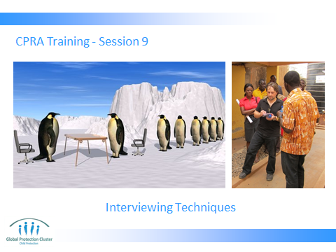

Trainer to go through the Learning Outcomes.

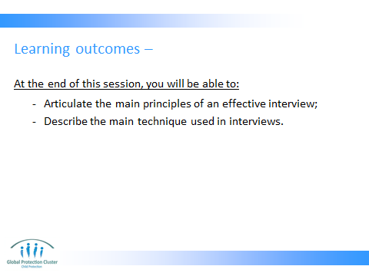

This module is particularly important if this training is happening in preparation for an actual assessment. It is done in two parts.

For the first part (which normally happens at the end of the first day) use the material.

The second part will be a practice at the beginning of the second day. For the second part you will need to recruit people who can act as key informants. These can be colleagues from UNICEF, NGOs, or the government.

The last resort option would be to recruit some of the participants themselves to act as key informants. You would need minimum 1 key informant per 3 participants (if possible, 1 per 2 would be even better).
- This module is more of a reminder. A lot of the things you see here are common sense and most people who have worked in the field will know them pretty well.
- A good reference document for this module is ACAPS’s ‘Technical Brief’ on ‘Direct Observation and Key Informant Interview Techniques for primary data collection during rapid assessments.’ http://dmeforpeace.org/sites/default/files/ACAPS_Direct%20Observation%20Techniques.pdf

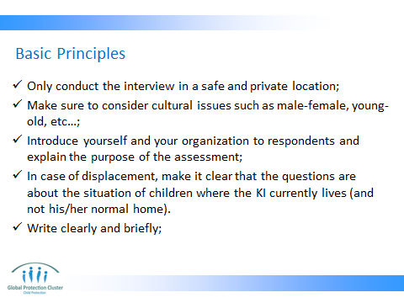

These are all commonsensical considerations, but are worth repeating to make sure everyone is on the same page.

On the cultural issue, you can spend more time and ask participants what cultural issues they can think of in their own context that should be taken into account when conducting an interview.

Write clearly and briefly, remind the participants that what they write is not just for themselves, but others should be able to read and understand what they have written. Some people prefer to take notes directly on the questionnaire, others prefer to have a notebook. In either case, all the important notes should be neatly reflected in the questionnaire and the site report before submitting them for data entry and analysis.

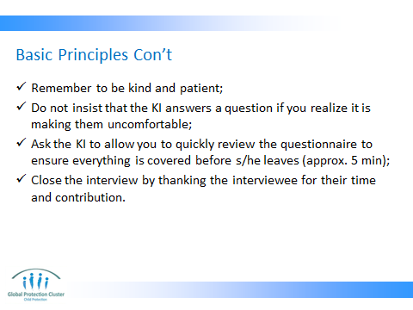

On being kind and patient, remind the participants that we are the ones who are disturbing the lives of the key informants. Therefore it is our responsibility to remain patient and kind to them regardless of their behaviour or attitude. If an interviewer thinks that s/he cannot control her/himself for some reason, they should excuse themselves and leave the interview site and immediately report this to their supervisor.

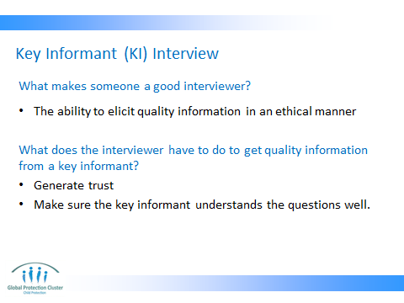

To reinforce this message, it is good to remind the participants that the main goal of an interviewer during an interview is to help the key Informant fully understand each and every question while not influencing their answers. This is even more important than writing the answers down because if the key informant did not understand the question, the answer s/he gives is not what you want to write down.

Many people get so busy writing down answers that even if a KI gives an irrelevant response (suggesting they didn’t understand the question), the interviewer does not realize it.

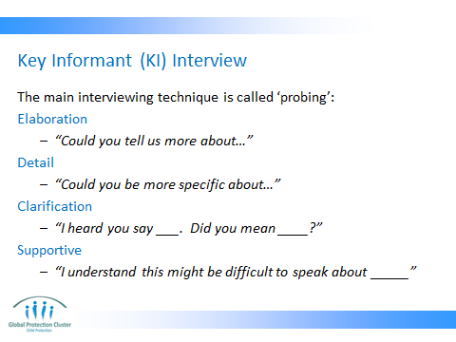

If a Key Informant does not understand a question, or does not fully answer the question, gently explain the question again for them or ask them to provide more details.

If there are certain words or phrases that are difficult to understand, explain the words or phrase in a way that is more easily understandable.

The facilitators could initiate a quick role play (either with other facilitators or with one of the participants) on each of these points.

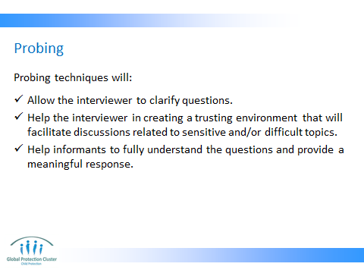

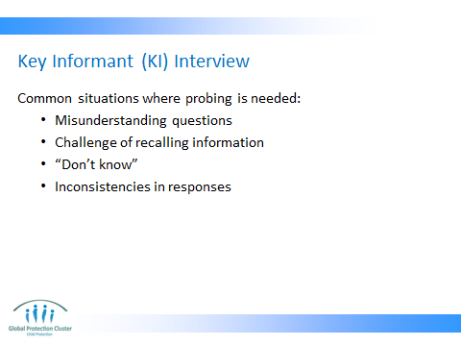

COMMON NEEDS FOR PROBING: MISUNDERSTANDING QUESTION
- Respondent didn’t hear or missed the key words in a question
Example
  - Question: “In the past 30 days, how many days have you had any use of alcohol?”
  - Answer: “I smoke cigarettes daily.”
  - Repeat the question with emphasis: In the past 30 days, how many days have you had any use of alcohol?”

COMMON NEEDS FOR PROBING: CHALLENGE OF RECALL
- Respondent has trouble recalling information, like dates
Example
  - Question: “When did you first move here?”
  - Response: “During the year of the great flood.”
  - Probe: “And what year was the great flood?”
  - Response: “I am not sure, but I think it was just after I graduated from high school.”
  - Probe: “And how old were you when you finished high school?”
  - Response: “18 years old”
  - Probe: “So what year would that be?”
  - Response: “1996”

COMMON NEEDS FOR PROBES: “DON’T KNOW”
- Respondent may say “DK” if he/she:
  - doesn’t understand the question
  - needs more time
  - thinks the question is too personal
  - is worried about giving a “wrong” answer.
- Possible solutions:
  - Repeat question
  - Use pauses
  - “Give me your best guess” or “What is the closest to what you think?”

COMMON NEEDS FOR PROBING: RESOLVING INCONSISTENCIES
- If respondent contradicts his/her own answers and it is not an attitude/opinion question, the interviewer can attempt to reconcile the discrepancy.
Example:
  - Question: “In the past 6 months, how frequently have you had sex?”
  - Response: “I have never had sex.”
  - Question: “I must have misunderstood you when you said earlier that you had sex in your lifetime.”

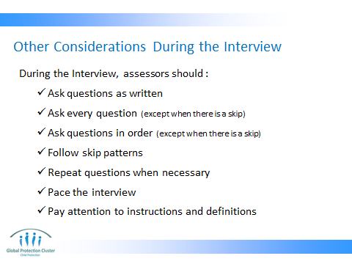

These are instructions for assessors during the interview. If you are training trainers, deal with these as things that they need to train others on. Again you can remind them that a lot of these are consistent with common sense, but it is important that assessors know them as rules.

- ‘Ask questions in order’ has an exception and that is when a respondent starts speaking about an issue that is of a sensitive nature.

For example when you ask about separation, and the respondent starts talking about how some separated children are subject to sexual violence. Or how one of the reasons for family to voluntarily ‘sell’ their children is rape. Given the sensitivity of these topics, now that the respondent has naturally opened up about it, it is prudent to skip to the relevant section and then come back to the question we were asking.

This should happen very smoothly so that the respondent does not feel strange about it. Notice most of the sensitive topics are left to the end of the questionnaires in the sample tools. The main reason for this is to allow for the trust to build up in the process of the interview before sensitive issues are discussed. But if the trust is achieved earlier or if the respondent is eager to talk about them, it is ok to do so only about these sensitive topics.

- Explain the idea of skip pattern. Skip pattern refers to the design of the questionnaire where a lead-in question determines whether the following questions should be asked or not. For example if the lead-in question asks: ‘do you have children’ and the respondent says ‘no’, the following questions about number, age and sex of the children should be skipped. And that is called the skip pattern.

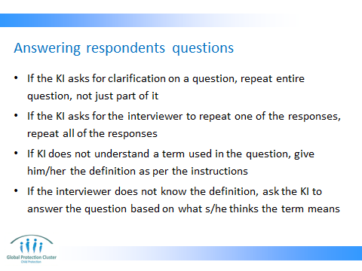

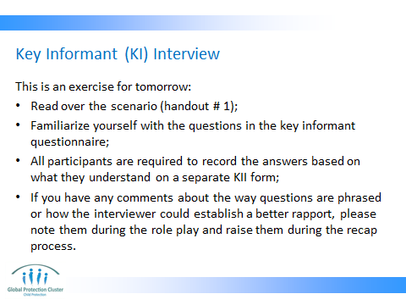

Handouts: handout #1 (already given out) & the key informant questionnaire (tool 2 from part 2 of the CPRA toolkit).

Ask participants to re-read through the scenario (that they have already read earlier in the day). Also, they should be asked to fully familiarize themselves with the questionnaire since tomorrow morning they will go directly to the mock interview session (see the notes for slide 2 above for more details).

Explain to participants how the exercise is going to work after lunch. Do not tell them who the key informants will be. Encourage them to work in groups to prepare themselves for the mock interview.

In explaining the exercise, emphasize on the fact that key informant interviews are done by only one interviewer. CPRA methodology recommends that we stay away from having 2 or 3 people interview one person. In one on one interviews, it is easier to build trust and it is easier to ensure confidentiality. The reason the exercise mandates 2-3 people to do the interview is only for logistical and pedagogical reasons. It will provide the participants with the opportunity to observe others and learn from them. So when they are conducting the mock interviews, they should pretend that others are not in the room. This is not a group interview.

Pointers for the facilitator before the mock interview session starts tomorrow:
- Remind them that this is a one-on-one interview.
- Ask groups to first decide who will cover what part of the questionnaire before they start.
- Remind participants that they all have to come out of the interview with a complete questionnaire. In other words, even if they are not the one asking questions about separation and/or psychosocial, they should still mark down all the answers as we will be using these answers for another exercise later in the day.
- Ask participants to give each other feedback at the end of the interview. (give them an extra 5-10 min for that).
- Once everyone is back around the table, ask the ‘key informants’ to first give their general views on how they felt and how they thing the experience could have improved. Then open the floor to everyone. Write down all the points on a flipchart and try to synthesize them for the group.
- One of the main messages that often come out of this exercise is that interviewers have to know the questionnaire very well (nearly by heart).
- Another key message could be not promising the KI anything.
- Another possible message is patience with difficult KIs.
- Try to have someone take notes of possible comments about modifications to the questionnaire.

Remember to distribute the roles to interviewers so that they can practice their roles as well.

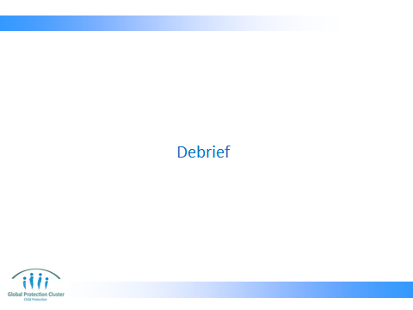

Ask participants in plenary or in two groups to debrief around technique, probing, adherence to questionnaire, answering KI questions – with facilitation that highlights key content from session.



