

MODULE PLAN FACE SHEET

TRAINING COURSE: CPRA Training of Trainers |  |  | MODULE 8: Sampling Methodology
TIMING: 150 Minutes |  | VERSION: 1 | Author: Hani Mansourian  CONTRIBUTORS: Elaine Jepsen
Session Aim:
To familiarize participants with the standard sampling approach used in CPRA.

LEARNING OUTCOMES:
- Describe the preferred sampling methodology for the CPRA;
- Articulate the relationship between unit of measurement and unit of analysis.

Activity:
- Canada-Australia sampling exercise.

child protection Minimum STandardS: N/A

CPIE COMPETENCY FRAMEWORK: N/A

REFERENCE(S):
- CPRA toolkit part 1, ‘Decide on a sampling methodology and sample frame’, pages 7 to 9.
- ACAPS, ‘Technical Brief, Purposive Sampling and Site Selection in Phase 2,’ 2011. Available at: http://www.acaps.org/img/documents/purposive-sampling-and-site-selection-purposive-sampling-and-site-selection.pdf
- ACAPS technical brief video on purposive sampling: http://www.youtube.com/watch?v=FuzE3Lrw2t0

RESOURCE(S): | Classroom and multimedia equipment, computer based information.  PowerPoint, Flip Charts, various coloured marker pens , VIPP Cards, prepared posters for: learning agreement; car park; and acronyms.  

SESSION 8 – LESSON PLAN – SAMPLING METHODOLOGY

TIME | OUTLINE – 120 MIN
INTRODUCTION
10 min | - Ask participants why we sample. Why don’t we just survey the entire population? What is good and what is bad about sampling. Also ask them what types of sampling they have used or know of.
BODY
10 min | Lay out the example of the egg truck and explain what possible units of measurement can be used in this case. Try to engage participants in determining the possible units of measurement. |  | All through this process, remember to refer back to the case of rapid assessments and draw parallels between eggs and individuals.
20 min | Explain purposive sampling and describe it using the egg truck metaphor.
10 min | Questions
5 min | Introduce the exercise (Canada-Australia)
30 min | Groups reflect on the exercise and write up their reports on flip charts
30 min | Debriefing by all groups.
CONCLUSION
5 min | O | Wrapping up and reviewing the main issues.
5 min | F
5 min | F

SESSION 8 – NOTES FOR TRAINER – SAMPLING METHODOLOGY

LEARNING OUTCOMES
- Describe the preferred sampling methodology for the CPRA;
- Articulate the relationship between unit of measurement and unit of analysis.

HANDOUTS Canada-Australia handout (to be given after the exercise is explained).

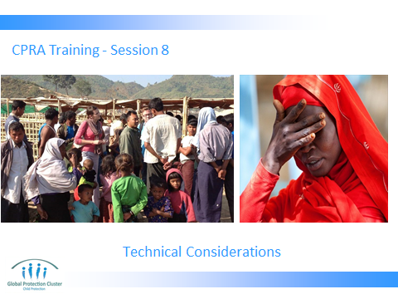

Go through learning outcomes of the session.

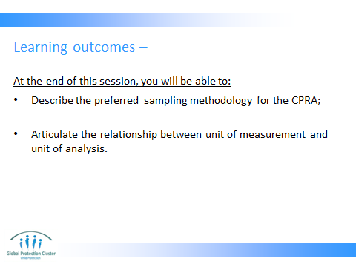

PART 1 – INTRODUCING UNIT OF MEASUREMENT AND THE SAMPLING APPROACH

HANDY HINT – This session is slightly theoretical and heavy. Ensure that participants have a higher energy level before starting. If you need to stop half way and do an activity to re-energize them, do not hesitate.


HANDY HINT – For this particular session, you may not be able to stick to flow of powerpoints since participants tend to ask questions a lot, which may force you to cover some issues out of order. Try not to be too dependent on the slides and flow with the participants.



This topic is easier when explained with an ongoing example. One of such examples that works is the example of a grocer who sells eggs (you may find some other examples that work too). The farm where he usually sources his eggs goes out of business and now he has to select a new source of eggs. He contacts a distributed who will agree to bring him some eggs. But he has never used this distributor before, so he cannot really trust them. And since he is a responsible business man, he does not want to risk selling bad eggs to his costumers.
Please draw a truck on the flip chart. As you draw, also write the content of the truck somewhere. There are 200 cartons of eggs in this truck. Each carton contains 20 egg trays (i.e. 4000 egg trays in the truck). Each egg tray contains 25 eggs (i.e. 100,000 eggs in the truck).
Ask participants how would they advise the grocer to determine whether the eggs in the truck are good (i.e. not broken or rotten).

The answer is that he needs to take a sample of the eggs and see if they are good or not. Otherwise if he wants to check all the eggs, it is too time consuming and too costly for him.
Now the question is, how should he go about selecting his sample? Should he sample based on eggs? Should he sample based on trays of eggs? Or should he sample based on cartons of eggs?

You will probably get a mix of answers to this.

Some answers will be about the sampling approach and some about the unit of measurement.

SAMPLING APPROACH:

One answer that comes up, in nearly every single training, is: ‘randomly select eggs’. You should then ask them: What do they mean by ‘randomly select’? How many and at with what level of detail?

Often times people’s idea randomly selection is based on the colloquial meaning of the term random. In other words they think of it as something that does not have any system to it. While in reality, a well done random sample is very systematic.

It is possible that participants will say something like: ‘we should take 1 egg for every 10 egg (i.e. 10%)’. But there are two questions there: 1. How did we come up with that 10%; and 2. Is this really random?

The answer to these questions are:
- The number of units that need to be sampled is dependent on the homogeneity of our population. The more homogeneous, the smaller the sample needs to be. For a very diverse population, we will need to draw a very large random sample. For example if the eggs in the truck are coming from 4 different farms, to ensure we do not by chance only check the eggs from the good farm or only the bad ones, we will have draw a large sample. However, if all eggs are coming from the same farm and were laid around the same time and were kept in the same conditions, we can draw a smaller sample.
- Randomness in statistics means that every member of our population should have the same probability of being selected into the sample as other members. So if we start from the first egg and pick every 10 egg, the second egg will never have a chance of being selected. So even the first egg to be selected needs to be randomized.

Building on the issues discussed above, the idea of purposive sampling should be elaborate on now. Purposive sampling allows us to use pre-existing information (from our desk review and other contextual knowledge) to determine how different parts of the population might be affected differently and thus have distinct needs. This will allow us to ensure we select units from all those sub-populations to make sure we get a sense the need of different populations without selecting a very large random sample.

In the egg truck example, if based on our pre-existing information (secondary data) we know that the eggs come from different farms or part of the cartons are older than others, we can use the information to make sure our sample reflects this distinction. If we know that there are eggs from 3 different farms in the truck, we can classify the eggs into those three groups. This is also referred to as stratification. In CPRA language, we call each of these sub-populations a scenario. So each group of eggs coming from a separate farm are considered a scenario. Now, if you have one group of old eggs from farm X and one group of fresh eggs from the same farm, you will have 2 scenarios under farm X.

This is an excerpt from CPRA toolkit part 1 on the idea of scenarios:

These scenarios should be based on and represent the various, known characteristics of the affected population and areas. These characteristics may include things such as: camp versus non-camp settings; directly versus indirectly affected areas; displaced versus non-displaced affected populations; origins of the displaced populations; IDPs within a host community versus on their own; mountainous versus coastal areas, ethnic or tribal differences or anything else that may be a reason for difference in the state of needs and capacities of the population.

Imagine a situation where a cyclone has affected two regions in country X. You know that:

- Region X1 is highly affected, while region X2 has been slightly affected;
- Information from an initial rapid assessment by NATF reveals that in area X1A (sub-region of X1) the population has been displaced while in area X1B (sub-region of X1) the population stayed in their villages;
- Two distinct ethnic groups live in areas X2A and X2B (sub-regions of X2).

- Based on this information, we can define four distinct scenarios: X1A, X1B, X2A, and X2B.

Some more reasons why purposive sampling is recommended under CPRA:
‘Assessments in Phase 1 and 2 do not need to be as representative as they need to be rapid. Time and information constraints will normally not allow for random or statistically representative sampling, consequently purposive sampling is the most appropriate solution for these phases.’

‘In this method units of measurement are purposefully selected, based on a set of defined criteria. It gives a measure and sense of the scale and priorities that is approximate enough to enable initial rapid prioritization and planning. It can also provide preliminary insight into how the emergency has impacted differently on the different categories of affected groups chosen for the sample.’

UNIT OF MEASUREMENT:
Now that we know our sampling approach, we need to decide the level at which we will select our units.
In response to your question to the participants earlier, some probably suggested selecting cartons, some suggested trays and some eggs. These are equivalents of communities, households and individuals in the world of humanitarian rapid assessments.

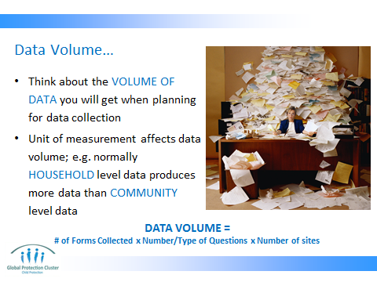

Let’s imagine that we have to fill out a small form (to record information about the physical situation, date of production, size, etc.) for each unit/egg(s) that we examine. If we take an individual egg as our unit of measurement and examine 10% of the eggs, we have to fill out 10,000 forms. If we go for trays as our unit of measurement and sample 10% of trays, we only have to fill out 400 forms. If we pick cartons as the unit of measurement and examine 10% of cartons, we have to only fill out 20 forms.

Note: it is true that we do not use percentage to come up with the number of sites we visit in a rapid assessment, but to illustrate the case here, we used percentages.

DATA AMOUNT TRIANGLE:

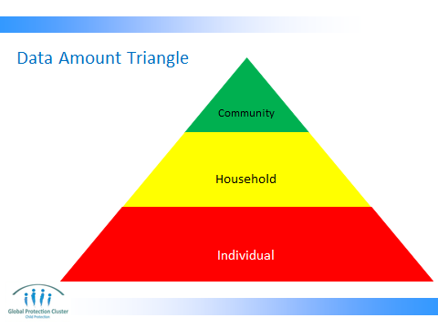

Explain using below –

Size of unit of measreuemnt
Amount of data
Amount of data we collect at community level.

Amount of data we collect at household level.

Amount of data we collect at individual level.

DATA AMOUNT GRAPH:
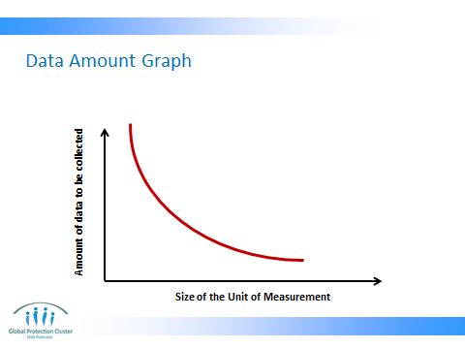

NOTE: The two figures above are showing the same thing in two different ways. Some people find the first one easier to digest and some will prefer the second one.

It is true that examining 10,000 individual eggs will probably give us a more accurate estimate of the situation of the eggs in the truck. But if we are pressed for time and resources and only need general information, why would we waste our time and resources on that? We might sacrifice some details (for example we might not be able to detect every single cracked egg) but we will get a ‘good enough’ sense of the situation of eggs in the truck.

This becomes even more important in a humanitarian context where accessing each unit might require long travel and logistical and/or security arrangements.

‘A unit of measurement is the level at which something is measured, e.g. an individual, a class, a school, a country, etc. For the purposes of a CPRA, the unit of measurement is at a community (rather than individual or household) level. For simplicity, each unit of measurement under CPRA is called a ‘site‘
Let’s imagine we picked cartons as our unit of measurement. And we found that 20% of sampled cartons had bad eggs in them. In our report, can we say 20% of trays had bad eggs in them? Can we say 20% of eggs are bad?

The answer is NO! Our unit of analysis cannot be smaller than our unit of measurement.

Unit of analysis is the unit that gets analysed. For the sake of the CPRA, we always keep the unit of analysis the same as the unit of measurement. And this part of the reason why we do not directly analyse key informant interview questionnaires, but the site reports.

NOTE: even though we still speak to individuals to collect information, but we don’t ask them questions about themselves, but about the community.
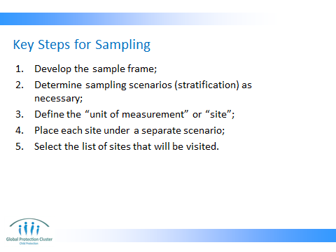

- A sample frame is basically the list of all communities that are in our population of communities. In the case of the egg truck, sample frame will be the list of all the cartons in the truck.
- As explained above, the next step is to define scenarios that make different sub-population of communities different from each other. In the egg truck example, this means putting cartons from different farms into separate piles.
- Defining unit of measurement means to determine whether a site is a village or a camp or a town etc. Normally a site should not have a very large population. The ideal size for a site is between 2000 and 5000.

Excerpt from the CPRA guide:

‘A site should be a distinct community with a formal, legal, customary, geographical or other pragmatic boundary allowing an estimate of its population. The exact definition of what constitutes a site needs to be determined by the CPRATF for each and every scenario. This will depend on the geographical spread of the emergency, populations affected, results of the previous assessments (if any), and available resources. The main parameters of selecting a site are as follows:
- In a non-camp setting, the smallest administrative unit (such as a village or a population grouping) can be taken as a distinct site.
- In camp settings, each camp can be taken as a site.
- If populations with distinct characteristics (such as language, ethnicity, place of origin, status, etc.) live together in one site, and you believe that these characteristics are likely to have an impact on how each group is affected by the emergency, these locations should be divided into multiple sites along the lines of those distinct characteristics regardless of their size.’

- Assigning sites to different scenarios can be a time consuming process. It also requires significant local knowledge. There is an excel tool developed to facilitate this process. There are two examples from Ethiopia and Philippines in session 9 folder. It helps if the facilitator demonstrates how this works using one of the examples (depending on the nature of emergencies in the region/country where the training is taking place). There is also an empty template if participants ask for it.

The list of sites is also referred to as the sample grid. It is basically the final list of selected sites. This can be done through randomization.

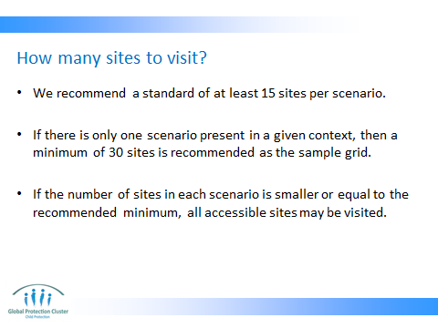

Based on a systematic review of literature, we determined that 30 is the optimal number of sites to be visited. But if we have more than one scenario, visiting a minimum of 15 in each scenario is recommended. For example if you have 4 scenarios, 60 sites should be visited.

A common question that people ask in this section is: ‘do we increase the number of site for a larger population’? The answer is no. The idea of ‘saturation’ should be explained to the participants at this point to clarify that in a qualitative research (CPRA is a qualitative research in nature, with some quantitative touches), what we care about is to reach the saturation point. Saturation point in a research is normally reached at a similar point regardless of the size of the population. Therefore whether we have 500 sites in our sample frame or 100 is not going to affect how many sites we pick in our sample. The scenarios in the context determine how many sites we sample.

You can use an example to illustrate this:
‘Imagine there is an explosion in the room where a conference is taken place. There are 100 people in the room. The police comes and starts asking individuals about what happened. Normally after 20 – 25 people, the police starts hearing the same stories. In other words, the information becomes repetitious. That is when saturation is achieved. But if there were 1000 people in the conference room at the time of the incident, it is still likely that saturation will be achieved around the same number. Maybe it will go up to 30 (because people couldn’t see well) but it won’t go to 200-250.’

This is why we say the number of people affected in a disaster is not what determines the total number of sites in our sample. However, if the number of people is larger, it is likely that we will have a larger number of scenarios as we will likely have more diversity.

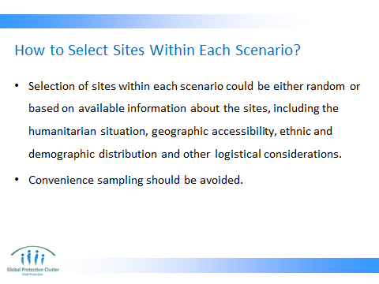

- For random sampling, excel can be used (but requires programming). There are also websites that randomize for you if you give them the range and number of sample units you want to draw. This is one example: http://www.randomizer.org/form.htm
Make sure you select the option for unique numbers so that there are no repetitions.
- If access or security is a major concern in the area, randomly selecting sites under each scenario may not be ideal because half of the site you randomly select may not be accessible. So it is better to go with a purposive sample again which suggest that you sample in a way that considers accessibility as well as enough variability in the sites. In other words, you can highlight all non-accessible sites in your sampling matrix and among the accessible ones, you should choose a variety of sites that represent for example rural, versus urban sites; hard to reach versus easy to reach sites; close to main roads versus far from main road sites; etc.
- Convenience sampling is when we go to the first and closest site. This is different from purposive sampling. It is true that we cannot send our interviewers to places where their lives can be put in danger, but we also should not select our sites based on convenience. Convenience sampling introduces a bias since the more accessible sites are often the ones that receive the most support. If security is a concern, you can still randomize, but select 10% more sites than your intended numbers so that if there are a few that are off limit due to security, you still have enough sites to visit.

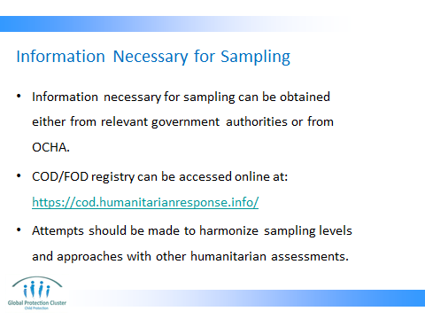

- Administrative data (including geographic boundaries, different admin levels, population size, etc) is necessary for effective sampling.
- Some governments will have such information in an organized way. The Office of Coordination of Humanitarian Action maintains a registry of such information for a large number of countries, especially the more emergency prone ones. This registry can be accessed at: https://cod.humanitarianresponse.info/
- If other sectors/clusters are implementing community level humanitarian assessment, it is best to harmonize the sampling approach with them to create comparability. This will also significantly reduce the burden of sampling.

PART 2 – GROUP EXERCISE – CANADA – AUSTRALIA

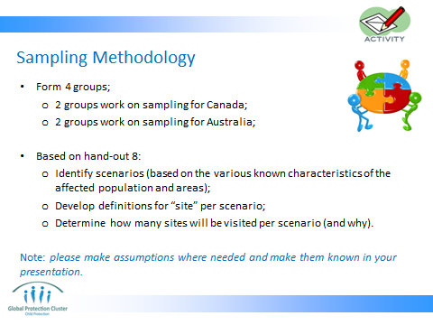

- Assign participants to even number of groups (ideally 4 groups, with a maximum of 6 people in each group).
- Assign half of the groups to Canada and the rest to Australia. This means that Canada groups will imagine they are planning an assessment in Canada and need to define their sample, while the Australia group will assume that they are planning an assessment in Australia. But both will be dealing with displaced populations from Canada.
- Distribute handout # 8. This handout is in 3 pages. Page 1 is for the Canada groups. Page 2 is for the Australia groups. And page 3 (the map) is for all groups.
- When explaining the exercise, remind participants that different site might have a different definition of site. For example if one scenario falls in an urban environment, the definition of site can be neighbourhoods. And if the second scenario falls in rural areas, where there are also camps, there can be two definitions for sites: 1. In camps it will be a block, and 2. in non-camp setting, it will be a village.

HANDY HINT – Ensure that all groups are clear on what the exercise is asking. It is worth going around in the groups and clarifying one by one.

It is common for a few groups to be completely off in their responses. It is also common for different groups to have come up with more or less the exact same answer. But that is totally fine and normal. This topic will take a while to fall in place for most people.

There are wrong answers for this exercise. But the right answers might be plenty. Therefore, it might be better to refrain from giving one correct answer to the participants for this exercise. They will probably ask for it, but you should clarify that there are many correct answers.

Some of the common mistakes made in the Canada-Australia scenario are:
- Use of percentages to determine the number of sites in each scenario. This happens often since people are used to badly done random sampling. Even in a random sample, we cannot just decide we want to do 10%. We need to calculate the best sample size based on many factors.
If this comes up, remind them of the rule of thumb of 15 per site and 30 if there is only one scenario.
- Use of the same site definition for all contexts (i.e. urban, rural, camp, etc). Because it fails to recognize the differences in geographic structure of different scenarios. For example, in a city, you may have neighbourhoods as your site, while in rural environments, you will not have that. Instead you will have villages.
- Creating scenarios only based on geography and not based on other characteristics (e.g. time of arrival of refugees, why they moved—conflict vs. drought, etc). Populations affected by different types of risks may end up in the same geography, but their needs can be significantly different. Also an IDP child in a city affected by conflicts can be susceptible to different risk as compared to an IDP child in a city affected by droughts.
- Sometimes people try to construct the scenarios based on whether people are affected by conflict or by drought. That is a right way of thinking, however, in this scenario we cannot really determine what part of the population is affected by what type of calamity (unless this information exists somewhere). So we cannot really use it for our sampling. But if this is important to us, we can always have a question in the questionnaire about it, which will then allow us to disaggregate our data and do some analysis based on that factor.

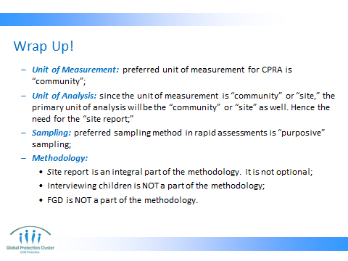

The facilitator should elaborate on the two following points:
  - Interviewing children is NOT a part of the methodology;
  - FGD is NOT a part of the methodology;

The main reason for both of these methods not being used within CPRA is the rapid nature of this exercise. Interviewing children and FGDs both require highly skilled assessors. Even with skilled assessors, children might be just too emotionally distressed in the aftermath of an emergency to be able to handle an interview without further stress. Also, property conducted and recorded FGDs require expertise and a lot of time for analysis of the results.



ACAPS, ‘Technical Brief, Purposive Sampling and Site Selection in Phase 2,’ 2011.
CPRA toolkit part 1, ‘Decide on a sampling methodology and sample frame,’ pages 7 to 9.
CPRA toolkit part 1, ‘Decide on a sampling methodology and sample frame,’ page 7.
CPRA toolkit part 1, ‘Decide on a sampling methodology and sample frame,’ page 9.

