Scenario 1: Country A (CANADA)
Drought and Conflict Stricken Canada…

Over the course of the past two months, over 200,000 people were forced to flee their homes in search of safety, shelter and food. Where sporadic conflict has been present for over 20 years, a drought has been declared in 3 provinces (Saskatchewan, Manitoba, and Ontarionia) destroying people’s livelihoods and causing 120,000 of individuals to find refuge within Canada and the other 94,000 who crossed the border into neighbouring Australia.

Of the internally displaced, the majority (78,000) fled to the capital city Ottawa with 45,000 finding refuge in the one official camp with the remaining 33,000 scattered throughout the city. There are 250 neighbourhoods in the city; however, data from UNHCR suggests that the IDPs are concentrated in 35 neighbourhoods in the southwest of the city.

12,000 of the IDPs fled to makeshift camps in the remote town of Calgary which does not have an airport and is only accessible by road. 20,000 of the remaining IDPs fled to makeshift camps in Edmonton and Winnipeg. The remaining 10,000 were scattered throughout the countryside in rural areas where their movement was restricted by on-going conflict.

As with many displacements, the vast majority of IDPs were women and children where many of the men have stayed behind to tend to whatever land they had left or to fight as part of the conflict. With the loss of the traditional familial protection mechanisms, many children have reportedly been separated from their families, both voluntarily and involuntarily, however, the extent to which is happening and the causes behind it remain unclear. Additionally, the risk of increased recruitment of children is a major concern in light of the on-going conflict. There are unconfirmed reports of significant increase of sexual violence, especially in camps. Historically, most sexual violence was perpetrated by youth within militant groups. There are also reports of landmines killing displaced population along the route to Australia and Ottawatown.

Displacements however are not new in Canada. There was a prior displacement 10 year ago when the official camps were set up in Ottawa. Between 80,000 and 90,000 of the previous IDPs still reside in the official camp in Ottawa and between 30,000 to 60,000 are scattered around town.

Due to the conflict, access in many of the drought affected areas, including rural areas and even parts of the capital city, remain extremely limited to humanitarian workers. What is known is largely by word of mouth with few verified reports and short duration missions by aid workers. The situation could possibly deteriorate rapidly if action is not taken immediately.

Scenario 2: Country B (AUSTRALIA)
The conflict in Canada has had a significant impact on neighbouring Australia – particularly along the border areas in the North, which are host to large concentrations of Canadian refugees and asylum seekers. The first wave of displaced Canadians arrived in Mandurah 10 years ago, following fierce fighting that broke out between the two main Canadian ethnic groups. Last year’s UNHCR statistics show that the official camp hosts more than 175,000 Canadian refuges who live there permanently (i.e. for at least 1 year). Over the past 10 years, hundreds of Canadians also crossed the border to escape sporadic fighting and insecurity. Therefore, the Australian Government had no option but to allow UNHCR to establish two additional refugee camps on the outskirts of the neighbouring towns of Bunbury and Manjimup. The population of these camps are at approximately 50,000 and 25,000 respectively. Despite relatively large numbers (50,000 households : 250,000 individuals) this refugee crisis has been “forgotten” by donors. Lack of funding has forced many international organizations stop their projects and the Australian government does not want to encourage the stay of these refugees by establishing permanent structures for them.

The situation of relative stability was seriously disrupted two months ago when pressure on resources was heightened because of droughts. Sporadic skirmishes in Canada once again intensified into widespread armed conflict, resulting in more than 50,000 people fleeing across the border. The fear of conflict spreading to other areas also forced 44,000 more to cross the border in search of security, food, water and other desperately needed humanitarian assistance.

Some of those displaced had familial ties to the communities already established in the camps of Mandurah, Bunbury and Manjimup and have been able to move into these camps (7000 households; 35,0000 individuals). Due to poor contingency planning, however, these new arrivals in the established camps caught the Australian government by surprise, with the result that the additional numbers have put pressure on existing services. This has consequently caused tensions, and forced different ethnic groups to cluster into separate blocks.

Those displaced by the drought, together with some of the conflict-displaced (approximately 11,000 households or 55,000 individuals), have been forced to settle in outer less-established areas – Woomera, Corroboree and Yakandandah – where there is limited humanitarian presence and reportedly no access to basic services such as latrines, schools, health facilities, etc. Majority of them are living in makeshift camps in these outer areas, and almost 15,000 of them have settled in the city of Corroboree, where the host community speaks a similar dialect to those from Manitoba. Some of the new arrivals, particularly those located in the low-lying areas of Yakandandah, have been affected by recent flooding.

Fewer numbers of displaced persons (approximately 800 households; 4000 individuals) – all belonging to clans originating from drought-affected areas in Canada – have set up makeshift shelters on the outskirts of the local villages of Billabong, Bombora, Boondock, and Gundiwindi. These villages, which are far from the main camps, are separated by long distances and are accessible only along rough dirt tracks that become almost impassable after heavy rain. No accurate information exist on how many are settled near which of these villages.

There are no recent reports on the child protection situation. However, reports indicate that children are being recruited and sometime abducted to go back to Canada and fight. Multiple displacements and lack of access to basic services has reportedly led to many voluntary and involuntary separations.

NB: Official camps have about 1000 people per block.
Process of Activity:
Divide into two groups: Canada and Australia
*Provide scenario and map including displacement
- Identify scenarios (based on the various known characteristics of the affected population and areas);
- Define unit of measurement per scenario;
- Create a sample grid by identifying how many sites will be visited per scenario (and why);
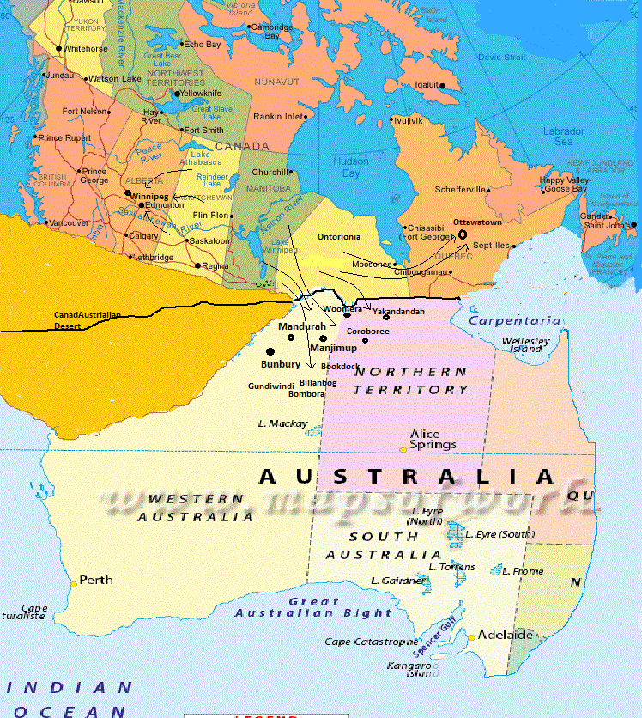
- Define priority areas in terms of most severely affected areas, areas with gaps in knowledge, time constraints, access, security, etc.

