

SESSION PLAN FACE SHEET

TRAINING COURSE: CPRA Training of Trainers |  |  | SESSION 6: Ethics and Confidentiality
TIMING: 1 Hour |  | VERSION: 1 | AUTHOR: Hani Mansourian  CONTRIBUTORS:
Session Aim:
Gain a clear understanding of ethical considerations and confidentiality as it relates to conducting a CPRA

LEARNING OUTCOMES:
- Articulate the ethical considerations during a CPRA;
- Describe confidentiality in the context of a needs assessment;
- Explain the necessity of informed consent.

Activity:

child protection Minimum STandardS:

CPIE COMPETENCY FRAMEWORK: N/A

REFERENCE(S): N/A

RESOURCE(S): | Classroom and multimedia equipment, computer based information.  PowerPoint, Flip Charts, various coloured marker pens, VIPP Cards, prepared posters for: learning agreement; car park; and acronyms.  

SESSION 6 – LESSON PLAN – ETHICS AND CONFIDENTIALITY

TIME | OUTLINE – 1 HOUR
** RESOURCE REMINDER **
INTRODUCTION
2 min | - This session will help you gain a clear understanding of ethical considerations and confidentiality as it relates to conducting a CPRA  - Go through the learning outcomes
BODY
10 min | Ethical Considerations – page 2 of toolkit
5 min | CPMS Principles
10 min | Ethical Considerations
15 min | Confidentiality
10 min | Informed Consent
CONCLUSION
3 min | O | We now know how to consider some of the complex ethical considerations and how confidentiality fits into the CPRA
3 min | F | This is a heavy session so well done.
3 min | F | Next session we will look at is Urgent Action

SESSION 6 – NOTES FOR TRAINER – ETHICS AND CONFIDENTIALITY

LEARNING OUTCOMES
- Articulate the ethical considerations during a CPRA;
- Describe confidentiality in the context of a needs assessment;
- Explain the necessity of informed consent.

Trainer - This session will help us gain a clear understanding of ethical considerations and confidentiality as it relates to conducting a CPRA.
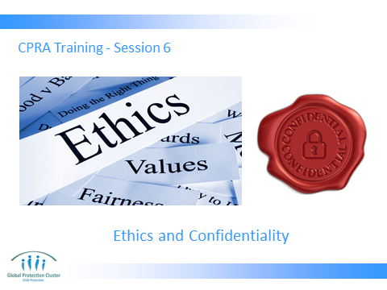

Trainer to go through the Learning Outcomes.

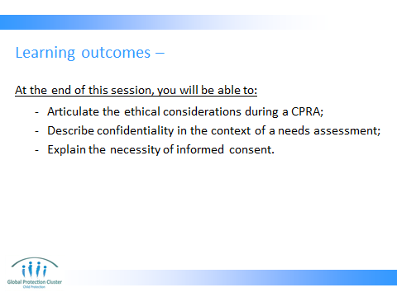

- The ethical considerations are primarily a review of what was presented in session 3. But given their importance, we do repeat them in more depth here.
- Confidentiality is part of the guiding principles, but given its importance in the context of data collection, we will give it a bit more time on a separate slide.
- And finally, the informed consent and what it is will be discussed.

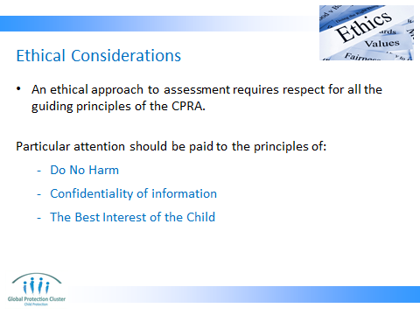

Refer to page 2 of part 1 of the toolkit (the guide). (page number might change in the printed version)

The guiding principles are:
  - Do No Harm
  - The Best Interest of the Child
  - Confidentiality of information
  - Recognition of children’s and communities’ capacities
  - Consideration of information already available
  - Non-hindrance of urgent action
  - Commitment to action upon availability of CPRA results

A few of the points that may require further elaboration:
- Do no harm and best interest can easily get mixed up and confusing. They are related, but not the same thing. Do no harm is a general statement that applies to all humanitarian actions and stipulates that we are responsible to ensure what we do, does not lead to any additional harm to an individual. While we cannot always predict such potential harms, it is our responsibility to reflect on them in advance and take steps to reduce the possibility of such harm.
- Best interest of a child is determined individually for a specific child. The bottom-line with this principles it that every child might require a different intervention and that needs to be determined specifically for that child. Given the fact that we only deal with individual children during a CPRA in case of an urgent action, this principle applies.

These two principles are the main reasons we often refrain from directly interviewing children in emergency contexts.

- Confidentiality of information (there is slide fully dedicated to this. This can be covered here or left to that slide) is at the core of any data collection activity. There are two main aspects to confidentiality. First one is the right of the person to speak to us in confidence and not having to worry about who will read about their opinion. This is very important for trust building. The second aspect is related to security and safety.

We are responsible to determine potential risks to individuals who are providing us with information and develop relevant protocols for restrictive data management to ensure their safety and confidentiality. An extreme example is: let us imagine that someone is giving us very sensitive information about government’s implication in child trafficking for example. We might not have even asked for it, but the person trusts us and willingly tells us about the issue. We know that a government official will be present during our daily debriefing and will read through all the documents. In this situation, we may need to stop the person and tell them because we cannot ensure the confidentiality, we cannot record their information. A compromise here would be not to record/document but still report the issue through the right channel for investigation.

- Recognition of children’s and communities’ capacities: this is particularly important during the adaptation process. It suggests that when we are thinking of needs, we should not forget that the affected population always have some level of ability to handle their own needs. We only need to intervene where they can’t handle it. So knowing what their capacities are, is very important so that we do not duplicate something that already exists.

- Consideration of information already available: this is basically an emphasis on the need to do a thorough desk review before deciding to do an assessment and before starting the adaptation process. If information already exists, why collect it again.

- Non-hindrance of urgent action: This applies to two levels:
  - It suggests that if there are CP issues that urgently need response and we know about them, we should not wait until the assessment is done. We have to urgently respond. For example, if we know that large groups of population are being displaced, we know that separation will inevitably happen. Therefore we cannot postpone our preventive actions as well as registration of separation and unaccompanied children until the assessment is done.
  - While collecting data, assessors may come across cases of children whose live and wellbeing are in immediate danger. In such situations, the assessment team needs to respond to the needs of the identified child. Please make it clear that we do not actively look for such cases, but if we come across one, or if one is referred to us when interviewing key informants, we will have to respond to it.

- Commitment to action upon availability of CPRA results: This principle suggest that the reason we collect data should always be because we want to identify the thematic and geographic areas that require emergency response in order to be able to better prioritize and allocate resources. Therefore, the ultimate goal of data collection is always to inform our response (be it direct programming or advocacy). This means that if agencies do not have the intention of responding to the needs of children upon availability of CPRA results, they should not be conducting a CPRA.

One may be asked: “what if they don’t find funding to respond?” That can always happen and it is fine. The important thing is that the organizations involved should have the intension to act and as part of it, try to find funding. But at the end of the day, if they don’t manage to secure any funding, it is understandable.

You may be asked: “what if the donor has asked us to conduct an assessment:” the answer is it depends. If the reason for this is to inform and/or improve your programming, then it is legitimate. However, if you are conducting the assessment only because of your donor’s requirement and have no intention of using the results in programming, it is unethical to engage in this exercise.

ACTIVITY: ETHICAL DILEMMAS Read the ethical dilemma to the group, ask participants to identify their response, and be prepared to articulate the rationale for their choice.

DILEMMA ONE: You are working in an environment where the culture has strong protocols around seniority, if older persons are present, children are not allowed to express opinions. You are in a community meeting with both older and younger persons present. You are wanting to collect information about the situation of children, and you have a well-trained person in your agency who can do interviews with children. Do you proceed with the interviews?

DILEMMA TWO: You are the assessment coordinator, leading an assessment in an area which includes some villages engaged in conflict. You are under pressure to collect data from this areas from the CPWG, but to do so could compromise surveyor safety. Do you send your surveyors to the area to collect the data?

DILEMMA THREE: You are the assessment coordinator facilitating a WWNK discussion with the CPWG. There is discussion about recruitment of children into armed forces and/or armed groups as the Government have not allowed the use of recruitment related information or response programmes in the past. Should you continue to collect the data anyway?

DILEMMA FOUR: You are an assessment coordinator who wants to find out about the issues of sexual violence and recruitment of children into armed forces and/or armed groups, which you know are happening in the area, however the adults that are interviewed do not want to discuss the issue. A colleague suggests that you could interview the children, as they will definitely talk. Should you proceed to interview children to get the information that you want?

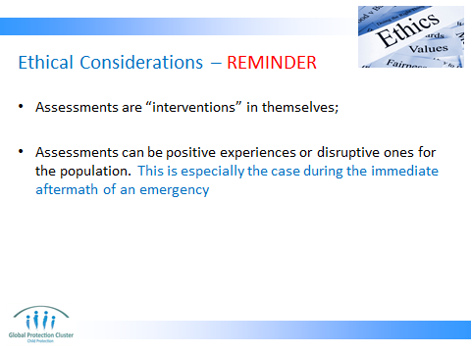

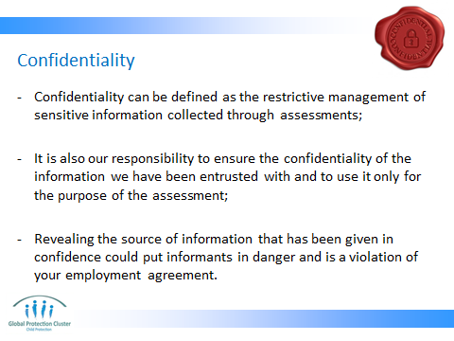

Distribute handout #8 and ask the participants to read through on their own.

This is a sample data confidentiality agreement to be signed by assessors. If this training is taking place prior to an actual assessment, this needs to have been adapted and translated to the local context and language. But if this is regional/global/preparedness training, it only needs to be presented to the participants as something that needs to be taken into account when and if conducting an actual assessment.

The below text is also reflected under slide 3.
- Confidentiality of information (there is slide fully dedicated to this. This can be covered here or left to that slide) is at the core of any data collection activity.

There are two main aspects to confidentiality. FIRST ONE is the right of the person to speak to us in confidence and not having to worry about who will read about their opinion. This is very important for trust building. THE SECOND aspect is related to security and safety.

We are responsible to determine potential risks to individuals who are providing us with information and develop relevant protocols for restrictive data management to ensure their safety and confidentiality. An extreme example is: let us imagine that someone is giving us very sensitive information about government’s implication in child trafficking for example.

We might not have even asked for it, but the person trusts us and willingly tells us about the issue. We know that a government official will be present during our daily debriefing and will read through all the documents. In this situation, we may need to stop the person and tell them because we cannot ensure the confidentiality, we cannot record their information. A compromise here would be not to record/document but still report the issue through the right channel for investigation.

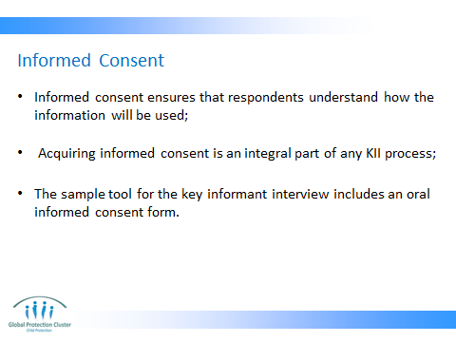

Informed consent is an integral part of any assessment activity that involves direct acquisition of information from people regardless of their age. Informed consent is “the voluntary agreement of an individual who has the capacity to give consent, and who exercises free power of choice.” A young child cannot give informed consent. A process of acquiring consent from a child is different from an adult and since we are not recommending interviews with children, we will not go into its details.

Just for facilitator’s information (in case this has to be explained): for young children we there is a process called ‘ascent’ which requires that the process be explained to a child in a language s/he understand and be asked to say yes or shake their head in agreement if they agree. At the same time, the guardian/caregiver/parent of the child will need to give informed consent on behalf of the child. In such situations it is important to ensure a written informed consent by the guardian/caregiver/parents to avoid future difficulties.

If the training is taking place prior to an actual assessment, facilitator to verify if the assessment task force has recommended an oral or written informed consent and change this accordingly.

In general, the CPRA recommends a verbal informed consent as opposed to written.



CONCLUSION
3 min | O | We now know how to consider some of the complex ethical considerations and how confidentiality fits into the CPRA
3 min | F | This is a heavy session so well done.
3 min | F | Next session we will look at is Urgent Action

