

SESSION PLAN FACE SHEET

TRAINING COURSE: CPRA Training of Trainers |  |  | SESSION 5: What We Need to Know - WWNK
TIMING: 1 Hour 45 Minutes |  | VERSION: 1 | AUTHOR: Hani Mansourian  CONTRIBUTORS:
Session Aim:
To help participants understand ‘What We Need to Know’ – WWNK.

LEARNING OUTCOMES:
- Explain the WWNK cycle;
- Articulate the process of developing the questionnaires from the list of WWNKs.

Activity:

child protection Minimum STandardS:

CPIE COMPETENCY FRAMEWORK: N/A

REFERENCE(S): N/A

RESOURCE(S): | Classroom and multimedia equipment, computer based information.  PowerPoint, Flip Charts, various coloured marker pens , VIPP Cards, prepared posters for: learning agreement; car park; and acronyms.  

SESSION 5 – LESSON PLAN – WHAT WE NEED TO KNOW - WWNK

TIME | OUTLINE – 1 HOUR 30 MIN
** RESOURCE REMINDER **
- List of WWNK
- Tables for the WWNK exercise
- General scenario
INTRODUCTION
2 min | - This session will help you understand WWNK  - Go through the learning outcomes
BODY
5 min | What is WWNK
45 min | Activity – Revision of WWKN
30 min | Activity – Linking WWNKs to questionnaires
CONCLUSION
3 min | O | We now know ‘What We Need to Know’…
3 min | F | Good job on both of the practical activities
3 min | F | Next session we will look at ethical considerations

SESSION 5 – NOTES FOR TRAINER – WHAT WE NEED TO KNOW - WWNK

LEARNING OUTCOMES
- Explain the WWNK cycle;
- Articulate the process of developing the questionnaires from the list of WWNKs.

Trainer - This session will help us all understand WWNK

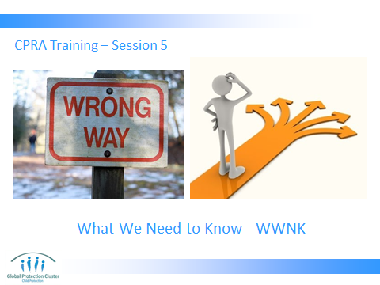

Trainer to go through the Learning Outcomes.

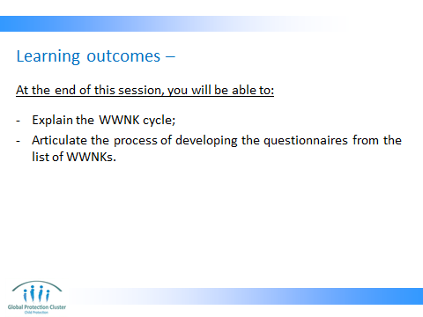

The concept of What We Need to Know is at the core of the CPRA. We will explore what they are and how they are used.

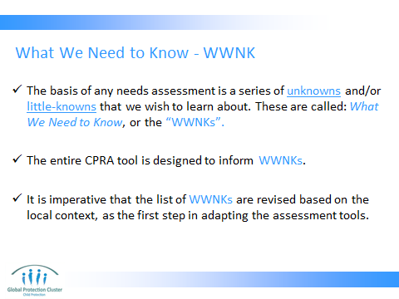

It is important to emphasize that the process of rolling out a CPRA start from adapting the ‘what we need to knows’ to the local context.

I always tell the story that I receive many requests for support for a rapid assessment and then when I ask them what you are trying to know through this assessment, they say things like “child protection” or “situation of children”. This is not good enough for a rapid assessment. We need to first break down what we need to know at this time with limited resources. And please emphasize on the fact that this not what is good to know, but rather what we NEED to know to be able to do better programming.

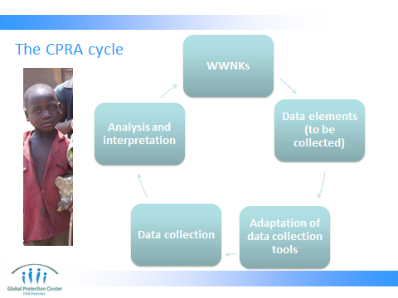

WWNKs are not questions for the questionnaires, but rather are a set issues and concerns related to the protection of children that we would like to learn about. Therefore, for each WWNK we may need to collect multiple data elements and for each data element we may need to ask one or more questions. For example you may have 10 WWNKs, but at the same time have 30 or 40 questions to inform your WWNKs.

Does the fact that the cycle takes us back to the WWNKs mean that we have to revise the WWNKs at the end of the process again? No. It means that once you collect the data and analyze them, you should have the necessary information to inform your WWNKs.

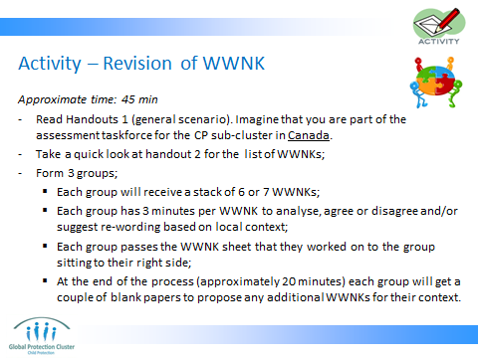


In any context, a scenario needs to be defined that will run throughout the exercise.

If this training is being done in an emergency context, the general scenario should ideally reflect the situation in that context. For regional or global trainings, the existing scenario (as presented in handout 1) can be used. Handout 1 lays out the basics of a scenario that will be used throughout the training.

The stacks that are given to each group at the beginning should ideally be separated based on each heading (for example all the WWNKs related to separated and unaccompanied children should remain in one stack and not separated).

The facilitators should go around to different groups to make sure the groups are discussing the relevance of the WWNKs in hand to their context (or to the context of scenario 1, if that is what is being used).

Then as groups go through their stack, facilitators take each completed topic and pass it on to another group until all 3 groups have provided their feedback for all WWNKs.

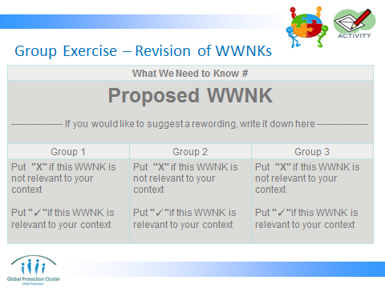

- The facilitator wraps up by reviewing the number of X and ✓ for each WWNK and deciding whether to keep or eliminate. Also the newly proposed WWNKs will be reviewed and agreed upon.
- It is important to quickly produce a revised version of the WWNKs based on this exercise and distribute it among the participants later in the day so that they see the result of their work and that they can use that version as their guide through the rest of the training.

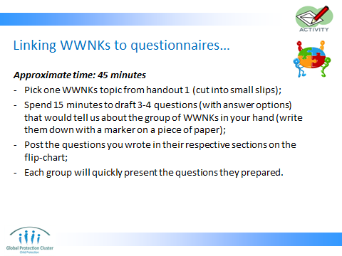

- Facilitator, cut up hand-out 1 into smaller slips of paper that each have one group of the WWNKs on them (e.g. WWNKs related to unaccompanied and separated children). Put them in a box and circulate for participants to pick one for each group.
- Each group will come up with 3-4 questions for that topic (not for each WWNK). So in total, each group will give the facilitator 3-4 questions related to one CP topic (e.g. psychosocial distress)
- Make it clear that the questions they are writing are mean for a key informant questionnaire and is targeted at an adult.
- Also ask them to write the necessary answer options.
- Facilitator, while participants are working on their questions, prepare a flip-chart that has the same headlines as the WWNK bundles distributed among participant with some space between each heading for participants to paste up to 4 questions.
- This exercise is meant to show them how the questionnaires were created.
- Facilitator will give quick feedback to each group on the questions they have developed. Example that often come up are:
  - Questions do not have answer options
  - Questions do not have a time frame/recall period
  - Questions are not location specific (i.e. it is not clear if they are asking about a household, a village, a country)
  - Questions without age and gender disaggregation
  - Questions that are too broad



CONCLUSION
3 min | O | We now know ‘What We Need to Know’…
3 min | F | Good job on both of the practical activities
3 min | F | Next session we will look at ethical considerations

