

SESSION PLAN FACE SHEET

TRAINING COURSE: CPRA Training of Trainers |  |  | SESSION 4: INTRODUCTION TO THE CPRA TOOL KIT
TIMING: 1 Hour 30 Minutes |  | VERSION: 1 | AUTHOR: Hani Mansourian  CONTRIBUTORS:
Session Aim:
To give an introduction to the CPRA toolkit

LEARNING OUTCOMES:
- List the three main components of the CPRA toolkit;
- Describe the difference between analysis and interpretation;
- Explain the overall methodology used in the CPRA

Activity:

child protection Minimum STandardS:

CPIE COMPETENCY FRAMEWORK: N/A

REFERENCE(S): N/A

RESOURCE(S): | Classroom and multimedia equipment, computer based information.  PowerPoint, Flip Charts, various coloured marker pens , VIPP Cards, prepared posters for: learning agreement; car park; and acronyms.  

SESSION 4 – LESSON PLAN – INTRODUCTION TO THE CPRA

TIME | OUTLINE – 45 MIN
** RESOURCE REMINDER **
 | CPRA Toolkit
INTRODUCTION
2 min | - This session will give you give an introduction to the CPRA toolkit  - Go through the learning outcomes
BODY
20 min | Activity – Introducing the CPRA tool kit
5 min | Direct Observation
5 min | Site Report and daily debriefing
10 min | Data analysis and Urgent Action
CONCLUSION
3 min | O | We now have a good overview of the CPRA tool kit
3 min | F | It is not as complex as you thought… is it? You all did very well.
3 min | F | Next session we will look at ethics

SESSION 4 – NOTES FOR TRAINER – INTRODUCTION TO THE CPRA

LEARNING OUTCOMES
- List the three main components of the CPRA toolkit;
- Describe the difference between analysis and interpretation;
- Explain the overall methodology used in the CPRA

Trainer - This session will give you give an introduction to the CPRA toolkit

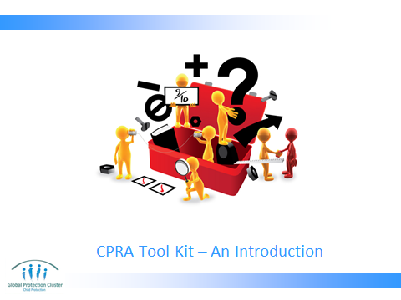

Go through the learning outcomes of the session.

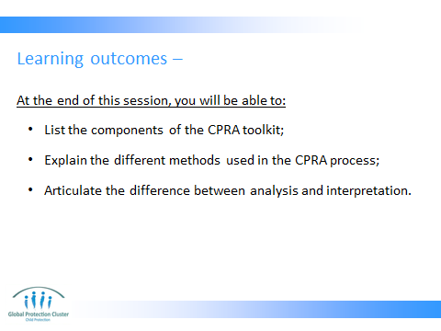

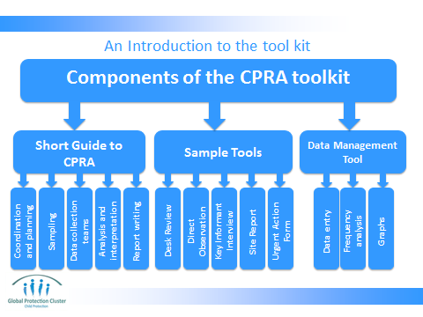
Give each group, these components – separated and ask them to construct the jigsaw. Then give them a copy of the toolkit. Ask them to find the pages where each of the components of the toolkit are explained.

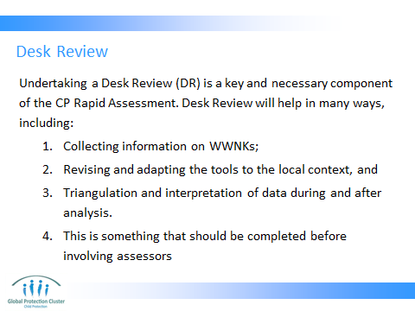

Desk review is not an optional component of the CPRA. It is an integral part of its methodology. Experience shows that wherever a desk review was conducted prior to a CPRA, it did not only significantly elevate the quality of the assessment, but it also greatly facilitated the interpretation and report writing part (which is often a difficult step).

The CPWG has developed a template on how to compile a desk review (see in session folder). This template should be distribute and an exercise will be carried out on day 2 during the desk review session.

Reference: the CPRA toolkit, part 1, page 6.

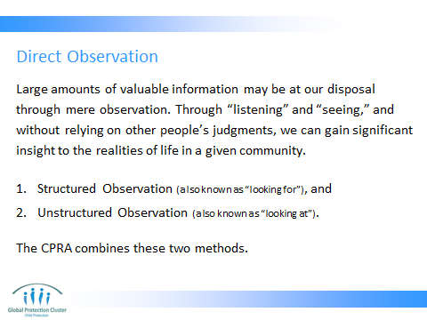

DURING A STRUCTURED OBSERVATION, also referred to as “looking for,” the observer is looking for a specific thing, such as a behaviour, an object or an event. For example, looking to see if children are using specific showers marked for the use of children. This method is also used to detect the non-existence of a specific thing, for instance, to see if children are NOT using a designated playground. To guide a Structured Observation, a checklist is normally developed to function both as a reminder and a recording tool.

DURING AN UNSTRUCTURED OBSERVATION, which is also referred to as “look at,” the observer is looking to see how things are done and what things exist. For instance, if an observer is interested in knowing where in the camps children congregate or play, an Unstructured Observation method would be the appropriate. To guide an Unstructured Observation, we develop a set of open-ended questions that will be answered based on observations.

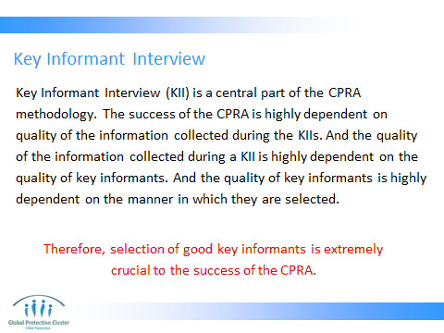

Selection of appropriate key informants is at the heart of a successful CPRA. Since the key informant interview is at the heart of our methodology, if we do not select the right profiles, we will not have a good quality data. Please refer them to appropriate section of the guide (see reference below) for more elaboration on the definition and selection of key informants.

NOTE TO FACILITATOR: please ensure that the understanding of the group from a key informant is not limited to a person in the position of power. In many contexts, the term ‘key informant’ is associated with the authorities. In this context, authorities are only one among many different profiles we are looking for.
Reference: pages 9 & 10 of part 1 (the guide) in the toolkit.

KEY INFORMANT IS anyone who can provide us with information about the population in the community of interest. In choosing the key informants, consider whether:
- There is reason to believe that they have significant knowledge of the situation of the population of interest;
- They will be able to understand the questions;
- Their personal experience is representative of the community, and if not whether this will affect their answers;
- They might have a dominant agenda.
- The facilitator can explain: While everyone might have a personal agenda, such biases should be taken into consideration in the selection and analysis

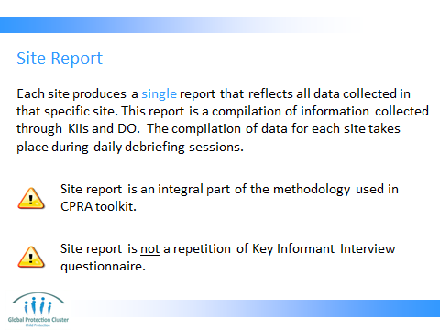

The site report concept is slightly difficult. So it is important for the facilitator to have fully understood the methodology and reasoning behind the use of site report.

The site report looks very similar to the key informant questionnaire. But it is not the same thing. The way data is recorded in it is different and it is a compilation of all KI interviews and direct observations in a given site. In some contexts where the CPRA taskforce decides to eliminate certain sensitive issues from the KI questionnaire (such as association of children with armed forces and groups), the theme can still be maintained in the direct observation checklist and then reflected in the site report. In this case, that part of the site report template will be similar to the observation check list (and not the KI questionnaire). This cannot happen if the theme in question is not observable, such as sexual violence.

Data entry is done from site reports (and not from KI interviews or direction observations). Therefore, the data analysis tool should be adapted based on the site report.

NOTE TO FACILITATOR: In some exceptional situations, it might be ok to skip the site report component. But this is not encouraged. This can be decided on a case to case basis in consultation with the CPWG technical advisors.

There will be a more elaborate session on site report compilation on day 2.

Reference: the CPRA toolkit, part 2, pages 29 to 45.

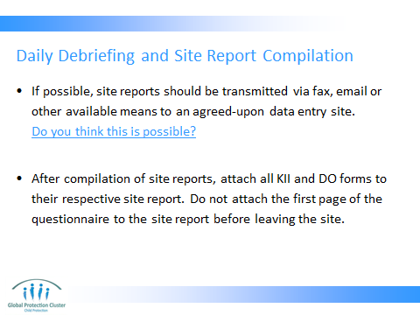

The facilitator should project the data management tool on the screen and show them how it works.

Work with the Team Leaders on this to create a system of daily submissions

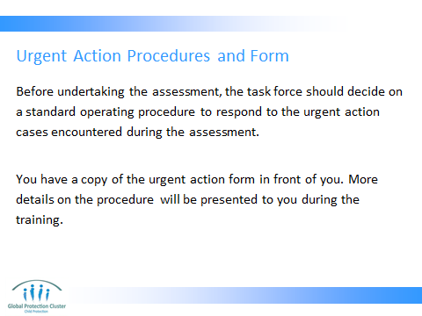

EXAMPLE:

Assessor encounters a case/urgent situation -- assessor to call on assessment team supervisor to consult -- supervisor to complete urgent action form -- team supervisor to send/refer forms to provincial assessment focal point -- provincial assessment focal point to refer case to relevant CP actors; provincial assessment focal point to send/refer forms to national level a CPWG coordinator to refer case to relevant CP actors à relevant CP Actors to follow-up on case/situation.

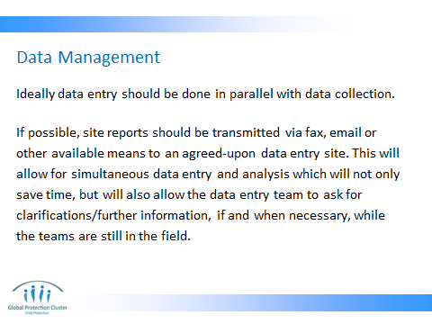

The method for data management depends heavily on capacity, scale of the assessment and ease of communication/transportation in the areas under assessment.

If we are dealing with a massive scale disaster and a massive scale data collection (e.g. Pakistan floods), then data management becomes much more of an issue. Or if we are doing an assessment in a country like Somalia where access is very difficult, more thought needs to go into how we will get the data into the data management tool. Sometime assigning regional data management hubs will help.

If the scale is small it is best to keep the process very simple and centralized. This means that all site reports/questionnaires can be shipped to a central location and managed by a person or a team.
Throughout either of these processes data confidentiality is of the highest priority. Make sure speed does not jeopardize confidentiality.

All collected data (including site reports, questionnaires, checklists and urgent action forms) should ultimately be transported to a central location and managed with utmost care and caution. All documents should be kept in a safe place for at least a year (or if the disaster/emergency continued beyond a year, until the end of the emergency). This needs to be communicated with the agency/organization who takes up the data management role in the assessment so that they can plan for it.

The facilitator should project a filled example of the data management tool on the screen and show them how it works.

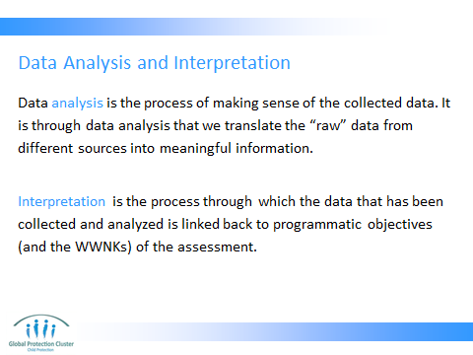

Facilitator should provide examples of how analysis is different from interpretation. This is a rather central concept to the report writing process, so it should be elaborated on extensively until you are sure that participants are clear about it.

Analysis is a mechanical process of making sense of the raw data. You can you descriptive analysis to summarise your data and present them in simple graphs or tables. You can also use more sophisticated analysis such as inferential analysis to make inferences and or even determine association between different data streams. But to inform programming, analysis is not enough.

Interpretation is the process of making sense of the analysis and making the data usable for programming. There is a great deal of local knowledge that is needed during interpretation. The desk review, if done well, is often very helpful in this process as it lays out a lot of the cultural and contextual peculiarities of the country/region in question.

The anecdote I always give that works well is: I, siting anywhere in the world, can do the analysis if the data is sent to me. The only thing I need to have is data, knowledge of analysis and knowledge of what your main questions are. However, an outsider like me will never be able to do the interpretation. Analysis is the easy part. You can hire a consultant who does not know much about child protection or the context to do the analysis, but interpretation is not as simple.

Site note: It has happened that someone (often with academic background) with very strong opinion about these issues will contradict you. If convincing does not work, you can always resort to the good old trick of saying: there might be different opinions about these are.

EXAMPLES:
Explain how compilation of site reports are a part of interpretation.


CONCLUSION
3 min | O | We now have a good overview of the CPRA tool kit
3 min | F | It is not as complex as you thought… is it? You all did very well.
3 min | F | Next session we will look at ethics

