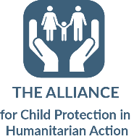
Reflective Practice Record

1. Describe the situation (what did you do/say)? | 2. How did you feel about what happened? | 3. What were you trying to achieve?
4. What choices did you have? | 5. What were the outcomes (for you/the child/ others)? | 6. What knowledge/skills/competencies did you draw on?
7. What did you learn from the experience? | 8. What might you do differently next time? | 9. What are your learning and development needs now? (competency based)

Adapted from Community based social work with children and families: Manual on Prevention and Reintegration (2005), Save the Children UK Bulgaria.

