

Focused non specialized MHPSS activities for caseworkers

Contents

MHPSS grounding techniques 6
Grounding technique 1: 5, 4, 3, 2, 1 senses 6
Grounding technique 2: ABC in the room 7
Grounding technique 3: Here and now hand trace 8
MHPSS activities to build up the child’s trust further and assess the child’s needs 9

Activity 1: Serve and return in play 9
Activity 2: Drawing the child’s family or daily activities 11
Activity 3: Drawing Safety Circles 12
Activity 4: Change cloud 13
Activity 5: In my own words 14
Activity 6: What happened? 15
Activity 7: What is a problem? 16
Activity 8: Then and now 17
MHPSS Activities to support the child to understand and cope with severely distressing experiences 18

Activity 9: Good and Bad stress 18
Activity 10: The stressed mind 20
Activity 11: Fight, flight, freeze statues 22
Activity 12: Your child’s reaction 23

MHPSS Activities to increase a child’s sense of safety 25
Activity 13: Protectors 25
Activity 14: Worry workshop 27
Activity 15: Emotional triggers or reminders 29
Activity 16: Talking about how I feel 30

MHPSS Activities to strengthen coping skills and to regulate emotions 32
Activity 17: Hello it’s your body calling 32
Activity 18: Face your fear 34
Activity 19: Coping Plan 36
Activity 20: My safe space 38
Activity 21: Belly breathing 40
Activity 22: Mandala colouring 42

MHPSS activities to strengthen a child’s self-esteem 43
Activity 23: What I Like About Myself 43
Activity 24: What am I telling myself? 44
Activity 25: Affirmation Cards 45
Activity tools and templates 46

Grounding technique 1: 5, 4, 3, 2, 1 senses 47
Grounding technique 2: ABC in the room 48 Grounding technique 3: Here and now hand trace 49
Activity 1: Serve and return 50
Activity 2: Drawing the child’s family or daily activities 51
Activity 3: Safety circles 52
Activity 4: Change cloud 53
Activity 5: In my own words 54
Activity 6: What happened 56
Activity 7: What is a problem? 58
Activity 8: Then and now 59
Activity 9: Good and bad stress 61
Activity 10: The stressed mind 62
Activity 11: Fight, flight freeze statues 63
Activity 12: Your child’s reaction 64
Activity 13: Protectors 65
Activity 14: Worry workshop 66
Activity 15: Emotional triggers and reminders 67
Activity 16: Talking about how I feel 68
Activity 17: Hello it’s your body calling 69
Activity 18: Face your fears 70
Activity 19: Coping plan 71
Activity 20: My safe space 72
Activity 21: Belly breathing 73
Activity 22: Mandala Colouring 74
Activity 23: What I like about myself 77
Activity 24: What I tell myself 78
Activity 25: Affirmation cards 79

!!

NOTE: This MHPSS Activity Handbook is not a standalone publication, but should be used in conjunction with the Level 3 Child Protection Case Management – MHPSS training materials.


MHPSS grounding techniques

GROUNDING TECHNIQUE

Grounding technique 1: 5 – 4 – 3 – 2 – 1 senses

Objective of the activity | Support the child to stay in the present and to interrupt or cope with distressing thoughts and negative emotions, including fear and anxiety.
Time | 10 min
Age | +5 years old
Materials | Candy, gum or a little snack
Participation | Activity with the child, but parent or caregiver can be included

Guidance

- Explain to the child that we will pay attention to our five senses
Activity tools and templates: Grounding technique 1
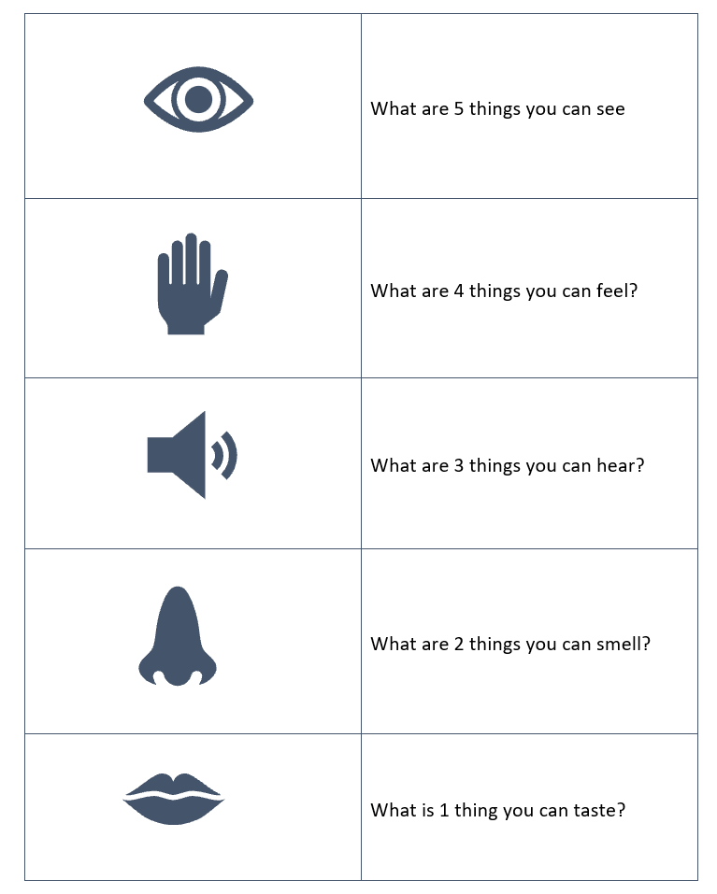
- Ask the child to list five things they can see.
  - For example, look for small details such as a pattern on the ceiling, the way light reflects on the floor or an object you don’t easily notice.
- Ask the child to list four things they can feel.
  - For example, notice the feeling of the wind or sun on your skin, the feeling of the chair or pillow you are sitting on, or pick up an object and examine its weight and texture. Try to feel four different things.
- Ask the child to list three things they can hear.
  - For example, try to hear sounds to which you normally don’t pay attention. The sound of the wind blowing trees, voices of people talking outside, the buzz of traffic in the distance. Try to hear three different things.
- Ask the child to list two things they can smell
  - For example, try to notice smells in the air around you, or you may search for something that has a scent, such as a bar of soap, toothpaste or a marker. Try to smell two different things
- Ask the child to list one thing they can taste
  - For example, carry gum, candy, or small snacks for this step. Pop one in your mouth and focus your attention closely on the flavors.


Grounding technique 2: ABC in the room
GROUNDING TECHNIQUE

Objective of the activity | Support the child to stay in the present and to interrupt or cope with distressing thoughts and negative emotions, including fear and anxiety.
Time | 10 min
Age | +6 years old
Materials | List of the alphabet as a reminder (optional)
Participation | Activity with the child, but parent or caregiver can be included

Guidance
Activity tools and templates: Grounding technique 2
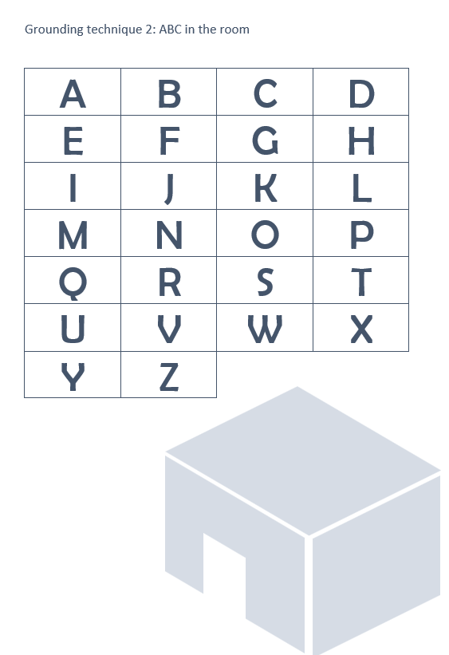
- Ask the child to look around them and try to identify and name objects that they can see or hear that start with each letter of the alphabet (or as many letters of the alphabet as possible before they feel calm and grounded).
  - You can use the overview of the letters of the alphabet as a support, or a bingo sheet, but do explain that they don't have to follow the order of the alphabet (unless they want to, which is also possible).

Grounding technique 3: Here and now hand trace
GROUNDING TECHNIQUE

Objective of the activity | Support the child to stay in the present and to interrupt or cope with distressing thoughts and negative emotions, including fear and anxiety.
Time | 10 min
Age | +5 years old
Materials | Paper, coloured pencils or markers
Participation | Activity with the child, but parent or caregiver can be included

Guidance
Activity tools and templates: Grounding technique 3

- Ask the child to trace their hand on a piece of paper. They can use use a marker or a pen to draw around their handshape.
- Ask the child to draw or write in their handshape what they see, hear, smell or feel.
  - What do you see in this room or place?
  - What do you hear?
  - Do you smell anything?
- Once the drawing has been completed, ask the child to decide on a place where they can keep it in case they want to look at it again.

MHPSS activities to build up the child’s trust further and assess the child’s needs

Activity 1: Serve and return in play

Objective of the activity | Support the parent or caregiver in strengthening their bond with the child through play.
Time | 20 min
Age | 0-6 years old
Materials | Any toys you have around, paper, crayons, musical instruments etc. allowing for the child/caregiver to engage in play
Participation | Activity with the child and their parent or caregiver

Guidance

- Explain that play can help to build a child’s brain, even from a very young age. Every day interactions and play can have a big impact on the development of the child.
- Explain serve and return:
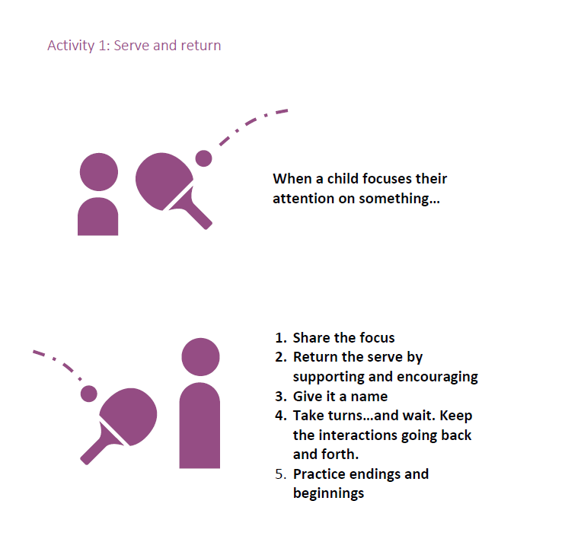
  - A child shows interest in something and the parent or caregiver responds in a supportive way.
Activity tools and templates: Activity 1

  - ‘Serve and return’ is an interaction between the caregiver and the child, in which the caregiver
    - shares the focus of the child
    - supports and encourages the child during the play
    - names what they see, or what they are playing with
    - take turns (back and forth) during the play
    - practices endings and new beginnings

Optional

- If the parent or caregiver consents and thinks it might be helpful, you can organize a meeting with them in which you observe the free play with the child and their parent or caregiver.
- Observe the child and parent or caregiver at play. Make sure to give positive affirmation to the parents on what they do well and do not judge them, or make them feel as if you have doubts about the quality of their interactions with their child!
  - Observe the play between child and caregiver for 10 to 15 minutes
  - Allow the child and caregiver to continue to play. For example, do not ask them to stop their game when it’s not yet finished or make sure they have time and space to complete their activity
- Thank them for allowing you to observe their play and provide positive affirmations.
TIP | Info on positive affirmations can be found in Level 2 Module 4 Communication and MHPSS competencies, Session 4 “Which techniques can I use to motivate for change?”

Activity 2: Drawing the child’s family or daily activities

EXPRESSIVE ACTIVITY

Objective of the activity | To use visual arts (drawing) as a tool to help children name and talk about their family, their day and their feeling about them
Time | 5 - 30 mins
Age | 3-12 years old
Materials | Paper of reasonable size (A4, A3 or flipchart), pencils and/or markers
Participation | Activity with the child, but parent or caregiver can be included

Guidance for drawing family picture

- Invite the child to make a drawing that can tell you more about their home and family
- Support the child to remain engaged (hand over pencils, praise their efforts,…)
Activity tools and templates: Activity 2
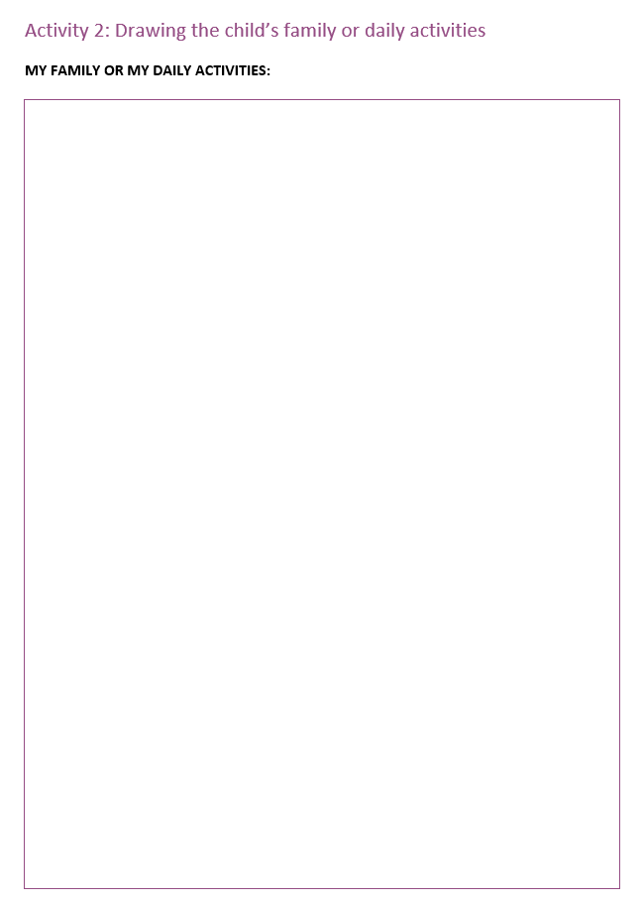
- Ask the child to identify and label every person they have drawn in their family picture
- Ask few additional questions:
  - Where do you eat, where do you sleep, where do you play?
  - What is your favourite room in the house and why?
  - Who do you spend most time with?
  - What does your family do during the day?
  - Do you sometimes have people visiting?
  - …

Variation for drawing daily activities

- Invite the child to make a drawing that can tell you more about their day.
  - Note: You can divide up the day in Morning, afternoon, evening and night but it is just as good to let the child draw freely from sunrise to sunset, or from when they wake up until they go to sleep
- Ask additional questions to show interest:
  - What is your favourite activity and why?
  - With who do you spend time during the day?
  - Have your daily activities changed?
  - …

Activity 3: Drawing Safety Circles

EXPRESSIVE ACTIVITY

Objective of the activity | To use visual arts (drawing) as a tool to help children identify safe spaces and persons with whom they feel safe.
Time | 5 - 20 mins
Age | 3-12 years old
Materials | Paper of reasonable size (A4, A3 or flipchart), pencils and/or markers
Participation | Activity with the child, but parent or caregiver can be included

Guidance

- Ask them to draw a circle in middle of the paper
Activity tools and templates: Activity 3
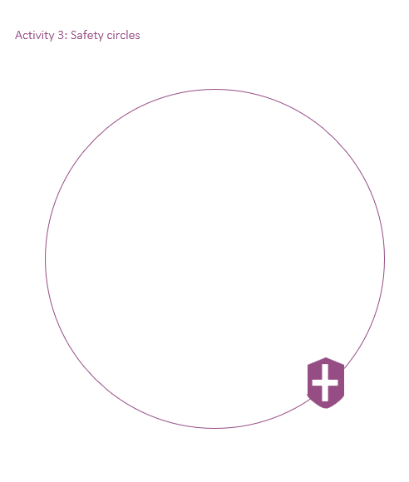
- Explain that this is a circle in which only nice things and people with who you feel safe and good can enter. The circle can only contain good things and good people with whom the child feels comfortable, confident and safe.
- Ask them to then draw everyone and everything that makes them feel comfortable, confident and safe inside the circle. If using a circle on the ground, they can then put dolls or figures that symbolize people inside the circle.
- Ask them to name or label all the people and things in the safety circle.
- If there is time and it is appropriate (not too upsetting) ask them to also put people or things outside the circle. These are the things or people they don’t like. For example, those with whom the child feels scared or make them feel bad.
- Use the questions about positive and negative people and things to generate as much conversation as possible to understand the potential risk and protective factors in the child’s community.

ADAPTATION | Instead of drawing on paper, you could also draw a circle on the ground and ask the child to use dolls, figures or things that symbolize people or places.

Activity 4: Change cloud

EXPRESSIVE ACTIVITY

Objective of the activity | To use visual arts (drawing) as a tool to help children name and talk about their emotions and the problems they are currently facing
Time | 5 - 20 mins
Age | 5-11 years old
Materials | Paper of reasonable size (A4, A3 or flipchart), pencils and/or markers
Participation | Activity with the child, but parent or caregiver can be included

Guidance

- You have identified a significant event, a big change or anything that is causing disruption to the child.
Activity tools and templates: Activity 4

- Explain to the child that you want to talk about this event, change or whatever is causing them disruption. Check with the child if they are willing to talk about it.
- Ask the child to imagine that this event, change or whatever is causing disruption has been created by a cloud.
- Explain that some clouds pass quickly and some stay for a very long time. Some clouds bring changes that we can manage easily, and some clouds bring changes that are really hard and we wish would go away
- Ask the child to describe the change, event or whatever is causing disruption through by asking them to describe the cloud:
  - What kind of cloud should it be, a big one or a small one, a bright one or a dark one?
  - What does your cloud look like, feel like, sound like?
  - Does this change feel big or little?
  - Did it happen slowly or all of a sudden?
  - Has it been around for a while or did it change your life recently?
  - What things have changed? What things have remained the same?
  - How do you feel about these changes? E.g., scared, worried, unsure, excited, disappointed, angry, sad, curious?
  - What do you miss about life before the change?

TIP | After completing this activity, you can use a grounding technique to support the child to cope with distressing thoughts or negative emotions.

Activity 5: In my own words

EXPRESSIVE ACTIVITY

Objective of the activity | To provide a child with a tool to support reflection and to name and potentially talk about their emotions
Time | 15 - 20 min
Age | 10+ years old
Materials | Paper, pens/crayons – the child needs to be able to write
Participation | Activity with the child, but parent or caregiver can be included
Note | Do not use this activity to discuss severely distressing or terrifying events, as it might be appropriate nor helpful for the child to discuss these events using a questionnaire

Guidance

- Introduce the activity to the child. You can use the following script as a source of inspiration for how to introduce the activity to the child:
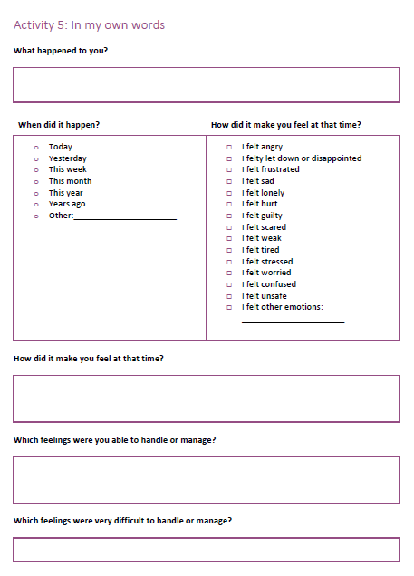
  - “I am sorry you have experienced or witnessed some distressing events. It can help us when we talk about it and express how what happened makes us feel. I would like you to describe what happened to you, so I can try to understand and to help you better. Could you please describe what happened with as many details as you are comfortable?”
Activity tools and templates: Activity 5

- Ask the child to read the questions, think about them and write some of their thoughts and ideas down (list of questions below)
  - “Think about the following questions I will share with you and write down what comes to mind. When you are finished, you can decide if you are comfortable to share your story. You can share it with me or with someone else, someone that you trust”.
- If the child feels comfortable, discuss their thoughts, ideas and feelings. This will provide you a better understanding of their needs (during assessment) and on what to work (during case planning).

ADAPTATION | You can print the questions or ask the child to write them down.
TIP | After completing this activity, you can use a grounding technique to support the child to cope with distressing thoughts or negative emotions.

Activity 6: What happened?

EXPRESSIVE ACTIVITY

Objective of the activity | To provide a child with a tool to name and potentially talk about their emotions. When it is difficult for children to express themselves, these scales can help them describe their experiences.
Time | 15 - 20 min
Age | 10+ years old
Materials | Paper, pens/crayons – the child needs to be able to write
Participation | Activity with the child, but parent or caregiver can be included

Guidance

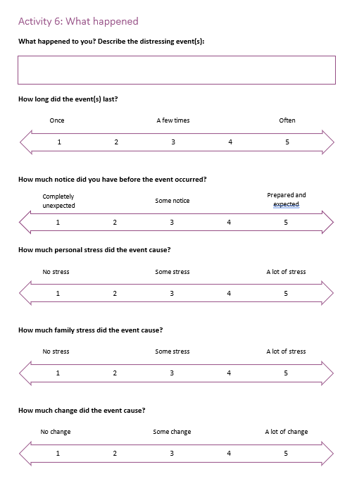
- Introduce the activity to the child. You can use the following script as a source of inspiration on how to introduce the activity to the child:
Activity tools and templates: Activity 6

  - “I am sorry you have experienced or witnessed some upsetting or troubling events. I would like you to describe what happened to you, so I can try to understand and help you better. Could you please describe what happened with as many details as you are comfortable.”
- Ask the child to read the questions, think about them and write some of their thoughts and ideas down (list of questions below)
  - “Think about the following questions I will share with you and write down what comes to mind. When you are finished, you can decide if you are comfortable to share your story. You can share it with me or with someone else, someone that you trust”.
- If the child feels comfortable, discuss their thoughts, ideas and feelings. This will provide you a better understanding of their needs (during assessment) and on what to work (during case planning).

ADAPTATION | You can print the questions or ask the child to write them down.

Activity 7: What is a problem?

EXPRESSIVE ACTIVITY

Objective of the activity | To use visual aids as a tool to help children name and talk about their problems, issues or challenges and how they feel about them.
Time | 15 - 20 min
Age | 10+ years old
Materials | Paper, pens/crayons
Participation | Activity with the child, but parent or caregiver can be included

Guidance

As with Activity 6:
Activity tools and templates: Activity 7
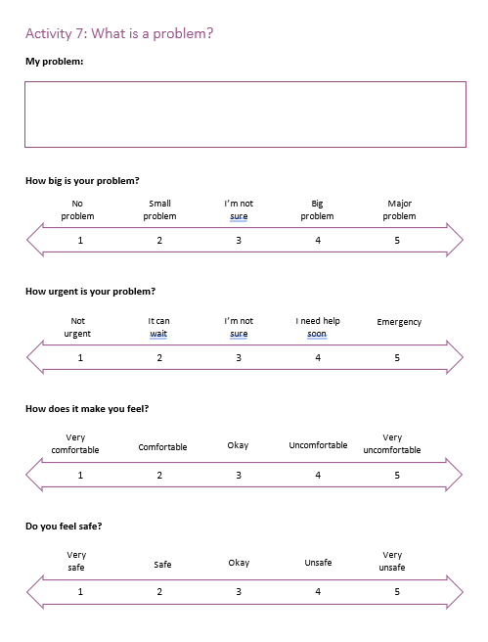
When it is difficult for children to express themselves, these scales can help them describe their problem or what is bothering them. Introduce the activity to the child.

- Ask the child to review the questions and the different scales.
- Ask them to identify one problem they are facing on which they feel able and comfortable to reflect by replying the questions using the different scales.
- If the child feels comfortable, discuss their thoughts, ideas and feelings. This will provide you with a better understanding of their needs (during assessment) and on what to work (during case planning).

Activity 8: Then and now

EXPRESSIVE ACTIVITY

Objective of the activity | To provide a child with a tool to name and potentially talk about their emotions
Time | 15 - 20 min
Age | 10+ years old
Materials | Paper, pens/crayons – the child needs to be able to write
Participation | Activity with the child, but parent or caregiver can be included

Guidance

PART 1
- Introduce and explain the activity to the child.
  - You can use the following script as a source of inspiration on how to introduce the activity to the child: “Let’s do an activity that will help me to get to know you a little better. I want to learn more about you and your life, who is important to you and important things that have happened in the past. You can use the icons or little drawings provided or add your own.”
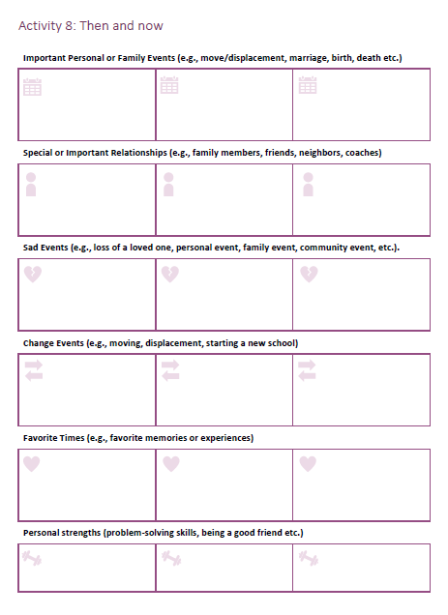
- Ask the child to review the tool, think about the questions and write or draw whatever comes to mind.
Activity tools and templates: Activity 8
- If the child feels comfortable, discuss their thoughts, ideas and feelings. This will provide you a better understanding of their needs (during assessment) and on what to work (during case planning).

PART 2
- Ask the child if they could line up some important events in a timelines.
  - You can use the following script as a source of inspiration on how to introduce the activity to the child: Can you make your own timeline? Try to stick your icons on a timeline and also try to include other important moments


MHPSS Activities to support the child to understand and cope with severely distressing experiences

PSYCHO-EDUCATION

Activity 9: Good and Bad stress

Objective of the activity | Recognize helpful stress and harmful stress and identify stressors (what is causing stress)
Time | 15 - 20 min
Age | 10+ years old
Materials | Paper, pens/crayons, flipchart or whiteboard
Participation | This tool can be used in an one-on-one activity with an adolescent

Guidance

- Define stress and discuss how it is a part of everyday life—especially for adolescents. Below you can find some examples of how to explain stress.
HOW TO EXPLAIN STRESS

Stress is normal and natural and it happens to everyone, children, teenagers and adults. Stress can be caused by all sorts of things. Like the time you were studying for a difficult test, or your parents are fighting, etc. You see your body and mind work together as a team. When we feel worried about something, our brain sends a signal to our body. Its called a stress response. The stress response helps get us ready for the things that come our way. We can expect this to show up every time we are facing something new or difficult. This is completely normal. The more we practise something, the better we get at it and the smaller the stress response gets. You build a stronger brain.

For example when a child has to start in a new school. It can be stressful. You don’t know the teachers nor the other children in your class. This feeling can make the child restless, maybe the child cannot sleep well the night before and remains awake while thinking or maybe worrying about the first day of school the next day. What this child is feeling is what we call a stress response.

For example, when a child needs to give a presentation in front of the whole class. This can be stressful. The child wants to do a good job but they can be a bit nervous, scared that it might not go well. The child can get a bit shaky, start sweating and find its hard to focus. What this child is feeling is what we call a stress response.

- Ask the adolescent to review the list of stress symptoms and circle these that they have shown or felt in the past. Explain that everyone feels and reacts differently, so the symptoms or stress signals are not the same for everyone, but personal.
Activity tools and templates: Activity 9
POSSIBLE SIGNS OF FEELING STRESSED

- Eating or sleeping too much or too little
- Pulling away from people and things (e.g. Playgroups and friends or things they used to like to do such as playing football)
- Having low or no energy
- Having unexplained aches and pains, such as constant stomach aches or headaches
- Having difficulty concentrating
- Feeling helpless or hopeless
- Worrying a lot of the time; feeling guilty but not sure why
- Becoming disruptive or aggressive at home or in the classroom (e.g. Hitting other children or adults)
- Having added conflict with peers or caregivers
- Thinking of hurting or killing yourself or someone else
- Having difficulty readjusting to home life
- Experiment with high-risk behaviours (e.g. Drinking, smoking, or using drugs, including prescription medications)

Activity tools and templates: Activity 9
MY EXAMPLES

- Ask the adolescent to reflect on when they have felt stressed. What has given them stress in the past and what is giving them stress now. When do they start to worry, stay up at night, start feeling shaky,… Provide them a few minutes to think about this and if they wish they can write down their ideas.
- Explain the difference between good stress and bad stress and provide a series of examples for each type of stress
  - Good stress, short-term stressors that push us to focus and improve performance.
  - Bad stress, chronic stressors that cause anxiety and unpleasant emotions and can make it difficult for anyone to function.
- Divide a A4 paper or flip chart into two sections: good stress and bad stress.
- Ask the adolescent to list three examples from their own stressor list on the board.
- Discuss some examples of good and bad stress
  - Tips for discussion:
    - How can you tell the difference between good and bad stress?
    - For groups: What common stressors did you notice from this activity?
    - How can understanding good and bad stress help you cope more effectively?

Activity 10: The stressed mind

PSYCHO-EDUCATION

Objective of the activity | Increase understanding of the difference between short term stress and prolonged stress.
Time | 15 - 20 min
Age | 10+ years old
Materials | Paper, pens, markers or crayons
Participation | This tool can be used in an one-on-one activity with an adolescent

Guidance

- Explain that there are different forms of stress.
  - Some stress you only feel for a short while, while other stress can take a long time before it goes away
  - Some stress is present at a low level, while other stress can be very intense and fully take over your feeling or thinking
  - Feeling stressed for too long, and/or very intensely can be very difficult, tiring and harmful.
- Ask the adolescent to think about how they feel, think and function when they are in a calm or more relaxed state and when they are very stressed. Ask them to draw or describe their calm mind (left) and their mind when they are stressed (right).
Activity tools and templates: Activity 10
CALM MIND | STRESSED MIND

- Ask the adolescent to think about the impact of stress on their well-being, their relationships with others and their self-image.
  - How can very high levels of stress impact your body, mind, and emotions? Let’s brainstorm ways stress can impact you in each of the categories listed.

Activity tools and templates: Activity 10
 | SHORT-TERM STRESS | ONGOING STRESS
Physical Well-Being (Eating, sleeping, health, exercise)
Emotional Well-Being (Moods, ability to adapt to change, ability to express emotions)
Relationship (Trust, how you interact with others, how often you see out others)
Problem-Solving Skills (Ability to predict what might happen, decision-making skills)
Self-Concept (Belief in yourself, self-image, self-confidence)

- Review the different mind and the different areas together with the adolescent, identify the similarities and differences.

Activity 11: Fight, flight, freeze statues

EXPRESSIVE ACTIVITY

Objective of the activity | To explain the fight, flight and freeze response to children and how they are different reactions. It also provides an opportunity for you to obtain further information about a child’s experience of worry and fear.
Time | 15 - 20 min
Age | 6+ years old
Materials | A device to play and pause music
Participation | Activity with the child, but parent or caregiver can join as well.

Guidance

- Explain the game to the child or group of children
Activity tools and templates: Activity 11
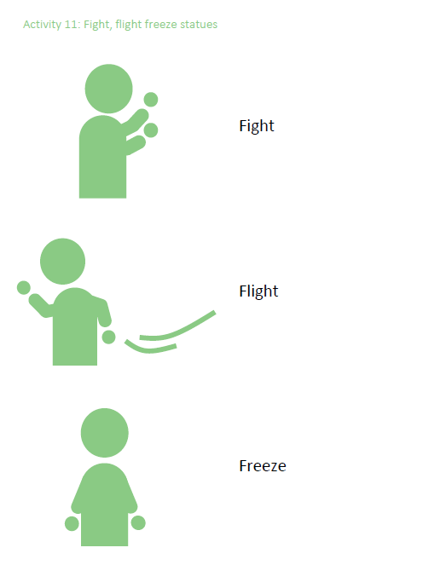
  - When we sense danger our body gets ready to fight or run away. Or, our body may freeze. Suggest that you play a game of musical statues or freeze dance to explore this. This involves dancing to music and, when the music stops, adopting either a fighting stance (e.g., with fists up), a running pose (e.g., ready to sprint), or freezing mid-dance. It is important not to decide in advance which stance to take, it needs to be spontaneous.
- When the child is ready, start playing and pausing music and let them take their stances.
- Talk with the child about the different reactions. Ask about what they noticed in their body at this time and what they did.

TIP | Remind the child that fighting does not always mean physical fighting. Sometimes when we are worried, we fight with our words. Similarly, flight is not always about actually running away; sometimes it might be about avoiding a situation. Share examples as you play about when the child has had a fight, flight or freeze reaction provides an opportunity to obtain further information.

TIP | This activity can also be useful in opening up discussion with caregivers who might otherwise misinterpret their child’s behavior as naughty, and it allows them to better understand what their child’s experience is. Families can easily play this game together in session and it provides a good opportunity to reflect on how other family members tend to respond. You may like to encourage the family to play the game together at home.

Activity 12: Your child’s reaction

PSYCHO-EDUCATION

Objective of the activity | To explain the fight, flight and freeze response to parents or caregivers and to gather information on the child’s feeling and reaction.
Time | 10 - 15 mins
Age | Parents of children 3+ years old
Materials | Checklist or paper, pen
Participation | Parent or caregiver

Guidance

- Explain survival reactions (fight, flight or freeze) to the parent or caregiver.
  - When children experience or witness a traumatic event, they can go into a survival mode and show one of these three reactions: fight, flight or freeze. We have listed a few examples of how children might react and we would like to have a look at these together.
- Ask the parent to review the list or to listen to examples shared and indicate which behaviours or reactions their child shows.
Activity tools and templates: Activity 12
FIGHT EXAMPLES  Argumentative  Impulsive  Defiant  Inattentive  Lacking self-control  Agitated  Quick to react  Temper tantrums | FLIGHT EXAMPLES  Avoiding others  Restless  Scared  Worried  Jumpy  Disorganized | FREEZE EXAMPLES  Withdrawn  Numb (without emotions)  Inattentive  Worried  Stuck  Obsessive  Non-responsive

- Summarize and discuss the reactions the parent or caregiver identified and ask what they think these mean and how they think their child is feeling.
- Review together the overview of areas of functioning and list different places or locations where the child frequently spends time. In discussion with the caregiver try to identify areas in which the child struggles and what goes well.
Activity tools and templates: Activity 12
Feeling safe (at home, at school, in new places,…)
Trusting others
Handling their emotions such as sadness, anger
Solving problems they face
Their self-esteem, self-image

- Discuss the needs of the child with the caregiver and ask them what they think would help. Include this in the assessment and use it as a basis in the case planning.


MHPSS Activities to increase a child’s sense of safety

PSYCHO-EDUCATION

Activity 13: Protectors

Objective of the activity | To help the child understand which protective factors they have in their life.
Time | 10 - 15 mins
Age | 8+ years old
Materials | Paper of reasonable size (A4, A3 or flipchart), pencils and/or markers. You can write or use the template.
Participation | Activity with the child, but parent or caregiver can join as well.

Guidance

- Explain to the child that there are people, things, places and activities that help you feel better and protected when times are difficult. You can name this protective factors or protectors.
  - Protectors can be people, things, places or activities that help you feel better and protected when times are difficult. We all have protectors.
- Provide some examples of what protectors can be:
People  - Parents, caregiver  - Other family members  - Your friends  - Your neighbours  - Your teacher  - … | Places  - Home  - School  - Youth club  - Church, mosque or temple  - … | Activities  - Playing games with others  - Doing sports with other children  - Going out with your parents, caregiver or family  - …

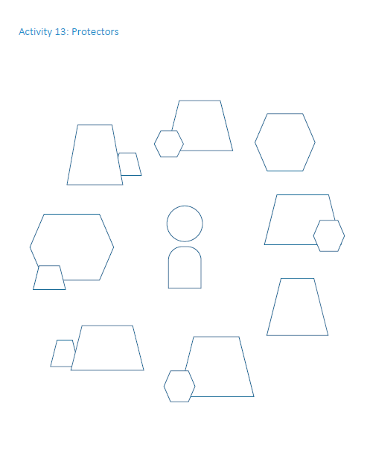
- Explain to the child that protectors are different for every child and that you are asking them to think about their own protectors.
Activity tools and templates: Activity 13
- Ask the child to draw themselves and then to think about their protectors and write them around th em.
  - You can help them explore options and think by asking questions or repeating examples. Possible questions:
    - Who is important in your life
    - To whom do you go when you need help?
    - With whom can you talk well or easily?
    - What are your favourite places?
    - Where do you like to go?
    - What are your favourite activities?
    - When you feel sad or angry, is there anything you can do that makes you feel better?
- Ask the child to also think about themselves, what makes them strong, and to write it on their drawing
  - What are your strengths?
  - What are you good at?
  - What makes you special?

TIP | You can use the drawing available as a template

SOLUTION FOCUSED

Activity 14: Worry workshop

Objective of the activity | To help the child to identify what makes them worry and practice to replace worrisome thoughts with positive thoughts.
Time | 10 - 15 mins
Age | 8+ years old
Materials | Paper, pens. You can draw or use the template.
Participation | Activity with the child, but parent or caregiver can join as well.

Guidance
Activity tools and templates: Activity 14
- Explain what are worries. You can use the guiding script as an inspiration:
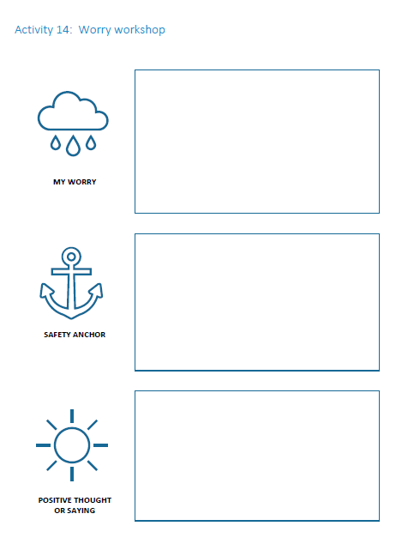
  - Worries are often negative thoughts or expectations we have about ourselves or others. It can involve imagining the worst possible outcome or having negative beliefs about ourselves. Worries or thinking “What if….” can increase str ess in the body, keep us from trying new things or interacting with others, or simply distract us from daily activities.
- Ask the child to identify what makes them worry now and in the past.
  - You can help them explore options and think by asking questions or giving examples.
- Ask the child to write down or draw what makes them worry
- Explain that there are things we can do to reduce our stress, to calm our mind and make us worry less. This also includes a positive thought, to replace the thought that makes you worry.
- Ask the child to choose one of the things they worry about and identify what they sometimes do or can do to help them to calm and what an alternative positive thought could be.
  - You can help them explore options and think by asking questions or giving examples.

Example

 |  | 
Worry: I worry about sleeping in the dark. I feel unsafe if I can’t see | Safety Anchor: Before I go to bed, I will read a story to quiet my mind. I will also use a small nightlight so it’s not so dark. | Positive thought or saying: tomorrow will be a good day

Activity 15: Emotional triggers or reminders

PSYCHO-EDUCATION

Objective of the activity | Help the child to identify what triggers them emotionally and that the reactions they have to it are normal.
Time | 10 - 15 mins
Age | 10+ years old
Materials | Paper, pen. You can write or use the template.
Participation | Activity with the child, but parent or caregiver can be included

Guidance

- Explain emotional triggers and include the fact that they are different for every child. You can use the guiding script as an inspiration: Each child or adult has different triggers, it is unique for every person. Certain sounds, smells, or places can remind you of a moment, an event or a period of time and make you feel a certain emotion. Some emotional triggers can be negative and remind you of a painful time, when you felt anguish, distress, anxiety, sadness, anger or any other intense negative emotion. When you experience this triggers, you get thrown back into that emotion and your body will react.
- You can help them understand by providing an example.
  - For example, if something bad happened to a child on a crowded bus the following things might be triggers for this child:
Activity tools and templates: Activity 15
    - Many people together, crowded places (people and places)
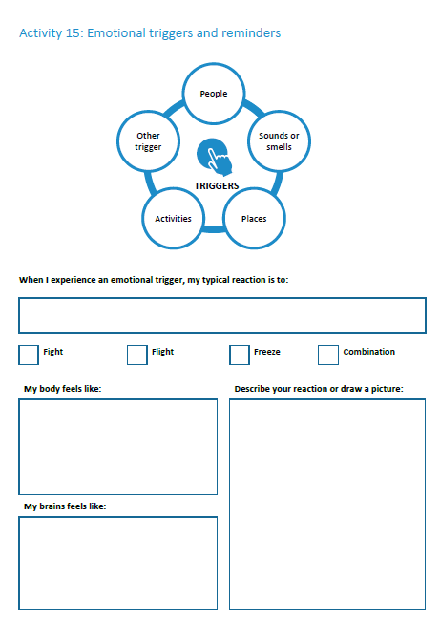
    - Bus drivers or ticket collectors (people)
    - The smell of the bus exhaust (smell)
    - Busses and bus stations (place)
    - The honking of the bus (sound)
- Check if the child understood what emotional triggers are and if they feel comfortable to identify some triggers they have.
  - You can help them explore options and think by asking questions or giving more examples.
- Together with the child write them down or draw them. You can use the template.
- Ask the child to think about how this trigger makes them feel (which emotion) and how their body reacts.

TIP | After completing this activity, you can use a grounding technique to support the child to cope with distressing thoughts or negative emotions.

Activity 16: Talking about how I feel

Objective of the activity | To support the child in exploring, recognizing and naming their emotions and feeling and practice in sharing them.
Time | 10 - 15 mins
Age | 10+ years old
Materials | Paper, pens
Participation | Activity with the child, but parent or caregiver can be included
Note | It is important to do this activity only with children who have already learned to label their emotions. Otherwise the child might feel incompetent and/or uncomfortable. For example, you can use the Emotions Wheel that can be found in Level 1 Module 8 Implementation.

Guidance

- Explain the purpose of the activity.
  - You can use the sample script as an inspiration:
Our emotions are very important and they have a big impact on our thinking and our behaviour. Sometimes, we try to ignore our emotions or tell ourselves that they are not important. In this activity, you will explore your feelings and why they are important to you. This will help you in recognizing your emotions, make you feel more confident to share and regulate them.
- Ask the child to think about five emotions they felt in the past week. Ask the child to label the emotions, to describe the feeling (intense or a little bit, felt like this for a short time or for days,..), to describe when or why they think they felt like this, and how they reacted.
Activity tools and templates: Activity 16

An emotion I felt | How did I feel it (intense, little bit, short time, long time,…) | When or why I felt like this | How did I react? What did I do?

- Explain to the child that you will ask them to do some homework. They are asked to share this paper with the table with someone they trust. Together with the child, try to identify the person with whom they would feel comfortable to share.
- In the next meeting with the child, check in if they have shared how they felt in the past week with someone as discussed. If they did it, check in with them how they felt about it. You can help the child to understand by giving an example.

Activity tools and templates: Activity 16

The emotion I felt before and how I felt it | How do I feel about it after talking about it.
For example, I felt very angry about it before. I was very angry during the whole afternoon. | For example, I don’t get very angry anymore when I think about it. It feels good that I know that it’s normal to be angry about it, but I feel guilty about losing my temper.

MHPSS Activities to strengthen coping skills and to regulate emotions

EXPRESSIVE ACTIVITY

Activity 17: Hello it’s your body calling

Objective of the activity | To help the child to recognize and identify how their body reacts to certain feelings, especially anxiety. This activity aims to help children to manage anxiety.
Time | 10 - 15 mins
Age | 7+ years old
Materials | Paper, pens
Participation | Child and their parent or caregiver (can be the child alone as well)

Guidance

- Introduce the activity to the child, by explaining that you sometimes miss a call, and that this can happen to everyone.
  - Sometimes I miss when someone calls me. They wanted to tell me something, by it didn’t notice. It is very easy to miss someone calling you, especially when you are very busy.
- Explain that our body also sends messages to us, but sometimes we miss these calls or messages.
  - Our body also sends messages, but sometimes we miss them too! We are too busy, we don’t hear them or don’t want to listen.
Activity tools and templates: Activity 17
- Suggest to make a body phone together, so the child can think about some messages their body might send.
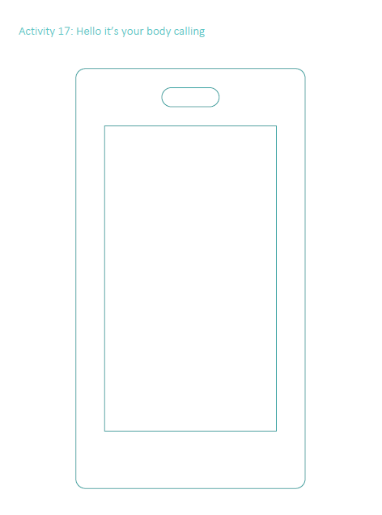
  - You can make a simple phone together using the cardboard, foam, felt, or box. (If you like, you can print the template below, colouring it in and pasting it onto the phone)
- Take it in turns to be your body calling and provide examples to help the child understand. Sharing some examples of the sensations you notice when your body is calling is often helpful and can be very normalizing for the child. Personalize the play so that you include bodily sensations that the child experiences along with feelings the child often has.
  - “Hello this is your tummy speaking. I’m feeling a little sick. Is something worrying you perhaps?”

TIP | For some children it can be useful to have a list of bodily sensations as examples they can draw on. You can propose the following examples and discuss with the child if they feel them. They are most often associated with fear and anxiety:
 | - Feeling hot  - Feeling cold  - My body shaking  - Breathing quickly  - My heart going fast  - Needing to go to the toilet | - My muscles getting tight or feeling sore  - Feeling sweaty  - Feeling dizzy  - Feeling like I’m going to be sick  - Feeling like there are butterflies in my tummy | - Sore tummy  - Sore head  - Feeling really tired  - Feeling like I can’t sit still  - Feeling jumpy  - Feeling like it’s hard to breathe  - My chest feeling tight

- You can ask about when the child finds it easier to get messages from their body and when it might be harder.
  - You can also wonder together about what might be helpful for getting the messages. Would it allow the child to do something differently?

TIP | The parents or caregivers can easily be involved in the session and may provide examples of situations when the child experienced physical symptoms, enabling some discussion about what they might have been feeling at the time.

- Have a discussion with the parent or caregivers after this activity, to debrief and inform them and ask them to continue this activity and have short chats with the child about the messages their body sends.

You can provide them with an explanation and some examples, and have the child show them the phone. This activity also helps caregivers to understand the link between bodily sensations and emotions. This may assist them to tune in and hear what their child’s body might be saying, supporting them to be better able to label their child’s feelings. The child might be happy for parents to use their phone when the child experiences bodily sensations so they can together figure out what their body is trying to say.
- Having caregivers continue these conversations at home is also particularly important for younger children.

Activity 18: Face your fear

EXPRESSIVE ACTIVITY

Objective of the activity | Help children recognize fearful emotions and provide support in expressing and regulating them.
Time | 10 - 20 mins
Age | 8+ years old
Materials | Paper, pens
Participation | Activity with the child, but parent or caregiver can be included

Guidance

- Explain that we all are scared sometimes.
  - Fear is a normal emotion, we all feel it sometimes. I would like you to think about being scared. Can you have a think about how you look when you are scared? You can do it!
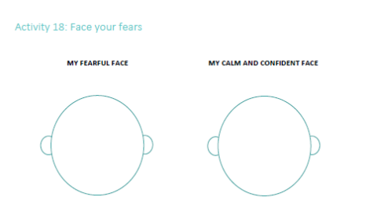
- Ask the child to draw their face when they feel scared. You can support them by asking some questions:
Activity tools and templates: Activity 18
  - How do your eyes look?
  - How does your mouth look?
  - What colours will you use to colour your face?
- Explain that there also must be things that make us happy, that help us to feel confident, hopeful or optimistic.
- Ask the child to draw their face when they feel happy, confident and optimistic. You can support them by asking some questions:
  - How do your eyes look when you feel in control?
  - How does your month look
  - Which colours will you use to colour your face?
- Ask the child if they have ideas on what they think or do when they feel fear and what they think of do when they feel optimistic and confident. They can write it down in the table.

Activity tools and templates: Activity 18

 | Fear Face | Calm, Cool and Confident Face
Thoughts
Actions

- Ask the child if they have ideas on how they can go from feeling fear to feeling more confident? Are there helpful thoughts or helpful actions, things they can do? Help the child to identify helpful thought and actions. Make sure you have some ideas and examples prepared, matching their specific situation!
TIP | After completing this activity, you can use a grounding technique to support the child to cope with distressing thoughts or negative emotions.

Activity 19: Coping Plan

Objective of the activity | Support the child in identifying positive ways of coping with feelings of sadness or fear and help to develop a coping plan.
Time | 20 mins
Age | 6+ years old
Materials | Paper, pens
Participation | Activity with the child, but parent or caregiver can be included

Guidance

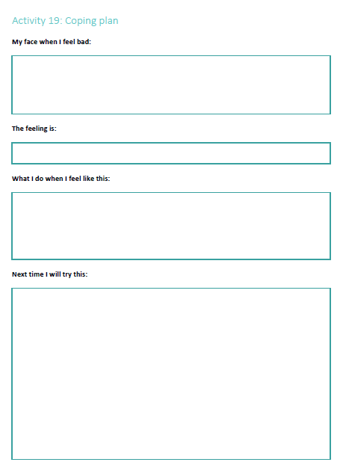
- Ask the child if they sometimes feel ‘bad’. If they say they do, ask them to explain and support them in labelling the emotion.
Activity tools and templates: Activity 19
- Ask the child to draw their face when they feel like this.
- Ask the child what they sometimes do when they feel like this (name the emotion identified in step 1) and map out their ways of coping.
  - Try to identify the positive ways of coping and the more negative ways of coping.
- Ask the child if there is someone they can talk to or any activity they enjoy doing. What else they can try next time they feel like this.
  - Support the child in finding positive ways of coping by asking questions or providing examples.

Mindfulness  Writing in a journal  Being creative  Setting positive intentions  Playing a game | Exercising  Stretching  Deep breathing/belly breathing  Muscle relaxation  Jumping (e.g., jump rope, trampoline)
Social  Visiting with a friend  Calling a friend  Talking with a trusted adult  Being around others  Helping others | Sensory  Listening to music  Tasting food or drink  Visualizing calming places  Touching something that feels nice (soft toy, favourite blanket,…)

- Ask the child to draw the things they will try next time.
- Building on the child’s answers, the caseworker can develop a plan with the child to engage the people, activities, interests and other strengths they have identified, to help them when they need support.

ADAPTATION | The activity can be adjusted to children or adolescents when the drawing is replaced by writing and listing.

TIP | The caseworker can ask caregivers to support the child in carrying out the plan. The caseworker can follow-up with the child and caregiver at their next meeting to find out if they have tried the plan and whether or not it is helping the child to feel better.


Activity 20: My safe space

EMOTIONAL REGULATION ACTIVITY

Objective of the activity | To reduce stress and increase sense of safety
Time | 15 - 30 mins
Age | 6+ years old
Materials | None
Participation | Activity with the child, but parent or caregiver can be included
Note | It is helpful for children to practice creating a “safe place” in their imagination. This gives children practice in manipulating their imagination and using visual imagery in a positive and proactive way. It also serves as a secure base in imagination to which children can return if they need to reduce the emotions being felt as they are carrying out later techniques. It is a non-threatening and fun way to begin working their imagination - using something visual to help calm them and to give children a sense of control. Once children have practiced this activity a few times, they can do it with caregivers to reduce stress at key times (e.g. before bedtime for children who are having nightmares). It is important they practice this in moments where they feel safe. Not when already flooded with emotions.

Guidance

- Introduce the Concept of a safe space
Activity tools and templates: Activity 20

  - Instructions: Have the child stand up and move around, or jump up and down, or shake him/herself so that s/he is refreshed to begin. Come back and make sure that the child is comfortable. Do this in a circle if you involve the caregivers.
  - Sometimes when we are feeling anxious or upset it is helpful to use our imaginations to create nice, happy images and feelings. This can help us calm down or feel less scared.
  - In this activity, we’ll practice using our imaginations to create positive feelings. I’m going to ask you to imagine a place or scene that makes you feel calm and secure and happy. This could be somewhere real that you remember, maybe from a holiday; or it could be somewhere you’ve heard about, maybe in a story; or it could be somewhere that you invent and make up yourself.
- Select a Safe Place
  - Instructions: Suggest some examples here that are relevant to your community. It might be a beach by the sea, or the countryside, or some other peaceful place. As you are giving the following instructions, keep an eye on the child to see if s/he seems to be having difficulties: relaxing in this way may sometimes increase the frequency of negative images. Pace the instructions to give the child time to use their imagination. Adapt these instructions as you wish, but give the child time to develop a comprehensive scene, and remember to encourage him/her to use all sensory modalities.
  - I’m going to ask you to imagine a place or scene that makes you feel calm and secure and happy. This could be somewhere real that you remember, maybe from a holiday; or it could be somewhere you’ve heard about, maybe in a story; or it could be somewhere that you invent and make up yourself.
- Spending Time in Your Safe Place
  - Instructions: As you are giving the following instructions, keep checking if the child is ok pace the instructions to give the child time to use his/her imagination.
  - Take a few deep steady breaths. Close your eyes and carry on breathing normally. Bring up a picture of your safe place and imagine that you are standing or sitting there. Can you see yourself there? In your imagination, take a look around. What do you see? What can you see close to you?
  - Look at the details of it and see what it is made of. See the different colors. Imagine reaching out and touching it. How does it feel? Now take a look further away. What can you see around you? See what’s in the distance. See the different colors and shapes and shadows.
  - This is your special place and you can imagine whatever you want to be there. When you’re there, you feel calm and peaceful. Imagine your bare feet on the ground. What does the ground feel like? Walk around slowly, noticing the things there. See what they look like and how they feel.
  - What can you hear? Maybe the gentle sounds of the wind, or birds, or the sea. Can you feel the warm sun on your face? What can you smell? Maybe it’s the sea air, or flowers, or your favourite food cooking? In your special place, you can see the things you want, and imagine touching and smelling them, and hearing pleasant sounds. You feel calm and happy.
- Inviting a Helper into the Safe Place
  - Now imagine that someone special is with you in your place. [With younger children especially, this might be a fantasy figure or a cartoon superhero] This is someone who is there to be a good friend and to help you, someone strong and kind. They are there just to help you and they’ll look after you. Imagine walking around and exploring your special place slowly with them. You feel happy to be with them. This person is your helper and they’re good at sorting out problems.
- Conclude
  - Just look around in your imagination once more. Have a good look. Remember that this is your special place. It will always be there. You can always imagine being here when you want to feel calm and secure and happy. Your helper will always be there whenever you want them to be. Now get ready to open your eyes and leave your special place for now. You can come back when you want. As you open your eyes, you feel calmer and happier.
- Discuss
  - Instructions: To finish this exercise, ask the child what s/he imagined. Younger children might want to draw out what they imagined. Ask how it made him/her feel. Point out the connection between imagination and feelings. Point out that s/he can have control over what s/he see in his/her mind’s eye, and therefore over how s/he feel. Reinforce that this is a fun thing to do, and that s/he can imagine being there whenever s/he feels miserable or scared, and that it will make him/her feel better. Say that his/her special place will get easier to imagine the more s/he practise it.


Activity 21: Belly breathing

GROUNDING TECHNIQUE

EMOTIONAL REGULATION ACTIVITY

Objective of the activity | Help the child to reduce their stress, to relax their mind and body through breathing exercises.
Time | 10 - 15 mins
Age | 6+ years old
Materials | Mat to lay on or a pillow
Participation | Activity with the child, but parent or caregiver can be included
Note | You can do this activity directly with the child, and if possible, include the caregiver so they can do this at home with the child as well. Ask the child for permission to do this activity and to lie alongside them.  Do the following sequence with the child. It works well for all ages, but we will propose a few variations below.

Guidance

- Introduce the activity. Sample script:
Activity tools and templates: Activity 21
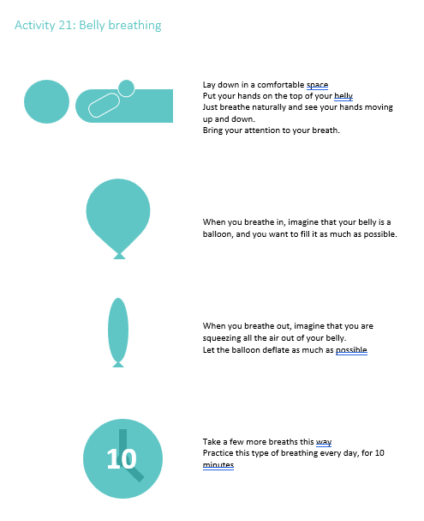
  - “Today we’re going to learn a way to help ourselves calm down and control our nervousness and upset feelings. We are going to do a breathing activity that can help you calm your mind and your body. When we get upset, we tend to breathe faster and not as deeply. This does not allow enough air into our lungs, which can make our body feel out of control. Doing this breathing exercise when you are upset will help you get more air into your lungs and will help your body and mind relax. It’s also something you can do anytime and anywhere.”
- Do the activity together
  - Lie alongside the child in a comfortable space and place your hands on top of your belly.
  - Ask the child to place his hands on his/her belly too. Now, you can both just breathe naturally and see if you notice your hands moving up and down. If your breathing—or the child’s breathing—is shallow (mainly in the chest), you may not notice much movement, and that’s okay. The point is simply to bring your attention to your breath. Next, try to engage your belly as you breathe. When you breathe in, imagine that your belly is a balloon, and you want to fill it as much as possible. (Sometimes children tense up when they are given this instruction, so encourage him/her to let his arms and legs and whole body be loose.) When you breathe out, imagine that you are squeezing all the air out of your belly.
  - Let the balloon deflate as much as possible (it’s hard to breathe more air into the balloon on the next breath if it’s still full with the last breath). You can instruct older children to imagine that they are pulling their belly button down to the floor below them. Take a few more breaths this way. You can them ask them:
  - Now do you notice your hands moving up and down with each breath?
- Debrief
  - Ask the child (and caregiver). What does it feel like to breathe this way? Is it different from how you normally breathe?
- Give homework
  - Ask the child to practice this type of breathing every day, for 10 minutes. Children can practice while they are falling asleep at night or at another time that is right for them. Older children can record these home practices on a form and discuss later with the caseworker. The caseworker should help the child decide when/where the homework will be done, trying to identify likely barriers to practicing on their own. Initially, the practice sessions should be done when the child is calm and can concentrate, not at times of stress and anxiety.

Variations

For children 3-6 you could put a stuffed animal or toy on the belly for the belly. Watching it move up and down creates a more helpful visual for him.

Older children 7+ can try additional practices for deep breathing. Ask them to try 4–6 breathing, where they make their inhale last a full four counts, and their exhale last a full six counts, or resonant/coherent breathing, where each in-breath and out-breath is the same length, but the breathing is slower (five or six counts to inhale, five or six counts to exhale).

Activity 22: Mandala colouring
GROUNDING TECHNIQUE

Objective of the activity | Help the child discover how to relax their body and mind using a visual aid
Time | 10 - 20 mins
Age | 6+ years old
Materials | An image with the wave (or you can draw it when you start the activities)
Participation | Activity with the child, but parent or caregiver can be included

Guidance

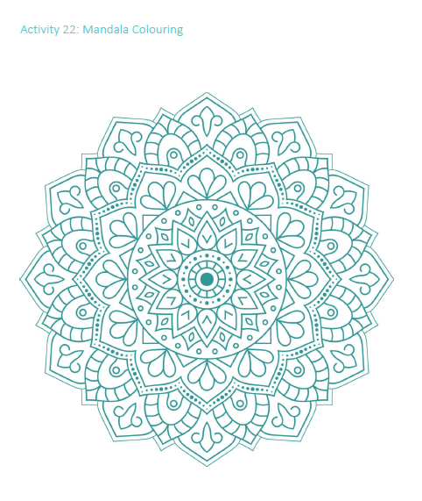
Mandalas are round geometric designs with repeating pattern. Colouring them requires patience and focus which are both elements of mindfulness. Colouring a mandala can help you to relax, reduce your stress and focus on the present.
Activity tools and templates: Activity 22

- Provide few templates of mandala and let the child chose one they would like to colour.
- Make sure the child has sufficient coloured pencils or markers.
- Explain to the child that they can use all their creativity to colour the mandala.
- If needed, support the child in staying motivated and praise their work.
- After the child has fully coloured the mandala or when they lost interest, ask them if they liked this activity and how they felt while colouring.

TIP | In the annex you will find example mandalas’ but you can use other’s if you would like, or create your own.

MHPSS activities to strengthen a child’s self-esteem

Activity 23: What I Like About Myself

Objective of the activity | To help children to identify their positive qualities, to raise awareness of them and to practice appreciating their positive qualities
Time | 10 - 15 mins
Age | 6+ years old
Materials | Paper, pens, markers or colored pencils
Participation | Activity with the child or group of children

Guidance

- Discuss how focusing on our positive qualities can help improve self-esteem.
Activity tools and templates: Activity 23
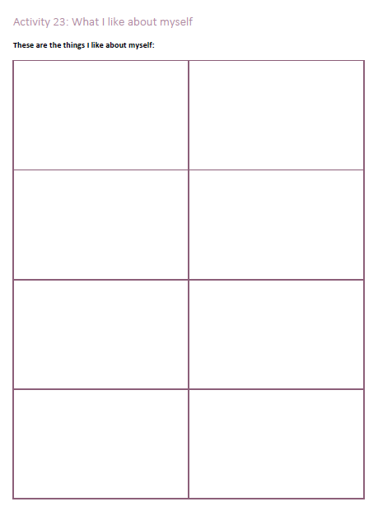
- Have the child give examples of positive qualities (not necessarily theirs).
  - You can support them by asking question or providing examples:
    - What makes your family proud?
    - What do you think your friends like about you?
- Give them a few minutes to quietly brainstorm their own personal positive qualities and draw them (for young children) or write them (adolescents) on a piece of paper.
- If you think the child is able to do this, give them about 10 minutes to make a small poster of their positive qualities. They can be as creative as they want. It is always good to make a visual reminder of this activity they could take home with them, it will help reinforce the ideas.
- Have them present their positive qualities to you and/or their caregiver, and/or their friends.

Activity 24: What am I telling myself?

Objective of the activity | Increase awareness on how their self-esteem can be affected by positive and negative self-talk. Identifying self-talk habits with the help of peers.
Time | 20 mins
Age | 12+ years old (can be in group or with children individually who are literate)
Materials | Pencils; sticky notes; dry-erase board and markers
Participation | Small group of children

Guidance

- Explain self-talk
  - Self-talk is the way you talk to yourself. It is our voice in our head or we sometimes call it our inner voice. We all do it, but sometimes we are not even aware that we are doing it. This voice in our head can tell us positive messages and negative messages.
  - Give examples of positive and negative self-talk (You can use the examples below, but are free to use any other example).
    - I probably won’t do well (negative self-talk)
    - I can do it (positive self-talk)
- One-by-one, read the open-ended statement and have the children write their responses on sticky notes and gather the notes. Remind the children that there are no right or wrong answers to the statements.
Examples of open ended statements:
  - Tomorrow will be a …… day
  - When I do my best,…
  - When I play a game with others,…
  - If someone was snappy to me, it’s probably because…
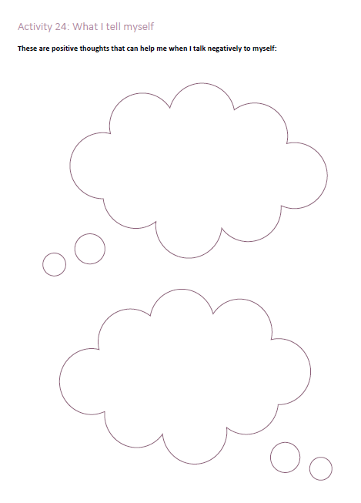
- One-by-one, read each response out loud and have the group of participants determine if it is positive of negative self-talk.
Activity tools and templates: Activity 24
- Stick each response on the dry-erase board, divided into positive or negative self-talk.
- Discuss with the group if some statements generated more positive or more negative self-talk.
- Explain that some questions can be helpful to stop negative self-talk and start to talk to yourself in a positive way, which will also make you feel better about yourself.
  - Do these thoughts help or not help me?
  - Am I blaming myself for something that’s not really my fault?
  - Am I expecting myself to be perfect?
- Ask the child to write down some positive thought or questions that they can ask themselves when they are talking negatively to themselves.

Activity 25: Affirmation Cards

Objective of the activity | To strengthen self-esteem through affirmations
Time | 15 - 20 mins
Age | 10+ years old
Materials | Note cards, pencils, colored pencils, markers.
Participation | Can be with children individually or in small groups

Guidance

- Discuss how using positive affirmations, or simple empowering phrases, can change negative self-talk, help you grow, and move on after difficult times.
Activity tools and templates: Activity 25
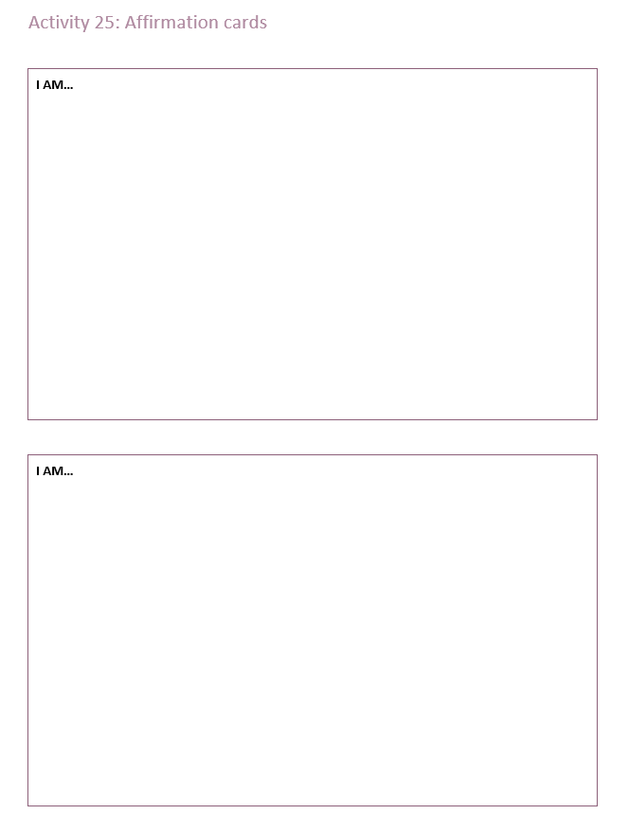
- Give examples starting with “I am . . . ” that address past mistakes or trigger positive thoughts to create a growth mindset. For example, “I am strong.”
- Guide them to create positive affirmation card.
  - Provide a variety of positive affirmations to inspire the adolescent(s) to find one that really resonates.
  - Give examples of when positive affirmations can be especially helpful—for example, when feeling inadequate around others.
- Have them write the affirmation on a note card, decorate it if they wish, and put it in an easily accessible place to use in a troubling moment.
- Remind them to use it as often as possible—even while doing mundane tasks.

TIP | If the child has a mirror at home, encourage them to stick the positive affirmation cards on or around them.

ADAPTATION | You can create 2 or 3 positive affirmation cards with younger children by helping them to list some good things about themselves and let them draw this on small cards. For example, I am strong (draw themselves looking strong).

Activity tools and templates

Grounding technique 1: 5, 4, 3, 2, 1 senses

 | What are 5 things you can see
 | What are 4 things you can feel?
 | What are 3 things you can hear?
 | What are 2 things you can smell?
 | What is 1 thing you can taste?

Grounding technique 2: ABC in the room

A | B | C | D
E | F | G | H
I | J | K | L
M | N | O | P
Q | R | S | T
U | V | W | X
Y | Z

Grounding technique 3: Here and now hand trace



Activity 1: Serve and return

 | When a child focuses their attention on something…
- Share the focus
- Return the serve by supporting and encouraging
- Give it a name
- Take turns…and wait. Keep the interactions going back and forth.
- Practice endings and beginnings

Activity 2: Drawing the child’s family or daily activities

MY FAMILY OR MY DAILY ACTIVITIES:

Activity 3: Safety circles

Activity 4: Change cloud

Activity 5: In my own words

What happened to you?

When did it happen? | How did it make you feel at that time?
- Today  - Yesterday  - This week  - This month  - This year  - Years ago  - Other:______________________ | - I felt angry  - I felty let down or disappointed  - I felt frustrated  - I felt sad  - I felt lonely  - I felt hurt  - I felt guilty  - I felt scared  - I felt weak  - I felt tired  - I felt stressed  - I felt worried  - I felt confused  - I felt unsafe  - I felt other emotions: ______________________

How did it make you feel at that time?

Which feelings were you able to handle or manage?

Which feelings were very difficult to handle or manage?

Who could have helped you?

Did anyone help you?

How do you feel about it now? | How you think about handling or managing all of this?
- I feel angry  - I feel let down or disappointed  - I feel frustrated  - I feel sad  - I feel lonely  - I feel hurt  - I feel guilty  - I feel scared  - I feel weak  - I feel tired  - I feel stressed  - I feel worried  - I feel confused  - I feel unsafe  - I feel other emotions: ______________________ | - I can handle it.  - I need some help  - I really need help.

Activity 6: What happened

What happened to you? Describe the distressing event(s):

How long did the event(s) last?

1
2
3
4
5
Once
A few times
Often

How much notice did you have before the event occurred?

1
2
3
4
5
Completely unexpected
Some notice
Prepared and expected

How much personal stress did the event cause?

1
2
3
4
5
No stress
Some stress
A lot of stress

How much family stress did the event cause?

1
2
3
4
5
No stress
Some stress
A lot of stress

How much change did the event cause?

1
2
3
4
5
No change
Some change
A lot of change

Activity 7: What is a problem?

My problem:

How big is your problem?

1
2
3
4
5
No problem
I’m not sure
Major problem
Small problem
Big problem

How urgent is your problem?

1
2
3
4
5
Not
urgent
I’m not sure
Emergency
It can
wait
I need help soon

How does it make you feel?

1
2
3
4
5
Very comfortable
Okay
Very uncomfortable
Comfortable
Uncomfortable

Do you feel safe?

1
2
3
4
5
Very
safe
Okay
Very
unsafe
Safe
Unsafe

Activity 8: Then and now

Important Personal or Family Events (e.g., move/displacement, marriage, birth, death etc.)


Special or Important Relationships (e.g., family members, friends, neighbors, coaches)
Sad Events (e.g., loss of a loved one, personal event, family event, community event, etc.).


Change Events (e.g., moving, displacement, starting a new school)
Favorite Times (e.g., favorite memories or experiences)


Personal strengths (problem-solving skills, being a good friend etc.)


THEN
NOW

Activity 9: Good and bad stress

POSSIBLE SIGNS OF FEELING STRESSED

- Eating or sleeping too much or too little
- Pulling away from people and things (e.g. Playgroups and friends or things they used to like to do such as playing football)
- Having low or no energy
- Having unexplained aches and pains, such as constant stomach aches or headaches
- Having difficulty concentrating
- Feeling helpless or hopeless
- Worrying a lot of the time; feeling guilty but not sure why
- Becoming disruptive or aggressive at home or in the classroom (e.g. Hitting other children or adults)
- Having added conflict with peers or caregivers
- Thinking of hurting or killing yourself or someone else
- Having difficulty readjusting to home life
- Experiment with high-risk behaviours (e.g. Drinking, smoking, or using drugs, including prescription medications)

MY EXAMPLES

Activity 10: The stressed mind

CALM MIND | STRESSED MIND

 | SHORT-TERM STRESS | ONGOING STRESS
Physical Well-Being (Eating, sleeping, health, exercise)
Emotional Well-Being (Moods, ability to adapt to change, ability to express emotions)
Relationship (Trust, how you interact with others, how often you see out others)
Problem-Solving Skills (Ability to predict what might happen, decision-making skills)
Self-Concept (Belief in yourself, self-image, self-confidence)

Activity 11: Fight, flight freeze statues

Fight
Flight
Freeze

Activity 12: Your child’s reaction

FIGHT EXAMPLES  Argumentative  Impulsive  Defiant  Inattentive  Lacking self-control  Agitated  Quick to react  Temper tantrums | FLIGHT EXAMPLES  Avoiding others  Restless  Scared  Worried  Jumpy  Disorganized | FREEZE EXAMPLES  Withdrawn  Numb (without emotions)  Inattentive  Worried  Stuck  Obsessive  Non-responsive

Feeling safe (at home, at school, in new places,…)
Trusting others
Handling their emotions such as sadness, anger
Solving problems they face
Their self-esteem, self-image

Activity 13: Protectors

Activity 14: Worry workshop


MY WORRY

SAFETY ANCHOR

POSITIVE THOUGHT
OR SAYING

Activity 15: Emotional triggers and reminders


People
Sounds or smells
Places
Activities
Other trigger

TRIGGERS

When I experience an emotional trigger, my typical reaction is to:

 | Fight |  | Flight |  | Freeze |  | Combination

My body feels like: |  | Describe your reaction or draw a picture:
My brains feels like:

Activity 16: Talking about how I feel

An emotion I felt | How did I feel it (intense, little bit, short time, long time,…) | When or why I felt like this | How did I react? What did I do?

The emotion I felt before and how I felt it | How do I feel about it after talking about it.
For example, I felt very angry about it before. I was very angry during the whole afternoon. | For example, I don’t get very angry anymore when I think about it. It feels good that I know that it’s normal to be angry about it, but I feel guilty about losing my temper.

Activity 17: Hello it’s your body calling

Activity 18: Face your fears

MY FEARFUL FACE | MY CALM AND CONFIDENT FACE

 | Fear Face | Calm, Cool and Confident Face
Thoughts
Actions

Activity 19: Coping plan

My face when I feel bad:

The feeling is:

What I do when I feel like this:

Next time I will try this:

Activity 20: My safe space

MY SAFE SPACE LOOKS LIKE THIS:

Activity 21: Belly breathing

Lay down in a comfortable space
Put your hands on the top of your belly
Just breathe naturally and see your hands moving up and down.

Bring your attention to your breath.

When you breathe in, imagine that your belly is a balloon, and you want to fill it as much as possible.

When you breathe out, imagine that you are squeezing all the air out of your belly.
Let the balloon deflate as much as possible

Take a few more breaths this way
10
Practice this type of breathing every day, for 10 minutes

Activity 22: Mandala Colouring







Activity 23: What I like about myself

These are the things I like about myself:

Activity 24: What I tell myself

These are positive thoughts that can help me when I talk negatively to myself:

Activity 25: Affirmation cards

I AM…

I AM…

Adapted from: Weed Phifer, Lisa; Sibbald, Laura. Trauma-Informed Social-Emotional Toolbox for Children & Adolescents: 116 Worksheets & Skill-Building Exercises to Support Safety, Connection & Empowerment. PESI Publishing & Media.
Adapted from Zandt, Fiona; Barrett, Suzanne. Creative Ways to Help Children Manage Anxiety . Jessica Kingsley Publishers.
Adapted from Rudell Beach, Sarah. Mindfulness for Children. Ryland Peters & Small. Kindle Edition.

